Name……………………………………………………. Adm no…………………….
Signature…………………… Date…………………………..
233/2
CHEMISTRY Paper 2 MATUGA GIRLS HIGH SCHOOL,
(THEORY) Kenya Certificate of Secondary Education (KCSE)
MAY_JUNE,2018.
TIME:2 HOURS.
Instructions
- Write your name and admission number in the spaces provided above.
- Sign and write the date of examination in the spaces provided above.
- Answer all the questions in the spaces provided
- Silent electronic calculators may be used.
- All working must be clearly shown where necessary.
- This paper consists of 12 printed pages.
- Candidates should check the question paper to ensure that all the pages are printed as indicated and that no questions are missing.

For Examiner’s use only
Question | Maximum Score | Candidate’s Score
1 | 11
2 | 13
3 | 14
4 | 10
5 | 13
6 | 10
7 | 09
Total Score | 80

1.a) Study the diagram below and answer the questions which follow.
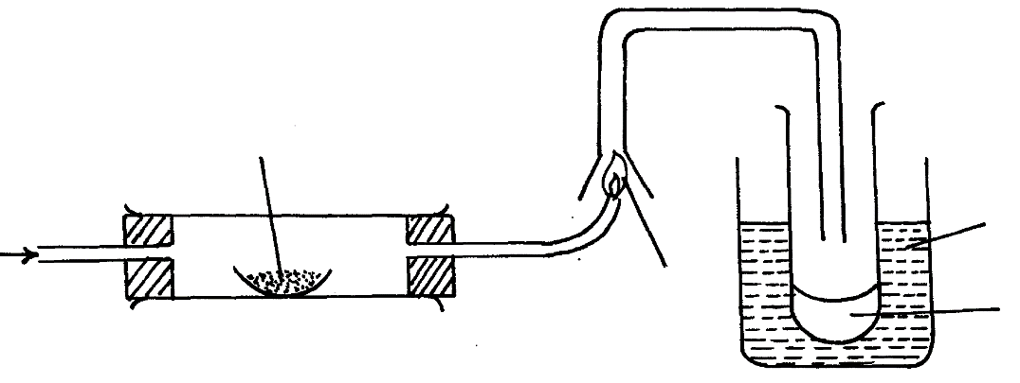
Lead II Oxide
Ice cold water
Flame
H₂
Liquid M

(i) State two observations made when hydrogen gas pass over hot lead II oxide. (2mks)
........................................................................................................................................................................................................................................................................................................................................................................................................................................................................................................................................................................................................................................
(ii) Write the equation for the reaction which occurs in the combustion tube. (1mk)
……………………………………………………………………………………………………………………………………………………
iii) What property of hydrogen is shown in the experiment above? (1mk)
……………………………………………………………………………………………………………………………………………………
(iv) Identify liquid M. (1mk)
……………………………………………………………………………………………………………………………………………………
(v) Name any other gas that can be used to investigate the property of hydrogen as shown in the diagram above. (1mk)
…………………………………………………………………………………………………………………………………………………… (vi) Give a simple physical test to prove the identity of liquid M. (2mks)
………………………………………………………………………………………………………………………………………………………………………………………………………………………………………………………………………………………………………….
b) State the role of ice cold water in the diagram above. (1mk)
………………………………………………………………………………………………………………………………………………………………………………………………………………………………………………………………………………………………………….
c) State one difference between a Crystal and a Powder. (1mk)
………………………………………………………………………………………………………………………………………………
……………………………………………………………………………………………………………………………………………….
d) State one industrial application of hydrogen gas. (1mk)
………………………………………………………………………………………………………………………………………………
2a) An atom of K can be represented as${39 \atop 19}K$. What does the number 19 represent? (1 Mark)
………………………………………………………………………………………………………
- Study the information in the table below and answer the questions that follow (letters are not the actual symbols of the elements)
Element | Element arrangement of stable ion | Atomic radius (nm) | Ionic radius (nm)
N  P  R  S  T  U | 2.8.8  2.8.8  2.8  2.8  2  2.8 | 0.197  0.099  0.160  0.186  0.152  0.072 | 0.099  0.181  0.065  0.095  - 0.068  0.136

- Write the formula of the compound formed when N reacts with P. (Atomic numbers are N=20 P=17) (1 Mark)
……………………………………………………………………………………………………………………………………………………………………………………………………

- Identify the elements which belong to the third period of the periodic table. Explain
.(2 Marks)
……………………………………………………………………………………………………………………………………………………………………………………………………………………
- Which of the elements identified in b(ii) above comes first in the third period? Explain (2 Marks)
……………………………………………………………………………………………………………………………………………………………………………………………………………………
- Select two elements which are non- metals. (1 Mark)
……………………………………………………………………………………………………………………………………………………………………………………………………………………

- The table below gives some properties of substances I, II, III and IV. Study it and answer the questions that follow.
Substance | Electrical conductivity |  | M.P⁰C | B.P⁰C
Substance | Solid | Liquid | M.P⁰C | B.P⁰C
I  II  III  IV | Does not Conduct  Conducts  Does not Conduct  Does not Conduct | Conducts  Conducts  Does not Conduct  Does not Conduct | 801  650  1700  113 | 1420  1107  2200  440

- What type of bonding exists in substance I and II (2 Marks)
I……………………………………………………………………………………………….
II………………………………………………………………………………………………
- Which substance is likely to be sulphur? Explain (2 Marks)
………………………………………………………………………………………………………………………………………………………………………………………………………………………………………………………………………………………………
c) Name the substances responsible for electrical conductivity in I and II (2mks) I…………………………………………………………………………………………………………..
II………………………………………………………………………………………………………….
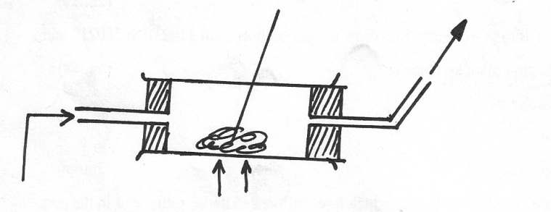
3. (a) When steam is passed over heated charcoal as shown below, Carbon (II) oxide and hydrogen gas are formed
Carbon (II) oxide gas and hydrogen gas
Charcoal
Steam

(i) What name is given to the mixture of gases produced above? (1mk)
………………………………………………………………………………………………………
(ii) Give two uses of Carbon (II) oxide gas which are also uses of hydrogen gas (1mk)
…………………………………………………………………………………………………….
…………………………………………………………………………………………………….
…………………………………………………………………………………………………….
(b) The diagram below represents a charcoal burner. Study it and answer the questions that follow.

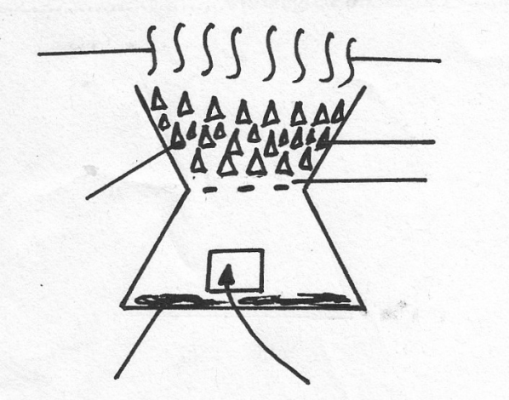
Flame
Zone I
Zone II
Zone III
Air
Ash
Charcoal

(i) Write equations for the reactions occurring at:
Zone I………………………………………………………………………………………(1mk)
Zone II………………………………………………………………………………………(1mk)
(ii) What is the colour of the flame (1mk)
…………………………………………………………………………………………………….
(iii) The ash that collects in the lower compartment was dissolved in water and filtered. Suggest
the PH value of the resulting solution . (1mk)
…………………………………………………………………………………………………….
…………………………………………………………………………………………………….
(c) Carbon (II) oxide gas can be prepared in the laboratory by a process shown below
Conc. H2SO4
(COOH)₂ CO_{2(g)} + CO_{(g)} + H₂O_{(l)}
(i) State the function of the concentration sulphuric (VI) acid in the process above (1mk)
…………………………………………………………………………………………………….
………………………………………………………………………………………………………
(ii) How would you remove Carbon (IV) oxide gas form the mixture of Carbon (II) Oxide and carbon (IV) oxide gas. (1mk)
…………………………………………………………………………………………………….
…………………………………………………………………………………………………….
(d) What volume of Carbon (II) Oxide at r.t.p is needed to reduce 106g Iron (III) Oxide to iron metal? (O=16, Fe=56, Molar gas volume at r.t.p=24 litres) (3mks)
……………………………………………………………………………………………………………………………………………………………………………………………………………………………………………………………………………………………………………………………………………………………………………………………………………………………………………………………………………………………………………………………………………………………………………………………………………………………………………………………………………………………………………………………………………………………………………………………………………………………………………………………… (e).A piece burning magnesium was inserted into a gas jar full of Carbon (IV) oxide. State and explain the observations that were made. (2mks)
………………………………………………………………………………………………………
………………………………………………………………………………………………………
4. (a) The diagram below shows an incomplete set-up used to prepare and collect ammonia gas.
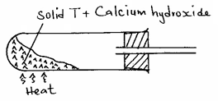

(i) Name solid T. (1 mark)
……………………………………………………………………………………………………………………………….

Write an equation for the reaction that occurred when a mixture of solid T and calcium hydroxide was heated. (1 mark)
……………………………………………………………………………………………………………………………………………………………………………………………………………………………………………………………….

Complete the diagram to show how a dry sample of ammonia gas can be collected. (3 marks)

(b) Ammonia gas is used to manufacture nitric (V) acid as shown below.
Cooling chamber
High temperature
Air
Ammonia
Water
Compound

U
Absorption tower
Air
Nitric (V) acid
Compound

V

(i) Name the catalyst used in the above process. (½ mark)
………………………………………………………………………………………………………………………………
(ii) Identify compound U. (½ mark)
………………………………………………………………………………………………………………………………
(iii) Write the equation for the reaction that took place in the absorption tower. (1 mark)
……………………………………………………………………………………………………………………………….....................................................................................................................................
Ammonia and nitric (V) acid are used in the manufacture of ammonium nitrate fertilizer, calculate the amount of the fertilizer manufactured per day, if the daily consumption of ammonia is 2400kg. Assume that the factory is 100% efficient. (N = 14, H = 1, O = 16). (3 marks)
……………………………………………………………………………………………………………………………………………………………………………………………………………………………………………………………………………………………………………………………………………………………………………………………………………………………………………………………………………………………………………………………………………………………………………………………………………………………………………………………………………………………………………………………………………………………………………………………………………………………………………………………………………………………………………………………………………………………………………………………………………………………………………………………………………………………………………………………………………………………………………………………….

5. a). Describe how Lead (ii) sulphate can be prepared if the following reagents are provided: (3mks)
- Distilled Water
- Dilute Nitric Acid
- Lead (ii) Carbonate
- Sodium Sulphate Crystals
……..………………………………………………………………………………………………

………………………………………………………………………………………………………

………………………………………………………………………………………………………

………………………………………………………………………………………………………

………………………………………………………………………………………………………

………………………………………………………………………………………………………

………………………………………………………………………………………………………

b) Study the flow chart below and answer the questions that follow Chart
Colourless solution F
Substance D
White precipitate
Solution C
Solid B+CO₂ (Yellow when hot)
Solid A
Step I

Dilute HCl
Step II
AgNO_{3 (aq)}

Few drops of aqueous NH₃

Excess NH₃

Identify the following: (4mks)
Solid A....................................................................................................................................................
Solid B.......................................................................................................................................................
Solution C................................................................................................................................................
Solid D.......................................................................................................................................................
Solution F..................................................................................................................................................
Identify process represented by step (i)...........................................................................................(1mk)
Write an ionic equation in step (ii) (1mk)
………………………………………………………………………………………………………………
………………………………………………………………………………………………………………
(c). Name the complex ion responsible for colourless solution F (1mk)
………………………………………………………………………………………………………………
(d).12.5g of Silver Nitrate was heated to a constant mass. Determine the mass of the residue. ( Ag= 108, N=14, O=16) (3mks)
………………………………………………………………………………………………………………………………………………………………………………………………………………………………………………………………………………………………………………………………………………………………………………………………………………………………………………………………………………………………………………………………………………………………………………………………………………………………………………………………………………………………………………………………………………………………………………………………………………………………………………………………………………………………………………………………………………………………………6.(a).When 0.048g of magnesium was reacted with excess dilute hydrochloric acid at room temperature and pressure,50.0cm³ of hydrogen gas was collected. Draw a diagram of the apparatus used to carry out the experiment described. (3mks)

(b) Write the equation for the reaction. (1mk)
………………………………………………………………………………………………............
(c) Calculate the volume of the hydrogen gas produced.(Mg=24.0,Molar Gas volume=24.0dm³) (2mks)
………………………………………………………………………………………………………
………………………………………………………………………………………………………
………………………………………………………………………………………………………
………………………………………………………………………………………………………
………………………………………………………………………………………………………
(d) Calculate the volume of 0.1M hydrochloric acid required to react with 0.048g of magnesium. (3mks)
………………………………………………………………………………………………………
………………………………………………………………………………………………………
………………………………………………………………………………………………………
………………………………………………………………………………………………………
………………………………………………………………………………………………………
………………………………………………………………………………………………………
…………………………………………………………………………………………………........
7. The chromatography below shows the constituents of a flower extract using an organic solvent:-
Yellow
Red
Blue
M
•
•
•
•

(a) (i) Name a possible organic solvent you can use for this experiment. (1mk)

(ii) State two properties that makes the red pigment to move the furthest distance from M. (1mk)
…………………………………………………………………………………………………………………………………………………………………
…………………………………………………………………………………………………………………………………………………………………. (iii) Describe how one could get a sample of yellow pigment. (2mks)
…………………………………………………………………………………………………………………………………………………………………
…………………………………………………………………………………………………………………………………………………………………
…………………………………………………………………………………………………………………………………………………………………. (iv) On the diagram indicate solvent front and baseline (1mk)
(b) State any two applications of chromatography. (2mks)
…………………………………………………………………………………………………………………………………………………………………
…………………………………………………………………………………………………………………………………………………………………
…………………………………………………………………………………………………………………………………………………………….......
…………………………………………………………………………………………………………………………………………………………………
(C) With the aid of a simple diagram show that almost colourless zone of the non-luminous flame consists of unburnt gas particles. (2mks)

