Name: ................................................................... Stream…………
533/1
BIOLOGY
Paper 1
Sept., 2018
2 ¼ hours.
BEGINNING OF TERM III, 2018
S.3 BIOLOGY EXAM
2 hours 15 minutes
Paper 1
INSTRUCTIONS:
Attempt all questions in Section A and B and two questions from Section C.
Section A, write the correct alternative in the table below.
Section B, write your answers in the spaces provided, not elsewhere.
Section C, write answers to this section on the answer sheets provided.

Table for answers to section A
1. | 7. | 13. | 19. | 25.
2. | 8. | 14. | 20. | 26.
3. | 9. | 15. | 21. | 27.
4. | 10. | 16. | 22. | 28.
5. | 11. | 17. | 23. | 29.
6. | 12. | 18. | 24. | 30.

SECTION A (30 Marks)
- Which one of the following bounds an animal cell?
A. cell membrane B. both cell membrane and cell wall
C. cell wall D. nucleus membrane
- Which one of the following hormones is essential for sugar balance in the body of man?
A. thyroxin B. insulin
C. vasopressin D. parathohormone
- Which one of the following is important in bending the root towards water?
A. thigmotropism B. chemotropism C. phototropism D. hydrotropism
- Which one of the following neurons conducts impulses from the receptors to the central nervous system?
A. relay neurone B. motor neurone
C. unipolar neurone D. sensory neurone
- One major characteristic used to identify class mammalian is
A. Closed Circulatory System B. Being endothermic
C. Possession of mammary glands D. An endoskeleton
- In the figure below, O, P, Q, and R are sets of experiments to study osmosis using freshly cut potato tubers. To start with, each petridish contains 10 cm³ of a liquid.
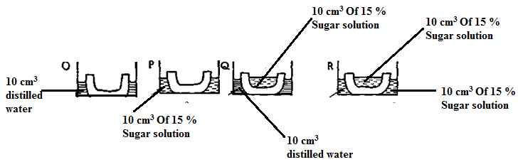
In which of the petridishes will the level of the liquid be lowest?
- O B. P C. Q D. R
- A soil with low humus content and coarse particles is most likely to have
A. High capillary B. High drainage
C. Low aeration D. High water retention
- At high PH the enzyme pepsin may be
A. In activated B. Denatured C. Inhibited D. Destroyed
- Which of the following is a pair of raw materials used in the process of photosynthesis?
A. Glucose and Oxygen B. Glucose and Water
C. CArbondioxide and Oxygen D. Carbon dioxide and Water
- A maize grain is an example of …………………..
A. An acheche B. a drop C. a caryopsis D. a seed
- Which one of the following responses involves the movement of the whole organism from one
place to another?
A. Nastic response B. Tropisms C. Reflex action D. Tactic response
- Dichorgamy is an attempt by plants to adapt for
A. Self pollination B. Cross pollination
C. Wind pollination D. Insect pollination
- A fruit with several sutures along which it splits when ripe is called a
A. Berry B. Legume C. Capsule D. Drupe
- During breathing in man, when diaphragm muscles contract then
A. Thoracic volume increase B. Thoracic pressure increase
C. Exhalation occurs D. The diaphragm attains a dome shape
- Which of the following is not associated with anaerobic respiration in muscles?
A. lactic acid B. energy C. ethanol D. carbon dioxide
- Reptiles are adapted to living in dry areas because of
A. possession of lungs B. possession of limbs for movement
C. internal fertilization D. possession of dry epidermal scales
- The following results were obtained in an experiment on a soil sample.
Weight of crucible = P g
Weight of crucible + soil = Q g
Weight of crucible + soil dried to no change = R g
Weight of the crucible + soil heated to red hot = S g
Which of the following expressions shows the percentage of humus?
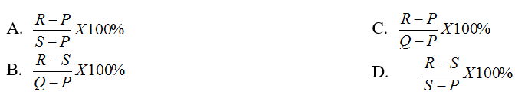
- Transpiration is important in plants except for;
A. absorption of water and dissolved slats B. regulation of plant temperature
C. transportation of water to the leaves D. elimination of excess water in plants
- The target organ for antidiurestic hormone ADH is the
A. Liver B. Kidney C. Pituitary D. Ovary
- Which one of the following is the function of myelin sheath on the axon of a neurone?
A. protects the axon B. synthesizes proteins
C. reduces the speed of impulses D. produces energy for active transport
- External digestion of food is a characteristic of
A. Amoeba B. Paramecium C. Houseflies D. Mucor
- Below is figure IV, that represents an open stoma.
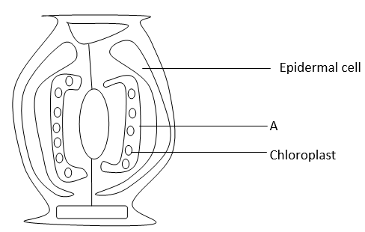
Letter A represents…
- Stoma B. Pore C. Guard cell D. Palisade cell
- Both urine formation and tissue fluid formation involve
A. Ultra filtration B. Selective re-absorption C. Active transport D. Osmosis
- Diabetes mellitus is as a result of malfunction of the
A. Pituitary B. Pancreas C. Liver D. Kidney
- Panting in dogs is aimed at
A. Cooling the body B. Paying the oxygen debt
C. Getting rid of excess carbon dioxide D. Obtaining maximum oxygen
- Which of the following compounds combines with fatty acids to form fats?
A. Acids B. Fructose C. Glycerol D. Glucose
- After manufacturing food, plants transport it in a ………..
A. Xylem B. Cortex C. Pilh D. Phloem
- Which one of the following substances does not contain Nitrogen?
A. Urea B. Amylase C. Glycerol D. Aminoacids
- Which of the following examples explains tropism?
A. withdrawal of noodlice from light
B. Bending of mimosa plant on touch
C. Withdrawal of housefly larva from light
D. Growing of a been root towards water
- Part of the middle ear is linked to the inner ear is the ;
A. Stapes B. Eardrum C. Cochlea D. oral window

SECTION B (30 MARKS)
- The graph below shows the relationship between body temperature and external temperature in a human being and lizard.
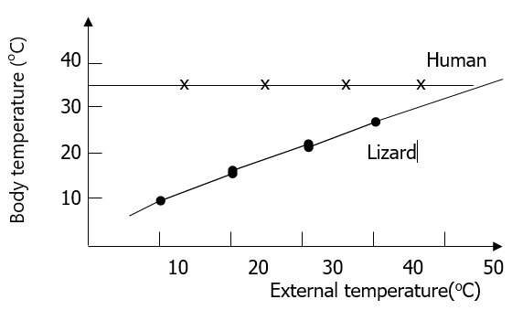
(a) What happens to the temperature of each organism as the external temperature increases in;
- Humans? (02 marks)
………………………………………………………………………………………………………..……………………………………………………………………………………………………………………………………………..
- Lizards? (02 marks)
………………………………………………………………………………………………………..……………………………………………………………………………………………………………………………………………..
- Why are humans described as endothermic? (01 mark)
………………………………………………………………………………………………………..……………………………………………………………………………………………………………………………………………..
- Suggest two ways by which a lizard living in desert area might avoid overheating if the external temperature rose above 40ºC. (03 marks)
………………………………………………………………………………………………………..………………………………………………………………………………………………………..………………………………………………………………………………………………………..………………………………………………………………………………………………………..…………………………………………………………………………
(d) State two physiological processes a human being can employ to avoid overheating.

………………………………………………………………………………………………………..………………………………………………………………………………………………………..………………………………………………………………………………………………………..………………………………………………………
- An experiment was set up as shown below to investigate a certain process that occurs in plants.
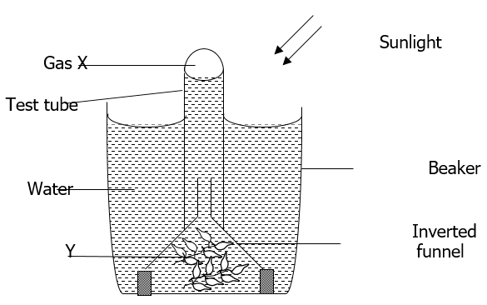
The set up was left in bright sunlight for several hours.
(a) State the aim of the experiment. (01 mark)

………………………………………………………………………………………………………..……………………………………………………………………………………………………………………………………………..
(b) (i) Name the gas labelled X. (01 mark)

………………….………………………………………………………………………………………………………..
- Structure labelled Y. (01 mark)

…………………..………………………………………………………………………………………………………..
(c) Other than sunlight, explain three other conditions that can affect the experiment above. (03 marks)

………………………………………………………………………………………………………..………………………………………………………………………………………………………..………………………………………………………………………………………………………..………………………………………………………………………………………………………..………………………………………………………………………………………………………..………………………………………………………………………………………………………..………………………………………………………………………………………………………..………………………………………………………………………………………………………..………………………………………………………………………………………………………..………………………………………………………………………………………………………..………………………………………………………………………………………………………..…………………………………………………………………………………
(d) Describe how the identity of gas X could be confirmed. (02 marks)

………………………………………………………………………………………………………..………………………………………………………………………………………………………..………………………………………………………………………………………………………..………………………………………………………………………………………………………..………………………………………………………………………………………………………..……………………………………………………………………………………………
(e) Write a well balanced chemical equation for the process in the experiment.
(02 marks)
………………………………………………………………………………………………………..………………………………………………………………………………………………………..……………………………………

- The diagram below shows the urinary system of a mammal. Study the diagram carefully and answer the questions that follow:

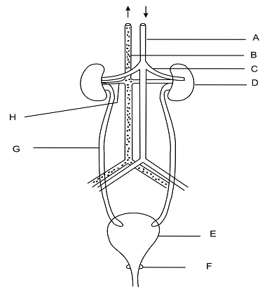
(a) Name the labelled parts (03 marks)
A. ………………………………………………………
B. ………………………………………………………
C. ………………………………………………………
D. ………………………………………………………
E. ………………………………………………………
G. ………………………………………………………
(b) Give the use of the part labelled (02 marks)
(i) E …………………………………………………………………………………………………………………………………………………………………..…………………………………………………………………………………….

(ii) F …………………………………………………………………………………………………………………………………………………………………..……………………………………………………………………………………
(c) Explain the fact that the blood that flows in C contains more urea than the blood that flows in H. (03 marks)

…………………………………………………………………………………………..…………………………………………………………………………………………..……………………………………………………………………………………..…………………………………………………………………………………………..…………………………………………………………………………………………..………………………………………………………………………………………..……………………………………………………………………………
(d) State the two major uses of the part labelled D in the system. (02 marks)
…………………………………………………………………………………………..…………………………………………………………………………………………..…………………………………………………………………………………………………………………………………………………………………………………………..
SECTION C
(Attempt only two questions from this section)
- a) Define the terms:
- Phototropism (02 marks)
- Geotropism (02 marks)
- Describe an experiment to show the effect of unidirectional light on growth of the plant shoot. (07 marks)
c) State any four differences between tropisms and nastic responses (04 marks)
- (a) Distinguish between double and single circulatory systems. (01 mark)
(b) Explain how each one of the following blood vessels are adapted for their function; (i) capillaries (ii) Veins (iii) Arteries (10 marks)
(c). Describe the route taken by blood from the Kidney until it is oxygenated.
(04 marks)
- (a) What is accommodation? (02 marks)
(b) Suppose a boy was sitting in a dimly lit room reading a book, then he suddenly stepped out of the room into bright sunshine to look at an aero plane in the sky. Describe the sequence of events which would occur in his eyes to enable him see the aero plane clearly. (09 marks)
(c) Explain why many old people use glasses to read. (04 marks)

END

