Name: ................................................................... Stream…………
533/1
BIOLOGY
Paper 1
July/Aug., 2018
2 ½ hours.
END OF TERM II, 2018
S.3 BIOLOGY EXAM
Paper 1
INSTRUCTIONS:
Attempt all questions in Section A and B and two questions from Section C.
Section A, write the correct alternative in the table below.
Section B, write your answers in the spaces provided, not elsewhere.
Section C, write answers to this section on the answer sheets provided.

Table for answers to section A
1. | 7. | 13. | 19. | 25.
2. | 8. | 14. | 20. | 26.
3. | 9. | 15. | 21. | 27.
4. | 10. | 16. | 22. | 28.
5. | 11. | 17. | 23. | 29.
6. | 12. | 18. | 24. | 30.

SECTION A (30 Marks)
- Clay soil has a high water retention capacity because it
A. has small air spaces.
B. contain little amount of humus.
C. is sticky when wet.
D. has good capillary attraction.

- Which one of the following types of fruits is a pineapple?
A. Drupe
B. Multiple fruit
C. Indehiscent fruit
D. Berry
- Which one of the following controls the rate of heart beat in mammals?
A. Cerebrum
B. Pituitary
C. Medulla oblongata
D. Cerebellum.
- Which one of the following is a reaction to over-cooling by a mammalian body?
A. Dilation of superficial blood vessels
B. Sweating
C. Decrease in metabolic rate
D. Shivering.
- Removal of the thyroid gland in a young child may lead to:-
A. stunted growth and mental retardation
B. failure to develop secondary sexual characteristics
C. development of diabetes
D. increased metabolic rate and restlessness.
- Which one of the following represents a reflex arc?
A. Receptor Motor neurone CNS Sensory neurone effector.
B. Receptor Sensory neurone effector CNS motor neurone.
C. Receptor Sensory neurone CNS Motor neuron effector.
D. Sensory neuron CNS receptor Effector motor neurone.

- Which of the following processes requires a high blood pressure?
A. Selective re absorption B. Glomeruler filtration
C. Tubular absorption D. Selective absorption

- Which one of the following is a long term adaptation of mammals to low environmental temperature?
A. Raising of hair B. Increase in metabolic rate
C. Deposition of fat under the skin D. Reduction of blood flow to the heart

- Many students were seen frequenting urinals on a cold day, this was because;
A. Their kidneys absorbed less water from blood
B. Their kidneys absorbed much water from blood
C. They had taken more water than usual
D. Their bodies lost very little water as sweat.

- Fig 1 shows how the body temperature of animals vary with environmental temperatures.

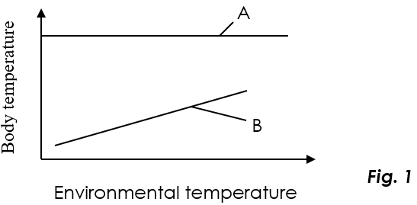
- Which of the following explains well the figure?
- Body temperature of A is dependant on environmental temperature.
- Body temperature of B is dependant on environmental temperature
- A has a higher body temperature than that of B.
B loses more heat than A.

- Strips W, X, Y and Z are of same size and shape were cut from a raw pawpaw, whose sap had a sugar concentration of 28%. The strips were then placed in sugar solution of different concentrations as shown in the table.

Strip | Concentration of solution (%)
W | 15
X | 25
Y | 28.5
Z | 48

Which strip would be longest after 4 hours?
- W
- X
- Y
- Z
- The following conditions are all a result of deficiency of vitamins of the B group except
A. night blindness.
B. beriberi.
C. pellagra.
D. pernicious anaemia.
- Which of the following word equations summarizes the process of fermentation?
A. Glucose → Ethanol + carbon dioxide + water.
B. Glucose → Lactic acid + energy + water.
C. Glucose → Ethanol + carbon dioxide + energy.
D. Glucose → Lactic acid + water + water + carbon dioxide.
- Which one of the following plant organs has a scattered arrangement of vascular bundles?
A. Root of a monocotyledonous plant.
B. Stem of a monocotyledonous plant.
C. Stem of a dicotyledonous plant.
D. Root of a dicotyledonous plant.
- Which of the following is a correct route taken by carbon dioxide from the body cells of an insect to the atmosphere?
A. Trachea – tracheoles – spiracles.
B. Spiracles – trachea – tracheoles.
C. Tracheoles – trachea – spiracles.
D. Spiracles – tracheoles – trachea
- Figure 2 below shows the changes in the lactic acid concentration in the blood during and after exercise.
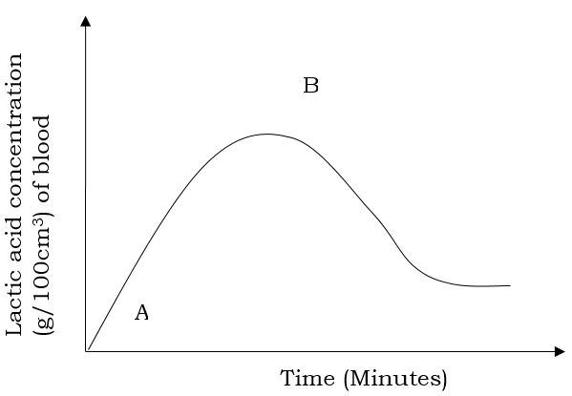
Fig.2

The correct explanation for what is occurring between points A and B is that
- breathing rate has increased.
- blood flow to muscles has increased.
- oxygen supply to the muscles is less than the demand.
- oxygen supply to the muscles in excess.
- Which of the following make the skin of a toad an effective respiratory surface?
- Moist surface.
- Rough skin.
- Rich blood supply to the skin.
- Large numbers of secretory glands on the skin.
- (i) and (ii)
- (i), (ii) and (iii)
- (i), (ii) and (iv)
- (i) and (iii)
- The part of the brain that controls breathing is the
A. cerebellum B. medulla oblongata
C. cerebrum D. hypothalamus
- A male cockroach is different from the female cockroach by having
A. styles B. circus
C. longer antennae D. larger abdomen
- Which one of the following could have their functions adversely affected by the AIDS virus?

  - erythrocytes
  - blood platelets
  - leucocytes
  - nerve cells
- Biological control as a method of prevention of malaria would include
  - spraying oil on the surface of stagnant water
  - spraying of insecticides on the mosquitoes
  - introducing fish in water bodies
  - draining of stagnant water
- Blockage of the bile duct would impair the digestion of

  - proteins
  - cellulose
  - starch
  - fats

- An athelete has just finished a race. The phrase “oxygen debt” refers to
  - the amount of oxygen originally present in the muscle of the athelete before the race.
  - The amount of oxygen taken in after the race and used to complete the combustion of some of the lactic acid
  - The total amount of oxygen taken in during panting after the race
  - The amount of oxygen needed by the lungs after the race for combustion of glucose.
- Which of the following groups of insects all have similar feeding habits?
  - Bee, mosquito, caterpillar
  - Housefly, cockroach, praying mantis
  - Tsetse fly, housefly, caterpillar
  - Bee, butterfly, bedbug
- A person of blood group A can be transfused with blood of
A. group A only B. group AB only
C. groups A and O D. groups B and AB
- Functionally, the most diversified organ in the human body is the

  - brain
  - liver
  - stomach
  - kidney

- The rate of glomerular filtration is highest in
A. man B. amphibians C. fresh water fishes D. marine fishes
- Figure 1 below shows the effect of relative humidity on transpiration rate.
Rate of transpiration

Relative humidity

Fig.1
From the figure above, transpiration rate
- increases with decreased relative humidity.
- increases with increased relative humidity.
- decreases with decreased relative humidity.
- remains constant with increased relative humidity.
- Which one of the following classes has the highest number of species?
A. Crustacae B. Arachnida
C. Insecta D. Myriapoda

SECTION B
Attempt all questions in this section.

- A study was conducted to monitor the amount of lactic acid in the blood of an athlete before, during and after the exercise and the following results were obtained. The exercise was for ten minutes.

Time (Minutes) | Concentration (mg/100ml) of blood
0 | 20
3 | 20
10 | 80
15 | 100
20 | 90
30 | 70
40 | 40
50 | 30

- Plot a graph paper to represent the above information. (07 Marks)

- (i) Describe the shape of the curve i.e changes in lactic acid concentration with time. (05 Marks)
..………………………….……………………………………………………………...……………………..…….…..…………………………………………………………...………………………….…………………..……………….………….……………………………………………………………...……………………..…….…………………. ..………………………….……………………………………………………………...……………………..…….…..…………………………………………………………...………………………….…………………..……………….………….……………………………………………………………...……………………..…….………………….
(ii) Explain the changes identified in b(i) above. (03 Marks)

..………………………….……………………………………………………………...……………………..…….……………………………………………………………...………………………….…………………..………………………….……………………………………………………………...……………………..…….…………………… ..………………………….……………………………………………………………...……………………..…….….
(iii) State one effect of high accumulation of lactic acid in the muscles. (01 Mark)
..………………………….……………………………………………………………...……………………..…….……………………………………………………………...………………………….…………………………………..
- Name and briefly explain any four industrial applications of anaerobic respiration. (04 Marks)

..………………………….……………………………………………………………...……………………..…….……………………………………………………………...………………………….………………………………….. ..………………………….……………………………………………………………...……………………..…….……………………………………………………………...………………………….………………………………….. ..………………………….……………………………………………………………...……………………..…….……………………………………………………………...………………………….………………………………….. ..………………………….……………………………………………………………...……………………..…….……………………………………………………………...………………………….…………………………………..
- The figure below is a representation of the reflex arc in the body of a mammal. Study it and answer the questions that follow.
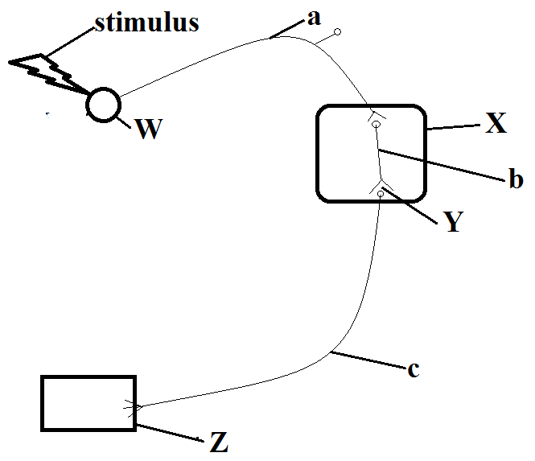
- Name parts labeled W,X,Y,a,b,c. (03 marks)
W: ……………………………………………… a: ……………………………………………….
X: ………………………………………………. b: ……………………………………………….
Y: ………………………………………………. c: ……………………………………………….
- Using arrows, indicate on the figure above the direction of flow of impulses.(01 mark)
- State the function of parts labeled: (03 marks)
- B………………………………………………………………………………………………………………………………………………………………………………………………………………………………………
- Y………………………………………………………………………………………………………………………………………………………………………………………………………………………………………
- Z………………………………………………………………………………………………………………………………………………………………………………………………………………………………………
- Give any three differences between simple reflexes and conditioned reflexes. (03 marks)
Simple reflexes | Conditioned reflexes

SECTION C (30 Marks)
Answer any two questions from this section.

33. (a) Describe what happens to a piece of cooked cassava from the time it is eaten to when it is absorbed into the blood stream of human being. (10 Marks)
(b) Explain what happens to the end products of digestion after absorption. (05 Marks)
34. a) What is excretion? (02 marks)
(b) Describe the functioning of the kidney in excretion. (13 marks)

35. a) Define:
    - Phototropism (02 marks)
    - Geotropism (02 marks)
  - Describe an experiment you would carry out to determine the effects of gravity on the root of a dicotyledonous plant. (11 marks)

END
Happy Holidays!!!!

