NAME: …………………………………. ADM NO: …………. CLASS: ………….
ANESTAR SCHOOLS
FORM THREE PHYSICS MID-TERM EXAMS 2017
Answer all the questions in the spaces provided.

1. A certain machine raises 2 tonnes of water through 22m. If the efficiency of the machine is
80%, how much work is done on the machine? (3 mks)

2. The diagram below shows a hydraulic system with pistons P and Q. The cross-section area of
P = 5 x 10⁻⁴m² and Q = 5 x 10⁻³m². A force of 20N is applied at piston ‘P’.
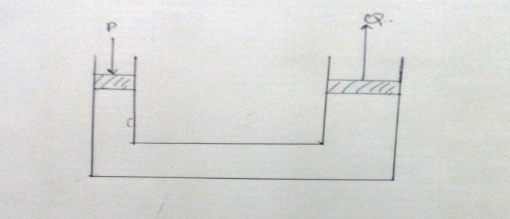

(a) Determine pressure at P and Q exerted by the oil. (3 mks)

(b) Determine the force exerted at Q. (2 mks)

(c) Calculate:-
(i) MA of the system if it works at 90% efficiency. (3 mks)

(ii) Velocity ratio of the system. (3 mks)

3. State three advantages of hydraulic machines. (3 mks)

4. (a) A wire has a resistance of 20Ω. Determine the voltage that drives the current of 0.5A
through it.
(3 mks)

(b) Other than the length of the conductor, state two other factors affecting resistance.(2 mks)

5. In an experiment to determine the resistance of a wire R, a student in form 3 in Anestar school
set an arrangement as given below. When he closed the switch, the voltmeter read a current of
30A while the voltmeter recorded 12V. Ignoring internal resistances of the ammeter and
voltmeter and also the battery, determine the resistance of the wire R. (3 mks)

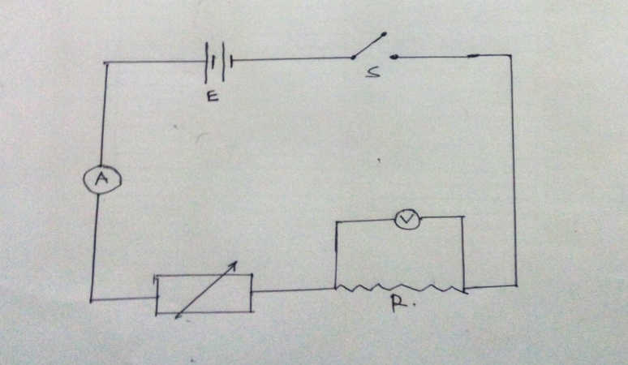

6. The table below shows how terminal voltage (V) of a certain battery varies with current (I) being
drawn from the battery.

I(A) | 0.02 | 0.04 | 0.06 | 0.08 | 0.10
V(Volts) | 4.8 | 4.3 | 3.7 | 3.2 | 2.7

(a) Draw a graph of V(volts) (y-axis) against current (Amperes) (x-axis). (4 mks)

(b) From the graph, determine:-
(i) The E.M.F of the cell. (2 mks)

(ii) The internal resistance of the cell. (4 mks)

7. (a) A circuit consists of a battery, a motal wire, an ammeter and a switch connected in series.
The switch is closed and ammeter reading noted. The metal wire is not heated. State the
observations made on the ammeter reading and give a reason for your answer. (2 mks)

(b) State the differences between ohmic and non-ohmic conductor. (4 mks)

(c) The sketch below show variation of current against voltage for three different conductors.
(i) Sketch on the axis above graphs of resistance against voltage for each of the three
conductors P, Q and R. (3 mks)

Resiatance
Ω

(i)

Voltage (V)

(ii) Suggest a suitable conductor that would show the behavior of graphs c(i) for P, Q and R
shown. (3 mks)

8. (a) State two distinctions between the way sound waves and light waves are transmitted.(2 mks)

(b) Waves in a ripple tank are incident on slits as shown below. Complete the diagram to show
the diffracted waves.

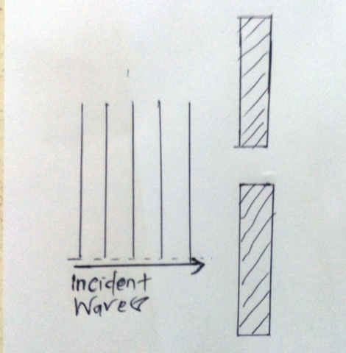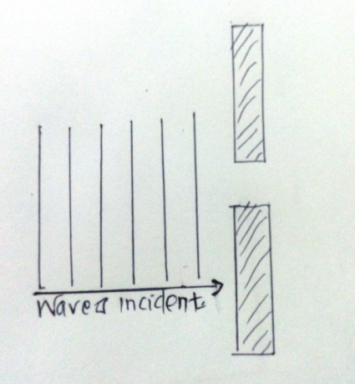
(c) Explain why diffraction of sound waves is a common phenomena than that of light waves.
(2 mks)

