101/1
ENGLISH
PAPER 1
(FUNCTIONAL SKILLS)
OCT./NOV.2006
2HOURS

THE KENYA NATIONAL EXAMINATIONS COUNCIL
K.C.S.E
ENGLISH PAPER 1
TIME: 2HOURS

Question 1 (20mks)
You are the chairperson of your school’s Wildlife Conservation Association (WICA). Your group has just come back from a visit to a national park in a neighbouring country.

Write a report to the patron of WICA about the trip. In your report indicate what you accomplished, the problems you experienced and what cautionary measures you would take during trips.
………………………………………………………………………………………………………………………………………………………………………………………………………………………………………………………………………………………………

Question 2 (10mks)
Fill in each of the blank spaces in the passage below with the most appropriate word.
There was time when telecommunication 1………………Africa was nearly non-existent. With the 2……………of one or two more developed nations, most African countries
3 …………… infrastructure and telephony was out of reach for 4………………. of the population. But mobile telephony has 5……………. a lot of that and has demonstrated Africa’s 6……………. to leap-frog older technologies with new ones more 7…………. to the environment.

Telecommunication in Africa is growing 8………….. there is room for improvement and development. A number of new networks 9………. coming up all over the continent and the African telecommunication market is growing 10………. The driver of this growth? Mobile telephony.
(Adapted from African Business, May 2004)

Question 3
a) Read the oral narrative below and then answer the questions that follow.
Nyasaye (God) wanted to put a stop to the rampages of death-death which claims the lives of everyone
Young and old
Boys and girls
Men and women
Strangers and kinsmen;

Death which kills
The innocent and the guilty
Chiefs and their subjects
The healthy and the sick
The wise and the foolish.
So one day he sent a servant to earth with a message for all his people. “send me an offering of fresh, untainted fat,” he ordered. “It should be as clean and sparkling as the moon.” Hearing this, the people slaughtered a goat, removed its pure white fat, and placed it in a clay dish overspread with fine fresh leaves.

Now they summoned Ngo’ngruok, also known as Haniafu the Chameleon, and ordered him to take their offering to Nyasaye. They also fashioned a long pole that reached up to heaven where Nyasaye dwells in his glory. This was the path Ng’ongruok would follow when carrying their offering.

But Ng’onguruok accidentally soiled the fat with his clumsy feet, and on his arrival before Nyasaye, presented a dirty and unsightly offering. Nyasaye was furious and rejected it, shouting: “tell the people of earth that because of this insult they must continue to die, just as their ancestors have done!”

Ng’ongruok descended from heaven delivered Nyasaye’s message, and returned the offering to the people. Ever since then, alas death has continued to ravage human beings. For his clumsiness, Ngo’ngruok was cursed by the people. Hence, he must always walk on all fours, and his steps must be hesitant and slow. That is why you will always see him carrying one leg raised from the ground as he tries to decide exactly where to tread.
(Adapted from: keep my words by B. Onyange-gutu and A.A Roscoe)

i) What would you do in order to capture the audience’s attention before you begin to tell this story? (2mks)
………………………………………………………………………………………………………………………………………………………………………………………………………………………………………………………………………………………………………………………………………………………………
ii) Explain two ways in which you would make the narration of lines 20 to 23 of the story effective (4mks)

……………………………………………………………………………………………………………………………………………………………………………………………………………………………………………………………………………………………………………………………………………………………..
iii) Mention two ways in which you would know that you audience in this story is fully participating in the performance. (4mks)
……………………………………………………………………………………………………………………………………………………………………………………………………………………………………………………………………………………………………………………………………………………………..
b) For each of the words below write another word that is pronounced in the same way.
Heir…………………………………………………
Weather…………………………………………….
Base………………………………………………..
Mourning………………………………………….

c) Read the poem below and answer the question that follow.
Isatou died
When she was only five
And full of pride
Just before she new
5 How small a loss
It brought to such a few
Her mother wept
Half grateful
To be so early bereft.
10 And did not see the smile
As tender as the root
Of the emerging plant
Which sealed her eyes
The neighbours wailed
15 As they were paid to do
And thought how big a spread
Might be her wedding too
The father looked at her
Through marble eyes and said;
20 “Who spilt the perfume
Mixed with morning dew?”
Lenrie Peters
(From: The Earth Is Ours. Edited by Ian Gordon)

i) Identify any two pairs of rhyming words in this poem. (2mks)
ii) Which words would you stress in line 2 of this poem, and why? (2mks)
iii) How would you say the last two lines of this poem? (2mks)

d) You have lost your luggage on your way back to school. You decide to report the matter to the nearest police station. Below is part of the conversation between you and the police officer at the reporting desk. Fill in the other part. (Read through the conversation first before writing your responses).

You:………………………………………………………………………………………………………………………………………………………………………………………………………………………………………………… (2mks)
Police Office: (Interrupting) Easy. I am sorry about what happened but before you go into the lost items, please give me your full name and address.
You:…………………………………………………………………………………………………………………………………………………………………………………………………………………………………………………
(2mks)
Police Officer: That is good. Now go ahead and tell me what happened, without leaving out any important details.

You:…………………………………………………………………………………………………………………………………………………………………………………………………………………………………………………
(3mks)

Police Officer: From which schools are the students who alighted before you? You see, it is possible that your box was off loaded from the bus by mistake especially because another box that nearly resembles yours was left behind.

You:…………………………………………………………………………………………………………………………………………………………………………………………………………………………………………………
(2mks)

Police Officer: Good. At least that is a starting point; we will get the box from the bus then go to that school to make enquiries.

You:………………………………………………………………………………
……………………………………………………………………………………
……………………………………………………………………………………
(1mk)

101/2
ENGLISH
PAPER 2
(Comprehension, Literary
Appreciation and Grammar)
Oct/Nov 2006
2 ½ hours

THE KENYA NATIONAL EXAMINATION COUNCIL
K.C.S.E
ENGLISH PAPER 2
TIME: 2HOURS.

1. Read the passage below and then answer the questions that follow.
During the last couple of decades, the developing world has made enormous economic progress. This can be seen most clearly in the rising trend of incomes and consumption: between 1965 and 1985 consumption per capita in the developing world went up by almost 70 percent. Broader measures of well-being confirm this picture-life expectancy, child mortality, and educational attainment have all improved markedly.
Against that background of achievement, it is all the more staggering-and all the more shameful-that more than one billion people in the developing world are living in poverty. Progress in raising average incomes however welcome, must not distract attention from this massive and continuing burden of poverty.
The same is true of the broader measures of well-being. Life expectancy in Sub-Saharan Africa is just 50 years, in Japan it is almost 80 more than 110 million children in the developing world lack access even to primary education while in the developed world, anything less than universal enrollment would rightly be regarded as unacceptable. The starkness of these contrasts attests to the continuity toll of human deprivation.
It should be noted that even in the developing world, poverty levels differ from region to region, country to country and even location to location within same country. For example, nearly half of the world’s poor live in South Asia, a region that accounts for less than one third of the world’s population. Sub-Saharan Africa accounts for a smaller, but still highly disproportionate share of global poverty- Within regions and countries, the poor are often concentrated in certain places: in rural areas with high population densities. Often, the problems of poverty, population, and the environment are intertwined; earlier patterns of development and pressure of rapidly expanding populations mean that many of the poor live in areas of acute environmental degradation.
It is also true that the weight of poverty falls heavily on certain groups. Women in general are disadvantaged. This is because in poor households, they often shoulder more of the workload than men, are less educated, and have less access to remunerative activities. Children, too suffer disproportionately, and the future quality of their lives is compromised by inadequate nutrition, health care, and education. This is especially true quality of their lives is compromised by inadequate nutrition, health care, and education. This is especially true for girls, for their primary school enrolment rates are less than 50 percent in many African countries.
Obviously, reducing poverty is the fundamental objective of the economic development in any country. It is estimated that in 1985, more than one billion people in the developing world lived in absolute poverty. Clearly then, economic development has a long way to go. Knowledge about the poor is essential if governments are to adopt sound development strategies and more effective policies for attacking poverty. How many poor are there? Where do they live? What are their precise economic circumstances? Answering these questions is the first step toward understanding the impact of economic policies on the poor.

a) What evidence does the author give to show that incomes and consumption trends are rising in the developing world? (2mks)
b) How does the author feel about the progress made so far by the developing world? (2mks)
c) Why does the author mention Japan? (1mk)
d) What is odd about the poverty situation in South Asia? (2mks)
e) Explain the relationship between poverty and a high population (3mks)
f) Rewrite the following sentence in the singular
“They are also less educated, and have less access to remunerative activity” (1mk)
g) Why is a girl doubly disadvantaged in a poor country? (3mks)
h) In about 55 words, summaries, the main argument of the author (4mks)
i) Explain the meaning of the following words as used in the passage (2mks)
Staggering
Compromised

2. Read the passage below and answer the questions that follow:
In the days after the bomb went off the air was full of whispers. Paulina knew the sense of them although they were often enough phrased in difficult English purposely order to exclude her. But she could not be excluded. Had she not lost a child? They said that Kariuki had gone to Zambia, had registered in a hotel there. But the elder Mrs. Kariuki was an acquaintance of the house and she did not know of it, her co-wife also did not know. There had been no preparations for going: there had been no custom of keeping unnecessary secrets. It was small husbands with small concerns who did that.
Whisper, whisper, whisper. They said the police officers had been transferred from here to there. That officers had been consulting with the missing man here and there. That there was a lot of money. That parliament- whisper, whisper, whisper.
Paulina went about her duties, ironing, setting tables, supervising the servant in the cleaning of the house and the hard washing. Sometimes her belly throbbed with the child who had been so casually taken from her at another time like this and the others who had been denied her. And yet a child was a child with a light hold on life. When it came to a man, a wealthy man, golden tongued, greatly loved, though he was not of her own people she knew this much, that the passing of such a man would be remembered, celebrate. Still not a week passed without someone speaking of Tom.
And when the body was found, discreetly mutilated, you knew what the event was that for weeks you had been expecting, although the real event was still not known. The police officers went about their leave or their business outside the station without referring to it, the mortuary keeper who had a well-dressed corpse of appropriate size and weight and characteristics in his charge did not tumble to it. The airline clerks checking flights to Zambia did not tumble to it, the children playing in the streets did not tumble to it -children who were of the age to have been shot in Kano or patel flats, children who did not shy away from the sight of a gun or hold their noses against white smoke from a bonfire, children who had been conceived after their fathers had come back from the camps, after the squatters had missed their chance to buy up the white farm settlement plots, after the land titles had been written, children who did not know the eerie stillness of the forest of the KEM prohibited signs. Children of the New Method, who knew John Wayne and the Aga Khan and Bruce Lee and Charlie Chaplin by sight, who knew how to figure on a base of five and counted out diligently in their nursery schools.
“Eeny, meeny, miny mo,
Catch a little baby so,
If he hollers let him go,
Eeny, meeny, miny mo.”
Even those terribly sharp children did not tumble to it.
Nobody really knew how it tied up with the bomb. There was no need to know, Hyenas were there to settle with those who asked too many questions. But while the casualties of the bomb were nameless people absorbed into the daily casualty lists of fire, flood and domestic quarrels, J.M burst upon the scene as a martyr and a paroxysm of grief ran through the city. The skies were leaden that April and it grew colder and colder. Eyes grew hard in Nairobi and conversations were rounded off with polite, empty phrases, even before the stranger came close. Photographs of J.M alternated with the Pope and the Sacred Heart on the roadside framing stands. The book was reprinted and within a few months parliamentary speeches were printed too. A kikuyu gramophone record was banned Mr. Mwangale remarked bluntly in parliament, “This is time we cannot be told Njenga did it. “Paulina and Martin did not discuss it. The employers spoke of it in low tones. In May the rains came, chill and steady, a bit late, and in the shanties by the river people squirmed and shivered over the water-logged ground and fires smoked damply at the amount of airless polythene shelter.

a) Which bomb is referred to in this extract? (1mk)
b) Explain why the author repeats the word “whisper”? (3mks)
c) “…..the child who had been so casually taken from her at another time like.” What incident in the novel does this relate to? (4mks)
d) Write notes on the aspects of the politics contained in this extract. (4mks)
e) Mr. Mwangale remarked bluntly in parliament,
“…this time we cannot be told Njenga did it”.
Rewrite as reported speech. (1mk)
f) In about 80 words, summerise the cover-up (6mks)
g) Identify and explain one use of sarcasm in this extract. (3mks)
h) What shows that J.M became even more popular after he died? (3mks)

3. Read the poem below and answer the questions that follow:
Touch by Hugh Lewin
When I get out
I’m going to ask someone
To touch me
Very gently please
And slowly,
Touch me
I want
To learn again
How life feels

I’ve not been touched
For seven years
For seven years
I’ve been untouched
Out of touch
And I’ve learnt
To know now
The meaning of
Untouchable.

Untouchable-not quite
I can count the things
That have touched me

One: fists
At the beginning
Fierce mad fists
Beating beating
Till I remember
Screaming
Don’t touch me
Please don’t touch me

Two: paws
The first four years of paws
Every day
Patting paws, searching
Arms up, shoes off
Legs apart-
Probing paws, systematic
Heavy, indifferent
Probing away
All privacy.

I don’t want fists and paws
I want
To want to be touched
Again
And to touch.
I want to feel alive
Again
I want to say
When I get out
Here I am
Please touch me.
(From poets to the people, edit by Barry Feinberg)
a) Where do you think the personal is? Briefly explain your answer. (3mks)
b) What do you think the persona means by “touch”? (3mks)
c) Using two illustrations, describe the persona’s experience during the seven years (4mks)
d) What is the significance of the word” paws”? (2mks)
e) Which device does the poet use to reinforce the theme? (2mks)
f) Explain the meaning of the following words as they are used in the poem (2mks)
Prodding
Indifferent (4mks)
g) What does the poem reveal about human need? (4mks)

4 a) Fill in the blank spaces in the following sentences with the most
appropriate word(s) (3mks)
i) If we had gone to bed early last night, we………………..rested enough.
ii) If I…………… the recruiting officer, I would not take bribes.
iii) Every one of the students now……….a role to play in keeping the school
compound clean

b) Rewrite the following sentences to remove gender bias. (3mks)
i) A professor should give his student opportunities to develop their skills
ii) My sister was appointed chairman of the Water Project Committee
iii) The firemen took a long time to arrive at the scene of the accident.

c) Fill in the blanks with the correct alternative from the choices given (3mks)
i) Who……..a fire outside my house? (Light/lighted/Lit)
ii) Since the introduction of community policing in our estates…………………..of
theft have reduced. (incidence /incident/incidents)
iii) an elephant looks after…..calf (it’s/its)

d) Rewrite the following sentences according to the instruction given after each. Do
not change the meaning. (6mks)
i) The choir entertained the visitors (beginning: the visitors……………)
ii) If we do not keep environment clean, the health officer will close our café
(Rewrite using “unless”)
iii) That patient could not stand without support. She also could not sit straight.
Rewrite as one sentence using: “neither ….nor”)
iv) The school team would not have won the game if it had not been for the captain’s
quick action. (begin: Had…..)
v) Jomo Kenyatta the first president of Kenya was a great orator (Punctuate the
sentence)
vi) We learn from the legend that Mekatilili was a powerful leader
(Begin: the legend…)
101/3
ENGLISH
Paper 3
(Imaginative composition and Essays based on set texts)
Oct.Nov 2006
2 ½ hours

1. Imaginative composition (compulsory) (20mks)
Either
a) Write a composition ending with the words: “It then dawned on me that perhaps this is why I had been born.”
Or
b) Write a composition agreeing or disagreeing with the statement, “A good name is better than riches.”

2) Drama (compulsory) (20mks)
William Shakespeare, The Merchant of Venice
“Racial and religious prejudice only cause misery. “Write a composition in support of this statement drawing your illustrations from the Merchant of Venice.

3) Optional set texts
Either
a) The short story
Macmillan (Ed.) Half a Day and other Stories (20mks)
Using illustrations from Nawal El Saadawi’s “Solitude” write a composition about
dehumanizing prison conditions.
Or
b) Drama
John Ruganda, Sheds of Tenderness (20mks)
Write a composition on the problems of jealously among siblings. Draw your illustrations from John Ruganda’s Shed of Tenderness
Or
c) The Novel
Velma Pollard, Homestretch (20mks)
Write a composition on the cause and effects of migration from developing to developed countries Refer to Velma Pollard’s Homestretch for your illustrations.

101/1
English
Paper 1
(Functional Skills)
Oct/Nov 2007
2 hours
You are the chairperson of the creative Writing Club in your school. The club would like assistance in publishing the winning entry in a recent competition. Write a letter to a publisher asking them to consider the book for publication. Remember to write through the head teacher.
In your letter, include the following
- The title of the book and name of author
- A brief description of what the book is about
- Why it is important for the book to be published.

- Read the passage below and fill in each blank space with an appropriate word
Good conversationalists are not born that way. They 1 ……………………… their skills through patience, preparation and practice 2…………………….. a long period of time. Some people find it 3……………………. To talk than others, but do not confuse talk with conservation that is, good conversation.
There are all kinds of conversations, 4 ………………………….. from poor to excellent. Unfortunately, some of the worst conversations come from those who find it easiest to talk. 5………………………….the very ease with which some people talk make them 6……………………… to what they say and unaware that they may say 7……………………………… much.

It lies within the power of each one of us develop quality in our conversational ability. However, one has to take some 8……………… you may need to force yourself to take part in conversations, even though you have 9………………… to contribute at first. If you cannot talk listen. If you cannot talk, listen. If you don’t understand, ask questions. Secondly, enlarge your storehouse of knowledge every day. Never let a day go 10………………… without learning something new: talk more with people; read; listen to the radio; watch television; be more observant of everything and everybody around you; travel as much as you can; start a hobby or two develop common interests with friends and classmates.

3. (a) Read the story below and answer the questions that follow
Once upon a time, there lived a young woman who ran away from home to secretly marry her warrior lover out in the wilderness. The warrior directed the young woman to a place in the forest where he would meet her. He said to her, “When you get to a fork along the path take the right path.” Then the warrior went ahead to await her arrival in the forest.

The young woman took off, and when she got to the fork that the warrior had mentioned, she followed the left path, forgetting which path the warrior had instructed her to follow.

As the girl walked on, she came upon an ogre who said to her, “hey, young woman where are going? Do you have anything to say now that I’m going to eat you?” the girl answered in song
Not here my dear
Let us go to the water hole
Where you can eat me
And have a drink
Oh my dear warrior, where was it?

And so it happened that this was very bushy country. The ogre led the young woman on, and when they got to another spot, he said to her, “I am now going to eat you here.” The girl broke into song, urging him not to eat her.

They went further, and the young woman kept hoping that the warrior would hear her voice. As they walked on, the ogre asked the young girl: “shall I eat you hear” The girl sang again

Not here my dear
Let us go to the water hole
Where you can eat me
And have a drink
Oh dear warrior, where was it?

But the warrior had still not heard her. When they got to a cave by a river, the ogre collected branches and leaves on which to place the young woman’s flesh after he had slaughtered her. When he brought one type of leaf, the girl objected to having her flesh laid on ordinary leaves preferring the sweet- scented leaves of the Matasia plant. The ogre brought another kind of leaf nut the girl also rejected it, until eventually the sweet- smelling leaves of Matassia plant were brought. When the ogre asked the girl whether those were the right type of leaves, she said: Yes, these are the ones.” The ogre then laid the leaves down on the ground and lit a big fire. All this while, the girl was continuously singing the same song.
Just when the ogre was about to jump on the young woman, the warrior suddenly emerged from the bush. The young woman said to the ogre, “It is now your skinny flesh that will be laid on those leaves.” The warrior killed the ogre and placed him on the bed of leaves and took the girl away. And that is the end of the story.
(Adopted from “a young woman and an ogre” in Oral Literature of the Maasai, by
Naomi Kipury. Nairobi: EAEP 1983)

- If you were performing this story, how would you say the words of the warrior? ( 1 mk)
- What could the warrior lover have done to improve on his giving of directions ( 1 mk)
- How would you deliver the first speech of the ogre?( 2 mks)
- The song is sung for both the ogre and the warrior lover. How would you perform it to show this? ( 2 mks)
- As the story teller, how would you say the sentence: “ just when the ogre was about to jump on the young woman, the warrior suddenly emerged from the bush.” ( 2 mks)
- How do you think the audience would react when the warrior lover arrivers? ( 1 mk)

(b) Identify and number any five pairs of words that are pronounced the same

Plane Mad Plain Mourn
Burrow cat Berry Mud
Bury You Bred cut
Pull Father Pool Ewe
Bread Moan Fool Farther
Further See Full Sea ( 5 mks)

(c) In the words given below, underline the part that should be stressed

- suc.cess
- chal.lenge
- ad.vice
- ap.proach

(d) Suppose you were asked to make a speech at a friend’s graduation party. What would you do to capture the audience attention? (4 mks)

(e) The following is a conversation between a father and his daughter. Identify eight shortcomings in the father’s listening skills ( 8 mks)

DAUGHTER: (shortly having arrived home from school) Good afternoon,
Daddy
FATHER: (Sitting complacently in the sofa, reading a newspaper. Looking up…..) Good afternoon (Resumes reading)
DAUGHTER: (Holding out her school report form) Daddy, I’m excited. My teacher said I was the best improved. I was………..
FATHER: Oh, you were? Me, I used to be number one. I was absolutely unbeatable.
DAUGHTER: Chemistry has been a particular headache ( now looking at the report form which she thought her father would want to see), but this time…….
FATHER: (Stretching his arms, looking preoccupied)
Chemistry for me was particular easy.
I never scored anything less than 90%
DAUGHTER: Dad, I was going to tell you that this time…….
FATHER: (Absent minded) by the way, where is your mum?
DAUGHTER: Mum is in the garden picking vegetables. But dad, you’re not listening to my story. I was telling you about Chemistry
FATHER: You mean you have a story about chemistry? Chemistry is not about stories. It is hard science.
DAUGHTER: It’s about my improvement……..
FATHER: (laughing) me, it wasn’t matter of improvement. I was always at the top of the class
DAUGHTER: Daddy, I give up. You’re not listening
FATHER: ( looking surprised) Listening? I heard you: you were talking about improvement in chemistry, weren’t you?
DAUGHTER: anyway, Dad. Thank you for paying attention. Enjoy your newspaper.
FATHER: Oh yes, I’m reading an interesting story about politics
101/2
English
Paper 2
(Comprehension, Literary)
Appreciation and Grammar
Oct/Nov 2007
2 ½ hours

1. Read the passage below and then answer the questions that follow
You may think that expecting food to change your life is too much to ask. But have you considered that eating the right food at the right time will increase energy, help you manage weight and ward off major illness?

Researchers have found that eating a meal with plenty of protein leaves you feeling more satisfied for longer when compared to a meal loaded with low - quality carbohydrates. Your body takes longer to digest protein, leading to a gradual increase in blood sugar. The high protein breakfast will therefore carry you through the morning and more importantly, through your tea break, many high carbohydrate meals are absorbed quickly and send blood sugar on a roller coaster ride, taking your appetite with it and depleting your energy.

Many foods contain antioxidants, but fruits and vegetables may be the richest source. Behaving like chemical warriors, antioxidants neutralize molecules known as free radicals before they damage arteries and body cells. This protects you from heart diseases, high blood pressure, cancer and diabetes. You can now see why antioxidant foods should be consumed in generous portions

Actually, forget pills – antioxidants work best when consumed in foods. In fact, nutritionists recommend that we eat five portions of fruit and vegetables a day. It’s less daunting than it sounds: a portion equals a piece of fruit, three tablespoons of cooked vegetables or a glass of fresh juice.

And do you desire to relive yourself of some baggage? Calcium is the latest weight – loss star to appear on the scene. Scientists stumbled on its magic by accident. From s study that measured the blood pressure of obese people. It was discovered that those who took one large tub of yoghurt a day in their diet lost an average of eleven pounds of body fat in one year, even though they did not eat less.

A follow- up study found that people on a high calcium diet lost weight and fat than did people on a low – calcium diet - and again, both consumed the same number of calories. Researchers believe calcium encourages fat cells to stop “ getting father” instead, the cells burn extra fat without you having to go anywhere near a gymnasium.

It probably sounds strange to say that you can eat more in order to lose weight. Obviously, the question you should ask immediately is, “Eat more of what?” We are talking about foods rich in fibre. They have what is referred to as low- energy density; that translates to few calories relative to weight. This means that you can down a mountain without fear of calories overload.

Fibre also aids weight loss because it’s filling. Most high - fibre foods take a lot of chewing, triggering your body’s fullness sensors. Moreover, you absorb the food more slowly so you feel full longer.

Will the wonders of food ever cease? Not if researchers in nutrition keep their pace. Let them keep the good news flowing- such as the fact that we don’t have to starve ourselves to lose weight and keep diseases at bay.
(Adapted from Reader’s Digest, January 2004

- From the information given in the first paragraph, how can you improve your life? ( 1 mk)
- In not more than 35 words, summarize the effects of eating carbohydrates
( 4 mks)
- Explain how free radicals contribute to the occurrence of high blood pressure and cancer ( 2 mks)
- In what two forms can antioxidants be consumed ( 2 mks)
- In fact, nutritionists recommend that we eat five portions of fruit and vegetable a day.”
- What is the attitude of the author towards calcium as a weight – cutting measure? ( 3 mks)
- According to the passage, how can you use up excess fat? ( 2 mks)
- Identify an instance of irony in the passage ( 2 mks)
- Explain the meaning of the following expressions as used in the passage
(3 mks)
Daunting
Baggage
Down a mountain

2. Read the except below and then answer the questions that follow
ANTONIO: I am as like to call thee so again,
To spit on thee again, to spurn thee too.
If thou wilt lend this money, lend it not
As to thy friends- for when did friendship take
A breed of barren metal of his friend?
But lend it rather to thine enemy
Who, if he break, thou may’st with better face
Exact the penalty.

SHYLOCK: Why look you how you storm!
I would be friends with you and have you love,
Forget the shames that you have stained me with,
Supply your present wants, and take no doit
Of usance for my moneys, and you’ll not hear me.

BASSANIO: This were kindness

SHYLOCK: This kindness will I show
Go with me to a notary; seal me there
Your single bond, and. In a merry sport,
If you repay me not on such a day
In such a place, such sum of sums as are
Expressed in the condition, let the forfeit
Be nominated for an equal pound
Of your fair flesh, to be cut off and taken
In what part of your body pleaseth me.

ANTONIO: Content, in faith. I’ll seal so such a bond
And say there is much kindness in the Jew

BASSANIO: You shall not seal to such a bond for me!
I’ll rather dwell in my necessity

ANTONIO: Why fear not, man, I will not forfeit it.
Within these two months- that’s a month before
This bond expires – I do expect return
Of thrice three times the value of this bond

SHYLOCK O father Abram, what these Christians are,
Whose own hard dealings teaches them suspect
The thoughts of others! (TO BASSANIO) pray you tell
Me this
If he should break his day, what should I gain
By the extraction of the forfeiture?
A pound of man’s flesh taken from a man
Is not so estimable, profitable neither
As flesh of muttons, beefs or goats. I say
To buy his favour I extend this friendship
If he will take it, so, if not adieu
And for my love, I pray you wrong me not

ANTONIO: Yes, shylock I will seal unto this bond

SHYLOCK: Then meet me forthwith at the notary’s
Give him direction for this merry bond
And I will go and pursue the ducats straight
See to my house, left in the fearful guard
Of an unthrifty knave and presently
I’ll be with you ( Exit)

ANTONIO Hie thee, gentle Jew
The Hebrew will turn Christians, he grows kind

BASSANIO I like not fair terms and a villain’s mind

ANTONIO Come on, in this there can be no dismay;
My ships come home a month before the day.
(Exeunt)

- What is Antonio referring to when he says:
I am as like to call thee so again? ( 2 mks)
- Why does Antonio hate Shylock? ( 4 mks)
- Rewrite Shylock’s first speech in this excerpt in your own words without changing its meaning ( 4 mks)
- Shylocks says he will cut off a pound of flesh from the part of the body that “ pleaseth” him. Later he is more specific. Which part does he target and why?
( 2 mks)
- What do we learn about the friendship between Bassanio and Antonio in this excerpt? ( 4 mks)
Explain you answer
- Describe the character of shylock as seen in this excerpt. ( 4 mks)
- Rewrite the following in indirect speech
ANTONIO: yes, shylock, I will seal unto this bond (2 mks)
- Explain the irony in the last speech by Antonio in this excerpt
( 3 mks)

- Read the poem below and then answer the questions that follow
“Sympathy”
I know what the caged bird feels, alas!
When the sun is bright on the upland slopes;
When the wind stirs soft through the springing grass
And the river flows like a stream of glass
When the first bird sings and the first bud opes
And the faint perfume from its petals steals
I know what the caged bird feels!

I know why the caged bird beats his wing
Till its blood is red on the cruel bars
For he must fly back to his perch and cling
When he rather would be on the branch a swing
And a pain still throbs in the old, old scars
And they pulse again with a keener sting
I know why he beats his wings

I know why the caged bird sings, ah me
When his wing is bruised and his bosom sore
When he beats his bars and would be free
It is not a song of joy or glee
But a prayer that he sends from his hearts deep core
But a plea, that upward to heaven he flings
I know why the caged bird sings!

(Adapted from the poem by Paul Laurence Dunbar in America Negco Poetry,
edited by Arna Bontempts. New York: Hill and Waug, 1974

  - Explain briefly what the poem is about ( 3 mks)
  - What does the poet focus on in each of the three stanzas? Give your answer in one form ( 6 mks)
  - How would you describe the persona’s feelings towards the caged bird? ( 4 mks)
  - What can we infer about the persona’s own experiences? ( 3 mks)
  - Identify a simile in the first stanza and explain why it is used( 2 mks)
  - Explain the meaning of the following lines
(i) And the faint perfume from its petals steals ( 1 mk)
(ii) And they pulse again with a keener sting ( 1 mk)

- (a) use the correct form of the word given in brackets to fill in the gap in
each sentence ( 3 mks)
(i) The …………………. Of the right of expression is a violation of human rights (deny)
(ii) Saving the child from the burning house was a ………. Act (hero)
(iii) They were asked to ……….. the alarm (active)

(b) Rewrite the following sentence as instructed
(i) We can control the spread of HIV/ AIDS by educating the public
(Begin: the spread of …………)
(ii) The man was arrested. His cattle destroyed the maize in the school farm
(Rewrite as one sentences)
(iii) Mount Kilimanjaro is the highest mountain in Africa.
(Rewrite using “higher” in stead of highest”)

(c) Use the correct form of the verb given in brackets
(i) Measles……………………… not common among adults. (be)
(ii) Every morning, either the puppy or the kitten………. For me at the door.
(wait)
(iii) The ministry of health has ………. An extensive inoculation programme for children under five years. (Begin)

(d) Complete each of the following sentences in the most suitable way
(i) If you really loved Kenya, you ………. Buy Kenyan products more
(ii) I would have cleaned the toilet if the detergent ……….. available

(iii) Hardly had she left the house …………… the guests arrived

(e) Choose the most appropriate conjunction from those given below to fill in the gap.
(When, what, while, which, who)
(i) She wouldn’t tell me ……………. I wanted
(ii) He walks to work everyday, ……………. Keeps him healthy
(iii) ………….. they waited as the secretary’s office, the suspect left by a back door.

101/2
English
Paper 3
Imaginative composition and composition based
On sets texts)
Oct/Nov 2007
2 ½ hours

1. Imaginative Composition (compulsory) ( 20 mks)

Either
- Write a composition beginning with the following sentence:
When I left home that bright Sunday afternoon, I did not realize that the events of the next few days would completely change my life.
Or
- Write a story to illustrate the saying
“Experience is the best teacher.”

2. The compulsory set text ( 20 mks)
Marjorie Oludhe Macgoye, Coming to Birth
Using the story of Martin and Paulina, write an essay on how intolerance and suspicion can ruin relationships. ( 20 mks)

3. The optional set texts
Answer any one of the following three questions

Either
(a) The short story
Macmillan (ed) Half a day and other stories
Drawing your illustrations from the life of Mme Lady in Wangui wa Goro’s “
Heaven and Earth” write an essay on the saying “ all that glitters is not gold.”
Or
(b) Drama
John Ruganda, Shreds of tenderness
Illustrations your answer with examples from Shreds of Tenderness, write an essay entitled:
“The effects of coups d’etat”
Or
(c) The Novel
Velma Pollard, Homestretch
Write an essay illustrating the following saying. “In love, all is well that ends well: refer to Homestretch for your examples.
101/1
K.C.S.E
English
Paper 1
(Functional Skills)
Oct./Nov. 2008
Time: 2hrs
You are secretary of the drama club in your school. The chairperson has asked you send out a notice of the second meeting to plan the staging of shake spear’s play, The Merchant of Venice. During the meeting, you will need to appoint the director of the play, set up a date for selecting the cast, discuss the budget for the play, and the dates of rehearsals and the final performance. (20mks)
a) Write the notice of this meeting which you would send to the members of the drama club.
b) Write the agenda that you would attach to the notice.

Fill each blank space in the following passage with the most appropriate word (10mks)
By far the 1__________________ obstacle to success, in my view, is poor understanding of people. Most careers2__________________ working with other people. You can have great academic intelligence 3________________ still lack social intelligence the ability to be 4_______________ good listener, to be sensitive 5______________others, to give and take criticism well.

If people do not like you, they may help you fail. On the other hand, you can get6_________with serious mistakes if you are socially intelligent. How are you when it comes to working with people? Are you genuine and authentic, or do you 7________________put up a front? Do you listen to 8___________or do you most of the talking? Do you expect everyone else to conform to your wishes, your schedule, and your agenda, or do you look for ways to meet people on their 9___________? If you haven’t learnt to get along with people, you will always be fighting a battle to succeed. 10______________making people-skill a strength will always be fighting a battle to succeed. 10___________making people –skills a strength will take you farther than any other skill you develop.

a) Provide a word which sound the same as each of the following (5mks)
i) Male…………………………
ii) Queue………………………..

iii) Hire………………………….

iv) Blue………………………….
v) Ate………………………….
b) Read the poem below and then answer the questions that follow.

“The Debt” by Paul Laurence Dunbar

This is the debt I play
Just for one riotous day,
Years of regret and grief,
Sorrow without relief.

Put it I will to the end-
Until the grave, my friend,
Gives me a true release-
Gives me the clasp of peace.

Slight was the thing I bought,
Small was the debt I though,
Poor was the loan at best
God! But the interest!
(From American Negro Poetry, Edited by arna Bontemps)

(i) List at the pairs of rhyming words (3mks)
(ii) Describe the tone of voice that would be appropriate in the reading of this poem. (3mks)
(iii) How does the punctuation in the second stanza influence your reading of the poem? (3mks)
(iv) How would you say the last are of the poem? (2mks)

c) Consider the situation below and then answer the question that follow.
You are part of an audience that is listening to a speech. You look around and notice that some people are looking at their watches, a few are yawning, and one or two are shifting in their seats.
i) What would be the likely cause of such behaviour? (3mks)
ii) What would you do to ensure you continue listening effectively? (3mks)

d) Consider the following conversation between a seller and a buyer of chickens and then answer the questions that follow.
BUYER: How are you this morning?
SELLER: I’m okay
BUYER: I’m looking for good chickens, but yours don’t look too good.
I’m going to have visitors, and this being the Christmas season, I really must give them a feast.
SELLER: These are the right kind of chickens for your visitors. They’re healthy and well fed.
BUYER: On the contrary, they look underfed. Anyway, what is your price?
SELLER: It depends I charge more for cocks; they have more meat, you know (pointing at a red cock). This one, for instance, goes for sh 400.00. as for the hens, I charge sh. 250.00
BUYER: You’re not serious! Much of the weight is a bundle of bones. I’m giving you sh. 150. 00 for each hen and sh. 300.00 for each cock. I’m buying three of each-three hens for Sh. 450.00 and three cocks for sh. 900.00. this will give us a total of sh. 1,350.00.
SELLER: You know, I buy and sell. I don’t get them from my shamba.
Your figure doesn’t give me any profit at all.
BUYER: But you also know money is hard to come by, and especially during this Christmas season. Give me a reasonable price, unless you prefer I go to another seller.
SELLER: Let me make it Sh. 225.00 for a hen and sh. 375.00 for a cock
BUYER: It looks like you’re not interested in selling your chickens
SELLER: No, I’m. why would I be here? My children’s fees come from this business.
BUYER: Okay, take sh. 175.00 for each hen and sh. 325.00 for each cock
SELLER: No, there would be no profit for me. You can do better than that
You can surely promote my small business. Give me Sh. 350.00 per cock and sh. 225.00 per hen. This would be sh. 675.00 for the three hens and sh. 1,050.00 for the cocks.
BUYER: (During his mental arithmetic) That’s a total of sh. 1,725.00. Okay, at least I’ll be able to feed may visitors. (Handing over the money) Here you are.
SELLER: Thank you. (As the seller ties them together) You’re good customer. Please come again. My name is Musimbi.
BUYER: And I’m Karani, See you then.
SEELER: See you.

i) What is the purpose of the greetings in this situation? (1mk)
ii) Identify and explain the negotiation skills of the buyer. (3mks)
iii) What does this business transaction reveal about the nature of negotiations? (4mks)
101/2
ENGLISH
PAPER 2
(COMPREHENSION, LIRETARY APPRECIATION AND GRAMMAR)
OCT./NOV. 2008
TIME: 2 ½ HOURS.

For Africans living abroad, nothing is more irritating than the constant diet of negative news on Africa. The only silver lining is that Africa is way down the list of news importance for the Western media. Most of the time Africa is ignored but when it does make it into the newspapers, radio or TV, then it is always portrayed as sinking in corruption, wars, famine and disease. If you set out to find a positive story on Africa, you may have to wait until your grand children have grown old.

What is more unfortunate is that whereas the rest of the world is divided into nations, Africa is lumped into one big sorry mass. A civil war in a tiny country in Africa elicits screaming headlines such as “Africa returns to barbarity”. Civil wars in Europe are not European civil wars but civil ears in Bosnia, Sebia and so on. No one bothers to mention that out of Africa’s 54 countries, only two may be engaged in civil wars. That means 52 countries are peaceful. But the impression you get from the Western media is that all of Africa is at war with itself.

The same goes for diseases, especially aids. Hardly does a week go by without the ‘experts’ from the West predicting how Africa’s entire population will be wiped out in fifty years’ time. If all the predictions made about the impact of Aids had been correct, most African countries would have been entirely depopulated by now.

According to the Western media, Africa is corrupt . All of Africa, all the time. It is interesting to note that in America, for example, only the executives of a given company are said to be corrupt while all African leader are seen as being irredeemably corrupt.

The point being put across is that Africa is guilty unless proven innocent. Western journalists assigned to cover Africa are in most cases the most junior and the least experienced in the organization. They are given this version of a ‘Hopeless Continent’ for so long that when they land in any African country, they immediately set out to confirm their prejudices. And you can always find what you are looking for.

The situation is similar to the search for weapons of mass destruction in Iraq. In Africa, Western journalists set out to find corruption, decay and mismanagement. And if they cannot find it, they will invent it on the basis that “ it must be there somewhere”

The causes of this generalized negative view of Africa are complex. When you confront Western journalists, they deny that their view of Africa is prejudiced. They are probably telling the truth because they report what they see- but they see what they want to see. And what they want to see, subconsciously is a version of backward, primitive and uncivilized Africa.
So, while we feel irritated and even angered by the Western media’s portrayal of Africa, we must remember that many journalists cannot help but see Africa the way they programmed to do. The only way this can change is if the programming is changed. But how do you go about doing so?

The first step is to create space for dialogue between the Western media and Africans. It is during such discussions that Africans will be able to tell their side of the story. If this happens, then the Western media will see Africa as we do –a glorious continent full of promise but going through a rough time at present.
(Adapted from African Business, May 2004)

a) What is the likelihood of finding a positive story on Africa? (2mks)
b) Why are Bosnia and Serbia mentioned? (3mks)
c) Why is the word “experts” on the third paragraph put within quotation marks?
(3mks)
d) Rewrite the following sentence to begin: Had….
“If all the predictions made about the impact of Aids had been correct, most African countries would have been entirely depopulated by now.” (1mk)
e) According to the passage is Africa more corrupt that America? Explain your answer. (3mks)
f) Give two reasons why African stories are mainly assigned to the most junior and inexperienced journalists (4mks)
g) How can we
h) Explain the meaning of the following expressions as used in the passage:
(3mks)
Silver lining
Sorry
Irredeemably

2. Read the passage below and then answer the questions that follow:

She lay there, more dazed than dozing, she did not know for how long.. No water, No charcoal. There was a little hand mirror in the cupboard and she looked at the dark bruises on her checks, but they were less swollen than her back and shoulders. She had opened the window a crack to see in the mirror, then closed it again but now there was a tapping on the shutter.

‘Who is it?” she called, fearful that he might be testing her by sending visitors

‘It is Ahoya Don’t be afraid,’ came the welcome voice in Luo.

‘Are you all right, Paulina?”

‘Are you all right, Paulina?’

‘I am all right but not very,’ said Paulina shamefacedly, pushing at the shutter,’ and I cannot open the door’.
‘Yes, I thought so,’ replied the matter-or-fact voice. ‘He has locked you in. Did he beat you also?’

‘Yes, he beat me also.’

‘And that is the first time?’

‘The first time. He used to love me.’

Ahoya laughed gently. ‘Well, he does love you. I could see it in his face as he caught sight of you. But I thought also he would beat you, for it is a shame to him to have you lost, though you did not mean it so. Have you anything to eat?’

‘No. I do not need anything, thank you.’
‘Or any medicine?’
‘No, I shall be all right.’

‘Be sensible, child. Every wife who comes to Nairobi from the country has problems. Do not think it is the end of the world. Every young man has problems too. Probably all his friends and workmates have been telling him he is too young to marry and now he begins to wonder how he will manage. Don’t you know that if ou had been married in the old way your husband would have given you a token beating while the guests were still there? They say that is so that if you are widowed and inherited you will not be able to say that you new husband was the first person ever to beat you. So don’t start to wish back wards. You praise God that He has given you a husband to love you, just as I have been able to do without one.’

‘You too?’ asked Paulina, wondering. ‘You too, like Drusilla, you are not married and yet you seem to understand so much?’

‘You have met Drusilla, have you? Well, she is a very great friend of mine. And Miriam, who lives quite near here is another. And we all know that God ca look after us in all that is needful. But you, who have a husband, also need food and medicines, and I will bring it myself so that no one can accuse you of having men visitors, but you can give the tray to Amina in the front room and I will get it collected.’

She rushed away and Paulina at once felt comforted. After half an hour Ahoya came back in the car.
She handed through the window a tube of ointment and a tray with thick slices of bread and jam and cold orange drink on it.

‘Now if he smells ointment, tell him I bought it and he can come and ask me questions he likes.
Paulina heard the car start. She ate carefully, forcing herself to finish, and when Amina tapped at the window to take the tray away they exchanged such small courtesies as can be managed without a common language. Paulina slept until the stiffness softened into a small ache all over her body, and Amina gathered her cronies to tell them:

That Martin, soft he may have looked and spoken but my goodness, did he go for her! And the mother’s milk hardly dried on her lips; poor thing. We’ll see that she learns to give him something to think about, won’t we just’

a) Explain what happens just before this extract. (2mks)
b) Describe the first meeting between Paulina and Ahoya. (4mks)
c) Explain the meaning of the following words as used in the extract. (2mks)
i) Dazed
ii) Courtesies
d) What does Paulina think of Martin after the events so far recorded in the novel?
(2mks)
e) Rewrite the following in reported speech: (1mk)
“No. I do not need anything, thank you.”
f) Describe two character traits of Paulina revealed in this extract. (5mks)
g) Make notes on Ahoya’s view of wife beating. (4mks)
h) Who is Drusilla? (3mks)
i) Comment on the expression ‘and the mother’s milk hardly on her lips’. (2mks)

Read the poem below and then answer the questions that follow.

The splash
Under warm sunshine,
A pond of water rests, calm and serene.
The blue sky inhabits the middle of the pond,
And its sides reflect the greenery,
Spotted with the yellow and the red,
The red and the violet
The water, the sky, the vegetation,
Hand in hand convey harmony and peace.
Then comes the splash!
And a tremendous stirring surges:
Reflections distort,
Giving way to a rushing flow of triples
Ripples innumerable,
All fleeing from the wound.
Time elapses,
Ripples innumerable
All fleeing from the wound
Time elapses,
Ripples fade,
Reflections regain their shape,
And once again emerges the pond
Smooth and tranquil.
But the stone!
The stone will always cling to the bottom
Yusuf O. Kassem
a) What do you think this poem is about? (3mks)
b) What is implied by the use of color imagery (lines 4, 5, 6)? (4mks)
c) Identify and explain two stylistic devices used in this poem other than color imagery. (4mks)
d) Describe the tone of this poem (3mks)
e) Explain the meaning of the last two lines. (3mks)
f) Explain the message of the following words as they are used in the poem: (3mks)
Surges
Fade
Tranquil

101/3
English Paper 3
(Creative composition and Essays based on set texts)
Oct./Nov. 2008
Time: 2 ½ Hours

Answer three questions only
1. Creative Composition (compulsory) (20mks)
Either
a) Write a composition illustrating the saying: “Honesty is the best policy”
Or
b) Write a story beginning:
I had never found myself in such a situation before..

2. Drama (Compulsory) (20mks)
Using William Shakespeare’s The Merchant of Venice for your illustrations, write an essay on the need for forgiveness in human relationships. (20mks)

3. Optional Set Texts
Either
a) The Short story
Macmillan (ED), Half a Day and other Stories
Using illustrations from the story ‘The Town’ by Eneriko Seruma, write an essay on the characteristics of Townspeople as seen through the eyes of The Villager.
In a paragraph, say whether or not you agree with The villager.
Or
b) Drama
John Ruganda, Shreds of Tenderness
There are several instances of “Play within a play” in John Ruganda’s shreds of Tenderness.
Write an essay describing any three such instances and indicate how they contribute to the play.
Or
c) The Novel
Velma Pollard, Homestretch
With illustrations from Velma Pollard’s Homestretch, write an essay on the relationship between children and their step-parents.

ENGLISH
PAPER 1
(FUNCTIONAL SKILLS)
2009
THE KENYA NATIONAL EXAMINATIONS COUNCIL
KENYA CERTIFICATE OF SECONDARY EDUCATION
ENGLISH
PAPER 1
2 HOURS

1. You are waiting to join college after you K.C.S.E examination. While reading newspaper, you see an advertisement for a volunteer worker at a children’s home. Write a letter of inquiry to the manager. Express your interest and inquire if they will pay any allowances and whether they can provide accommodation. Remember to quote the reference number of the advertisement. (20 mks)

2. Read the passage below and fill in each blank space with an appropriate word (10 mks)

If our skins were to be complainants in a court of law, they would 1………….. us of committing all manner of dermatological crimes 2……………. Them. And they would have legitimate grounds to do so.

They would, for instance, argue that some of us assault them with bleaching creams, all in an 3 ……………. to make our complexions look much 4 …………….. they would produce exhibits of ugly 5………………….. left behind by the hazardous substances.

In addition, some would recount how we usually 6………………..them to layers of irritating anti-aging creams without consulting them. They would insist that we allow them to age 7…………….. and gracefully. Moreover, there would be 8 …………..that would object to continually being plastered with choking substances meant to eliminate non-existent pimples.
In closing, our skins would submit that they have suffered gross skin abuse in our hands
9……………….hope that the judge would find us 10……………as charged.
a) Read the following oral chant and then answer the questions that follow
Rain Making Litany

(Reciter) (Responders)
We overcome this wind we overcome
We desire the rain to fall, that it may be poured in showers
Quickly
Ah! True rain, I adjure three falls, if thou rainest, it is well It is well
A drizzling confusion Confusion
If it rains and our food ripens, it is well it is well
If the children rejoice, it is well it is well
If the young men sing, it is well it is well
If the young men sing, it is well. If our women rejoice, it is well
If the young men sing, it is well it is well
A drizzling confusion confusion
If our grain ripens, it is well it is well
If our women rejoice, it is well
If our women rejoice, it is well
If our children rejoice, it is well
If the young men sing it is well
If the aged rejoice it is well
An overflowing in the granary overflowing
May our grain fill the granaries may it fill
A torrent in flow A torrent
If the wind veers to the south, it is well It is well
If the rain veers to the south, it is well It is well

i) Identify three aspects of oral performance that make this chant easy to remember.
(3 mks)
ii) In what ways would this chant be made interesting to listen to. (3 mks)chant be made interesting to listen to. (3 mks)
iii) what preparations do you think a narrator would make to ensure that the audience listens to and participates in the performance of the chant. (4 mks)
b) You are going to take part in a debate. Explain how you would deal with the fear and anxiety associated with public speaking of this kind. (6 mks)
c) Classify the words below according to the sound of the underline ’ch’ letter. An example of each of the seconds represented has been given. (3 mks)
Bench Chore chanderlier
Charisma parachure trachoma
Chauvinism choral church
Champagne charm chrysalis
/t∫/ /∫/ /k/
Church champagne trachoma

d) The underlining indicates the stressed word in the sentences below. Briefly explain what each sentence means. (3 mks)

i) I wrote the love poem for you

ii) I wrote the love poem for you

iii) I wrote the love poem for you.

e) Shouting and screaming from your class monitor, you have been called by the teacher on duty to her office to give an explanation.
Complete the conversation below by filling in the blank spaces.
Teacher: You are the class monitor of Form Two East, aren’t you?
You: ……………………………………………………..(1 mk)
Teacher: Why was your class shouting and screaming?
You: I am not sure, madam. The noise started at the back of the classroom.
Teacher: ……………………………………………………………………………………………………………………………………………(1 mk)
You: You see madam, I sit at the front of the classroom and by the time I turned to look, the boys at the back were already on top of the desks and some were trying to jump out of the window.
Teacher ……………………………………………………………
…………………………………………………………….(1 mk)

You: I ran out, madam!
Teacher: ……………………………………………………………..(1 mk)
You: I ran out, madam!
Teacher: …………………………………………………………..(1 mk)
You: I am sorry madam, but it seemed like there was great danger in the middle of the class. I had to run for my life.
Teacher: when the noise subsides, what did you find out?
You: ………………………………………………………….(1 mk)
Teacher: Snake?
You: ……………………………………………………….(1 mk)
Teacher: whose toy snake was it?
You: …………………………………………………………(1 mk)
Teacher: whose toy snake was it?
You: ………………………………………………………….. (1 mk)
Teacher: You can go now, but I will need to know whose toy snake it was.
You: ………………………………………………………..(1mk)

101/2
ENGLISH
PAPER 2
(COMPREHENSION, LITERARY
APPRECIATION AND GRAMMAR)
OCT./NOV/.2009
2 ½

1. Read the passage below and the answer the questions that follow.

In the eighteenth century, the field of science was virtually closed to women. In France, the countess wrote a highly regarded book about Newtonian physics, but its very excellence spoke against her. The manuscript was so good that it was widely assumed that it had been written by the countess’s tutor rather than by the countess herself. Sadly enough, the tutor Samuel Konig, did nothing to discourage the rumous about the book’s authorship. Instead, he took full credit for the countess’s efforts. In England, the leading nation in science, the situation was worse. Women were strictly prohibited from admission to scientific societies. Indeed, the English denied women access to all forms of scientific study.

Italy, however, was something of an exception to the general European rule, and a number of provincial scientific societies did admit women. It is perhaps not surprising, them that the one woman who crashed the barriers erected against her gender was an Italian, Laura Bassi (1711-1778). Bassi actually became a respected scientific figure at a time when women were generally thought to be too intellectually limited for the rigors of scientific study. By all accounts, she thoroughly disproved the sexist notion that women and sciences were opposed to one another.

Bassi was one of the lucky women of her era. Her father was an enlightened lawyer in bologna, Italy, who believed that women should be educated. Thus, young Laura was schooled by the family times, particularly Newtonian physics. Because her father encouraged her to display her erudition at social gatherings, Bassi’s reputation as a learned woman grew. Tested by a group of professors and scholars anxious to prove that a woman could not possibly be so clever, Bassi astonished the skeptics with her intelligence, learning, and eloquence. Local scholars were so impressed that in 17321 they invited her to join the Bologna Institute of Sciences and to study for a degree at the University of Bologna. On May 12, 1732, Bassi became only the second woman ever to gain an academic degree. A few months later, she became the world’s first female professor.

But despite her breakthrough, those in charge of the University of Bologna had very rigid ideas about what Bassi could or could not do as a professor. For example, she had no say over her schedule. To the University’s leaders, she was an intriguing oddity. They might trot her out for display to curious visiting scholars, buttery would not let her lecture on a regular basis. Nor, for that matter, could she pursue her own studies or research. Still , Bassi was not an easy woman to control, and to a degree she managed to go her own way.

In 1749, to escape university restrictions, Bassi began offering private lessons in experimental physics. She also began championing Newtonian physics at a time when it was relatively unknown in Italy, and she promoted Newton’s findings about gravity even in the face of widespread intellectual resistance. In addition, Bass corresponded wit the leading physicists of the day. Thus, she kept her country a breast of new scientific theories
In 1776, when Bassi was sixty-five, the university acknowledged her contributions to scientific thought by bestowing upon her an unheard of honour for a woman: She was appointed chair of experimental physics, and her husband, the father of her eight children, was appointed her assistant

Contrary to expectation, Bassi’s achievements did not pave the way for other women. This is because many of her male colleagues had been disturbed by her extraordinary progress and were reluctant to let any other female follow in her footsteps. After Bassi’s death in 1778, it took more than a century, and the arrival of Marie Curie, for another woman to find herself at home in the male-dominated world of science.
Adapted from reading for Results by Laraine Fleming (2008) New York: Houghton Mifflin.
a) Why was it widely assumed that the countess’s tutor had written the book on Newtonian physics? (2 mks)
b) In what way was France better than England in the treatment of women interested in the sciences? (3 mks)
c) Rewrite the following sentence using the word” surprisingly”.
(1 mk)

It’s perhaps not surprisingly, then, that the one woman who crashed the barriers erected against her gender was an Italian, Laura Bassi.
(3 mks)
d) According to the passage, what was a professor expected to do?
(3 mks)

e) For what selfish purpose did the University of Bologna use Bassi?
(2 mks

f) What evidence is given to show that Bassi was difficult to control?
(3 mks

g) Why do you think the author mentions the fact that Bassi had eight children? (3 mks)
h) Explain the meaning of the following expressions as used in the passage
.(3 mks)
Erudition………………………………………………………….

To a degree……………………………………………………….

Find herself at home…………………………………………….

2. Read the excerpt below and then answer the questions that follow:
DR. STOCKMANN: No, no; I am impatient, as you can understand. I shallnot know a moment’s peace of mind until I see it in print.
HOVSTAD: Hm!- It will take a good while yet. Won’t it, aslaksen?
ASLAKSEN: Yes, I am afraid it will.
DR. STOCKMANN: all right, my dear fellows; I will come back.
I do not mind coming back twice if necessary. A matter of such great importance- the welfare of the town at stake-it is no time to shirk trouble.(About to go, but stops and comes back) Look here- there is one more thing I want to talk to you bout.
HOVSTAD: Excuse me, but could it not wait till some other time?
DR. STOCKMANN: I can tell you in half a dozen words. It is only this. When people read my article tomorrow and realize that I have been quietly working the whole winter for the welfare of the town…
HOVSTAD: Yes, but doctor…
DR. STOCKMANN: I know what you are going to say. You don’t see how on earth it was any more than my duty – my simple duty as a citizen. Of course it wasn’t; I know that as well as you do. But my fellow citizens, you know….! Good Lord, think of all the good souls who think so highly of me….!
ASLAKSEN: Yes, our town folk have had a very high opinion of you up to now Doctor.
DR. STOCKMANN: Yes, and that is just why I am afraid they …. Well, this is the point; when this reaches them, especially the poorer classes; they take it like a summons to take the town’s affairs into their own hands for the future…..
HOVSTAD Hm! Doctor, I won’t conceal from you the fact….
(Getting up)
DR. STOCKMANN: Ah I – I knew there was something in the wind! But I won’t hear a word of it.
If anything of that sort is being organized
HOVSTAD: Of what sort?
DR. STOCKMANN: well, whatever it is – whether it is a demonstration in my honor, or a banquet or a subscription list for some presentation to me- whatever it is, you must promise me solemnly and faithfully to put a stop to it. You too, Mr. Aslakesen: do you understand
HOVSTAD: excuse me, Doctor, but sooner or later you’ve got to hear the plain truth.
a) Where is this dialogue taking place? (2 mks)
b) What is it that Dr. Stockmann wants to see in Print? And what are its contents? (3 mks)
c) How are Hovstad’s and Aslaksen’s jobs related to Dr. Stockmann’s concerns? (2 mks)
d) What new information do Hovstad and Aslaksen have that has changed their attitude towards Dr. Stockmann? (4 mks)
e) What does this dialogue reveal about the character of Dr. Stockmann?
(5 mks)
f) Dr. Stockmann’s last speech in this excerpt proves ironic in the light of what happens later in the play. Explain the irony. (4 mks)

g) What “plain truth” is Hovstad referring to? (2 mks)
h) Hovstad’s last speech in this except is interrupted. State who interrupts him and why? (3 mks)
Read the story below and then answer the questions that follow;
Hare, the cleverest and funniest of animals, was once on good terms with Elephant and Hippo. He knew very well that he was weaker than his mighty friends, yet oddly enough he was always seeking ways of showing that he was, infact, much stronger than they.

While drinking at the lakeshore one day, he met Hippo, “How are you, brother, you big –for –nothing brute?” He began. “I’ve been waiting a long time to prove how much stronger than you I am. It’s time you recognized your betters and gave me the respect I deserve.”

“What!” Hippo retorted, unable to believe his ears, “do you really dare to address me like that, you worthless little creature? Have you forgotten I’m the biggest and strongest of all the water creatures?”

Hare’s reply was deliciously cool. “You may well be, “he said, “but I’m the strongest of all animals wherever they live; and from now on be sure you remember it. If you want to see how weak you are let‘s meet here in three days’ time and try a little tug-of-war. I promise you I’ll haul you clean out of the lake into the forest”. Such imprudence infuriated Hippo.
“stop this idle prattle!” he retorted. “Go home and eat for a few years. You ‘ll need to before you start dreaming of pulling me from the lake.”
And so they parted. Now as it happened, Hare, as yet, had no idea how he could outwit Hippo. He spent the remainder of the day deep in thought. by late afternoon the rather obvious idea of tying one end of a rope to a tree-trunk was taking root in his mind when suddenly his friend Elephant appeared.
His mind raced like the wind. “Hello, you long-eared oaf!” he shouted. “Why on earth do you keep swinging your snout like that?”
Elephant was not amused. He replied in rather hurt tones. “What’s wrong with you today, Hare?” he asked. “Have you taken leave of you senses? You sound like someone who’s never slept a night in his grandfather’s house. Have you forgotten how to respect your elders?”
Hare pretended that he had. “stump- footed fool!” he roared. Don’t talk such nonsense. It’s you who should recognize your betters and one day I’ll teach you how.”

Elephant was growing weary. “Look, I’ am busy today,” he said, “run along and find a child to play with – someone like yourself.”

Hare now pushed out his tiny chest, quite swollen with self-confidence. “all right, “ he shouted, “I’ll offer you challenge. Come here in three days and I’ll prove I’m stronger than you by dragging that great carcass of yours out of the forest and into the lake.” And without more ado, he turned on his heels and bounced off into the forest.
Three days later, Hare took the longest rope he could find and ran to the shore to find Hippo. He gave his friend one end, saying, “Here, catch this and hold tight. Do nothing until you hear a horn blowing then pull as hard as you can.” Taking the rope, Hippo sank back complacently into the water, his big eyes twinkling merrily on the surface of the lake. The rope’s other end Hare carried to Elephant who reliable and punctual as ever, was waiting in the forest. Raising his voice to his huge friend, Hare shouted, “Hold this and stay put. Don’t pull until you hear a horn blowing. Now I’m Off to drag you into the lake.”

And away he sped, hiding himself in a clump of bushes where he enjoyed a clear view of both animals. In the forest, elephant waited patiently; in the lake Hippo smiled to himself, convinced in his heart that it was all just a bad joke. Hare now blew his horn, and with a crashing of trees and a wild cascading of water, the colossal beasts began their tug-of-war. Hour upon hour the struggle went on, forest and shore echoing to the noise of their furious grunting and trumpeting.
At last, seeing his friends reduced to complete exhaustion, Hare again blew the horn and told them to stop.

Then quickly rolling in the dust, he ran down to the shore and addressed himself to Hippo. “Brother”, he began, “I hope you now realize your mistake. You see, I ‘m not only clever but remarkably strong as well. From now on perhaps you’ll respect me.” They shook hands and parted, Hare leaving his friend to go to Elephant. “Well, you wouldn’t believe me,” he said, speaking boldly to Elephant, “Now you’ve learnt your lesson. You may be as big as a mountain, but basically you’re a weakling.” Puzzled and dumbfounded, Elephant shook his head, and after reluctantly shaking hands, lumbered away into the forest.

(From keep My Words by Onyango- Ogutu and A. A. Roscoe) EAEP Ltd.
a) From the first paragraph how can we tell that Hare was not contented with his?
State (2 mks)

b) Why is it ironical that Hare is asking to be respected? (2 mks)

c) From the information in paragraph 5, explain what Hippo’s attitude towds Hare is. (3 mks)

d) From the information in paragraph 5, explain what Hippo’s attitude towards Hare is. (3 mks)

“Now as it happened, hare as yet, had no idea how he could outwit Hippo” (1 mk)

e) in about forty words, summarize Elephant’s feelings about Hare.(6 mks)

f) Both Hippo and Elephant do what Hare says. What does this prove? (3 mks)

g) Explain the meaning of the following expressions as they are used in the story:

i) Imprudence (1 mk)

ii) Taking root (1 mk)

ii) Lumbered (1 mk)

4. a) Identify, underline and correct the four words that have been mis-spelt in the
paragraph below. (4 mks)

We didn’t give him the privilege of representing us on the District Environmental committee because he has a tendency of disagreeing with everyone. He embarrasses himself by pretending to be so knowledgeable.

b) Rewrite the following sentences as instructed. (3 mks)

i) She realized that she had made such a serious blunder.
(Rewrite using “What)

ii) Just in case you change your mind, call this number
(begin: should ..)

iii) I don’t know either of them. (End..to me)

c) Fill in the blank spaces with correct preposition. (4 mks)

i) Nyawira, get…………the wet wall immediately!

ii) My sisters and I will share this piece of land ……….. ourselves

iii) We wondered if there was need ………such equipment

iv) Mwela dipped the bucket …………the well.

d) Use the correct form of the nouns given in brackets. (4 mks)

i) These …………….. (Student) phones were confiscated.

ii) There are many…….. (Hero) who fought for our independence

iii) How many ……….. (editor-in chief) were invited?

iv) This must be your…………. (Father-in-law) car

101/3
ENGLISH
PAPER 3
(CREATIVE COMPOSITION AND ESSAYS BASED ON SET TEXTS)
OCT. /NOV. 2009

2 ½ HOURS

Answer three questions only

Imaginative Composition (compulsory) (20 mks)

Either

a) Write a composition to illustrate the saying.
“Truth will always set you free”.

Or

Write a story beginning:
The birds ha already started their morning songs, and here I was wondering whether...

The Compulsory Set Text (20 mks)

Ngugi Wa Thiong’o, The River Between

Drawing you illustrations from Ngugi WA Thiong’o the River Between, Write an essay on the challenges of reconciliation.

The Optional set Texts (20 mks)

Answer any one of the following three questions.

Either
a) The short Story
Macmillan (Ed.) , half a Day and other stories
With illustrations from Contheth’s short story “ Letter to may sisters”, show how traditions have been used to oppress women.

Or

b) Drama

John Ruganda, Shreds of Tenderness
“During a civil war, those who flee their country suffer as much as those who remain behind.”
Drawing illustrations from Ruganda’s Shreds of Tenderness, write an essay in support of this statement.

Or

c) The Novel
Velma Pollard’s Homestretch.

Write an essay on ways of encouraging “domestic tourism”. Drawing your examples from Velma pollard’s Homestretch.

K.C.S.E YEAR 2010 PAPER 101/1

1 .You are the Chairperson of the Environmental Club which has just been newly introduced in your school. There is going to be an official launching of the club. Write a brief speech that you will deliver at the launch. Your speech should include the following: introduction, club officials, the objectives (aims) of the club, the activities to be carried out, conditions for membership, enrolment and any other relevant information. (20 marks)

2. Read the passage below and fill in each blank space with an appropriate word. (10 marks)

I met Frank as soon as he was 1 ................... from the hospital. He felt 2 ................... to be alive. His seat-belt had kept him from going 3 ................... the windscreen, and he had only a 4 ................... cheek and some double-vision to indicate he 5 ................... had a nearly fatal crash. In the weeks that followed, 6 ..................., I began to notice strange after effects. Frank forgot to return phone calls. One afternoon, while writing out payroll cheques for his staff, he repeatedly asked me the date. I watched as his pen froze over the yellow cheque-book. He would 7 ................... flip the pages to check the spelling of a colleague's name. At the piano, he played the same note over and over again, seemingly 8 ................... to proceed to the next. It 9 ................... be months before any of us were willing to accept the painful 10 ................... that his music career was over.

3. (a) Read the poem below and then answer the questions that follow.
When, in disgrace with Fortune and men's eyes, I all alone beweep my outcast state, And trouble deaf heaven with my bootless cries, And look upon myself and curse my fate, Wishing me like to one more rich in hope, Featured like him, like him with friends possessed, Desiring this man's art and that man's scope, With what I most enjoy contented least, Yet in these thoughts myself almost despising; Haply I think on thee, and then my state, (Like to the lark at the break of day arising) From sullen earth sings hymns at heaven's gate,
For thy sweet love remembered such wealth brings That then I scorn to change my state with kings.
(William Shakespeare's Sonnet 29)
(I) Identify any four pairs of words that rhyme in this poem (2 marks)
(ii) Give two instances of alliteration in this poem. (2 marks)
(iii) How would you say the words in brackets in this poem? (2 marks)
(iv) How would you perform the last two lines of this poem? (2 marks)

4. (b) Read the passage below and then answer the question that follows.
It's a cold, misty December morning. You hear the sharp screeching of brakes followed by a loud bang, then screams. You rush to the scene of the crash, where you find a car overturned with a young woman and two small boys inside. The woman and one of the boys climb from the wreckage unhurt; but the other boy is pinned between the dashboard and the roof of the car, groaning in pain. Kru, kru, km, you scratch your scalp as you try to remember your lessons in first aid.
Identify any four instances of onomatopoeia in the passage. (4 marks)
(c) For each of the following five words, write another word that is pronounced the same.
(i) past ............................................................
(ii) aren't .........................................................
(iii) hole ............."...............................................
(iv) what ...........................................................
(v) male ........................................................... (5 marks)
(d) For each of the following letters, provide a word in which the letter is silent. (i) (I)p....................................................................
(ii) b ....................................................................
(iii) 1 ....................................................................
(iv) n....................................................................
(v) t .................................................................... (5 marks)
(e) Your school choir is rehearsing a choral verse for the school's music festival. They are making a presentation for the rest of the school so as to get some feedback.
Give four things that the listeners need to pay attention to and explain why. (8 marks)

K.C.S.E YEAR 2010 PAPER 102/2
1. Read the passage below and then answer the questions that follow,
Moving to a new country can be an exciting, even exhilarating experience. In a new environment, you somehow feel more alive: seeing new sights, eating new food, hearing the foreign sounds of a new language, and feeling a different climate against your skin stimulate your senses as never before. Soon, however, this sensory bombardment becomes sensory overload. Suddenly, new experiences seem stressful rather than stimulating, and delight turns into discomfort. This is the phenomenon known as culture shock. Culture shock is more than jet lag or homesickness, and it affects nearly everyone who enters a new culture - tourists, business travellers, diplomats and students alike. Although not everyone experiences culture shock in exactly the same way, many experts agree that it has roughly five stages.
In the first stage, you are excited by your new environment. You experience some simple difficulties such as trying to use the telephone or public transportation, but you consider these small challenges that you can quickly overcome. Your feelings about the new culture are positive, so you are eager to make contact with people and to try new foods.
Sooner or later, differences in behaviour and customs become more noticeable to you. This is the second stage of culture shock. Because you do not know the social customs of the new culture, you may find it difficult to make friends. For instance, you do not understand how to make "small talk," so it is hard to carry on a casual, get-acquainted conversation. One day in the school cafeteria, you overhear a conversation. You understand all the words, but you do not understand the meaning. Why is everyone laughing? Are they laughing at you or at some joke that you did not understand? Also, you aren't always sure how to act while shopping. Is this store self-service or should you wait for a clerk to assist you? If you buy a sweater in the wrong size, can you exchange it? These are not minor challenges; they are major frustrations.
In the third stage, you no longer have positive feelings about the new culture. You feel that you have made a mistake in coming here. Making friends hasn't been easy, so you begin to feel lonely and isolated. Now you want to be with familiar people and eat familiar food. You begin to spend most of your free time with students from your home country, and you eat in restaurants that serve your native food. In fact, food becomes an obsession, and you spend a lot of time planning, shopping for, and cooking food from home.
You know that you are in the fourth stage of culture shock when you have negative feelings about almost everything. In this stage, you actively reject the new culture. You become critical, suspicious, and irritable. You believe that people are unfriendly, that your landlord is trying to cheat you, that your teachers do not like you, and that the food is making you sick. In fact, you may actually develop stomachaches, headaches, sleeplessness, lethargy, or other physical symptoms.
Finally, you reach the fifth stage. As your language skills improve, you begin to have some success in meeting people and in negotiating situations. You are able to exchange the sweater that was too small, and you can successfully chat about the weather with a stranger on the bus. Your self-confidence grows. After realizing that you cannot change your surroundings, you begin to accept the differences and tolerate them. For instance the food will never be as tasty as the food in your home country, but you are now able to eat and sometimes even enjoy many dishes. You may not like the way some people in your host country dress or behave in public, but you do not regard their clothes and behaviour as wrong -just different.
In conclusion, nearly everyone moving to a new country feels some degree of culture shock. Symptoms may vary, and not all people experience all five stages. Newcomers with a strong support group may feel at home immediately in the new culture, while others may take months to feel comfortable. Staying in touch with friends and family, keeping a positive attitude, and, above all, learning the language as soon as possible are ways to overcome the difficulties and frustrations of adapting to life in a new land.
From: Writing Academic English, Alice Oshima and Ann Hogue, Pearson Education, Longman (2006)
(a) According to the passage, what is the meaning of culture shock? (2 marks)
(b) Identify any three factors that can cause culture shock. (3 marks)
(c) What evidence does the author give to show "you understand all the words, but you do not
understand the meaning"? (2 marks)
(d) Give any three features that characterize a person in the worst state of culture shock. (3 marks)
(e) In note form, give the difficulties experienced in the second stage of culture shock. (4 marks)
(f) Why is making friends helpful in overcoming culture shock? (2 marks)
(g) Explain the meaning of the following words as used in the passage: (3 marks)
alive .....................................................................................................................................................
obsession .............................................................................................................................................
negotiating ...........................................................................................................................................
(h) Staying in touch with friends and family, keeping a positive attitude, and, above all, learning the language as soon as possible are ways to overcome the difficulties and frustrations of adapting to life in a new land.
(Rewrite the sentence above without changing the meaning. Begin: You ....) (1 mark)

2. Read the excerpt below and then answer the questions that follow:
Again Nyambura glanced over her shoulder in the direction of her home. She wondered whether to stop or to go on. She heard Waiyaki's voice.
"T am going to see Kamau."
"And I Johana. My father has sent me to him to tell him to come to our home today."
"Then we can walk together," he suggested.
They moved on slowly. He was thinking of this girl. Muthoni had been the cause of their first meeting. Then Nyambura had been a fairly tall girl with well-formed features. Now he could see the woman in her under the bright moonlight.
"What are you going to do there?" she asked. Waiyaki thought: What am I going to do there? It was then that it occurred to him that he did not want to see Kamau. Not now. He too thought of the people and what they would say now if they saw them walking together. Above them the moon gazed and lit the whole land, Nyambura was not circumcised. But this was not a crime. Something passed between them as two human beings, untainted with religion, social conventions or any traditions.
“Just to see Kamau and the family."
Nyambura felt a little angry. She thought; their activities. They came to a place where their ways parted. They stopped there and stood as if held together by something outside themselves. Perhaps it was the magic of the moon that held them both rooted to the spot. Waiyaki wanted to dance the magic and ritual of the moon. His heart beat hard, beating out the darkness. And Nyambura stood there looking as if she were the embodiment of serene beauty, symbolised by the flooding moon and the peace around.
Suddenly Waiyaki felt as if the burning desires of his heart would be soothed if only he could touch
her, just touch her hand or her hair. He controlled himself. A strange uneasiness began to creep through
him.
"Are you still teaching?"
"Yes..."
"I have not seen your school."
"You should come some day. And why not tomorrow in the afternoon just after school closes? I could take you round."

(a) Why did Waiyaki want to see Kamau at that time of the evening? (2 marks)
(b) Muthoni had been the cause of their first meeting. Explain how Muthoni had been the cause of
Nyambura and Waiyaki's first meeting. (4 marks)
(c) What indicates that both Nyambura and Waiyaki are uncomfortable in the circumstances they find themselves in this excerpt? (4 marks)
(d) Identify and explain any two character traits that Nyambura and Waiyaki share in this excerpt.
(4 marks)
(e) "What are you going to do there?" she asked.
(Rewrite in reported speech) . (1 mark)
(f) Briefly describe aspects of the themes of the Novel that come through in this excerpt. (6 marks)
(g) Identify and illustrate any two aspects of style used in the excerpt. (4 marks)

3 Read the poem below and then answer the questions that follow.
"Song of the wagondriver". B.S. Johson
My first love was a ten-ton truck They gave me when I started, And though she played the bitch with me I grieved when we were parted.
Since then I've had a dozen more,
The wound was quick to heal,
And now it's easier to say
I'm married to my wheel.
I've trunked it north, I've trunked it south, On wagons good and bad, But none was ever really like The first I ever had.
The life is hard, the hours are long,
Sometimes I cease to feel,
But I go on, for it seems to me
I'm married to my wheel. . ;
Often I think of my home and kids, Out on the road at night, And think of taking a local job Provided the money's right.
Two nights a week I see my wife And eat a decent meal, But otherwise, for all my life, 5. I'm married to my wheel.
(From The Earth is Ours: Poems for Secondary Schools.
Selected by lan Gordon)
(a) Briefly explain what the poem is about. (2 marks)
(b) What is contradictory about the persona's relationship with his first truck? (2 marks)
(c) The persona is facing a real dilemma. Which is it? (2 marks)

d) Identify and illustrate any two literary devices that the poet uses. (4 marks)
(e) What makes the persona's job demanding? Give your answer in note form. (4 marks)
(f) Explain the meaning of the following lines: (i) Sometimes I cease to feel
(i) Sometime I cease to feel (2 marks)
(ii) Provided the money's right (2 marks)
(g) Explain the meaning of the words below as used in the poem.
(i) grieved ......................................................................................................................................... (1 mark)
(ii) trunked ........................................................................................................................................ (1 mark)
4 (a) Rewrite the following sentences in Direct Speech. (2 marks)
(i) The tourist exclaimed that Kenya was a beautiful country.
(ii) Halima told James to go where she was.
(b) Rewrite each sentence below to make it communicate more sensibly. (2 marks)
(i) They left the field full of sweat.
(ii) Powerful and comfortable, the buyer really liked the car.
(c) Fill in the blank spaces with an appropriate pronoun. (3 marks)
(i) The children and ..................... ought to leave immediately if we want to arrive there before dark.
(ii) The organisers have invited Mwamburi and ..................... but I don't intend to go.
(iii) Since she obtained the highest grade, the school should give the award to no one else but

(d) Fill in the blank spaces -with the correct form of the verb in brackets, (3 marks)
(i) A flock of birds ..................... (fly) away from this lake every week.
(ii) I wondered why they had ..................... (sing) that particular song.
(iii) The ball must have been ..................... (hit) too hard.
(e) Rewrite each of the following sentences as instructed. (3 marks)
(i) It is amazing that the couple takes care of so many orphans.
(Begin: That......)
(ii) What we need in Kenya is patriotism.
(End: .......... in Kenya.)
(iii) My students don't drink. My students don't smoke. (Join into one sentence using 'neither ....)
(f) Fill in each blank space with the appropriate word. (2 marks)
(i) I stopped the child from chewing a ..................... of grass.
(ii) The doctor told her to take the ..................... of medicine according to the prescription.

K.C.S.E YEAR 2010 PAPER 101/3

Answer three questions only.
1 Imaginative Composition (compulsory) (20 marks)
Either
Write a composition illustrating the fact that crime does not pay.
Or
Write a composition explaining how young people can overcome tribalism in Kenya.
2 The Compulsory Set Text (20 marks)
Henrik Ibsen, An Enemy of the People.
Write an essay supporting the proposition that: "Katherine Stockmann is the embodiment of reason in
Ibsen's play An Enemy of the People."
3 The Optional Set Texts
Answer any one of the following three questions. (20 marks)
Either
(a) The Short Story
Macmillan (Ed.), Haifa Day and other stories
Using Honwana's short story 'Hands of the Blacks' for illustration, write an essay on racial prejudice.
Or
(b) Drama
John Ruganda, Shreds of Tenderness
"Sibling rivalry should never be allowed to get out of hand."
Using the characters in John Ruganda's play Shreds of Tenderness write an essay in support of this statement.
Or
(c) The Novel
Veltna Pollard, Homestretch "East or West, home is best."
Drawing examples from the lives of Edith and David in Homestretch, write an essay illustrating the
truth of this statement.

ENGLISH PAPER 1
2011
FUNCTIONAL SKILLS

1 Your Drama Club is organizing to stage a performance of Henrik Ibsen's play,
An Enemy of the People. You are inviting neighbouring schools and the general public to the event.
(a) Write the notice announcing the event and inviting other schools and the public to
attend. (8 marks)

(b) In not more than 200 words, write a synopsis of the play to accompany the notice.
(12 marks)
Read the passage below and fill in each blank space with an appropriate word.
As you think about the different aspects that go 1 our persona, it is important to
2 your best traits and recognise the 3 you may have been taking for
granted all 4 Doing this will provide a foundation of confidence that serves as a
5 to connect you to other people.
6 your appearance is what makes people curious to get to know you, your presence
is what makes them respond to you. Your presence is your energy, your spirit and your aura. It includes 7 those qualities that help you bond with another human being. It starts with eye contact and moves into your listening skills as well as the extent to which you are engaged in a conversation. Some people are 8 there, giving 100 percent; others give 20 percent at 9 because their minds are elsewhere.
Eye contact is an 10 powerful tool. So long as you are making eye contact while talking, the topic is not likely to matter much.
Adapted from Love Smart by Dr. Phil, McGraw (2006). Simon & Schuter, UK Ltd.

(a) Against each of the following sentences, indicate whether you would end with a rising
or falling intonation. (5 marks)
(i) You actually saw the pyramids?---------------------------------------------------------
(ii) My younger sister has identical twins. ------------------------------------------------
(iii) Why did you oversleep?--------------------------------------------------------------

(iv) Could I come with you, please?-------------------------------------------------------

(v) What a tragic experience that was!------------------------------------------------------.

(b) Read the following poem and then answer the questions.
Lazybones, let's go to the farm
Sorry, I've got a headache
Lazybones, let's go pounding grain
Sorry, my leg isn't right
Lazybones, let's go fetch firewood
Sorry, my hands are hurting
Lazybones, come and have some food
Hold on. let me wash my hands!
(From Oral Poetry from Africa. Compiled by Mapanje and White. Longman Group, U.K)
(i) How would you say Lazybones' responses in lines 2,4 and 6? Give reasons
for your answer. (3 marks)
(ii) If you were performing this poem, how would you say the last line?
(2 marks)

(iii) Provide another word that has the same pronunciation as each of the following words:
some:……………………………………………………………………………………..
right:……………………………………………………………………………………
come: .................................................................................................................................
.(3 marks)
(c) Apart from the voice, what else would you use to capture and maintain an audience's
attention when delivering a speech? Explain, (6 marks)

(d) Read The dialogue below and then answer the question that follows;
JUMA: Do you know? I think the new law will transform our society. OWING: Juma, you can't argue like that. You sound like somebody from...
JUMA: I don't want to argue with you, anyway, How can I stoop so low. You are unlikely to comprehend my point,
OWING: You see. You are rude and unrefined.
JUMA: And you. of course, have such fine manners!
Whats wrong with what I said?
OWING: A document or mere legislation cannot transform a society.
It's the people who must change their thinking and demonstrate a willingness to make things better.
JUMA: But the new law provides guidelines that will put us on the right path. It's like a compass. If we follow it, we won't get distracted...
OWING: You have made your point.
JUMA: I give up. Every word you say confirms that I shouldn't be talking to you.
Explain the features that make the conversation between Juma and Owino ineffective.
(6 marks)

(e) Underline the part (syllable) where the stress falls in each of the following words.
(5 marks)
(i) descent
(ii) contest (verb)
(ill) discuss
(iv) friendly
(v) present (noun)
2011
ENGLISH
Paper 2
(Comprehension, Literary Appreciation and Grammar) Oct/Nov 2011
2¹/₂ hours

Read the passage below and then answer the questions that follow.
When I visited my mother last May, much of her sitting room had been converted into what I half jokingly called a Barrack Obama shrine. Since Obama had declared his candidacy for president, my mother had diligently collected everything about the man that she could get her hands on. Magazines, newspaper articles, and T-shirts formed the bulk of her collection, all of it in pristine condition and not to be handled except with utmost care. Almost overnight, all things Obama had become a staple of my mother's conversation. His message of unity and transcendence, his unwillingness to be cowed by "a chorus of cynics," all of this inspired in my mother a late-life surge of confidence. It had even led to her changing the way she answered her phone. Instead of her usual "Hello," she took to lifting the receiver and announcing, "This is our moment."
By the night of Obama's remarkable triumph, she had digested far more than his trademark phrases. Still, she was more than thrilled when, during his victory speech at Chicago's Grant Park, he once again proclaimed, "This is our moment." Obama's victory seemed "just too good to be true, overwhelmingly good, "she told me. 'There are no words to describe how I feel. 'Elated' is not good enough.'*
Hers is a voice tempered and made scratchy by seventy-seven years of living, and decades of making herself heard in a house crowded with loud, boisterous youngsters. My mother is special to me, of course, but in many respects she's a typical black woman of her generation. A child of the Depression, she married young, and stayed home to raise six children. She remembers Jim Crow quite well and, like many of her peers, has more than a few chilling firsthand tales of travel in Mississippi (where her father was born), Missouri, and other places known for white residents' historically open and violent hostility towards African Americans. She is faithful, fearless, and frank, adept at blessing you with gentle encouragement while demonstrating her unerring skill at telling it exactly like it is. While her experience, her lifetime of dearly purchased knowledge, deeply informs my own life, there are parts of it to which I have no access. Her memories contain mysteries that I can only guess at. To hear her answer her phone with such an uncautiously optimistic phrase was a startling, wonderful surprise.
[Adapted from What Obama Means: For Our Culture,
Our Politics, Our Future.
by Jabari Asim. New York: Harper
Collins Publishers, 2009]

(a) What does the author of this passage suggest by referring to his mother's living room as a shrine?
(2 marks)
(b) Why does the author's mother like and support Barack Obama's candidacy?
Give two reasons. (2 marks)
(c) Explain why the words: 'This is our moment" particularly thrilled the mother. (2 marks)
(d) Why does the author's mother find Obama's victory "just too good to be true"? (2 marks)
(e) Give one reason why the author uses his mother and not himself to explain the significance of the
Obama campaign and victory? (2 marks)
A child of the Depression, she married young. (Rewrite using: for) (1 mark)

(g) Describe the relationship between the author and his mother. Illustrate your answer. (4 marks)

(h) The author's mother remembers Jim Crow. Do you think this memory is positive or negative?
Illustrate your answer. (2 marks)

(i) Explain the meaning of the following as used in the passage: (3 marks)

(i) staple of my mother's conversation;

(ii) surge;

(iii) digested.

2 Read the excerpt below and then answer the questions that follow.
HOVSTAD: Hush! (calls out.) Come in! (DR. STOCKMANN comes in by the street door,
HOVSTAD goes to meet him) Ah, it is you, Doctor! Well?
DR. STOCKMANN: You may go ahead and print it, Mr. Hovstad!
HOVSTAD: Has it come to that, then?
BILLING: Hurrah!
DR. STOCKMANN: Yes, you may go to press. Certainly it has come to that. Now they must take what they get. There is going to be a fight in the town, Mr. Billing!
BILLING: War to the knife, I hope! We will get out knives to their throats, Doctor!
DR. STOCKMANN: This article is only a beginning. I already have four or five more figured out in my head. Where is Aslaksen?
BILLING: (calls into the printing-room): Aslaksen, just come here for a minute!
HOVSTAD: Four of five more articles? On the same subject?

DR. STOCKMANN: No - far from it, my dear fellow. No, they are about quite another matter. But they all spring from the question of the water supply and the drainage. One thing leads to another, you know. It is exactly like beginning to pull down an old house.
BILLING: By God, it's true; you find that you are not done till you have pulled all the old
rubbish down.
ASLAKSEN: (coming in): Pulled down? You are surely not thinking of pulling down the
Baths, Doctor Stockmann?
HOVSSTAD: Far from it, don't be alarmed.
DR. STOCKMANN: We meant something quite different. Well what do you think of my article, Mr. Hovstad?
HOVSTAD: I think it is simply a masterpiece.
DR. STOCKMANN: You really think so? Well, I am very pleased.
HOVSTAD: It is so clear and intelligible. One need have no special knowledge to
understand it. You will have every enlightened man on your side, once they have read it.
ASLASKEN: And every prudent man too, I hope!
BILLING: The prudent and the imprudent alike - almost the whole town.
ALASKEN: In that case we may venture to print it.
DR. STOCKMANN: I should think so!
HOVSTAD: We will put it in tomorrow morning.
DR. STOCKMANN: Of course - you must not lose a single day. Aslaksen, please do me a favour. Could you supervise the printing of it yourself.
ASLAKSEN: With pleasure, Dr. Stockmann.
DR. STOCKMANN: Take care of it as if it were a treasure! No misprints - every word is important. I will look in a little later; perhaps you will be able to let me see a proof. I can't tell you how eager I am to see it in print, and see it fired off...
B [LLINGS: Yes, like a flash of lightning!
DR. STOCKMANN: ... and to have it submitted to the judgement of my intelligent fellow
townsmen. You cannot imagine what I have gone through today. I have been threatened with all sorts of things; they have tried to rob me of my most elementary rights as a man...

(a) Briefly explain what Hovstad and Billing were talking about before Dr. Stockmann entered.
(2 marks)
(b) "You may go ahead and print". What had made Dr. Stockmann delay the printing of the article?
(2 marks)
(c) Briefly state what the content of the article is. (4 marks)

(d) " In that case we may venture to print it". What do these words tell us about Aslaksen's attitude
towards the article? (3 marks)
(e) "There is going to be a right in town". Outline the losses incurred by Dr. Stockmann.
his family and friends as a result of the fight. (6 marks)

(l) "Now they must take what they get". To whom does 'they' refer? (1 mark)
(g) Why doesn't Aslaken want the baths to be pulled down? (2 marks)

(h) Hovstad and Aslaksen's decision on whether to publish the article changes twice after this
incident. What does this reveal about their character. (2 marks)

(i) What is the irony in Dr. Stockmann asking Aslaksen to supervise the printing of the article
himself? (2 marks)

(j) " I have been threatened with all sorts of things." Rewrite using "me" instead of "I." (1 mark)

Read the passage below and then answer the questions that follow.
Once upon a time, there lived a boy called Nzoko. He liked two things more than anything else: the forest and mitsic. Scarcely did a moment pass before he sang or quietly whistled a little tune to himself.
The boy's father kept goats, and when Nzoko returned from school, he always took them out to graze in the forest. Once there, he would begin singing, first repeating all the songs he knew and then trying out a few new ones. The murmuring of the river, the rustle of the wind in the trees, even the hum of the bumble bees, all made little tunes for him. One day, he cut a short piece of wood from a willow trees, whittled it down, pierced holes into it and made a flute. On his flute, the tunes sounded lovelier than ever before-One warm day. Nzoko heard something moving in the bushes around him. On looking up, and to his amazement, he saw a little fairy man. "Do you know what I have come for? the fairy asked. "No", I'm ... I'm ve..jy so..rry but don't," answered the boy.
"Well.” the fairy said, " the spirits of the forest have been long listening to your flute and they are con-vinced only the fairy piper can play as well as you do. So I have come to hear for myself and I will reward you well if you impress me too."
Nzoko did not need telling twice. He was quite at ease with the little man now, and he began to play music so sweet that it entranced the fairy, making him stay on until the moon rose over the distant hills. Before leaving, he asked Nzoko what reward he desired most. "The fairy fiddle, please. For 1 have heard it said that it is the finest in the whole wide world," the boy replied expectantly.
"'The fairy fiddle!" exclaimed the fairy, greatly astonished. "That is the most precious gift, and onlone who fulfils these three conditions will obtain it. Now listen carefully, Nzoko: your playing must be so enchanting that it will charm the birds into stopping their own music to listen; your music must make animals stop their fighting and finally, your tunes must heal the sick. Take this ring, and when you have worked hard enough, and only then, turn it and it will bring you the fairy fiddle," the fairy said and then vanished.
In the following days. Nzoko played every song over and over, trying to make each better and better. He tried to silence the music of a blackbird with his own but to no avail. However, he didn't give up and one sunny afternoon, there suddenly gathered a wide circle of birds: robins and wrens, finches and blackbirds, cuckoos and wagtails. And they listened. Could this be the first condition fulfilled?
Several days later, he heard a great din coming from a farm. On checking, he saw a fox running after cackling hens, wanting to turn them into a meal. Without realizing it, Nzoko started playing his flute loudly and as if by magic, the fox melted away. Thus, the second condition was fulfilled.
On yet another day. as he drove the goats home, he heard a child cry weakly in agony. He peeped through the window of the cottage and saw a little girl lying in bed, pale and worn. The mother must have gone to look for herbs. Nzoko's eyes welled with tears, and as if driven by some force beyond him, he started playing a merry tune on his flute, then a merrier one still. And, slowly, very slowly, colour began to creep back into the girls face and after a little while she asked for food. The third and last condition fulfilled?
Nzoko leapt for joy and turned the ring, and there, right there in front of him, was the most wonderful fiddle there ever was.
(Adapted from Your Ora! Literature by Henry Mbarwa (1989). Nairobi: Kijabe Printing Press)
(a) From the second paragraph, what inspired Nzoko to create new tunes? (2 marks)
(b) Why do you think the boy's reply to the fairy is broken with dots? (3 marks)
(c) How do we know that Nzoko was very eager to play the flute for the fairy man? (2 marks)
(d) Give two reasons why you think the fairy set conditions for Nzoko before he could get the fairy
fiddle. (4 marks)
(e) Why do you think the narrator mentions six different kinds of birds? (2 marks)
(f) With an illustration for each, describe any two character traits of Nzoko. (4 marks)
(g) What can we learn about the values of this community? (3 marks)

(a) Rewrite the following sentences according to the instructions given after each. (3 marks)
(i) Aisha asked Tom to return her key the following day. Rewrite in direct speech)
(ill The teacher asked them where they had been the previous Friday. {Rewrite in direct speech)

(iii) It is a pleasant surprise to meet you again after all these years. (Rewrite beginning: What ...)

(bi Complete the sentences below with the correct form of the verb. (2 marks)

(i) Each of the boys............................................. given a present.
(ii) Either Joyce or her daughters ...................................... coming.
(c) Briefly explain the difference between the following pairs of sentences. (4 marks)
I (i) They collected all the money they needed.
(ii) They needed all the money they collected.
II. (i) Four of those students were admitted to the university, (ii) Those four students were admitted to the university

(d) For each of the following sentences, provide the appropriate noun formed from the word 'break'
to fill the blank space. (3 marks)
example
The story of the .................................... of prisoners from the maximum security prison was
carried by all the dailies.
Answer: breakout
(i) Scientists have been working hard to find a cure for HIV-AIDS without a major
(ii) The ........................................ of their friendship was caused by unfaithfulness.
(iii) The business has operated for quite sometime but is yet to reach the ........................................point.
(e) For each of the following sentences, use the correct form of the word in brackets to fill in the blank
space. (3 marks)
(i) Once the sun has .................................... I cannot sleep any more, (rise)
(ii) How long have you ................................... here? (dwell)
(iii) It is advisable that we ................................... forgive those who wrong us. (condition)

PAPER 3
2011
Answer three questions only.
Imaginative Composition (Compulsory) (20 marks)
Either
(a) "Both boys and girls have equal rights to their parents' inheritance."
Write a composition, supporting or opposing this statement.
Or
(b) Imagine that a friend has invited you to an occasion. Initially you were reluctant to
attend but a sibling persuaded you to go and you really enjoyed yourself. Describe
what the occasion was and why you felt so fulfilled.
The compulsory Set Text (20 marks)
Ngugi wa Thiongo, The River Between
Write an essay on cultural conflict, citing examples from Ngugi Wa Thiongo's novel: The River Between.
The Optional Set Texts (20 marks)
Answer any one of the following three questions.
Either
(a) The Short Story
Macmillan (Ed.), Haifa Day and Other Stories
Write an essay supporting or refuting the statement, "School is the factory that makes men
and women out of boys and girls, respectively."
Illustrate your answer with references from the short story, 'Half a Day' by Naguib
Mahfouz.
Or
(b) Drama
John Ruganda, Shreds of Tenderness
Using illustrations from John Ruganda's play, Shreds of Tenderness, write an essay entitled: "The Truth Shall Set You Free"
Or
(c) The Novel
Velma Pollard, Homestretch
"Difficulties in life strengthen one's character."
Using Brenda's experiences in the United States, in England and in Jamaica, write an essay supporting this statement.

2012
K.C.S.E ENGLISH P1

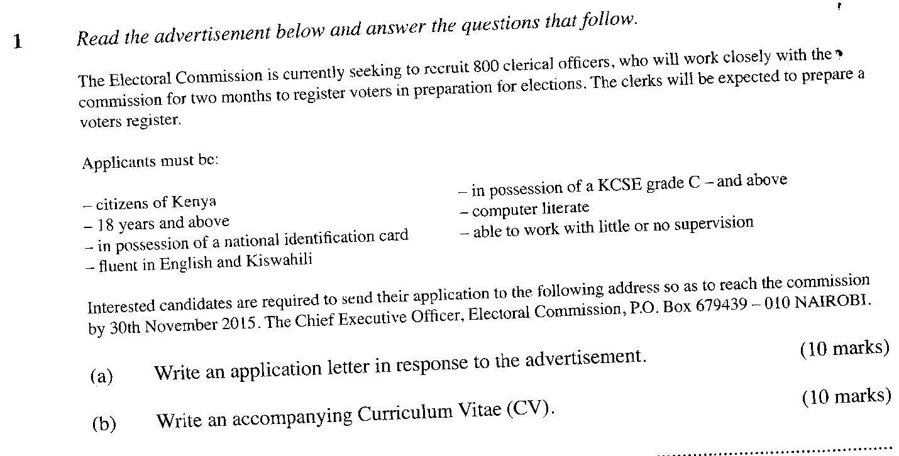
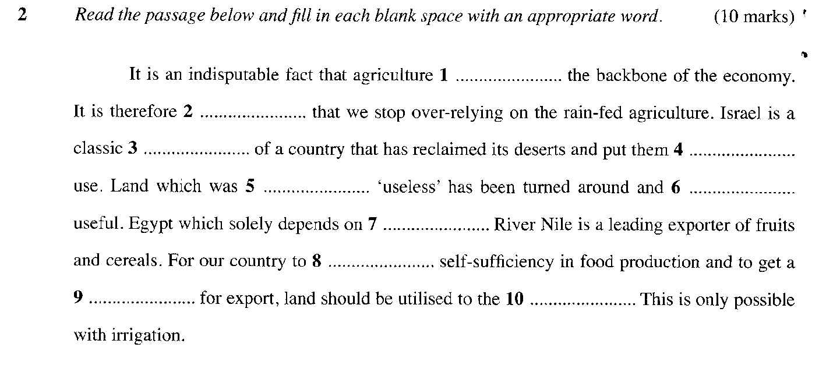

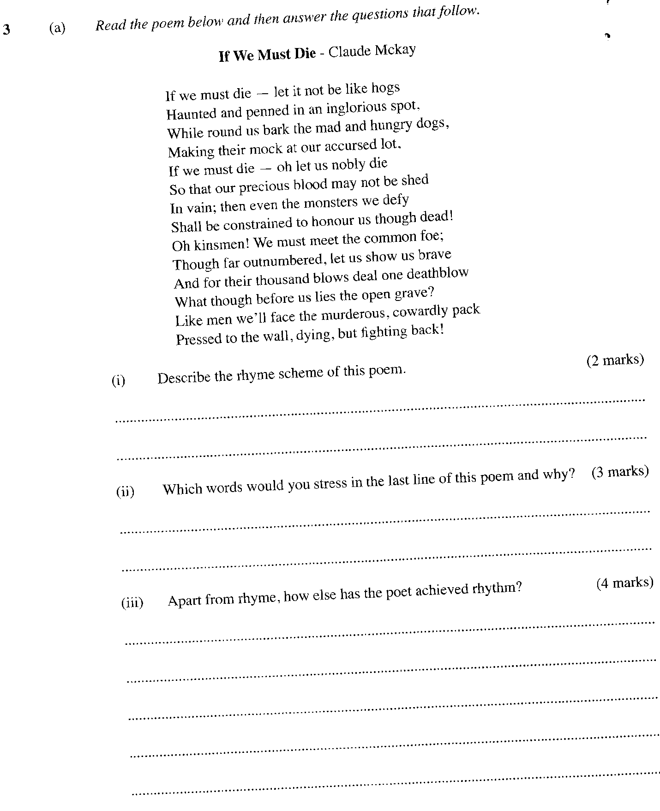

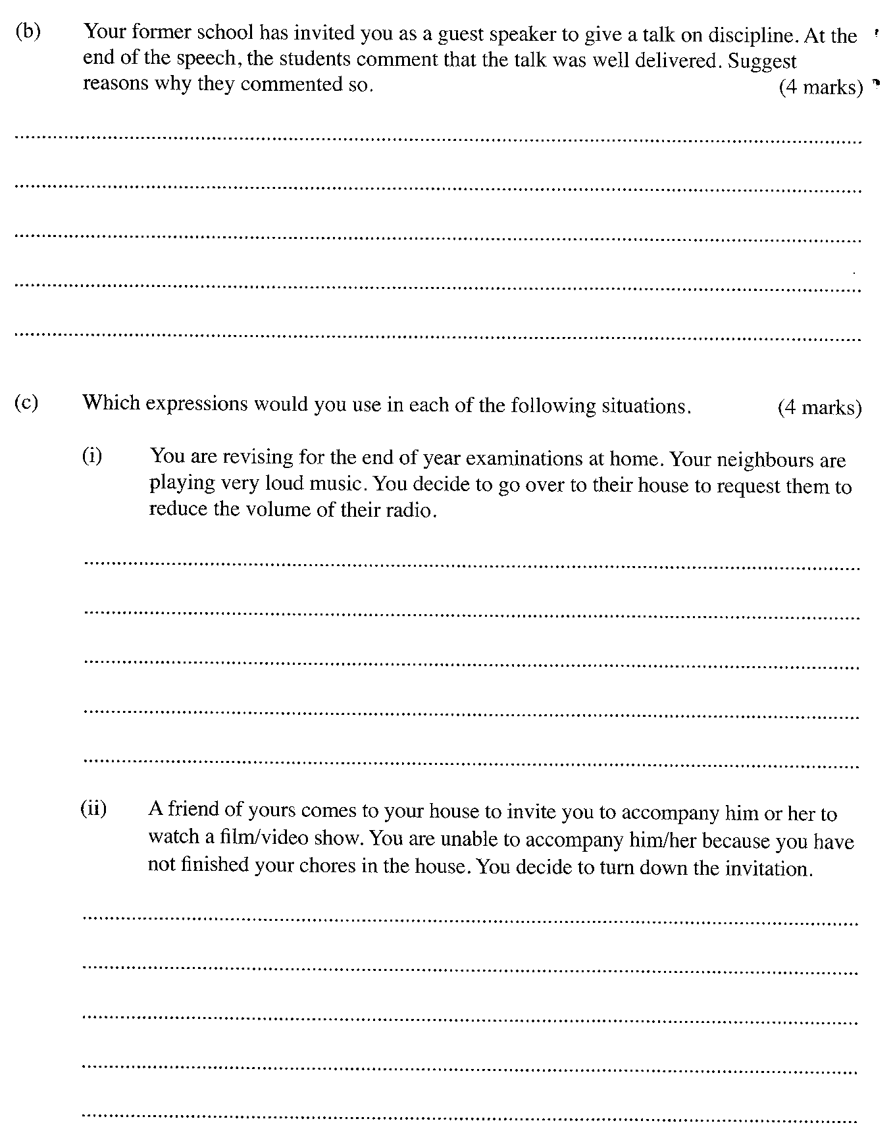

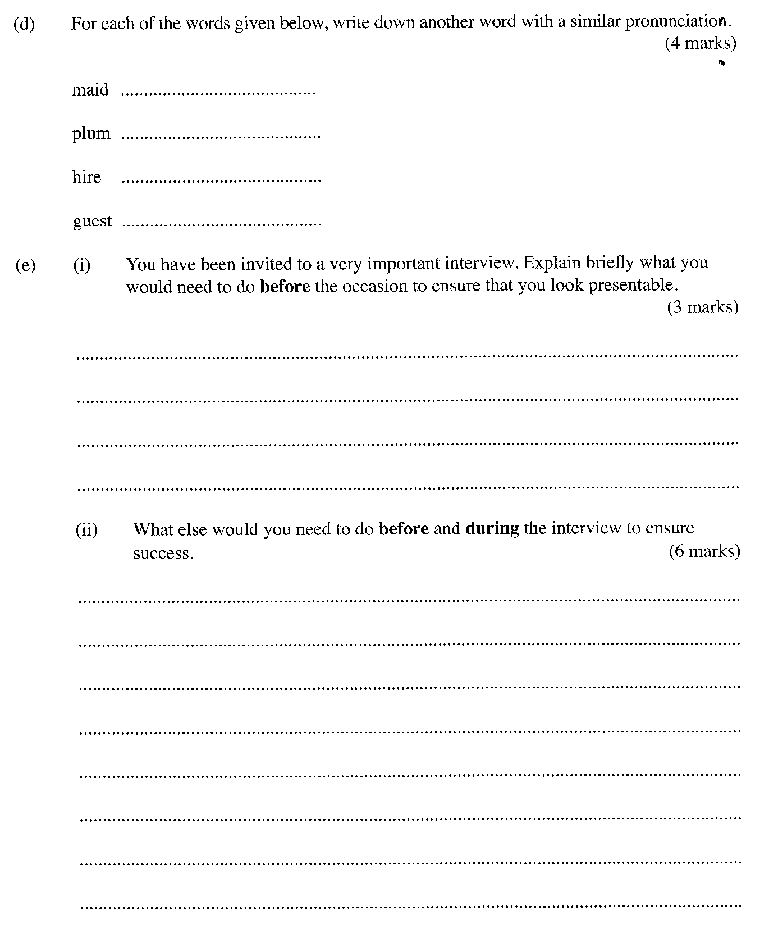

ENGLISH P2

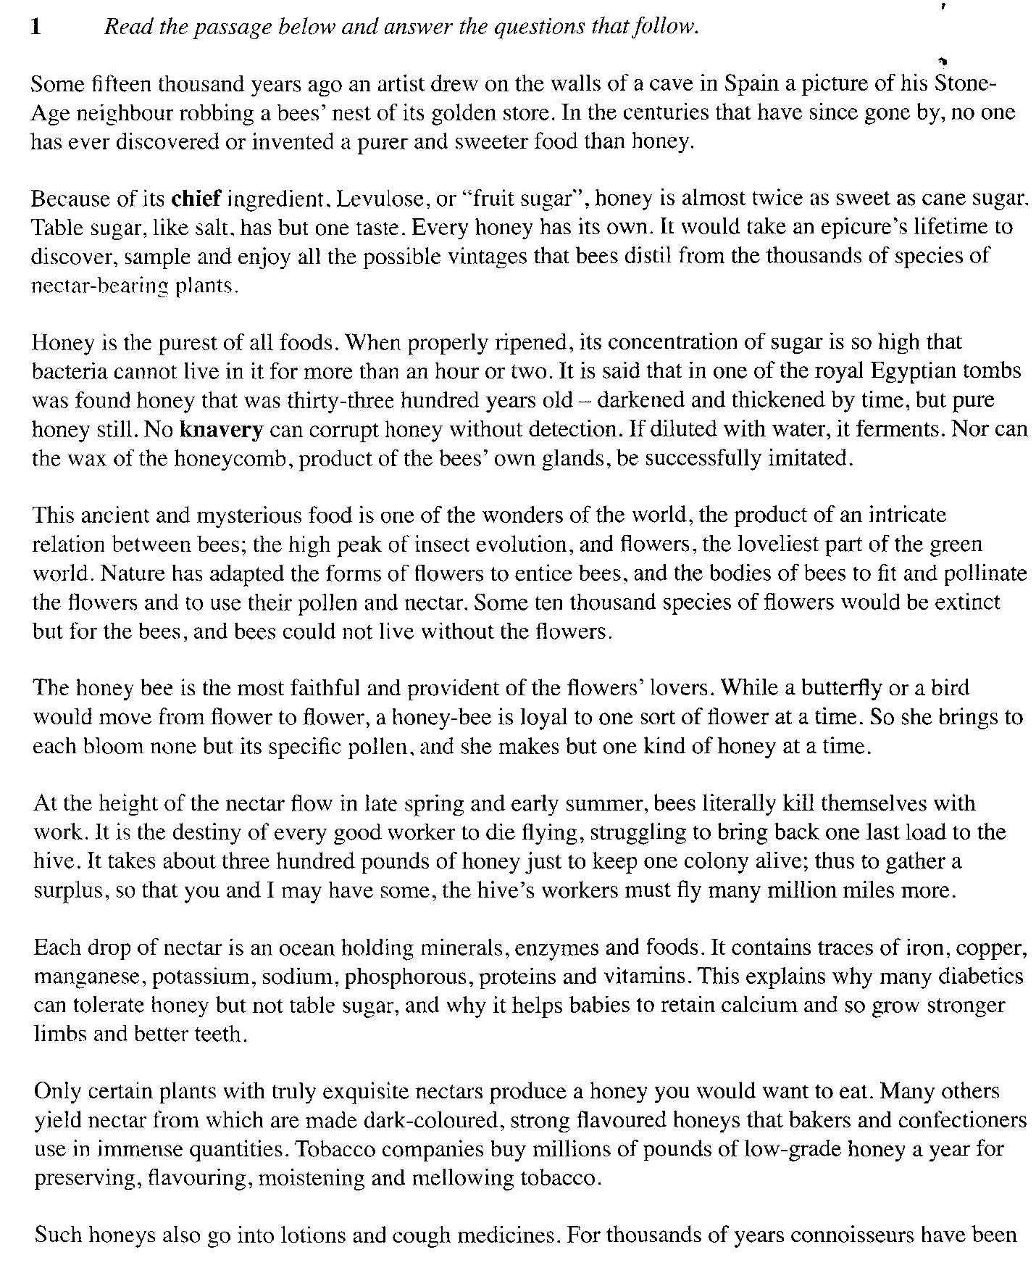
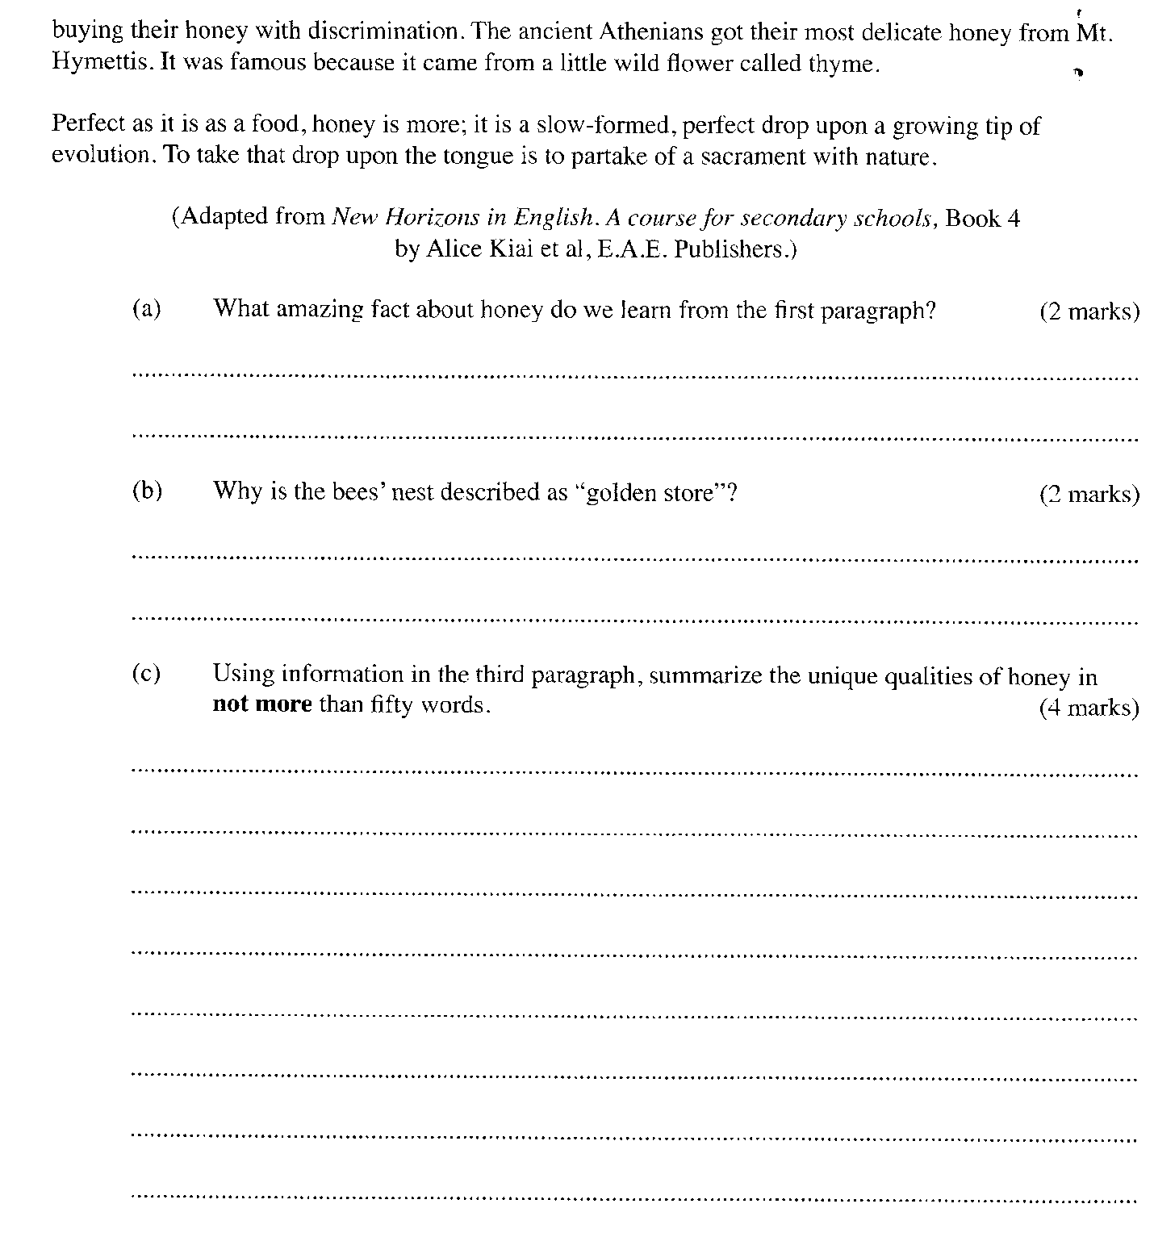
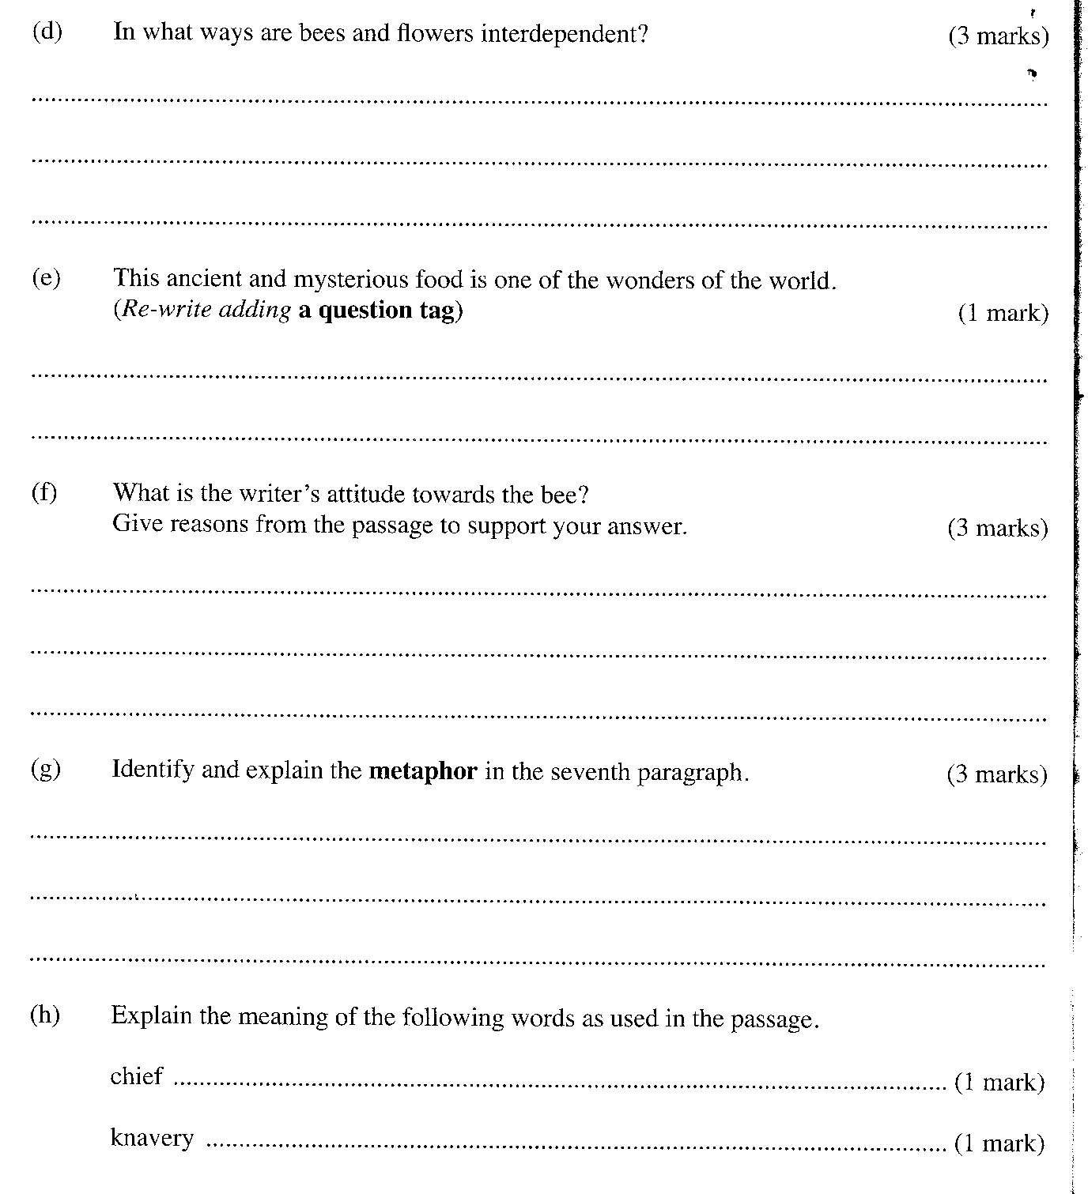

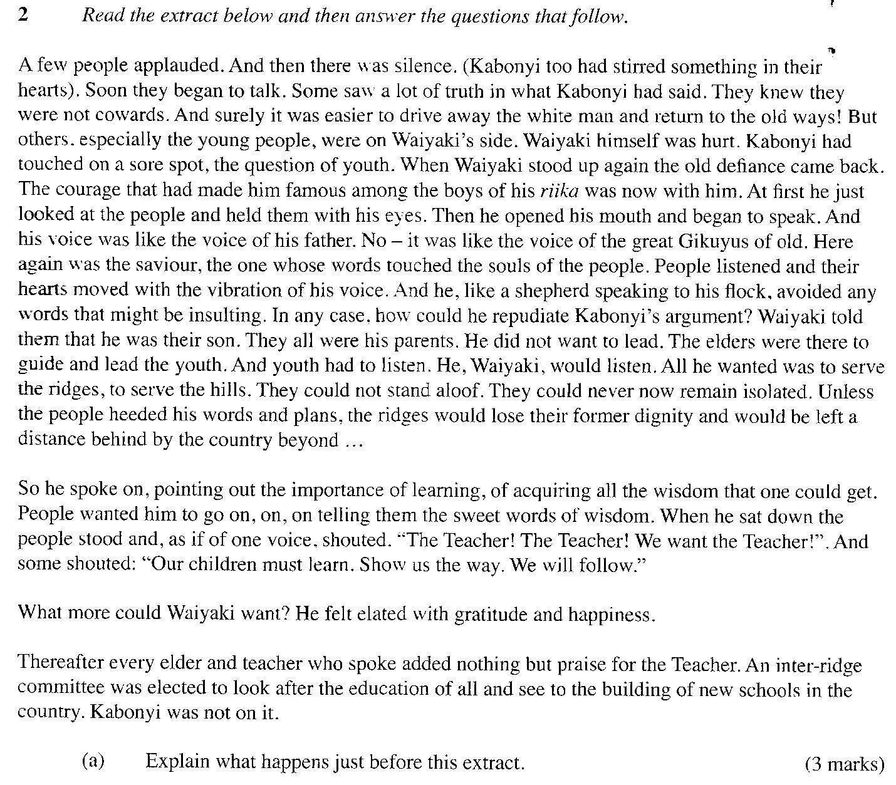
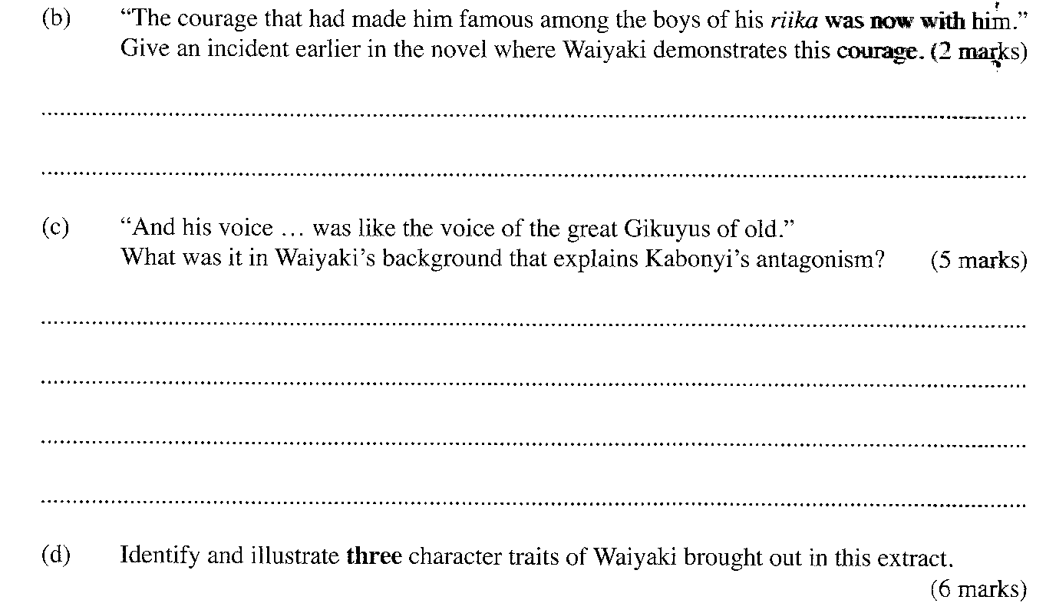
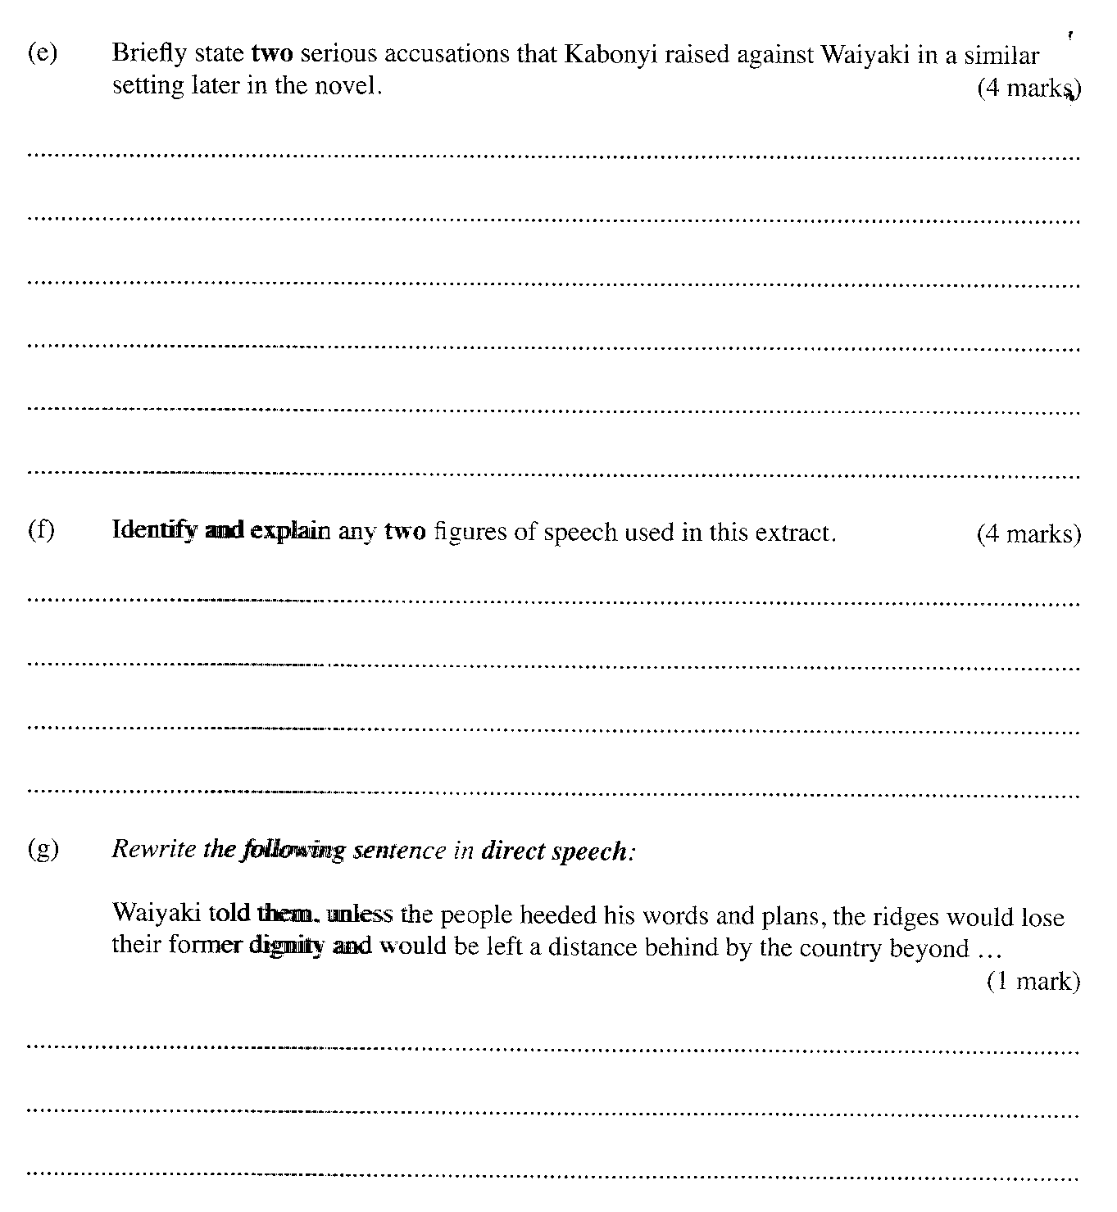

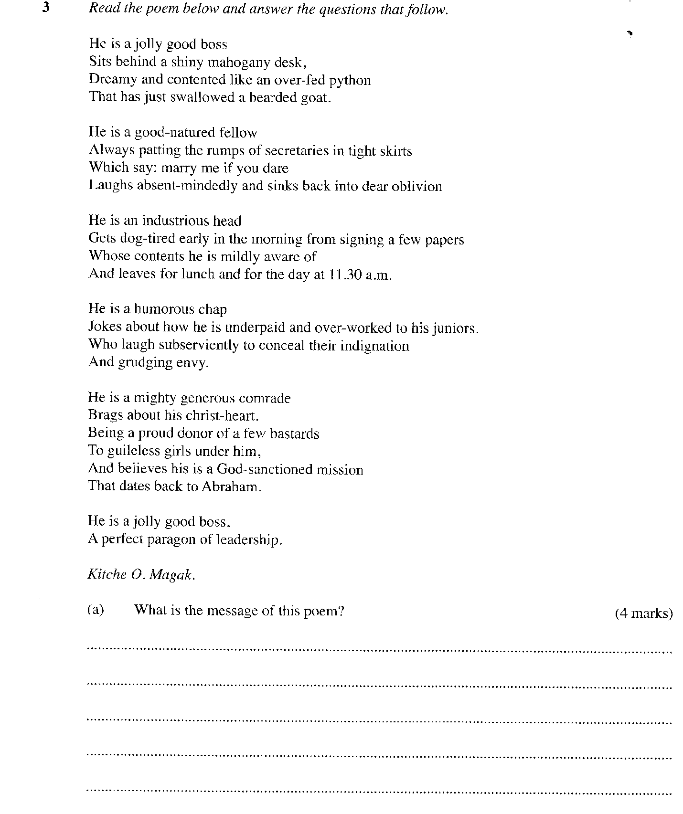

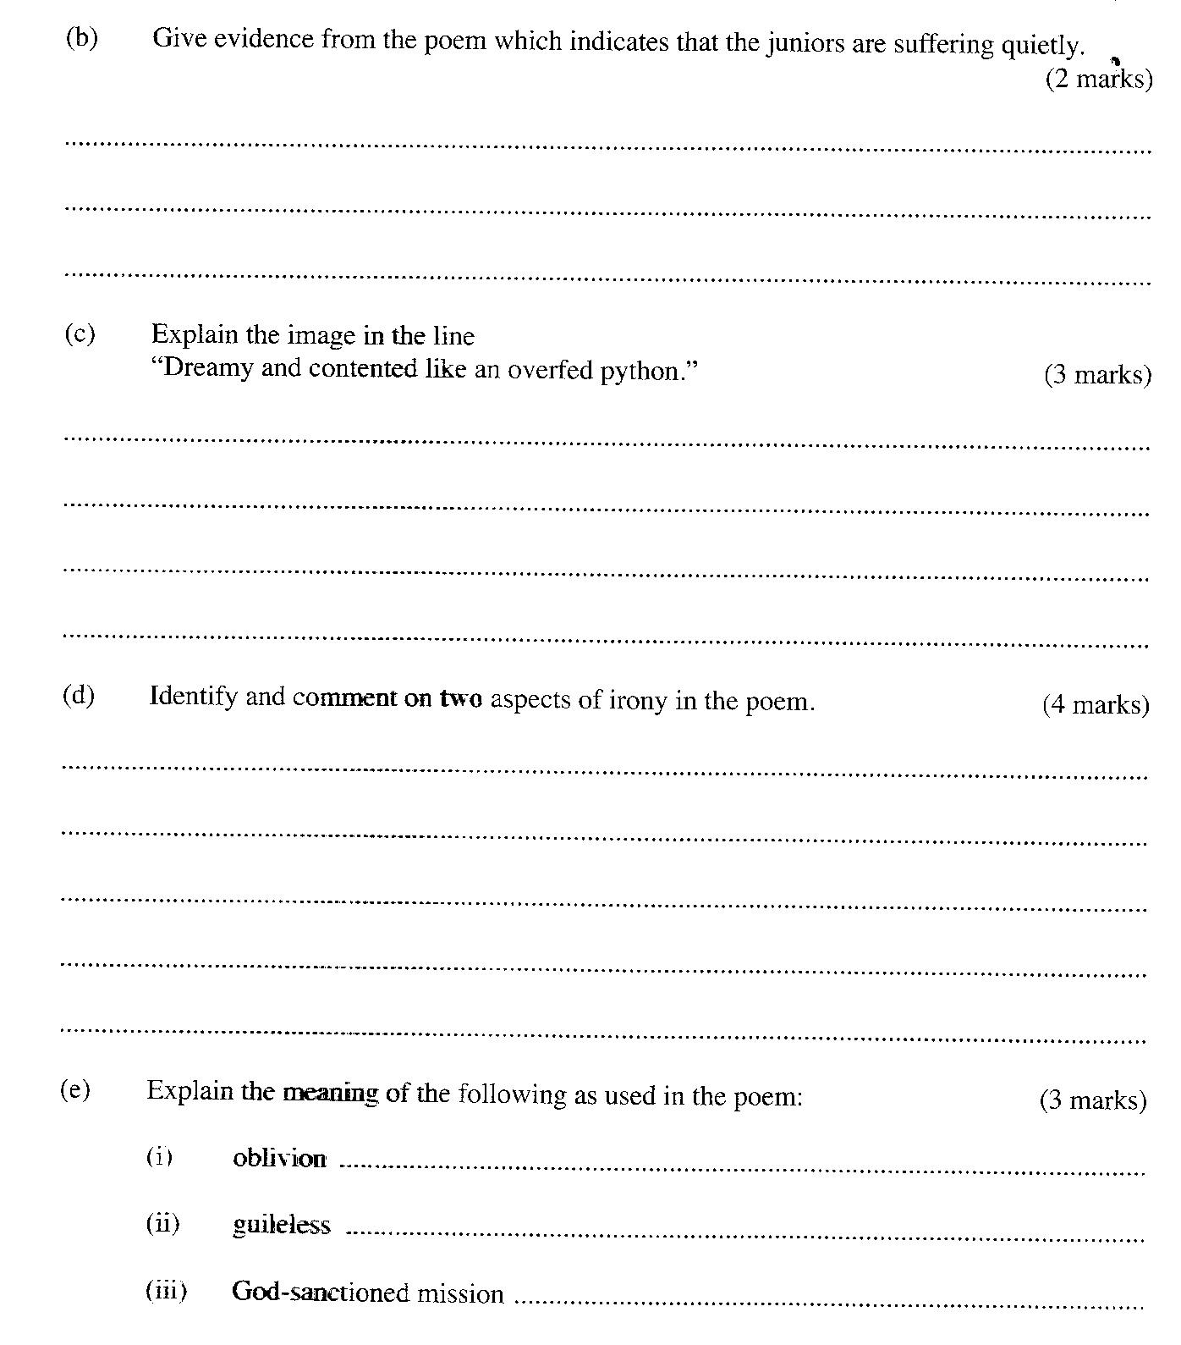

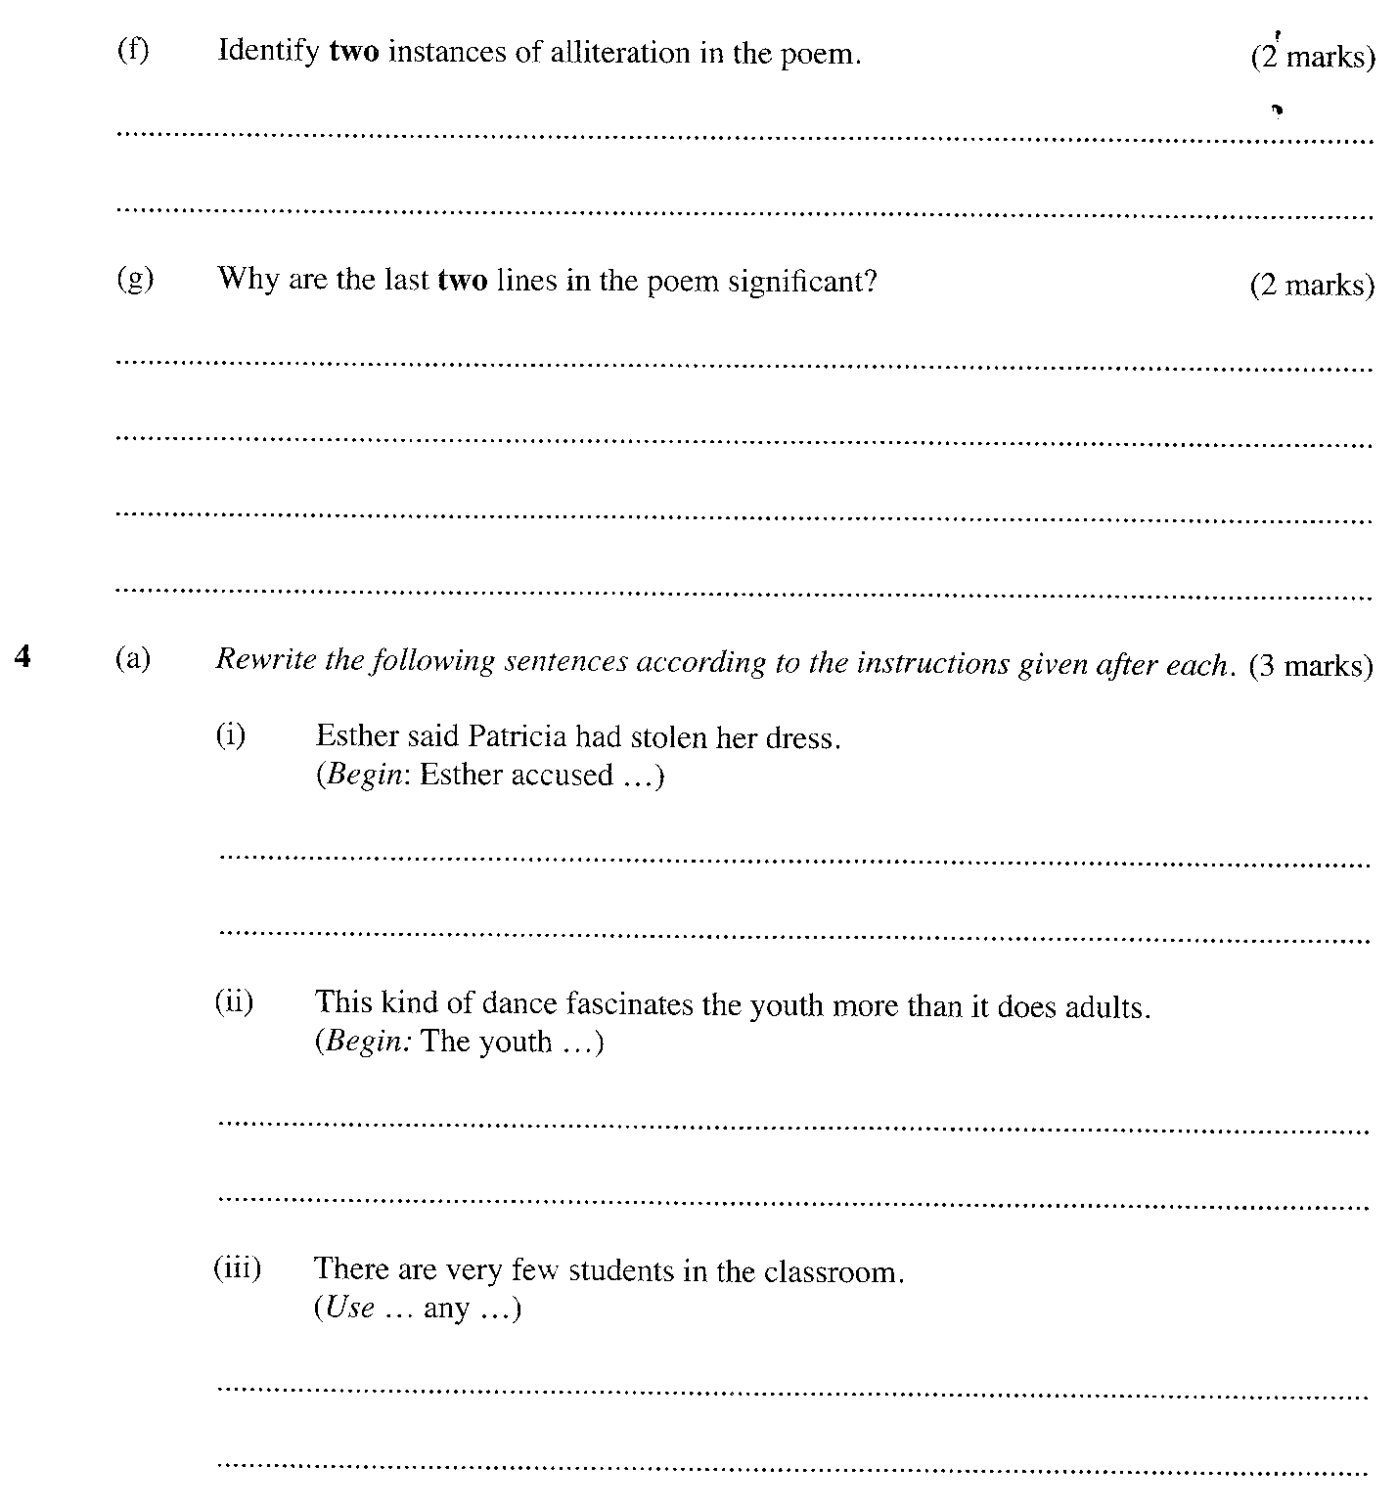

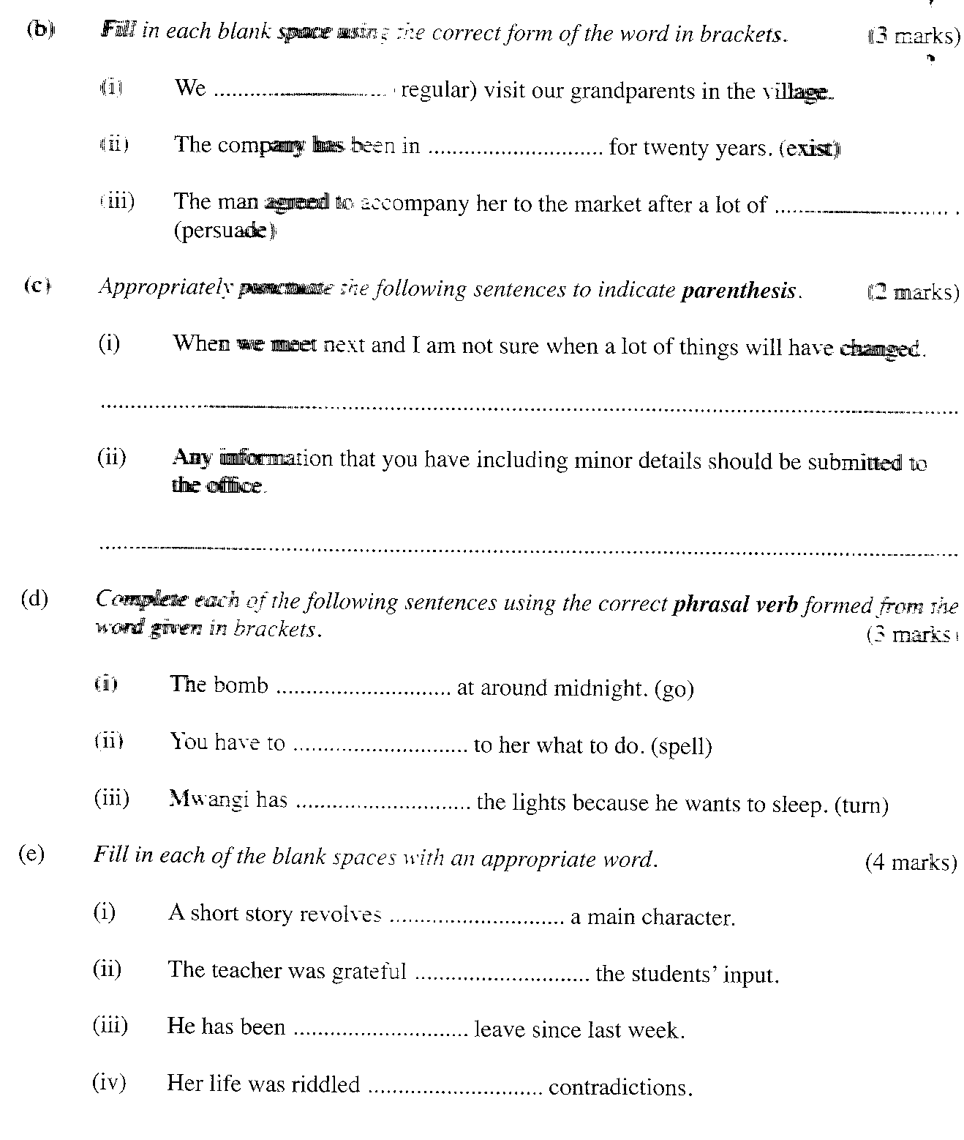

ENGLISH PAPER 3
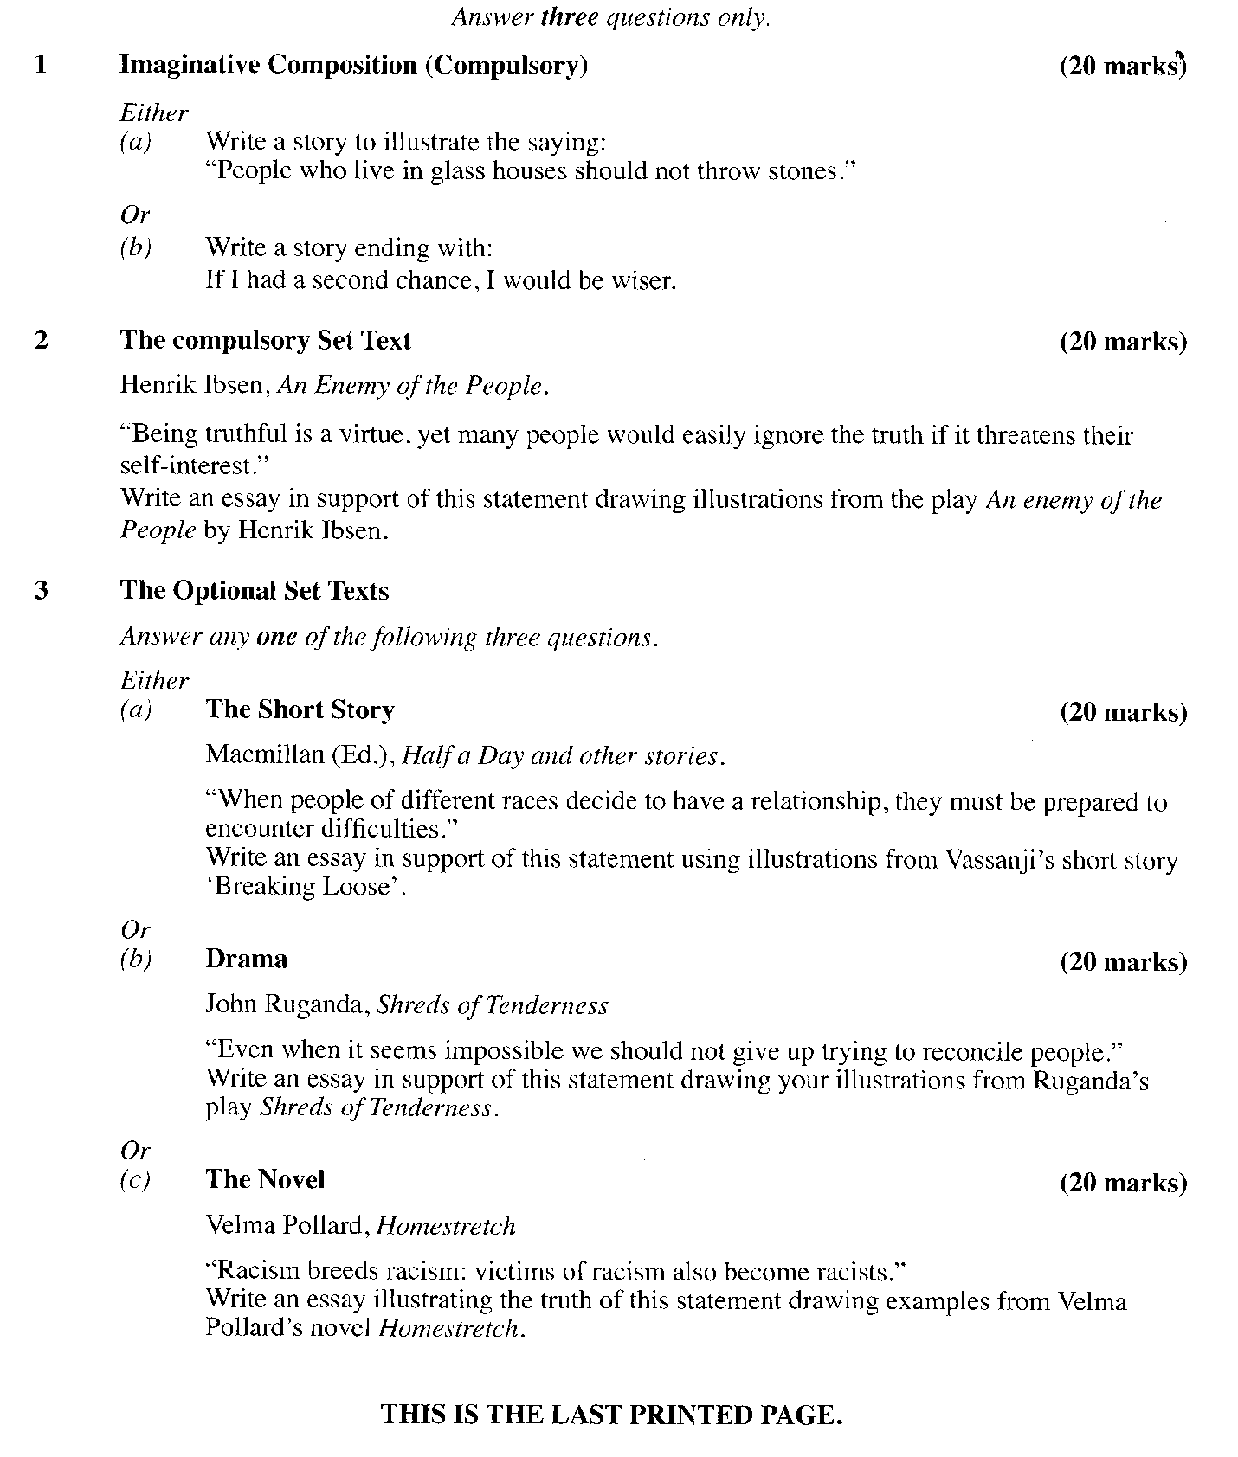

KCSE 2013
PAPER 1 ENGLISH

1 (a) Imagine that you are the caretaker of Fahari Children's Home in Bahati. There is a heavy storm one evening. After the storm you discover that one of the children is missing. The child is hearing impaired (deaf). Write a notice appealing to the public for help to trace the child. There will be a handsome reward for information that will help locate the child. (10 marks)
…………………………………………………………………………………………………………………………………………………………………………………………………………………………………………………………………………………………………………………………………………………………………………………………………………………………………………………………………………………………………………………………………………………………………………………………………………………………………………………………………………………………………………………………………………………………………………………………………………………………………………………………………………………………………………………………………………………………………………………………………………………………………………………………………………………………………………………………………………………………………………………………………………………………………………………………………………………………………………………………………………………………………………………………………………………………………………………………………………………………………………………………………………………………………………………………………………………………….

(b) Three days later, you receive a telephone call from the local police station informing you that the child has been found. Write a thank you note to the person who found and brought the child to the police station, giving details of how he/she will receive the reward.
(10 marks)
…………………………………………………………………………………………………………………………………………………………………………………………………………………………………………………………………………………………………………………………………………………………………………………………………………………………………………………………………………………………………………………………………………………………………………………………………………………………………………………………………………………………………………………………………………………………………………………………………………………………………………………………………………………………………………………………………………………………………………………………………………………………………………………………………………………………………………………………………………………………………………………………………………………………………………………………………………………………………………………………………………………………………………………………………………………………………………………………………………………………………………………………………………………………………………………………………………………………….
2. Read the passage below and fill in each blank space with an appropriate word.
(10 marks)
When people hurt you, should you lash out at them 1............................ give them a piece of
your 2............................? There are those that argue that 3............................ your emotions is much better than suppressing them. Perhaps the 4............................ lies in between.
What most people would readily agree 5............................ is the fact that it is 6:........................
to run away from the cause of your hurt because 7.................... is likely to breed resentment.
Imagine that your cubemate in the dormitory has 8............................ damaged your reputation
by telling blatant lies about you. instead of 9............................ him or her to settle the matter,
you move to the 10............................ cubicle. You may feel better for some time, but what if the
teacher puts the two of you in a discussion group?

3. (a) Read the poem below and then answer the questions that follow.

DAY SEVENTEEN
FEBRUARY 6, 2009_____
i find myself
looking at Black men
with different eyes

thinking things like
Act right fool, don't you know
we got a Black president!

i take Barack's
success & failure
personally

somehow i
feel as if

i represent him as much as
he does me

From Auction Block to Oval Office: 100 Poems in 100 Days of Obama's Presidency by Kahlil Almustafa. New York: MVMT Publishing, 2009.

(i) Identify one instance of alliteration in this poem.
……………………………………………………………………………… (1 mark)

(ii) Give two examples of assonance in this poem. …………………………………………………………………………….. (2 marks)

(iii) How would you perform the lines in italics? (4 marks)
………………………………………………………………………………………………………………………………………………………………………………………………………………………………………………………………………………………………………………………………
(iv) Pronouns such as "him" and "me" are usually not stressed. Explain why you
would stress them in the last stanza. (1 mark)
……………………………………………………………………………………………………………………………………………………………………………………………………………………

(b) Identify any jive pairs of words that are pronounced the same from the list below.
(5 marks)
phloem mad

floors flaws

berry coarse

clause mud

course cause

close cloze

bold bald

floss flame

phlegm bury
(i)…………………………………….. …………………………………….

(ii)…………………………………….. ………………………………………..

(iii) …………………………………… ………………………………………..

(iv) ………………………………….. ………………………………………..

(v) …………………………………….. …………………………………………

(c) For each of the following words, underline the part that is stressed
col.league
re.gis.ter (verb)
ap.proach (noun)
a.larm (noun)
a.buse (noun)
(5 marks)
(d) Your school has organized a farewell party for the form four students. You have been asked at short notice to move a vote of thanks. This will take the form of an impromptu speech. List the elements of your speech in the order in which they will appear. (6 marks)
………………………………………………………………………………………………………………………………………………………………………………………………………………………………………………………………………………………………………………………………………………………………………………………………………………………………………………………………………………………………………………………………………………………………………………………………………………………………………………………………
(e) Read the dialogue below and then answer the questions that follow.
REHEMA: Good morning, Aisha.

AISHA: Good morning.

REHEMA: (frowning) You don't look happy... What's the matter?

AISHA: I have just received a call from home, and...

REHEMA: Ah, these fellows from home are always calling. My mother also called me.

AISHA: Well, in my case, it is bad news. My brother...

REHEMA: As I was saying, my mother called me, and all she wanted to tell me is that they're fine, (shaking her head absentmindedly)

AISHA: My brother was involved in a car accident. But you're not listening... -

REHEMA: What did you say?

AISHA: (despairingly) I give up.

(i) What kind of listener is Rehema? Illustrate your answer. (4 marks)

(ii) What should Rehema do to improve her listening skills? (2 marks)
……………………………………………………………………………………………………………………………………………………………………………………………………………………

2013 ENGLISH PAPER 2

1. Read the passage below and answer the questions that follow. (20 marks)

To understand garbage, both industrial and domestic, you have to touch it, feel it and smell it. You have to pick through hundreds of tons of it, counting and weighing all the daily newspapers, the directories, the soiled diapers, the lipstick cylinders coated with grease, the medicine vials still encasing brightly coloured pills, the forsaken toys, and cigarette butts. You have to sort and weigh the volume of all the organic matter, discards from thousands of plates: rice; ugali; fish heads to which justice has hardly been done; rotting water melons bleeding from gaping holes; the half eaten bananas, mostly still within their peels, black and incomparably sweet in the embrace of the final decay.

To understand garbage, you need thick gloves, a mask and a vibrant immune system. However, the knowledge harvested from a dumpsite makes up for the grim working conditions. To an archaeologist, ancient garbage pits are among the happiest finds. Every archaeologist dreams of discovering spectacular objects - but the bread and butter work of archaeology involves the most common and routine kinds of discards. .

Interestingly, much conventional wisdom about garbage and its disposal consists of myths and assertions that turn out, upon investigation, to be misleading or dead wrong. For example, plastics are assumed to constitute the highest quantity of waste matter. For the record, the item most frequently encountered in a dumpsite is plain old paper. At one point, there was a lot of talk about how technology, computers in- particular, would bring about "paperless office" - a risky prediction, given the way things have turned out. Personal computers and printers grace many offices and homes today. Consequently, where the creation of paper waste is concerned, technology is proving to be a fertility drug rather than a contraceptive.

Concerning plastics, it is true that the number of plastic objects has been increasing over the years. Nevertheless, the proportion of space they take up in a dumpsite has hardly changed. The explanation appears to be the result of what is called "light-weighting" - making objects in such a way that they retain all their functional characteristics but require the use of less resin. These days, even the plastic in disposable diapers ensures that they enter the house very light but leave it much heavier than ever before. The result is that many more plastic items can be squeezed into a given volume.

Plastics are the Great Satan: gaudy, cheap, a convenient scapegoat for people who claim we waste and consume too much. Although it is paper more than anything else that is filling up the dumpsites, in its defense one frequently hears the claim that paper biodegrades while plastic remains inert and will take up space until the end of time.
Not really.

The reality is that the dynamics of a modern dumpsite are very nearly the opposite of what most people think. Biologically and chemically, a dumpsite is much more static than we commonly assume. For some kinds of garbage, bio degradation goes on for a while and then slows down to a virtual standstill. For other kinds, bio degradation never gets underway at all.

[Adapted from "Five Major Myths about Garbage , and Why they Are Wrong" by
William Rathje and Cullen Murphy, appearing in The Presence of Others (1994).
New York: St Martins Press]

(a) From paragraph one, name two examples of industrial waste and two examples of
domestic waste. (1 mark)

(b) According to the passage, how does a banana change as it rots? (2 marks)

(c) Why do you think a vibrant immune systern is said to be important in understanding
garbage? (2 marks)

- In the following sentence, replace the underlined expression with one word.
(1 mark)
However, the knowledge harvested from a dumpsite makes up for the grim working conditions.
………………………………………………………………………………………………………………………………………………………………………………………………………………………………………………………………………………………………………………………

(e) Why do you think the author puts the words "paperless office" in quotation marks?
(2 marks)

(f) Explain how technology has become a fertility drug rather than a contraceptive. (3 marks)

(g) What can we infer about resin? (2 marks)

(h) In point form, summarize the reasons why the author feels paper waste poses a greater danger to the environment than plastics. (4 marks)

Rough Copy

Fair Copy

(i) Explain the meaning of each of the following expressions as used in the passage.
(3 marks) bread and butter work;

static;

gets underway.

Read the excerpt below and then answer the questions that follow.

PETER STOCKMANN: By the way, Hovstad was telling me he was going to print another of your articles.

DR. STOCKMANN: One of my articles?

PETER STOCKMANN: Yes, about the Baths. An article you apparently wrote during the
winter.

DR. STOCKMANN: Oh, that one! No I wouldn't want that to appear now.

PETER STOCKMANN: Why not? I should have thought that this would be the most
opportune moment.

DR. STOCKMANN: Yes, very likely - under normal conditions.
(crosses the room.) .

PETER STOCKMANN (following him with his eyes): Is there anything extraordinary about
the present conditions?
DR. STOCKMANN (standing still): To tell you the truth, Peter, I can't tell you just at
this moment - at least not tonight. There may be much that is very abnormal about the present conditions - and it is possible there may be nothing extraordinary about them at all. It might very well be just my imagination.

PETER STOCKMANN: I must say it all sounds most mysterious. Is there something going on that I am not supposed to know? I should have imagined that I, as Chairman of the governing body of the Baths ...
DR. STOCKMANN:And I should have imagined that I ... Oh, come, don't let us fly off the handle at one another, Peter.

PETER STOCKMANN: Heaven forbid! I am not in the habit of flying off the handle, as
you call it. But I am entitled to request most emphatically that all arrangements shall be made in a businesslike manner, through the proper channels and shall be dealt with by the proper authorities. I can allow no dubious or underhand methods.

DR. STOCKMANN: Have I ever at any time used dubious or underhand methods?

PETER STOCKMANN: You have an ingrained tendency to take things into your own hands, at least; and, that is almost equally inadmissible in a well-ordered community. The individual ought undoubtedly to subordinate himself or herself to the community - or, to be more accurate, to the authorities who have the care of the community's welfare.

DR. STOCKMANN: Very likely. But what the devil has all this got to do with me?

PETER STOCKMANN: That is exactly what you never seem to learn my dear Thomas. But,
mark my words, some day you will have to suffer for it - sooner or later.

(a) Explain why the brothers, Peter and Thomas Stockmann, differ over the timing of
publication of the article mentioned in this excerpt. (2 marks)

(b) Give two reasons why Dr. Stockmann is reluctant to discuss the "present conditions" of the Baths with the mayor. (2 marks)

(c) Identify and illustrate three character traits of Peter Stockmann evident in this excerpt.
(6 marks)
(d) In the light of what happens later in the play, say to what extent each of the two brothers has got "the care of the community's welfare". (4 marks)
(e) What is it that Dr. Stockmann "never seems to learn" according to the mayor? (2 marks)

(f) "Have I ever at any time used dubious or underhand methods?"
(Rewrite in reported speech) (1 mark)

(g) Identify and explain three aspects of foregrounding the author uses in this excerpt.
(6 marks)

(h) Pick out a phrase in this excerpt that may suggest that Peter Stockmann exaggerates or even falsely accuses Dr. Stockmann of insubordination. Explain your answer.
(2 marks)

3. Read the poem below and answer the questions that follow.

OUT- CAST
They met by accident
He proposed the idea
She gave her consent
All the way to the altar

The casualty was male
And his pigment was pale
Unlike his alleged sire
Who was black with ire

The recourse was legitimate
He disclaimed responsibility
So they had to separate
The boy remains illegitimate

Last month, not long ago
They both took their go
Coincidentally by accident
No will, no estate Nothing to inherit

The poor boy is hardly ten
And knows no next-of-kin
He roams the streets of town
Like a wind-sown out-cast

G. Gathemia
(From:. Boundless Voices)..
Edited by Arthur I. Luvai

- Briefly explain what the poem is about. (4 marks)
(b) Describe two character traits of the mother in the poem.
(4 marks)
(c) Explain the meaning of the following as used in the poem. (3 marks)

(i) disclaimed

(ii) unlike his alleged sire who was black with ire

(d) Identify and explain one instance of irony in the poem. (3 marks)

(e) What is the persona's attitude towards the boy in the poem? (3 marks)

(f) Rewrite the following in your own words.
('They both took their go') (1 mark)

(g) Give a proverb which appropriately summarizes this poem. (2 marks)

4 .(a) Rewrite the following sentences according to the instructions after each. (4 marks)

(i) It was difficult but we completed the task.
(Begin: Difficult...)
(ii) He said that he had not insulted me.
(Use: 'denied'...)

(iii) I will not at any cost support your evil plans. (Begin: At no cost...)

(iv) She is renovating her house so that she may sell it. (Rewrite using: 'with a view'...)

(b) Explain the difference in meaning of each of the following pairs of sentences.
(2 marks)

(i) I. Even I attended the ceremony.

II. I even attended the ceremony.

(ii) I. Bring an umbrella if it rains.
II. Bring an umbrella in case it rains.

(c) Replace each of the underlined words with a phrasal verb.
(3 marks)

(i) The meeting was postponed to a later date. .............................................................

(ii) After consultations the man agreed to assume the role of manager.

(iii) The number of smokers has decreased because of the cancer awareness campaign.

(d) Fill in each of the blank spaces with the appropriate form of the word in brackets.
(3 marks)
(i) The chairman expressed doubts about the ............................................ of showing the film on children's television, (suit)

(ii) We could not understand him. His actions were completely ................................... (explain).

(iii) Wearing a mask, he was totally ................................................(recognize)

(e) Fill in each of the blank spaces with the appropriate form of the word in brackets.
(3 marks)
(i) If they had worked hard, they ......................................... the
examination, (pass)

(ii) If the athlete had maintained the pace, she .............................................................. (overtake)

(iii) Unless the ambulance arrives in time, his life ......................................................... (save)

KCSE ENGLISH PAPER 3

Answer THREE questions only.

1. Imaginative Composition (compulsory) (20 marks)
Either

(a) Write a story to illustrate the saying: "A stitch in time saves nine."
or

(b) Write a story ending with:
...This is when i realised that it is noble to have and keep friends.

2. The Compulsory Set Text (20 marks)
Ngugi wa Thiong'o, The River Between

"Although change is inevitable, it comes with a lot of challenges."
Drawing illustrations from the novel The River Between, write an essay illustrating the truth of this statement.

3 The Optional Set Texts (20 marks)
Answer any ONE of the following questions.
Either
(a) The Short Story
Ilieva and Olembo (Ed.), When the Sun Goes Down and Other Stories
With illustrations from Haruki Murakami's short story "The Mirror"., explain the problem of superstition in human life.
or
(b) Drama
John Ruganda, Shreds of Tenderness
"In the opening section of the play Shreds of Tenderness, Odie engages in a one-sided dialogue with His Highness, The King of Termites. Much of it is diversionary, even verging on a 'madman's' gimmick. Yet it makes its contribution to the play."

Write an essay on the use Ruganda makes of these episodes both as a prologue to the play and as a commentary on the situation depicted in the play Shreds of Tenderness.
or
(c) The Novel
Witi Ihimaera, The Whale Rider
"A seedling that will grow into a big tree can be spotted early."
Using examples from the character of Kahu in the novel The Whale Rider, write a composition in support of this statement.

