NAME INDEX

SCHOOL DATE

FACTORS INFLUENCING AGRICULTURE
- 1995
List four environmental factors that affect crop distribution in Kenya.
……………………………………………………………………………………………………………………………………………………………………………………………………………………………………………………………………………………………………………………………………………………………………………………
- 1996
State two ways by which wind affects the growth of crops.
…………………………………………………………………………………………………………………………………………………………………………………………

3. 1997
a) State two ways by which wind affects the growth of crops.
………………………………………………………………………………………………………………………………………………………………………………

b) Give two roles of micro-organisms in the soil that are beneficial to crops
………………………………………………………………………………………………………………………………………………………………………………
c) State three properties of soil that are influenced by its texture.
………………………………………………………………………………………………………………………………………………………………………………………………………………………………………………………………………
4. 1999
List down the four aspects of rainfall that affect agriculture. ……………………………………………………………………………………………………………………………………………………………………………………………………………………………………………………………………………………………………………………………………………………………………………………
5. 1999
Describe the environmental conditions that may lead to low crop yields.
……………………………………………………………………………………………………………………………………………………………………………………………………………………………………………………………………………………………………………………………………………………………………………………

6. 2000
Outline three effects of soil organisms which benefit crop growth.
………………………………………………………………………………………………………………………………………………………………………………………………………………………………………………………………………………………

7. 2001
State two causes of hard pan in a crop yield.
…………………………………………………………………………………………………………………………………………………………………………………………

8. 2002
a) Name two processes of rock weathering. ………………………………………………………………………………………………………………………………………………………………………………
b) Differentiate between soil texture and soil structure.
………………………………………………………………………………………………………………………………………………………………………………
………………………………………………………………………………………………………………………………………………………………………………………………………………………………………………………………………

c) State three benefits of good soil structure in crop production.
………………………………………………………………………………………………………………………………………………………………………………………………………………………………………………………………………

9. 2003
a) List two aspects of light that influence crop growth.
………………………………………………………………………………………………………………………………………………………………………………

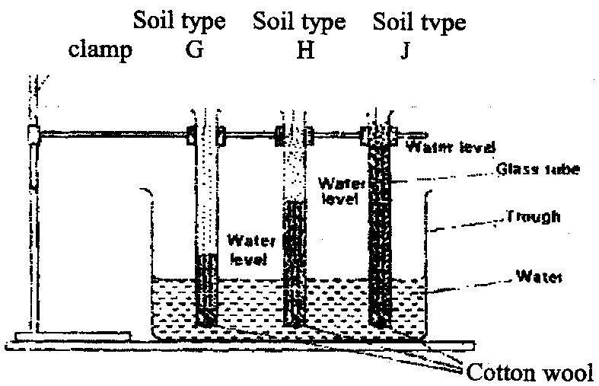
b) The diagram below shows an experiment set up using soil types &, H and J and observations made after 24 hours. Study the diagram and answer the questions that follow.

i) What is the experiment represented above designed to study? ………………………………………………………………………………………

ii) Name the three soil types & H and J.
………………………………………………………………………………………………………………………………………………………………………………………………………………………………………………………………………
iii) What is the characteristic texture of soil types G and J?
………………………………………………………………………………………………………………………………………………………………………………
iv) State how a farmer would improve the structure of soil type G.
………………………………………………………………………………………………………………………………………………………………………………………………………………………………………………………………………

10. 2004
a) Give 3 reasons why soil is important to crops.
………………………………………………………………………………………………………………………………………………………………………………………………………………………………………………………………………
b) State two benefits of optimum soil temperature in crop production.
………………………………………………………………………………………………………………………………………………………………………………
c) Give 3 factors of soil that influence soil productivity.
………………………………………………………………………………………………………………………………………………………………………………………………………………………………………………………………………

11. 2004
Give three reasons why soil is important to crops.
………………………………………………………………………………………………………………………………………………………………………………………………………………………………………………………………………………………

12. 2004
a) Give four reasons why a well drained soil is suitable for crop production.
………………………………………………………………………………………………………………………………………………………………………………………………………………………………………………………………………………………………………………………………………………………………

b) State two benefits of optimum soil temperature in crop production.
………………………………………………………………………………………………………………………………………………………………………………

c) Give three soil factors that influence soil productivity.
………………………………………………………………………………………………………………………………………………………………………………………………………………………………………………………………………

13. 2005
State three advantages of adding organic matter to sandy soil.
………………………………………………………………………………………………………………………………………………………………………………………………………………………………………………………………………………………

14. 2005
a) State two roles of good soil aeration in crop growth.
………………………………………………………………………………………………………………………………………………………………………………
b) Give two roles of micro-organisms in the soil that are beneficial
to corps.
………………………………………………………………………………………………………………………………………………………………………………
c) State three properties of soil that are influenced by its texture.
………………………………………………………………………………………………………………………………………………………………………………………………………………………………………………………………………

15. 2006 Q2 P1
State three ways by which biological agents can enhance the process of soil formation
(1 ½ marks)
………………………………………………………………………………………………………………………………………………………………………………………………………………………………………………………………………………………

16. 2007 Q2, 3 P1
2. List three physical weathering agents in the soil formation process (1¹/₂marks)
………………………………………………………………………………………………………………………………………………………………………………………………………………………………………………………………………
3. State two mechanical methods of separating soil particles according to size during
soil analysis (1marks)
………………………………………………………………………………………………………………………………………………………………………………

17. 2008 Q2 P1
State two effects of HIV/AIDS on agricultural production (1marks)
…………………………………………………………………………………………………………………………………………………………………………………………

18. 2008 Q4 P1
Distinguish between soil structure and soil texture (1mark)
…………………………………………………………………………………………………………………………………………………………………………………………

19. 2009 Q12 P1
Give two roles of soil micro- organism those are beneficial to crops. (1 mark)
…………………………………………………………………………………………………………………………………………………………………………………………

20. 2009 Q15 P1
State two harmful effects of strong wind on crop production. (1 mark)
…………………………………………………………………………………………………………………………………………………………………………………………

21. 2009 Q20 P1
Name four natural factors that may influence soil erosion (1 mark)
……………………………………………………………………………………………………………………………………………………………………………………………………………………………………………………………………………………………………………………………………………………………………………………

22. 2009 Q23 P1
The diagram below illustrates an experiment on soil. Study it carefully and answer the questions that follow.
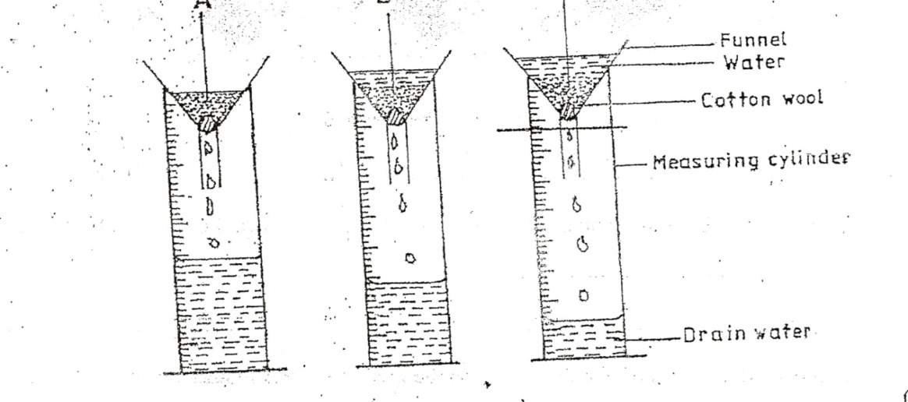
- State the aim of the experiment (1mark)
……………………………………………………………………………………………………………………………………………………………………………………

- If the volume of water illustrated in the measuring cylinder was observed after one hour identify the soil sample labeled A and B. (¹/₂ mark)
…………………………………………………………………………………………………………………………………………………………………………………………

- State two ways in which the soil structure of the sample labeled C above can be improved (2 marks)
…………………………………………………………………………………………………………………………………………………………………………………………

23. 2010 Q23c P1
State five soil factors that should be considered when selecting a crop to grow in an area
……………………………………………………………………………………………………………………………………………………………………………………………………………………………………………………………………………………………………………………………………………………………………………………
……………………………………………………………………………………………

24. 2010 Q24a P1
Outline five ways in which high temperature affects agricultural production in Kenya.
(5 marks)
……………………………………………………………………………………………………………………………………………………………………………………………………………………………………………………………………………………………………………………………………………………………………………………
……………………………………………………………………………………………

25. 2011 Q28a P1
Explain five ways in which biotic factors influence crop production in agriculture
(5marks)
……………………………………………………………………………………………………………………………………………………………………………………………………………………………………………………………………………………………………………………………………………………………………………………
……………………………………………………………………………………………

26. 2012 Q2 P1
State four biotic factors that influence crop production. (2marks)
……………………………………………………………………………………………………………………………………………………………………………………………………………………………………………………………………………………………………………………………………………………………………………………

27. 2012 Q24c P1
Explain the different ways in which each of the following environmental factors influence crop production:
- Temperature; (4marks)
………………………………………………………………………………………………………………………………………………………………………………………………………………………………………………………………………………………………………………………………
- Wind. (5marks)
………………………………………………………………………………………………………………………………………………………………………………………………………………………………………………………………………………………………………………………………………………………………………………………………………………

