Name………………………………………………Center/IndexNo……………………………
Signature……………………………………………………
553/1
BIOLOGY
2$\frac{1}{2}$ hours
HAN EXAMINATION SECRETARIAT
Uganda Certificate of Education
BIOLOGY (THEORY)
2 Hours 30 minutes
INSTRUCTIONS TO CANDIDATES:
- This paper consists of sections A, B and C.
- Answer all questions in section A and B, plus any two questions in section.
- Write the answers to section A in the boxes provided, answers to section B in the spaces provided and answers to section C in the answer booklet provided.
Section | For Examiner’s Use Only
Section | Marks | Examiner’s No & Initials
A | 1-30
B | 31
B | 32
B | 33
C | 34
C | 35
C | 36
C | 37
Total
SECTION A: (30 MARKS)
- In plants, efficient gaseous exchange due to large surface to volume ration is achieved by.
- many stomata on leaves C. large sized lenticels
- flatness of leaves D. numerous root hairs
- Which of the following would happen is a torch was shown directly into a person’s eye?
- Radical muscles would contract, narrowing the pupil
- Lens would bulge, allowing less light to enter
- Radical muscles would relax, narrowing the pupil
- Lens would flatten, diverging light rays
- Figure below shows the concentration of lactic acid in the blood of an athlete during and after a race. During which period on the graph does the athlete not experience both aerobic and anaerobic respiration?
- P-Q C. R-S
- Q-R D. P-R
- Which one of the following is a nastic response?
- Bending of a plant shoot towards light
- Folding of plant leaflets when touched.
- Growing of plant roots towards water
- Bending of plant root towards gravity
- Which one of the following contains a set of cells which are all haploid?
- Pollen grain, ovules and root hair cells C. sperms, ovules and brain cells
- Sperms, pollen grains and ova D. cells of the anididymia, ovules and ova
- Which one of the following features distinguishes insects from other arthropods?
- Jointed legs C. Two pairs of wings
- Three main body parts D. A pair of antennae
- A plant with green leaves growing on a tree with its roots embedded in the stem of the tree is an example of………
- A saprophyte C. a symbiont
- An epiphyte D. a parasite
- Which one of the following occurs during inter phase in mitosis?
- Division of the nucleus into two C. duplication of genetic materials
- Constriction of cytoplasm D. arrangement of chromosomes on spindle
- 20cm³ of soil was poured into a measuring cylinder, 50cm³ of water was added and the volume of the mixture was 68cm³ after gently stirring. What was the percentage of air in the soil?
- 10% C. 2%
- 20% D. 30%

- Which one of the following statements is true about fertilization in flowering plants?
- Eggs nucleus fuses with one male nucleus to form a triploid zygote
- Secondary nucleus fuses with one male nucleus to form a triploid endosperm
- Polar nuclei fuse with one nucleus to form a diploid endosperm
- Egg nucleus fuses with one male nucleus to form a diploid zygote
- A growing seedling was placed horizontally as shown in the figure (i) below and left for 3 days. After the three days, the seedling appeared as in figure (ii) below;
The main aim of the experiment was to investigate the effect of…………
- Light on growing of radicals C. gravity on growing tips of seedling
- Light on growing of tip of seedling D. water on growth of radicals
- Mammals have a higher capacity to learn than other animals due to their enlarged………
- Medulla oblongata C. hypothalamus
- cerebellum D. cerebrum
- Which of the following components of an ecosystem has the highest energy content?
- Decomposers C. Secondary consumer
- Primary consumer D. Tertiary consumer
- For a person to stretch a hand,……….
- Biceps relax C. both biceps and triceps contract
- Triceps relax D. both biceps and triceps relax
- In insects, the type of joint in their legs is called………….
- Ball and socket joint C. peg and socket
- Hinge joint D. flexor and extensor
- The figure below is a simplified representation of the nitrogen cycle.
Plant proteins

Ammonium compounds Nitrates
Y
Nitrites
Which one of the following types of bacteria is responsible for the change along Y?
- Nitrogen fixing bacteria C. Putrefying bacteria
- Denitrifying bacteria D. Nitrifying bacteria
- When a seedling is placed on a klinostat, no curvature occurs because……..
- Auxins are not produced C. auxins are uniformly distributed in the growth parts
- Growth is accelerated D. all parts of the seedling are uniformly lit

- The following is a dichotomous key of invertebrates.
  - (a). Has 8legs………………………………..W
(b). Has 6 legs………………………………..2
  - ( a). Has long antennae………………………X
(b). Has short antennae………………………3
  - (a). Has proboscis……………………………Y
(b). Has mandibles…………………………...Z
Which one of the organisms is a fly?
A.W C. Y
- X D. Z
- Which of the following organisms reproduce by fragmentation?
- Bacteria C. Amoeba
- Spirogyra D. Fungi
- The relationship between fungi and algae in lichen is best described as……..
- Mutualistic C. predatory
- Parasitic D. symbiotic
- Which one of the following sets, consists of bones of the fore limb?
- Fermur, tibia, humerus C. Tibia, fibula, ulna
- Radius, ulna, femur D. Humerus, radius, ulna
- Strips W, X, Y and Z of same size and shape were cut from a raw pawpaw, whose sap had a sugar concentration of 28%. The strips were then placed in sugar solutions of different concentrations as shown in the following table;
Strip | Sugar concentration of solution (%)
W | 15
X | 25
Y | 28.5
Z | 48

Which strip would be longest after 4 hours?
- X C. Y
- W D. Z
- Which one of the following sets of joints consists of only the hinge type?
- Hip, wrist and elbow C. Elbow, knee and finger joints
- Neck, shoulder and elbow D. Knee, wrist and ankle

- Which one of the following is the least important reason why plants need to ensure efficient disposal of seeds in nature?
- Increasing chances of finding a better habitat for multiplication
- Escape being eaten by animals in its original habitat
- Reducing competition for food.
- Ensuring better colonization of different places
- Which one of the following does not contribute to the efficiency of a housefly as a vector?
- Ability to fly C. feeding in dirty places
- Feeding on liquid food D. possession of hairs on the body
- Which one of the following would not contribute to the accuracy of the capture –recapture method of estimating population size?
- Using a stable population C. Use of very small marks
- Capturing animals selectively D. Allowing time before the recapture
- Which of the following features show continuous variation?
- A, B and O blood groups C. Haemophilia
- Sickle cells D. Height
- The following events occur during germination of a bean seed.
- Development of lateral roots
- Growth of radical out of the testa
- Hypocotyls pulls cotyledons out of soil
- Growth of root hairs
Which one of the following gives the correct sequence of the events?
- (i), (ii), (iii) and (iv) C. (ii), (iv), (i) and (iii)
- (ii), (iii), (iv) and (i) D. (ii), (i), (iii) and (iv)
- Which of the following conditions increases the rate of transpiration?
- High temperatures, windy conditions and high humidity
- Low temperatures, windy conditions and high humidity
- High temperatures, low humidity and windy conditions
- Low temperatures, low humidity and still air
- Which one of the following is a long term adaption of mammals to low temperature environment?
- Raising of hair C. Deposition of fats under the skin
- Increase in metabolic rate D. Reduction of blood flow to the skin

SECTION B: (40 MARKS)
Answer all questions in this section
Answers must be written in the spaces provided.
- Figure below shows the results of an experiment in which water weeds were grown in a glass tank. The oxygen concentration and PH of the water were recorded over 24-hour period. Carbondioxide dissolves in water to form carbonic acid.
Oxygen concentration/PH

12:00 midnight 6:00am 12:00 noon 6:00pm 12:00mid night
(a). At what time of the day is the water most;
(i). Acidic. (02 marks)
…………………………………………………………………………………………………
(ii). Alkaline. (02 marks)
…………………………………………………………………………………………………
(b).At what time of the day does the water have the most and least carbondioxide dissolved in it?
(i). Most carbondioxide. (02marks)
…………………………………………………………………………………………………
(ii). Least carbondioxide dissolved. (02marks)
…………………………………………………………………………………………………

(c). Describe the change in oxygen concentration between 12:00 midnight to 12:00 noon. (04marks)
………………………………………………………………………………………………………………………………………………………………………………………………………………………………………………………………………………………………………………………………………………………………………………………………………………………………………………………………………………………………………………………………………………………………………………………………………………………………………………
(d).Explain the change in oxygen concentration and PH between 6:00am and 12:00 noon. (04 marks)
………………………………………………………………………………………………………………………………………………………………………………………………………………………………………………………………………………………………………………………………………………………………………………………………………………………………………………………………………………………………………………………………………………………………………………………………………………………………………………………………………………………………………………………………………………………………………………………………………………………………………………………………………………………………………………………………………………………………………………………………………………………………………………………………………………………………………………………………………………………………………………………………………………………………………………………………………………………………
(e).If some fish were introduced into the tank how would this affect the PH of the water? (01 mark)
………………………………………………………………………………………………………………………………………………………………………………………………………………
(e).The tank was sealed inside a black polythene bag so that no light would reach the water. After a few days, the fish died. Explain why this happened. (03 marks)
………………………………………………………………………………………………………………………………………………………………………………………………………………………………………………………………………………………………………………………………………………………………………………………………………………………………………………………………………………………………………………………………………………………………………………………………………………………………………………

- The apparatus in the figure below is a photometer.
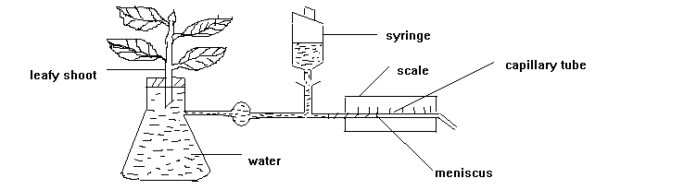

(a).What does it measure;
(i).directly. (1$\frac{1}{2}$marks)
………………………………………………………………………………………………………
(ii).indirectly. (1$\frac{1}{2}$marks)
………………………………………………………………………………………………………
(b).What purpose is served by the syringe? (02 marks)
………………………………………………………………………………………………………………………………………………………………………………………………………………………………………………………………………………………………………………………
The table given below shows time of movement of water in the capillary tube over a distance of 10cm under different conditions;
Normal room condition…………………………64 seconds
Air from a fan blown onto the leaves…………...50 seconds
Two 150 watt bulbs shone onto the leaves……….20 seconds
(c). Name the factor (s) which is being investigated with the shoot.
(i).fan. (01 mark)
………………………………………………………………………………………………………
(ii). two 150 watt bulbs one on each side of the shoot. (01 mark)
………………………………………………………………………………………………………
(d).Why is there variation in time taken for water to move a long 10cm in the capillary tube under the three conditions above?
(i). Normal room condition. (01 mark)
………………………………………………………………………………………………………………………………………………………………………………………………………………………………………………………………………………………………………………………
(ii). Air from the fan blown onto the leaves. (01 mark)
………………………………………………………………………………………………………………………………………………………………………………………………………………………………………………………………………………………………………………………
(iii). Two 150 watt bulbs one each side of the shoot. (01 mark)
………………………………………………………………………………………………………………………………………………………………………………………………………………………………………………………………………………………………………………………
- Figure below shows part of a section of a human eye.
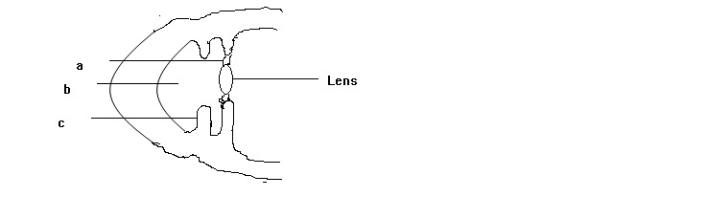

(a).Name the parts marked; (01 mark)
b……………………………………………c………………………………………………………
(b).What is the function of the part marked b?$(\frac{ 1}{2}$ mark)
………………………………………………………………………………………………………………………………………………………………………………………………………………
(c ).State the changes that take place on the following structures when the eye is used to see;
(i).A distance object
change on “a”. (02 marks)
………………………………………………………………………………………………………………………………………………………………………………………………………………
Change on lens. (02 marks)
………………………………………………………………………………………………………………………………………………………………………………………………………………
(ii).In a deem light.
Change on lens. (1$\frac{1}{2}$ marks)
………………………………………………………………………………………………………………………………………………………………………………………………………………
Change on “c” (1$\frac{1}{2}$ marks)
………………………………………………………………………………………………………………………………………………………………………………………………………………
(d).
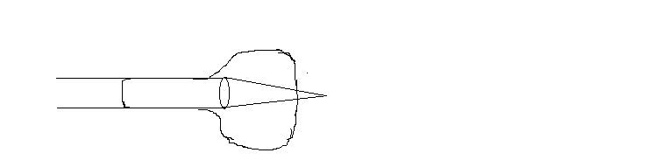

(i).Name the eye defect represented in the figure above. ($\frac{1}{2}$ mark)
…………………………………………………………………………………………………
(ii).What is the cause of this defect? ($\frac{1}{2}$ mark)
…………………………………………………………………………………………………
(iii).Name the type of lens used to correct this defect. ($\frac{1}{2}$ mark)
…………………………………………………………………………………………………

SECTION C: (30 MARKS)

Answers are to be written in the booklets provided. Additional questions answered will not be marked.
34. (a). What is homeosis? (02marks)
(b).Explain the role of the kidney in osmoregulatuion in man. (13 marks)

35.(a).Compare the process of inhalation and exhalation in man. (03 marks)
(b).How does oxygen in the alveoli move into cells in the blood? (06marks)
(c).List the properties of an efficient respiratory surface. (06marks)

36.(a).Define the following terms;
(i). Population size. (02 marks)
(ii).Community. (02 marks)
(b).List down four factors that limit population size of fish of organisms in their natural habitat. (04 marks)
(c).Describe how you would estimate population of fish in a water pond. (07marks)

37.(a).Draw and label a transverse section of a stem of herbaceous dicotyledonous plant.
(05 marks)
(b).State the functions of five of parts that can be identified in the section. (05 marks)
(c).Describe how stems are modified to perform other functions other than conducting materials within the plant. (05 marks)

END

