NAME INDEX NUMBER
SCHOOL DATE

CLASSIFICATION
1. 1995 Q3 P1
State two ways in which some fungi are harmful to man (2 marks)

………………………………………………………………………………………………………………………………………………………………………………………………
2. 1995 Q6 P1
The diagram below represents a fern
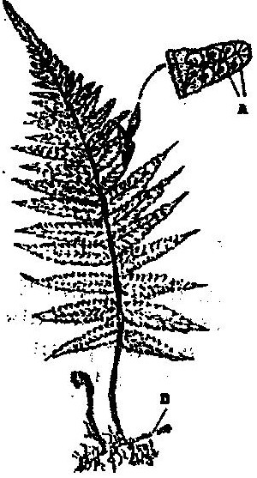

Name
  - The parts labelled A and B ( 2 marks)

…………………………………………………………………………………………………………………………………………………………………………
  - The division to which the plant belongs ( 1 mark)

…………………………………………………………………………………….
3. 1996 Q5 P1
An organ is with an exoskeleton, segmented body, two pairs of legs per segment, a
pair of eyes and a pair short antennae belongs to the phylum (1 mark)

…………………………………………………………………………………….
4. 1996 Q6 P1
What are two organisms considered to belong to the same species (2 marks)

……………………………………………………………………………………………………………………………………………………………………………………
5. 1997 Q2 P1
A student caught an animal which had the following characteristics:
Body divide into two parts
Simple eyes
Eight legs
The animal belongs to the class?

…………………………………………………………………………………………..

6. 1998 Q16 P1
A student placed a drop of pond water in a cavity slide and observed it under the
microscope. The student observed many fast moving organisms, one of which is
represented in the diagram below.
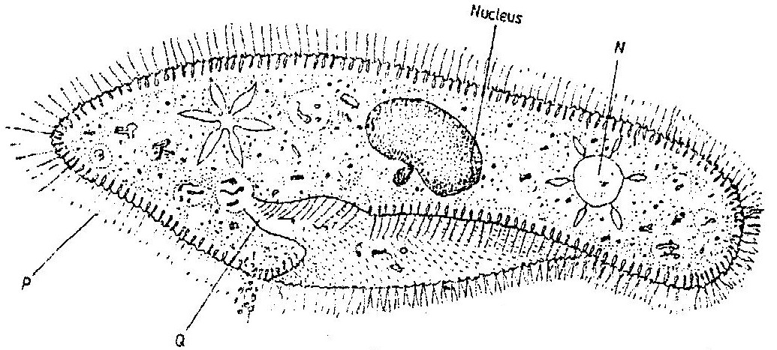

- (i) Name the phylum to which the organism belongs

…………………………………………………………………………………………
(ii) Give a reason for your answer in (a) (i) above

…………………………………………………………………………………….

- Name the structures labelled N, P and Q.

N………………………………………………………………………………………...
P…………………………………………………………………………………………
Q………………………………………………………………………………………...

- State two observable features that enable the organism to move fast.

…………………………………………………………………………………………………………………………………………………………………………

7. 1999 Q10 P1
Below is a list of organisms, which belong to classes Insecta, Myriapoda and Arachnida: Tick, centipede, praying mantis, tsetse fly, millipede and spider. Place the organisms in their respective classes in the table below.
Give reason in each case.

Classes | Organisms | Reasons
Insecta
Myriapoda
Arachnida

8. 2000 Q3 P1
State two characteristic features of members of phylum Bryophyta.

…………………………………………………………………………………………………………………………………………………………………………
9. 2000 Q4 P1
State two ways in which some fungi are beneficial to humans.

………………………………………………………………………………………………….…………………………………………………………………………………
10. 2001 Q1 P1
Other than having many features in common, state the other characteristics of a
Species

……………………………………………………………………………………………………………………………………………………………………………………
11. 2002 Q1 P1
Beside the abdomen, name the other body part of members of Arachnida.

…………………………………………………………………………………………

12. 2003 Q2 P1
Name the phylum whose members possess notochord

………………………………………………………………………………………….

13. 2004 Q8 P1
Name the class in the phylum Arthropoda which has the largest number of individuals? (1 mark)

…………………………………………………………………………………………

14. 2005 Q5 P1
To which class does an animal with two body parts and four pairs of legs belong? (1 mark)
………………………………………………………………………………………
15. 2006 Q6 P1
a) State three characteristics of Monera that are not found in other kingdoms. (3 marks)

………………………………………………………………………………………………………………………………………………………………………………………………………………………………………………………………………………
b) Name the class to which a termite belongs (1 mark)

…………………………………………………………………………………………
16. 2007 Q1 P1
(a) What is meant by the term binomial nomenclature (1 mark)

…………………………………………………………………………………………
(b) Give two reasons why classification is important (2 marks)

……………………………………………………………………………………………………………………………………………………………………………………
17. 2008 Q25 P1
Giving a reason in each case, name the class to which each of the following organisms belong (4 marks)
Bean plant…………………………………………………………………………. Reason……………………………………………………………………………..
Bat………………………………………………………………………………… Reason…………………………………………………………………………….
18. 2009 Q1 P1
(a) Name the external feature which is common in birds, fish and reptiles (1 mark)

……………………………………………………………………………………..

(b) State two characteristics of fungi (2 marks)
………………………………………………………………………………………………………………………………………………………………………………
19. 2010 Q8 P1
State three external differences between chilopoda and diplopoda. (3 marks)

………………………………………………………………………………………………………………………………………………………………………………………………………………………………………………………………………………
20. 2011 Q3 P1
Give three reasons for classifying organisms. (2 marks)

……………………………………………………………………………………..
………………………………………………………………………………………………………………………………………………………………………………………………………………………………………………………………………………
21. 2011 Q4 P1
State one use for each of the following apparatus in the study of living organisms.
a) Pooter (1 mark)

……………………………………………………………………………………….
b) Pitfall traps. (1 mark)

………………………………………………………………………………………..
22. 2011 Q8 P1
State three characteristics of the class crustacea. (3 marks)

………………………………………………………………………………………………………………………………………………………………………………………………………………………………………………………………………………
23. 2012 Q2 P1
The diagram below represents a certain organism collected by a student at the sea shore
- Name the class to which the organism belongs (1mark)

……………………………………………………………………………………………..
- Give three reasons for your answer in (a) above (3 marks)

………………………………………………………………………………………………………………………………………………………………………………………………………………………………………………………………………………………………………

