Name………………………………………………………………….Stream……………………

HOUSE…………………………………………..
840/1
COMPUTER STUDIES
Paper 1
27th April 2016
1Hour 25min

KIIRA COLLEGE BUTIKI
Senior Two End of Term one Examination 2016
COMPUTER STUDIES
Paper 1
SENIOR TWO
1 Hour 25Minutes

INSTRUCTIONS TO CANDIDATES:
Write your name and stream in the spaces above.

This paper consists of two sections: A and B

Section A contains 20 compulsory objective-type questions. Write your best alternative: A, B, C or D, in the table provided below.

Section B contains compulsory structured questions. Answers must be written in the spaces provided.

TABLE FOR SECTION A ANSWERS
 |  | 5. |  | 9. |  | 13. |  | 17.
 |  | 6. |  | 10. |  | 14. |  | 18.
 |  | 7. |  | 11. |  | 15. |  | 19.
 |  | 8. |  | 12. |  | 16. |  | 20.

SECTION A
- A computer is said to be a stupid machine mainly because it
- Works without getting tired
- Thinks all the time
- Does what is instructed
- Spoils man’s sight
- One of the following is a disadvantage of an A.T.M card
- Ability to withdraw money at any time
- Codes can easily be forged
- Withdrawing money anywhere in Uganda
- Tracking one who used it
- Some students want to draw a sketch of Uganda on a computer which of the following devices would you recommend to them
- Touch pad
- Mouse
- Joystick
- Stylus pen and Digitizing tablet
- The device used in data communication network to perform the conversion between analogue and digital signals is called a ………………..
- Front end processor
- Modem
- Decoder
- Multiplexer
- Vacuum tubes are associated to…………….computers
- 2nd generation
- 5th generation
- 1st generation
- 3rd generation
- The terms used to describe the acts of computers to mimic the action of human beings is called.
- Diligence
- Versatility
- Reliability
- Artificial intelligence
- The speed of computer is measured in
- MIPS
- Megahertz
- Gigabyte
- Terabyte
- Charles Babbage is the father of modern computing. This is attributed to….
- Inventing an analytical engine
- Inventing a mechanical calculator
- Inventing a slide rule
- None of the above

- One of the main advantages of hardcopy over soft copy is that
A. A soft copy is not attacked by computer virus
B. A hard copy can be photocopied unlike softcopy
C. A hard copy exists physically and in a more permanent form than soft copy
D. A hard copy is hard while soft copy is soft
10. The term used to describe programs and instructions written for computers is
A. hard ware
B. analog
C. software
D. digital
11. The device that stores programs and data when working with a computer and is lost
When power is switched off
A. CPU.
B. RAM.
C. UPS.
D. ROM
12. …………….is the one word term used to refer to the setup procedure for putting new
Programs into the computer
- Copying
- Encrypting
- Installation
- Compressing
13. An example of an analog computer may be
A. Pocket calculator
B. Minicomputer
C. House thermostat
D. Personal computer
14. Viruses are activated in all of the following ways except by:
A. Deleting e-mail without opening or executing any attachment
B. Opening an infected file
C. Booting a computer with an infected floppy disk in the disk drives
D. Running an infected program.
15. If the computer does not show any sign when pressing the power button, it is quite possible that
A. the operating system is not installed.
B. there are some loose or disconnected plugs.
C. the computer is not connected to a UPS.
D. a virus has deleted some of the files.
16. A computer program that converts an entire program into machine language is called a/an
A.Interpreter.
B.Simulator.
C.Compiler.
D.Commander.

17. Backing up of computer data is the process of:
A. Reversing the files stored on the hard drive.
B. Putting your computer in the back of the room.
C. Raising up the back part of the computer’s system unit.
D. Storing an extra copy on an external storage device
18. Which of the following is a basic unit of measuring computer memory?
A. How heavy the hard disk is in grams (g)
B. Millions of instructions per second.
C. Byte.
D. How fast the computer is in meters (m).
19. The term used to refer to the ability of computers to perform the same task for long
Without getting tired
A. Spontaneous.
B. Versatile.
C. Diligent.
D. Accurate.
20. Main frame computers have many users connected via
A. Dumb Terminals
B. Intergrated computer system
C. Work stations
D. Connected Computer Monitor

SECTION B
21. Mention one similarity and one difference between the following:
(i) RAM and ROM

Similarity | Difference
………………………………………………  ……………………………………………… | ………………………………………………  ………………………………………………
(02 Marks)
(ii) A printer and Speakers
Similarity | Difference
………………………………………………  ……………………………………………… | ………………………………………………  ………………………………………………
(02 Marks)
(iii) A Mouse and a Keyboard
Similarity | Difference (02 Marks)
…………………………………………………  ………………………………………………… | …………………………………………………  …………………………………………………

22. Flat screen monitors are also referred to as LCD monitors whereas the convex-screen monitors or those monitors that have a shape similar to that of a TV set are referred to as CRT monitors:
a) Write the following abbreviations in full. (2 Marks)

LCD: …………………….………………….…………………………………………………

CRT: …………………….………………….…………………………………………………

b) Distinguish between an input device and an output device (2 Mark)
…………………………………………………………………………………………………………………………………………………………………………………………………………………………………………………………………………………………………………………………………………………………………………………………………………………………………………………………………………………………………………………………………….
c) Give four examples of each of the above (2marks)
Input device
……………………………………………………………………………………………………………………………………………………………………………………………………………………………………………………………………………………………………………………………………………………………………………………………………………………………………………………………………………………………………………………………………..
Out devices (2marks)
……………………………………………………………………………………………………………………………………………………………………………………………………………………………………………………………………………………………………………………………………………………………………………………………………………………………………………………………………………………………………………………………………..
23. A system Unit is one of the major hardware components of a computer system: List any four hardware components found in a system unit. (4marks)
(i) ……………………………………………………………………………………
(ii) ……………………………………………………………………………………
(iii) …………………………………………………………………………………..
(iv) ……………………………………………………………………………………
(b) Briefly explain the function of any three components you have given in (a) above. (6marks)
(i) ……………………………………………………………………………………
(ii) ……………………………………………………………………………………
(iii) …………………………………………………………………………………..
(iv) ……………………………………………………………………………………
24. Name the output devices A, B, C and D using the words from the list. [4 marks]
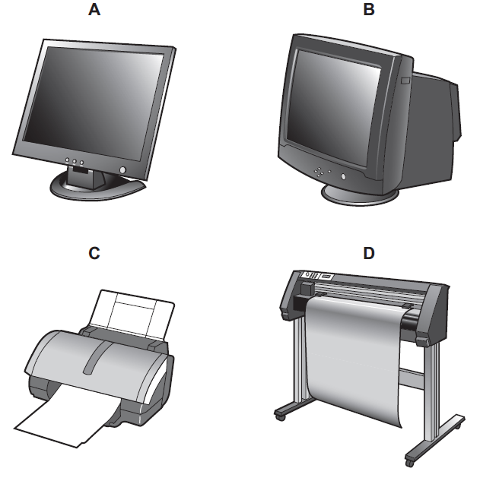

CRT monitor Dot matrix printer Graph plotter Inkjet printer
Joystick Multimedia projector TFT monitor Tracker ball
A …………………………… B ………………………..
C ……………………………. D …………………….….

25. A computer system is a composition of several components list any four components that make up a computer system (4marks)
(i) ……………………………………………………………………………………………….
(ii)………………………………………………………………………………………………..
(iii)……………………………………………………………………………………………….
(iv)………………………………………………………………………………………………
(b) Briefly explain the function of any three components given in (a) above (3marks)
(i)……………………………………………………………………………………………….
(ii)……………………………………………………………………………………………..
(iii)……………………………………………………………………………………………

END

