ACTION OF WIND AND WATER IN ARID AREAS
Introduction
- Arid areas are lands that receive insufficient rainfall, usually less than 250mm per annum. They have little or lack vegetation covers due to moisture deficiency
- Aridity is common in desert areas
- Deserts are named according to the nature of their surfaces into
(a) Sandy deserts: -covered by large deposits of sand; known as Erg in the Sahara
(b) Stony deserts: -are covered by angular pebbles, gravels and boulders; they are known as Reg in Algeria and Serir in Libya & Egypt.
(c) Rocky deserts: -are dominated by bare rock surfaces and are known as Hamada in the Sahara desert.

- Deserts can also be classified according to their latitudinal location and the temperatures they experience into
(a) Continental deserts
(b) West coast deserts
(c) Hot deserts
(d) Cold deserts
(a) Continental deserts
- These are located in the interior of continents or on the leeward sides of high mountains
- They can be hot or cold depending on their latitudinal location i.e. those on the tropics are hot e.g. Sahara (Africa) and Arabian while those in temperate/polar areas are cold e.g. Gobi (Central Asia), Greenland and Patagonian (South America)

(b) West Coast Deserts
- These are found on the western coasts of continents
- They are mainly characterized by offshore trade winds and cold ocean currents
- Examples include Atacama (South America), Namib (Africa) and Californian (USA)

Action of Wind in Arid Areas
- Wind action is more effective in the hot deserts e.g. Sahara compared to the cold deserts. This is due to the following factors
- Presence of loose and unconsolidated dry masses of mud, sand and gravel that can be easily transported, eroded and deposited by wind
- Occurrence of strong and tropical winds/storms within the hot deserts
- Absence of vegetation cover

- Action of wind in arid areas involves erosion, transportation and deposition

Wind Erosion
- Wind erodes the desert surfaces through
(a) Abrasion
(b) Deflation
(c) Attrition

(a) Abrasion
- Weathered materials that are loose on the desert surface are picked by the wind and used to grind, scrape and polish the desert surface they come in contact with.
- The weathered materials knock against rock surface thereby polishing them.

(b) Deflation
- This involves the wind removing dry and unconsolidated material of dust and sand from the bare desert surface through rolling them on the ground and lifting them up in the air.
(C) Attrition
- This is the process where the sand grains are transported by wind collide against one another and wear each other down.

Resultant features of wind erosion in arid areas
Rock pedestals
- This is an irregular pillar of rock formed through wind abrasion in deserts/arid areas
- It forms when a mass of rock with alternating layer of resistant and less resistant (heterogeneous) rock lie horizontally in the path of wind ladened with weathered material
- The less resistant layers are heavily eroded by wind abrasion as the wind borne materials knock on them compared to the resistant rock layers that undergo little erosion
- This result in the formation of an irregular rock mass with protruding layers of resistant rocks alternating with layers of less resistant rocks called a rock pedestal or gour.

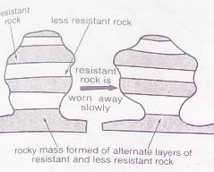

Mushroom blocks
- This is a massive rock with a broad smoothed and rounded top and a very narrow bottom.
- Forms from a homogenous rock of uniform hardness and resistance lie vertically in the path of wind ladened with weathered materials.
- Wind abrasion is more intensive at the base of the vertically laid rock mass.
- The top part of the rock undergoes slow, gradual polishing and smoothing (fewer airborne materials at this level).
- This differential abrasion results into a structure with a broad top but a very narrow base called a mushroom block
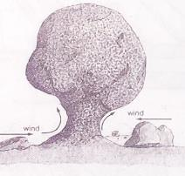

Zeugens
- A ridge and furrow landscape which is formed from a massive rock with alternating layers of resistant and less resistant rocks lying horizontally to one another and in the path of prevailing wind ladened with weathered materials.
- The top layer of hard rock is jointed/has cracks.

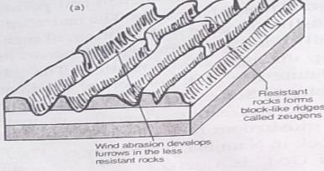
- Physical weathering assists in widening the joints/cracks on the upper layers of rock and causing the rock to disintegrate along the cracks/joints
- Prevailing winds then remove and carry the loose unconsolidated materials through deflation
- Abrasion continues to act on the lines of weakness, enlarging and deepening the furrows
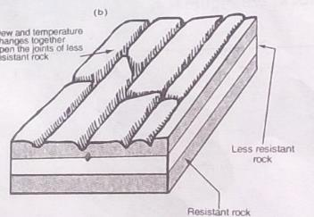

- The less resistant rocks are eroded further leaving behind a hard standing tabular mass/ridge on either sides of the furrow called a zeugen
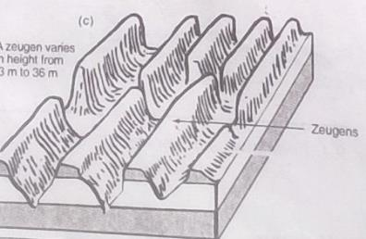
Yardangs
- These are elongated rock ridges of vertically laid rocks.
- They are formed when heterogeneous rocks lie vertically and to the path of prevailing wind ladened with weathered material

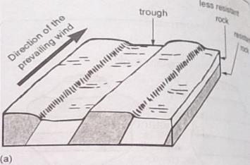

- Wind abrasion acts directly on the less resistant layers, removing and transporting the weathered materials by deflation.
- This results in the formation of large furrows in between the resistant rocks

- Continued abrasion in the furrows deepens them further leading to formation of high ridges (about 6m) called yardangs

Ventifacts
- These are boulders, stones or pebbles that are polished and sculptured through abrasion by windblown sand in the desert

Depression hollows
- Physical weathering and abrasion in deserts result in large scale production of unconsolidated materials of dust and sand particles.
- The loose materials are then scooped/removed by wind through deflation forming a shallow depression
- The basin is widened and deepened through continued wind abrasion and deflation forming a depression called deflation hollow.
- Wind eddies remove unconsolidated materials from the surface through deflation.
- Wind deflation, weathering and abrasion further enlarge and deepen the depression.
- The surface of the depression is lowered until it reaches the water bearing rocks/aquifer/water table.
- Water oozes out of the ground and collects in the depression to form Oasis.
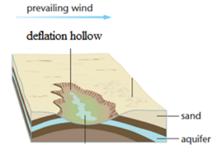

Wind Transportation
- This depends on the following factors: -
- Strength and speed of wind – strong winds transport more and heavier materials compared to a weak wind.
- Obstacles – Intervening obstacles e.g. rock outcrops/desert vegetation on the path of a prevailing wind reduces its speed causing the wind to drop some of its load.
- Nature of load – Light particles such as fine dust are easily picked up by wind and blown to far distances.
- Vegetation cover/water mass – areas where the surface is covered by vegetation/ a water mass, the sand particles are bound together. This reduces the ability of wind to pick and transport these particles.
- Periodic changes in weather – e.g. sudden short rains may interfere with transportation

- Wind transports its load through suspension, saltation and surface creep

(a) Suspension: - this involves the transportation of very fine particles e.g. dust that are held in the wind above the ground. They are lifted high/clear of the ground by air currents and carried to greater distances e.g. dust storms.
(b) Saltation: -this involves the movement of medium sized sand particles are lifted from the ground by eddy action then dropped on the ground by gravity. They are moved in a series of short hops or jumps along the desert surface
(c) Surface Creep: -is the movement of heavy unconsolidated large materials/small stones/pebbles are dragged along the ground by wind current

Wind Deposition
- When the speed/strength of wind is reduced, the rate of transportation is reduced, the wind therefore deposits its load
- The factors that influence the rate of wind deposition in arid areas include
- Presence of intervening obstacles – checks the speed of wind forcing it to drop some load.
- Nature of the desert surface – moist grounds impedes the transportation of materials close to the ground due to friction. The materials are dropped.
- Strength and direction of wind – When the wind slackens, it begins to drop some of its load. Similarly when winds blowing from different directions meet, collision occurs resulting in some of the load being dropped.
- Amount of load carried – Materials carried by overloaded wind constantly collide among themselves causing some of them to be dropped.
- Variation in weather conditions – Moist conditions/showers lead to deposition of the load suspended in the air.

Resultant features of wind deposition
(a) Sand dunes
- This is a low ridge or hills of sand that have been accumulated and sorted by wind
- They mainly occur in the interior of deserts and along low lying coasts
- They are further classified into
- Barchans.
- It develops when sand particles accumulate around an obstacle that lies in the path of wind.
- The obstacle causes the wind to deposit some of the sand by trapping it on the windward side to form a low hill/ridge.
- Continued deposition makes the mound of sand to grow bigger and blow over to the leeward side.
- Eddy currents on the leeward slopes lead to formation of a shallow depression and a concave slope.
- Continuous accumulation and forward movement of sand on the windward slope and the effect of wind eddies on the leeward slopes results into the formation of a crescent shaped dune called a barchan
- Barchans may be found as individual or as a group of hills of sand
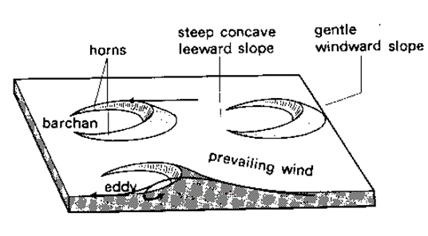

(ii) Seif Dunes
- These are sand dunes that area deposited parallel to each other by troughs. They are parallel to the path of prevailing wind
- As the prevailing winds blow between the dunes, it creates eddies that move sand towards the sides
- This lead to accumulation of sand on the sides of the dune. The dunes are lengthened/elongated by the prevailing winds to form long and narrow steep ridges called seif dunes.
More illustration
- These are elements formed in desert areas which are long and parallel to reach other separated by roughs.
- They are formed in areas where there are prevailing winds which are interrupted by strong cross-winds.
- The cross-winds divide the sand side by side thus heading them into long parallel done which are separated from each other by trough.
- The ridges of sand are then known as safe.

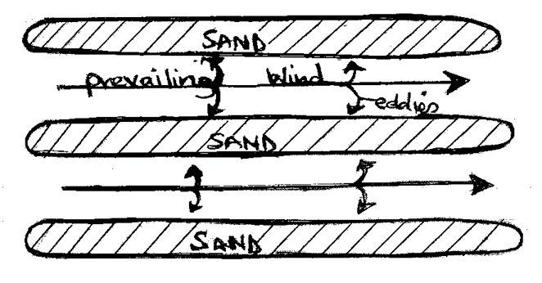

(iii) Transverse and wake dunes
- These are wave-like shaped sand dunes that are separated from one another by a flat bottomed trough.
- They are formed by light to moderate winds that blow from one direction.
- This leads to an accumulation of sand in a series of transverse ridges/dunes.
- If the sand dune forms on the leeward side of the larger dune trailing away in the direction of wind to form a wake dune

(b) Loess
- These are fine unconsolidated light colored dust that is blown by wind further away from their places of origin
- They form when desert sand and dust storms pick up loose dust materials, transport and deposit them in the neighboring wetter region
- Gradually they accumulate to form fertile soils with greater thickness called loess

(c) Draas
- These are similar to seif and transverse dunes only that they are higher compared to seif and transverse dunes (about 200m)

Action of water in arid areas
This produces the following features
(a) Wadis
- This is a deep sided dry valley in arid lands formed when flash floods occur on steep and undulating landscape
- They are formed by strong surface run offs/flash floods that cut small rills that later develop into gullies
- Continued erosion by the streams enlarge the gullies rapidly to produce steep sided valleys called wadis

(b) Bajadas/Bahadas
- This is a continuous gentle sloping fringe of angular scree, gravel and coarse sand around the margins of an inland basin in a desert landscape. They can also form along the base of a mountain range in semi arid areas
- They form when a series of alluvial fans unite/join/coalesce together at the point where the stream/river leaves a constricted/narrow valley

(c) Inselberg
- This is a steep isolated round topped mass of rock standing in an extensive flat area in arid areas
- It results from wind erosion and sheet wash that removes the weathered material to leave a mass resistant rock standing on its own to form an inselberg

(d) Mesas and buttes
- Mesas are extensive flat topped residual tablelands that are capped with resistant rock layers in ASALs
- Buttes are also flat topped hills capped with resistant rock layers which remain after denudation of a plateau in ASALs. They are less extensive compared to mesas
- Mesas and buttes are formed within plateaus comprising of resistant sedimentary rocks that are not easily eroded by sheet floods
- The less resistant surface layers of rocks undergo physical weathering and later removed by sheet floods until a horizontal layer of rock that protects the layers beneath from erosion is exposed/reached
- This results in residual hills with tabular shapes called Mesas
- Continued erosion reduces the mesas to buttes

(e) Pediment
- This is a gently sloping rock platform with bare or thin layer of deposited loose materials/debris stretching away from the foot of a ridge or mountain in ASALs
- They are formed through the following processes: -
- When a slope retreats i.e. when progressive back wearing of soil profile occur in the course of weathering and erosion, the steep mountain/hill front then retreats forming a low angle slope known as pediment

- Lateral planation by streams, sheet floods, rills and downwash resulting from rain storms

(f) Pediplain/Pediplane
- These are extensive low and sloping lands formed in ASALs when large scale adjacent pediments join up due to widespread surface water erosion in arid areas
- When pediments surround an original highland, the slopes at the edges of the highland continue to retreat all round forming extensive pediments
- Continued water erosion reduces the highlands to residual hills that are eventually eroded to form a continuous plane with many concave surface called pediplanes/pediplain

(g) Playas
- This is a basin of inland drainage that contains a shallow fluctuating lake that is usually saline
- They originate from wind deflation to form depressions in ASALs
- Water from torrential downpours in ASALs flow into the depression to form small fluctuating lakes called playas

(h) Salinas
- When playas dry up due to intense evaporation from high temperatures in arid areas, it leaves a hard salty crystal surface called salina/salar

(i) Dry river valleys
- During the short and wet season in arid areas, sheet and flash floods will collect in river valleys to form fast flowing streams.
- During the dry season, such river beds remain dry to form dry river valleys in ASALs
Significance of the resultant features of action of wind and water in arid areas
- Sand harvested from desert surfaces is used in building and construction
- Water from oases and pans provide water for irrigation and domestic uses
- Desert landscape are ideal for military training and testing of weapons as well as experimental grounds for spacecrafts this is because they are sparsely settled
- The unique desert features e.g. yardangs, rock pedestal attract tourists who in turn bring foreign exchange
- Desert surfaces can be used for recreation such as the Dakar motor rally
- Loess/alluvial deposits have fertile soils suitable for agriculture
- Sand dunes are unstable and hinder establishment of infrastructure
- Desert soil is infertile thus hinder agriculture

