553/1 S.3
BIOLOGY (Theory)
Paper 1
2 ¹/₂ hours

UGANDA MARYR’S S.S.S SEMBABULE
BOT 1 EXAMINATIONS, JULY 2020
553/1 BIOLOGY (Theory)
Paper 1
2 hours 30 minutes

INSTRUCTIONS TO CANDIDATES:
This paper consists of sections A, B, and C.
Answer all questions in Sections A, B and C.
Write the answers to Section A in the boxes provided, answers to Section B in the spaces provided, and answers to Section C in the answer booklets provided.

FOR EXAMINERS’ USE ONLY
Section |  | Marks | Examiner’s Signature & No.
A
B | No. 31
B | No. 32
B | No. 33
C | No.
C | No.
TOTAL

SECTION A
- The products of photosynthesis are
- Glucose and carbon dioxide B. Oxygen and starch
C. Oxygen and Glucose D. Carbon dioxide and water
- Which of the following in NOT an arthropod?
- Millipede B. Earthworm C. Beetle D. Cricket
- Carnivorous plants trap, digest and absorb insects’ nutrients. Which one of the following nutrients would they obtain in abundance from this process?
- Phosphate for nuclear formation B. Magnesium for chlorophyll synthesis
C. Carbohydrate for energy supply D. Nitrogen for protein synthesis
- Intestinal juice works best in pH conditions which are
- acidic B. Neutral C. alkaline D. variable
- Which of the following vitamins help to prevent rickets?
- Vitamin A B. Vitamin D C. Vitamin B₂ D. Vitamin C
- Mammalian teeth may differ widely in size and shape according to the animal’s
- feeding habits B. shape C. weight D. size
- Which one of the following represents the correct biochemical conversion catalysed by salivary amylase enzyme?
- Starch to glucose B. Starch to maltose
C. Lactose to glucose D. Maltose to glucose
- In swallowing, the epiglottis has the following functions:
- Prevents air from going into the trachea
- Prevents food from going into the trachea
- Prevents food from entering the nasal passage
- Causes the stomach sphincter muscle to open.
- A dry fruit which splits open along both sutures is a
- Follicle B. Capsule C. Achene D. Legume
- Which of the following is NOT a function of the liver?
- Storage of vitamins C. Storage of proteins
- Manufacture of plasma proteins D. Formation of Bile.
- Which of the following is a modified root?
- Irish Potato tuber B. Cassava tuber C. Rhizome D. Corm
- The deficiency disease caused by lack of protein in the diet is
- Marasmus B. Kwashiorkor C. Beriberi D. Pellagra
- In the leaf, most of the food is made in the
- spongy mesophyll B. palisade mesophyll C. lower epidermis D. upper epidermis
- Carnassials are characteristics of
- Herbivores B. Carnivores C. Omnivores D. Saprophytes
- Which of the following elements is present in ALL proteins?
- Sulphur B. Phosphorus C. Magnesium D. Nitrogen
- External digestion of food takes place in
- Amoeba B. Butter flies C. Rats D. Rhizopus
- Which of the following environmental factors least affects the rate of photosynthesis?
- Humidity B. High intensity C. Carbon dioxide D. Temperature
- Which of the following food substance is NOT a reducing sugar?
- Maltose B. Fructose C. Sucrose D. Galactose
- The concentration of some mineral salts may be higher in the root cell sap than in the soil. Their uptake is thus possible by
- Osmosis B. Active transport C. Diffusion D. Mass flow
- Which of the following is NOT a respiratory surface?
- Alveolus B. Spiracle C. Tracheole D. Filament
- Which of the following is NOT a kingdom?
- Monera B. Protozoa C. Fungi D. Animalia
- Which of the following arteries carries deoxygenated blood?
- Renal artery B. Hepatic artery C. Carotid artery D. Pulmonary artery
- Amoeba obtains oxygen from the surrounding water through its membrane by a process called
- gaseous exchange B. active transport C. osmosis D. diffusion
- In a stem, the tissue responsible for the movement of manufactured food from leaves is the
- Cortex B. Cambium C. Xylem D. Phloem
- The stalk that attaches a seed to the placenta in a fruit is called
- Pedicel B. Petiole C. Funicle D. Style
- The last segment of a cockroach bears a pair of structures called:
A: Prolegs B: true legs C: styles D: claspers
- Which one of the following is characteristic of monocotyledons?
A: leaf sheath B: net venation
C: prominent taproot D: cork layer.
- Which one of the following is characteristic of animal cells?
A: presence of cell walls B: cells consist entirely of cytoplasm
C: have regular shape D: have large centrally placed vacuoles.
- Which one of the following structural adaptations of leaves is important for light absorption during photosynthesis?
A: Dense network of veins
B: large numbers of stomata on leaf surface
C: large intercellular air spaces in the spongy layer
D: broad and flat shapes of leaves.
- What are the products of hydrolysis of maltose
A: Galactose and fructose B: Glucose and galactose
C: Glucose only D: Glucose and fructose

SECTION B
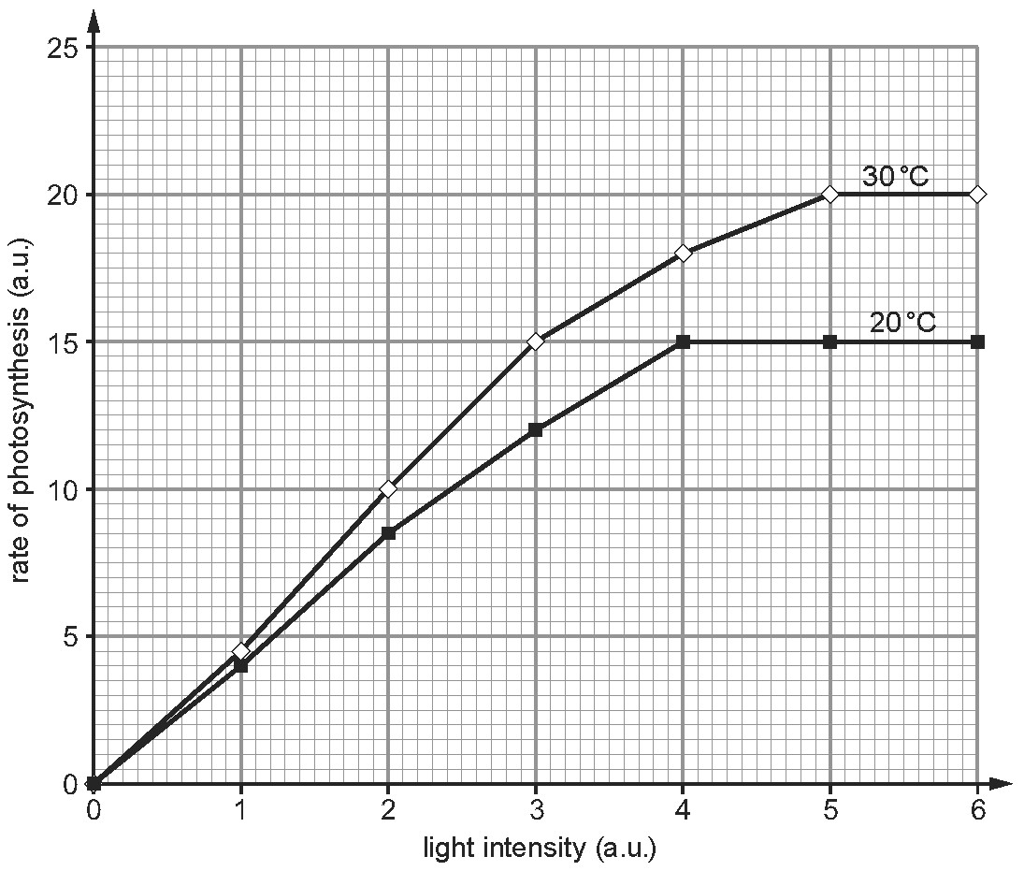
- The graph below shows the rate of photosynthesis at different light intensities and temperature.

      - Describe how light intensity affected the rate of photosynthesis at 20⁰C. (2 marks)
…………………………………………………………………………………………………………………………………………………………………………………………………………………………………………………………………………………………………………………………………………………………………………………………………………………….
      - Explain
          - the effect of light intensity on the rate of photosynthesis at 20⁰C. (2 marks)
…………………………………………………………………………………………………………………………………………………………………………………………………………………………………………………………………………………………………………………………………………………………………………………………………………………….
          - the difference in the rate of photosynthesis at 20⁰C and 30⁰C. (2 marks)
………………………………………………………………………………………………………………………………………………………………………………………………………………………………………………………………………………………………………………
        - Compare the rate of photosynthesis at 20⁰C and 30⁰C. (2 marks)
………………………………………………………………………………………………………………………………………………………………………………………………………………………………………………………………………………………………………………

        - Calculate the difference in the rate of photosynthesis between 20⁰C and 30⁰C at a light intensity of 3.5 a.u. (2 marks)
…………………………………………………………………………………………………………………………………………………………………………………………………………………………………………………………………………………………………………………………………………………………………………………………………………………….
        - Name two other environmental factor which can affect the rate of photosynthesis. (2 marks)
…………………………………………………………………………………………………………………………………………………………………………………………………………
        - The optimum PH for enzyme X is 2.00 and for enzyme Y is 9.00. Suggest the name of the enzymes X and Y, and name the parts of the alimentary canal where you would expect to find each enzyme, food substrate it acts on and the product. (4 marks)
 | Name of enzyme | Part of alimentary canal the enzyme is found. | Food substrate | Product
X
Y
        - State three enzymes contained in the pancreatic juice, the food substance acted on by each enzyme and the product formed in each case. (3 marks)
Enzyme | Food acted upon | Product formed
(i)
(ii)
(iii)
        - State the contents of bile secretion in the liver. (1 marks)
…………………………………………………………………………………………………………………………………………………………………………………………………………………………………………………………………………………………………………………………………………………………………………………………………………………….
        - Explain the digestive functions of the bile contents. (2 marks)
…………………………………………………………………………………………………………………………………………………………………………………………………………………………………………………………………………………………………………………………………………………………………………………………………………………….

- (a) what is pollination. (2 marks)
…………………………………………………………………………………………………………………………………………………………………………………………………………
(b). Describe the adaptation of a flower to carry out
(i) Self-pollination. (2 marks)
………………………………………………………………………………………………………………………………………………………………………………………………………………………………………………………………………………………………………………………………………………………………………………………………………………………………………………………………………………………………………………………………………………………………………………………………………………………………………………………………………………………………………………………………………………………………………………………………………………………………………………………………………………………………………………………
(ii) cross pollination. (3 marks)
………………………………………………………………………………………………………………………………………………………………………………………………………………………………………………………………………………………………………………………………………………………………………………………………………………………………………………………………………………………………………………………………………………………………………………………………………………………………………………………………………………………………………………………………………………………………………………………………………………………………………………………………………………………………………………………
      - In the space below, draw and label a grass flower. (3 marks)

- (a) Differentiate between diffusion and osmosis. (2 marks)
…………………………………………………………………………………………………………………………………………………………………………………………………………………………………………………………………………………………………………………………………………………………………………………………………………

(b) State five factors that affect the rate of diffusion. (5 marks)
………………………………………………………………………………………………………………………………………………………………………………………………………………………………………………………………………………………………………………………………………………………………………………………………………………………………………………………………………………………………………………………………………………………………………………………………………………
(d) State 3 significances of diffusion in living organisms. (3 marks)
…………………………………………………………………………………………………………………………………………………………………………………………………………………………………………………………………………………………………………………………………………………………………………………………………………

SECTION C
- (a) Draw and label the internal structure of a leaf (6 marks)
(b) What factors affect the rate of photosynthesis? (3 marks)
(c) How is a leaf adapted to carry out photosynthesis efficiently? (6 marks)
- (a) Draw a labelled diagram to show the internal structure of the villus. (5 marks)
(b) Describe how the villus is suited for its functions. (5 marks)
(c) Explain what happens to the end products of digestions when they leave the small intestines. (5 marks)
- (a) Describe the process through which a meal of posho and beans (starch, proteins and lipids) undergo from the time food is placed in the mouth up to when it is absorbed in the ileum. (7 marks)
(b) State the enzymes involved in the process above, food worked upon and products formed. (5marks)
(c) State three adaptations of herbivores to ensure they obtain maximum nutrients from plant materials. (3 marks)
- (a) State three characteristics of phylum Arthropoda. (3 marks)
(b) State the classes in the phylum above. (3 marks)
(c) (i) State two differences between a tick and a cock roach. (2 marks)
(ii) Differentiate between a male and female cock roach. (2 marks)
(iii) Describe the life cycle of a cock roach. (5 marks)
END

