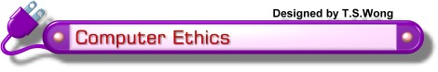
Computer ethics are the moral guidelines that govern the use of computers and information systems.
Frequently concerned areas of computer ethics are
Unauthorized access and use of computer systems
Software piracy
Information privacy
Information accuracy
Intellectual property rights
Codes of conduct
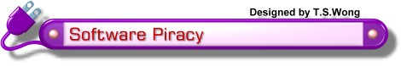
Software piracy refers to the unauthorized and illegal duplication of copyrighted software.
Software piracy is the most common form of software theft.
Purchasing a software only provides a consumer with a license agreement, or the right to use the software.
A single-user license agreement, or end-user license agreement is the most common type of license included with software packages purchased by individual users.
A software site license gives the buyer the right to install the software on multiple computers at a single site (e.g., a school computer laboratory).
A network site license allows network users to share a single copy of the software, which resides on the network server.

Risks of software piracy include
Increase the chance of spreading computer viruses.
No technical support for the software can be received.
Drive up the software cost for all legal users.
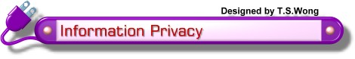
Information privacy refers to the right of individuals or organizations to deny or restrict the collection and use of information about them.
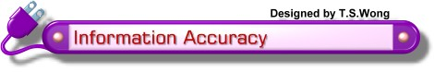
Information accuracy becomes an important issue when it is necessary to access information maintained by other people or companies, such as that on the Internet.
Inaccurate input can result in erroneous information and incorrect decisions made based on that information.
Never assume that information provided on the Web is always correct.
The Web site providing access to the information may not be the creator of the information.
Always evaluate the content provided on a Web page before using it.

Some people also concern with using computers to alter output, particularly graphical images (e.g., retouching a photograph).
They believe that even the slightest alteration could lead to deliberately misleading photographs.

INTELLECTUAL PROPERTY
Intellectual property (IP) refers to work created by inventors, authors, and artists.
Intellectual property rights are the rights to which creators are entitled for their work.
A copyright gives authors and artists exclusive rights to duplicate, publish, and sell their materials.
A common infringement of copyright is software piracy.
Copyright law usually gives the public fair use to copyrighted material (e.g., for educational purposes). However, this vague definition is always subject to widespread interpretation.

A trademark protects a company's logos and brand names.
The controversy with trademarks often relates to domain names, when some people or smaller companies purposely acquire a domain name that uses the exact trademarked name of their competition.

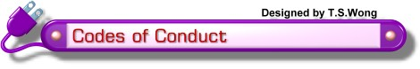
A code of conduct is a written guideline that helps determine whether a specific action is ethical or unethical.
Sample IT Codes of Conduct
- Computers may not be used to harm other people.
- Users may not interfere with other's computer work.
- Users may not meddle in other's computer files.
- Computers may not be used to steal.
- Computers may not be used to bear false witness.
- Users may not copy or use software illegally.
- Users may not use other's computer resources without authorization.
- Users may not use other's output.
- Users shall consider the social impact of programs and systems they design.
- Users should always use computers in a way that demonstrates consideration and respect for other people.
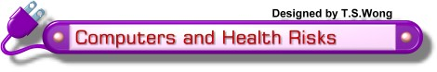
Prolonged computer usage can lead to health risks such as
Repetitive stress injury, which include tendonitis and carpal tunnel syndrome.
Eyestrain
Lower back pain
Muscle fatigue
Emotional fatigue
Precautions to help prevent such risks include
Pay attention to sitting posture.
Take a break to stand up, walk around, or stretch every 30 to 60 minutes.
Place the display device about an arm's length away from the eyes with the top of the screen at eye level or below.
Adjust the lighting in the room.
Ensure that the workplace is designed ergonomically.

