NAME: …………………………………………………………………………………………
STREAM: ………………………………………. SIGNATURE: ………………………………

535/1
Physics
Paper 1
March, 2020
1 hr 40 min


Uganda certificate of education
PHYSICS MONTHLY TESTS
MARCH, 2020

S.4 PHYSICS
Paper one
Time allowed: 1 Hour 40 Minutes

INSTRUCTIONS TO CANDIDATES:
Attempt all questions in this booklet
Answers to Section A must be placed in the answer table provided on page 2
Answers to Section B must be placed in the spaces provided.
All rough work must be done in pencil in this booklet at the last page.
Where necessary assume;
- Acceleration due to gravity, g = 10 ms⁻²
- Speed of sound in air = 320 ms⁻¹
- Density of mercury = $1.36 × {10}^{3} {kgm}^{-3}$
Turn over

PLEASE WRITE ANSWERS TO SECTION, A HERE:

1 |  |  | 9 |  |  | 17 |  |  | 25
2 |  |  | 10 |  |  | 18 |  |  | 26
3 |  |  | 11 |  |  | 19 |  |  | 27
4 |  |  | 12 |  |  | 20 |  |  | 28
5 |  |  | 13 |  |  | 21 |  |  | 29
6 |  |  | 14 |  |  | 22 |  |  | 30
7 |  |  | 15 |  |  | 23 |  |  | 31
8 |  |  | 16 |  |  | 24 |  |  | 32

SECTION A
- Materials which break as soon as their elastic limit is exceeded are said to be
- Ductile C. Plastic
- Brittle D. Weak

- A force of 2N causes an extension of 0.4 cm in a string. Find the force in newtons, required to cause a 0.3 cm extension in the same string.
- $\frac{2 × 0.3}{0.4}$ C. $\frac{2 × 0.4}{0.3}$
- $\frac{0.4 × 0.3}{2.0}$ D. $2.0 ×0.3 ×0.4$

- Which of the following properties of x-rays enables them to investigate a bone fracture?
- They ionize gases
- They darken a photographic plate
- They travel in a straight line
- They travel at the speed of light in a vacuum
- (i) and (ii) only C. (ii) and (iii) only
- (ii) and (iv) only D. (iii) and (iv) only

- The activity of a radioactive substance X changes from 30 counts per minute to of a 3.75 counts per minute in 2 hours. Calculate the half-life
- 30 minutes
- 40 minutes
- 37.5 minutes
- 2 minutes

- Which of the following energy changes occurs when a gun is cocked and a bullet fired from it?
- Kinetic energy to potential energy
- Chemical energy to kinetic energy
- Sound energy to kinetic energy
- Potential energy to kinetic energy

- The pressure exerted by a solid on a surface depends on the
- Mass of the solid and the area of contact
- Volume of the solid and the area of contact
- Weight of the solid and the time of contact
- Density of the solid and the time of contact

Turn Over

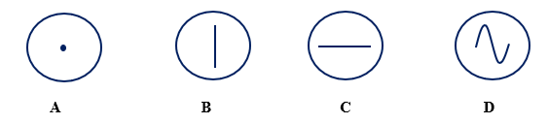
- Which of the following traces is obtained when a microphone is connected to a cathode ray oscilloscope and both x and y-plates are switched on?

- From Archimedes’ principle,
- the up thrust is equal to the weight of the body immersed
- the up thrust is equal to the weight of the displaces fluid
- the up thrust is equal to the mass of the fluid displaced
- the up thrust is equal the mass of the body immersed.

- An arrow of mass 30 g is struck from a bow using 6 J of energy. The maximum speed of the arrow is
- $\sqrt{\frac{6 ×30}{1000}}$ $ms^{-1}$ C. $\sqrt{\frac{2 ×6}{30 × 1000}}$ $ms^{-1}$
- $\sqrt{\frac{2 ×6 ×1000}{30}}$ $ms^{-1}$ D. $\sqrt{\frac{2 ×30 ×1000}{6}}$ $ms^{-1}$

- An oil drop of volume ${10}^{-4} {cm}^{3}$ spreads to form a patch of radius 2.5 cm. Estimate the thickness of the oil molecule
- $5.1 × {10}^{-6} m$ C. $5.1 × {10}^{-9} m$
- $1.91 × {10}^{-6} m$ D. $5.1 × {10}^{-9} cm$

- A small phone battery is charged for two hours till full using a charger rated ‘d.c 5.0V, 500mA', calculate the maximum charge the battery can hold.
- $5.0 × 2$ coulombs C. $5.0 ×2 ×500$ coulombs
- $\frac{500 × 2 ×3600}{1000}$ coulombs D. $\frac{5.0 × 2 × 3600}{1000}$ coulombs

- The figure below shows a wooden block of mass 3.5 kg lying on a rough horizontal table. If the coefficient of friction between the wood and the table is 0.14, calculate the force P required to move the block at an acceleration of 2 ${ms}^{-2}$
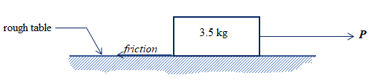
- $P=\left(3.5 ×2.0\right)- \left(3 ×10 ×0.14\right) N$
- $P=\left(3.5 ×2.0\right)+ \left(3 ×10 ×0.14\right) N$
- $P= \left(3 ×10 ×0.14\right) N$
- $P=\left(3.5 ×2.0\right) -0.14 N$

- In a kitchen, smoke from the concrete chimney will
- move out faster on a hot day because the chimney expands
- move out faster on a hot day because the temperature outside is high
- move out faster on a cold day because the temperature outside is low
- move out slower on a cold day because the chimney contracts

- Alpha – particles are more ionizing than beta-particles moving at the same speed because;
- they have less mass, hence they are more energetic
- they have more mass, hence they are less energetic
- they are positively charged, hence they are more energetic
- they have more mass, hence they are more energetic

- Which of the following statements is/are true about identical dry cells arranged in parallel?
- Effective e.m.f is the sum of all e.m.f’s
- Effective e.m.f is equal to the e.m.f of only one cell
- Effective internal resistance is the sum of all individual internal resistances
- Effective internal resistance is the quotient of one internal resistance and their number
- (i) only
- (ii) and (ii) only
- (ii) and (iv) only
- (i) and (iii) only

- Which of the following can be used to study wave forms?
- X-ray tube C. cathode ray oscilloscope
- Vacuum diodes D. Maltese cross tube

- Which of the following changes when a force is applied on a body?
- Mass
- Velocity
- Displacement
- (i) and(ii) only C. (ii) and(iii) only
- (i) and (iii) only D. (i), (ii) and (iii)

- A ball of 3 kg moves at 10ms⁻¹ towards a volley ball player. If the player hits the ball and it moves back with a velocity of 5 ms⁻¹, find the change in momentum.
- 3 (10 – 5) C. 3 (10 + 5)
- $\frac{3 × 5}{10}$ D. $\frac{3 × 10}{5}$

Turn Over
- The figure below shows a rectangular structure ABCD under the action of force P.
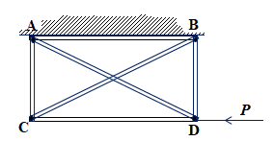
Which of the girders prevents the structure from shearing under P?
- AB C. BD
- CD D. AD

- Images formed by diverging mirrors are
- laterally inverted
- real
- diminished
- upside down

- The equation below shows changes that occur when a nuclide$S$ decays to $T$.
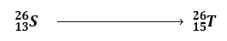

Which one of the following radiations are emitted?
- Two alpha particles
- One beta particle and one alpha particle
- Two beta particles
- One alpha particle

- A car radiator is painted black and filled with water because
- Black bodies are good absorbers and emitters of heat
- Water transfers heat by convection
- Water is a poor conductor of heat
- (i) and (ii) only C. (i) and (iii) only
- (iii) only D. (ii) only

- The reluctance of a body to remain in motion depends on its
- Mass
- Velocity
- Direction of motion
- (i) only C. (i) and (ii) only
- (i) , (ii) and (iii) D. (ii) and (iv) only
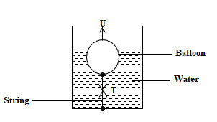
- The figure below shows a balloon inflated with air and tied to the bottom of a water tank using a string. If W is the weight of the balloon and T, the tension in the string, which of the following is correct?
- $U+ W = T$
- $W= U + T$
- $T = W + U$
- $T = U - W$

- The figure below shows the motion graph of a car. The car is at rest;
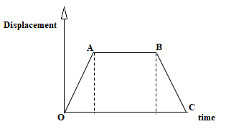
- between O and A
- between A and B
- between B and C
- between O and C

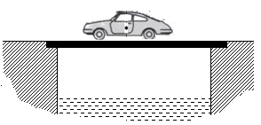
- The figure below shows a car moving over a bridge.

Which of following is true about the mechanical structural state the bridge layers?
 | Upper layer | Middle layer | Under layer
A | Under compression | Neutral | Under tension
B | Under tension | Neutral | Under compression
C | Under tension | Neutral | Under tension
D | Under compression | Under tension | Under compression

Turn Over
- Two insulators Y and Z are rubbed together. Z loses electrons to Y. Which of the following happens when Z is brought near the cap of a positively charged gold leaf electroscope?
- The leaf diverges further
- The leaf collapses
- The leaf collapses and then diverges
- The leaf remains stationary

- The efficiency of a simple machine can be increased by
- Increasing the effort
- Increasing the effort distance
- Increasing the load
- (i) and (ii) only
- (ii) and (iii) only
- (i) and (iii) only
- (iii) only

- An object of height 12 cm is placed 24 cm in front of a pinhole camera in which the screen is 8 cm from the hole. The image received is;
- Erect and 4 cm tall
- Inverted and 4 cm tall
- Erect and 16 cm tall
- Inverted and 12 cm tall

- A sphere of radius 15 cm floats with ½ of it submerged in water. Calculate the volume of water displaced.
- $\frac{3π × {15}^{3}}{2 × 4 }$ cm³ C. $\frac{4π × {15}^{3}}{ 2 × 3 }$ cm³
- $\frac{2 π × {15}^{3}}{3 × 4 }$ cm³ D. $\frac{4 × {15}^{3}}{2 × 3π }$ cm³

- The acceleration of a body depends on
- Force applied only
- Mass of the body only
- Force applied and mass of the body
- Mass of the body and time for which the force is applied

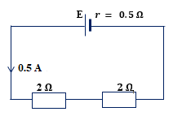
- The figure shows a cell of emf E, and internal resistance, 0.5 $Ω$ connected to two 2 $Ω$ resistors arranged as shown. Calculate the emf of the cell

- 2.25V C. 9.0 V
- 2.0 V D. 2.5 V

SECTION B
- (a) What is meant by the term up-thrust? (01 mark) ………………………………………………………………………………………………
………………………………………………………………………………………………
(b) A block of wood of volume $1.2 × {10}^{-3} m^{3 }$floats in water of density ${10}^{3} kgm^{-3 }$floats in water with $4/5$ of its volume submerged.
(i) Sketch a diagram to show the forces acting on the block in equilibrium (01 mark)

(ii) determine the density of the wood block. (02 marks)
………………………………………………………………………………………………………………………………………………………………………………………………………………………………………………………………………………………………………………………………………………………………………………………………………………………………………………………………………………………………………………………………………………………………………………………………………………………………
- (a) State two differences between x-rays and cathode rays (02 mark)
……………………………………………………………………………………………………………………………………………………………………………………………………………………………………………………………………………………………………………………………………………………………………………………………… Turn Over
(b) The figure below is of an x-ray tube.
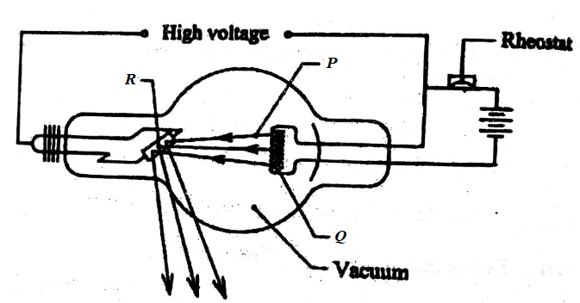

- Name the parts labelled P and Q (01 mark)
P = ………………………………………………………………
Q = ………………………………………………………………
- Of what importance is the part labeled R? (01 mark)
……………………………………………………………………………………………………………………………………………………………………………………………………………………………………………………………………………………………………….
- (a) What is meant by emf of a cell? (01 mark)
………………………………………………………………………………………………………………………………………………………………………………………………………….
(b) State two ways of increasing the resistance of a conductor. (01 mark)
……………………………………………………………………………………………………………………………………………………………………………………………………………………………………………………………………………………………………………………………………………………………………………………………………………………
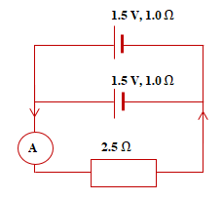
(c) The figure below shows two identical cells of emf 1.5 V and internal resistance 1.0 $Ω$ connected to a 2.5 $Ω$ resistor as shown. Calculate the ammeter reading. (02 marks)

……………………………………………………………………………………………………………………………………………………………………………………………………………………………………………………………………………………………………………………………………………………………………………………………………………………
- (a) What is fluorescence? (01 mark)
…………………………………………………………………………………………………………………………………………………………………………………………………………
(b) (i) State the energy changes that occur when a torch bulb lights from a dry cell (01 mark)
…………………………………………………………………………………………………………………………………………………………………………………………………………
(ii) Explain why a parabolic mirror is preferred to a concave mirror for use as a torch reflector. (02 marks)
……………………………………………………………………………………………………………………………………………………………………………………………………………………………………………………………………………………………………………………………………………………………………………………………………………………
- (a) Define the frequency as applied to waves. (01 mark)
…………………………………………………………………………………………………………………………………………………………………………………………………………
- A wave has a frequency of 50 Hz. Calculate the period of its source. (01 mark)
……………………………………………………………………………………………………………………………………………………………………………………………………………………………………………………………………………………………………………………………………………………………………………………………………………………
- Explain why a good solar panel should be curved and painted black. (02 marks)
……………………………………………………………………………………………………………………………………………………………………………………………………………………………………………………………………………………………………………………………………………………………………………………………………………………
END

With determination, you too can!

