MATHEMATICS
PAPER 456/1
MOCK 2019

TIME; 2 HOURS .30MIN.

INSTRUCTIONS;
- Answer all the questions in Section A and NOT more than five questions from section B.
- All necessary calculations must be done in the same booklet provided. Therefore no paper should be given for rough work.
- Squared paper is provided.
- Silent, non –programmable scientific calculators and mathematical tables with a list of formulae may be used.

SECTION A. (40 MARKS)
- Given that a $*$ b = ab² , Find the value of ;
- 2 $*$ 5.
- b if 3 $*$ b = 48 (4marks)
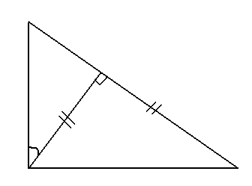
- In the figure below AD is perpendicular to BC, AD = BD, AC = 4 cm and CAD = 30⁰.
C

30⁰
A B
Find the value of AB. (4marks)

- Make p the subject of the formula.
K = $\frac{3x }{2y-p }$ = 1 (4marks)
- A bag contains 5 black balls and 3 green balls. Two balls are randomly picked one after the other without replacement. Find the probability that both balls are same colour. (4marks)

- Find the value of X which satisfy the inequality
x² $-$ 12 $≥$ 1
X (4marks)
- In the triangle PQR, angle QRP = 150⁰, $\overline{PQ }$ = 5CM and $\overline{PR}$ 4CM.
Calculate the area of the triangle PQR. (4marks)

- Find the value of X in the equation.
x + 1 = x $-$ 1
2x + 5 3 (4marks)
- A plot of land on a map of 1.50,000 has an area of 300cm². Determine the actual area of the land in Km² (4marks)
- Convert 5.272727…….to a mixed number. (4marks)
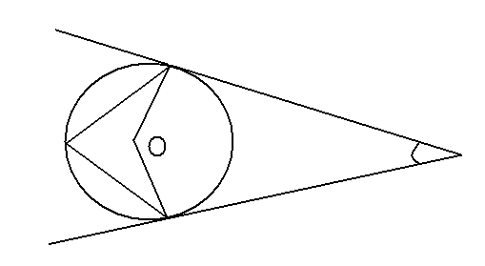
10. In the diagram below, O is the center of the circle. AB and BC are tangents to the circle. Angle ABC = 54⁰. Find Angle ADC.

C

54⁰ B
D

A (4marks)

SECTION B

11. a) A matrix P is given by P = $\begin{matrix}1 & 3 \\ 1 & -2\end{matrix}$

Find another matrix Q such that Q = P² + 2P. Hence the determinant.
(5marks)
b) Use Matrix method to solve the following simultaneous equations.
5x + 2y – 11 = 0
3x – 17 = 4y (5marks)
12. a) Copy and complete the table below for the function y = 5 + 4 x – x².
X | -2 | -1 | 0 | 1 | 2 | 3 | 4 | 5 | 6
5 | 5 | 5 | 5 | 5 | 5 | 5 | 5 | 5 | 5
4x |  | -4 | 0 | 4 |  |  | 16 | 20 | 24
-x |  | -1 | 0 | -1 |  |  | -16 | -20 | -36
y

b) Draw the graph of y = 5 + 4x - x²
c) By drawing appropriate straight lines, solve the equation.
i) 5 + 4x - x² = 0
ii) 9 + 3x - x² = 0
d) State the equation of the two lines in c) above. (12 marks).

13. a) Given that x +y = 15 and xy = 3, Find the value of;
i) $\frac{1}{x }$ + $\frac{1}{y}$
ii) y ÷ $\frac{1}{x}$ (4 marks)
b) Factorize completely the following expressions.
i) a² + b² - 4 + 2ab
ii) a² - 5a - 36 + am + 4m. (8 marks)

14. The points A (1, -2) B (4, 2) C (4, 1) and D (1, 1) are vertices of a
Square ABCD. The images of ABC and D under reflection in the line x = y
Are A'B'C' and D' are then mapped on to the points A"B"C"D" respectively
By enlargement with scale factor 2 and center of enlargement of the origin
O (0, 0).
- Write down the matrices for the reflection and enlargement. 4marks
- Find the co-ordinates of the points.
- A'B'C' and D'
- A"B"C" and D". (8 marks)

15. Town B is 100km away from town A on bearing of 135⁰. Town D is on a
Bearing of 090⁰ from town B, 124km apart. Town C 160km away from
Town D is on a bearing of 030⁰ from D.
- Using a scale of 1cm to represent 20km, make an accurate drawing to show the relative positions and distances of towns A, B, C and D.
- Determine the;
- Shortest distance and bearing of town C from town A.
- Distance and bearing of town B from town C. (12marks)

16. A class of 35 students obtained the following marks in a mathematics test.
28 35 41 47 51 54 57 59 60
61 62 70 80 66 67 68 69 70
62 64 73 74 76 77 78 72 72
83 88 90 94 76 44 81 80
a) Construct a frequency distribution table, taking 20 – 29 as the first group.
(3marks)
b) Using 64 as the assumed mean, determine the mean mark of the class.
c) Construct a cumulative frequency curve and use it to determine the
Median mark of the distribution. (9 marks)

10. A factory wishes to transport atleast 480 tyres from its stores to one of its sales point. It has two types of trucks, A and B. Truck A can carry 40 tyres at a cost of shs. 30,000/= per trip. Truck B can carry 60 tyres at a cost of shs. 45,000/= per trip. There is shs. 600,000/= available for transport.
The number of trips made by A should not exceed 12. Those made by B should not exceed twice the number of trips made by A.
a). If X and Y are the trips made by A and B respectively, write down four
inequalities satisfying the given conditions. (4 marks.)
b) i)On the same axes, draw the graphs of the inequalities and shade the
unwanted region.
ii) Find all the possible numbers of trips made by each truck so that the transport cost minimized. (8marks)
END

