P640/2
FOODS AND
NUTRITION
(With Science
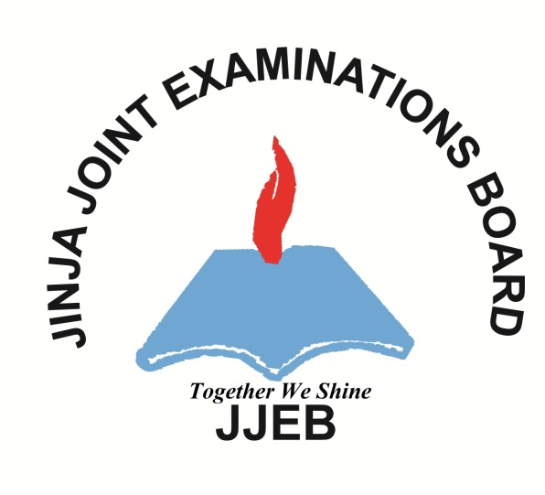
in the Home)
(Theory)
Paper 2
AUGUST, 2017
2 hours

JINJA JOINT EXAMINATIONS BOARD

Uganda Advanced Certificate of Education

MOCK EXAMINATIONS – AUGUST, 2017

FOODS AND NUTRITION
(With Science in the Home)

(THEORY)

Paper 2

2 hours

INSTRUCTIONS:
You may work out your answers using any units but imperial units must not be mixed with metric
This paper consists of six questions
Answer any FOUR questions.
All questions carry equal marks
Any additional question(s) answered will NOT be marked

1a. Giving one example, define friction. (02 marks)
b. State the merits and demerits of friction. (08 marks)
c. Outline the finishes that are commonly given to wooden surfaces in the home.
(03 marks)
d. Of what importance are the finishes in (c) above? (06 marks)
e. Suggest the appropriate care that should be given to a washing machine to maintain its efficiency. (06 marks)

2(a) With the aid of a diagram, explain the working mechanism of the micro-wave oven. (10 marks)
(b) Identify three modern features in an electric cooker and explain their purpose.
- marks)
- How would you economize gas when cooking. (05 marks)
- State seven desirable qualities of fuel that you would recommend for cooking?
(07 marks)
3(a) What is an Abrasive? (02 marks)
(b) Describe the role of the following in household cleaning.
(i) Sodium hydroxide. (03 marks)
(ii) Acetic Acid. (03 marks)
(iii) Salt. (03 marks)
(c) Outline five additives used in soap making and state their functions. (10 marks) (d) State the effects of poor ventilation in a home. (04 marks)

4(a) Describe the following properties of light.
(i) Reflection. (03 marks)
(ii) Refraction (03 marks)
(iii) Diffusion. (03 marks)
(b) Give two applications of each of the above properties of light. (06 marks)
(c) Explain the effect of the following elements of design on the size of a room;
(i) Pattern. (04 marks)
(ii) Texture (04 marks)
- What is the importance of using bowls and shades when providing light in the home? (02 marks)

5(a) Describe the postures that minimize fatigue in daily work. (06 marks)
(b) State the factors to consider when planning an ideal kitchen. (05 marks)
(c) Suggest six methods used in house construction to reduce noise in dwellings. (06 marks)
(d) Illustrate the wiring of a three-pin plug. (08 marks)

6(a) How would you prevent electric shock in the home. (05 marks)
(b) Describe the working of a filament lamp. (08 marks)
(c) An automatic one litre kettle is rated at 2400 watts and is used on a 240volts mains. calculate the following:-
(i) The resistance of the heating element. (04 marks)
(ii) The time taken to heat up the filled kettle from 25⁰C to 100⁰C (the thermal heat capacity of the water is 4.2KJ. (04 marks)
(iii) The cost of heating up the water in the kettle to boiling point. (4 marks)
(1 unit of electricity costs Shs. 300).

