840/2
COMPUTER
STUDIES

Paper 2

Aug, 2016
2 ½ hours
UNNASE MOCK EXAMINATIONS

Uganda Certificate of Education
COMPUTER STUDIES
PRACTICAL
Paper 2
2 ½ hours

INSTRUCTIONS TO CANDIDATES:

- This paper is made up of 2 sections A and B questions.
- Attempt All questions in Section A and Any 2 in Section B.
- All questions in Section B carry equal marks.
- Each candidate is provided with a blamk compact Disc Rewritable (CD_RW) or a Flash disk.
- Candidates should continously save their work.
- Each candidate must produce a hard copy for each of their work to accompany the Compact Disc or flash disk.

SECTION A (40 marks)
This section is compulsory
1. A) Type the following document as it is and follow the instruction in the required list: (2 marks)
Greatness does not come overnight. It is a persistent struggle that involves a lot of hard work. We are told to work hard but it is of no use if we don’t work intelligently. Strength without skills cannot be reliable in the current world. Challenges come in our way in a rapid changing forms and with renewed intensity.
You cannot build your future in future. We traverse in hardships to be able to conquer vicious difficulties with skillful approach. Knowledge is power, not the reverse. Do not ignore knowledge of any form. We learn from our teachers and, perhaps, the books that we read. You can earn a living using learnt skills even where there are limited resources.
No one should be proud of the riches acquired through theft, corruption, tax evasion or diverting resources meant for the welfare of the disadvantaged. Do not play shortcut games because you failed to prepare your future in time. If you do, you know you are working your way to imprisonment and hell!

Required:
- Apply page break and copy and paste the passage you have typed in three other new pages. (2 marks)
- Insert page numbers at the top right of the pages. (2 marks)
- Change the font style of the first page to Arial Narrow and font size 13. (2 marks)
- Change the work in page two to appear in three columns, justified and with 10% grey background shade. (3 marks)
- Indent the work in page three to 1.1” both left and right margins, should appear justified and surrounded with a thick border. (4 marks)
- Change the work in page four to double line spaced, character space of style Expanded at 1.2pt. (3 marks)
- Insert a footnote at the bottom of the last page as “With ICT we shall gain Skills” (1 mark)
- Print your work. (1 mark)
- Save your work as: Your Name – Modern Life.
1. B) Use a spreadsheet program to enter the following information and perform the following activities as indicated in the required list.
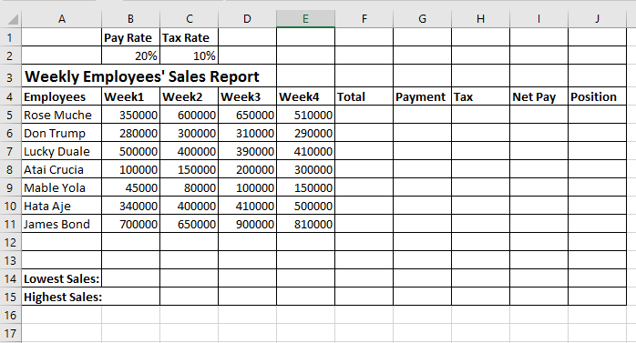
Required:
- Use a function to calculate the Total amount for all the weeks in each employee. (2 marks)
- Use the obtained Total value and the payment rate seen on your worksheet and calculate the Payment for each employee.
(2 marks)
- Use the Tax Rate value and calculate the tax to be paid by each employee from the payment. (2 marks)
- Use a formula to calculate the Net Pay for each employee (after tax) (2 marks)
- Use the formula and from the Total column, calculate the position held by each employee beginning from the highest total sales to the lowest total sales. (2 marks)
- Use a function to calculate lowest sale performed in every week in row 14. (2 marks)
- Use another function to calculate the highest sale performed in every week in row 15. (2 marks)
- Rename your worksheet as Employees. (2 marks)
- Create a Pie Chart based on Employees and Total columns showing values in Percentage. Your chart should be just below your data. (2 marks)
- Print your work. (1 mark)
- Save your work as: Your Name – Employees. (1 mark)
SECTION B (60 marks)
Attempt only two (2) Questions in this section

2. Create a database called Client List and design the two tables where the first table is called Customers and the second table called Invoice.
Customers
CustID | Customer Name | Home Address | Contact | DateOfBirth
C001 | Mary Uwera | Mukono | +256773556677 | 12/12/1980
C002 | Kapro Ben | Kampala | +256752776655 | 12/4/1976
C003 | Dawin Miiro | Jinja | +256703543675 | 3/11/1970
C004 | Titus Kiwiwa | Mukono | +256776876543 | 4/5/1986

Invoice
InvNo | CustID | InvDate | Unit | Quantity | Price
1 | C002 | 3/7/2016 | Sugar | 8 | 700000
2 | C003 | 3/7/2016 | Rice | 9 | 800000
3 | C001 | 4/7/2016 | Soap | 10 | 760000
4 | C002 | 5/7/2016 | Rice | 33 | 1000000
5 | C004 | 5/7/2016 | Soya | 45 | 450000
6 | C003 | 5/7/2016 | Sugar | 7 | 800000
7 | C002 | 6/7/2016 | Rice | 23 | 400000
8 | C001 | 6/7/2016 | Wheat | 65 | 780000
9 | C004 | 7/7/2016 | Wheat | 77 | 870000
10 | C001 | 7/7/2016 | Sugar | 87 | 760000
11 | C002 | 7/7/2016 | Wheat | 54 | 580000
12 | C003 | 8/7/2016 | Soap | 7 | 850000

Required:
- Design the above two tables using appropriate data types
(4 marks)
- Format the Price field in Invoice table with UGX monetary unit and of two decimal places. (2 marks)
- Enter data in the two tables. (4 marks)
- Create a one to many relationship of the two tables. (3 marks)
- Create a form based on Invoice table showing Unit, Quantity, and Price fields with calculated Total Price. Include the header as “Invoice Data Form”, put your full name as a footer, add a closing button at the top right side of your form and save your form as Invoice Form. (6 marks)
- Design a query combining fields from the two tables but only showing CustomerName, HomeAddress fields in Customers table and Unit, Quantity, Price fields of Invoice table displaying only wheat product. Name your query as Combined query. (5 marks)
- Create a report based on the same fields as in part vi above grouped by Unit field. Put a header as Invoice Management Report. Save your report as My Report. (4 marks)
- Print your tables, form, query, and report. (2 marks)

3. The ICT teacher of Koinange High School has requested you to prepare a presentation about Computer Software to be used in a Form two lesson. You should design a summarized presentation as described below:
Slide I: Should include the heading of the topic to be presented and your full name as the name of the presenter. (2 marks)
Slide II: Should include the definition of Software. (3 marks)
Slide III: Should include a small software chart showing only software and the three branch of software (i.e. Systems Software, Application Software, and Development Software) (5 marks)
Slide IV: Should include a list of five application software programs
(5 marks)
Slide V: Should include five functions of Operating System (5 marks)
Slide VI: Should include a list of five Utility programs (4 marks)
- Include minimal animations (2 marks)
- Include action buttons that can make presenter move back and forth in each slide (1 mark)
- Put your name as a footer in each slide (1 mark)
- Print your handout (1 mark)
- Save your presentation using your full names. (1 mark)
4. Uchumi Supermarket has contacted you as a professional web designer to design a website that include the home page and six other pages.
- The homepage should include a brief background of Supermarket and showing links to six other pages that will lead the site navigator to click and link to Contacts, Product, Imports, Promotional Goods, Suppliers, and Management. (6 marks)
- The Contact page should include unordered list of telephone numbers and e-mail addresses of at least five branches of the supermarket (3 marks)
- The Product page should include a table with the list of product and the corresponding prices available at the supermarket.
(3 marks)
- The Import page should contain the ordered list of at list four countries and within each country to have unordered list of imported goods (6 marks)
- The Promotional goods page should include the ordered list of goods that are on promotion (2 marks)
- The Suppliers page should include the list of local suppliers to the supermarket and the product that they supply (2 marks)
- The management page should contain the list of managers in each branch (2 marks)
- Link all the pages back to the home page (3 marks)

- Creativity and the use of good designs (3 marks)

**END**

