MATHEMATICS
PAPER 456/2
MOCK – 2019
TIME; 2.30MIN.

INSTRUCTIONS.
- Answer all the questions in Section A and NOT more than five questions from Section B.
- All necessary calculations must be done in the same booklet provided. Therefore no paper should be provided for rough work,
- Squire paper is provided.
- Silent, non –programmable scientific calculators and mathematical tables with a list of formulae may be used.
SECTION A. 40 MARKS.
- Simplify; 2 ½ ÷ 4 ¹/₃ $-$ 2 ¼
4 ¹/₆ (4 marks)
- Evaluate; 1 + $\sqrt{5}$ + 1 $-$ $\sqrt{5}$
2 + $\sqrt{5}$ 2 $-$ $\sqrt{5}$ (4 marks)
- Olga bought a motor cycle and sold it to Okello at a loss of 25%. If he bought it at 1,200,000shillings. Find how much money Olga paid for it? (4 marks)
- Use substitution Y = 2^{x} . Solve; 2^{(2X +3)} $-$ 6(2x) + 1 = 0 (4 marks)
- Given points A(0, 3) and B(6, 6). Find an equation of the perpendicular bisector of the segment AB.
- Given that P = The square of all prime numbers and
Q = The first ten square numbers .
Write down the members of P∩Q. (4 marks)
- Use logarithm table to find the square root of 0.0576. (4 marks)
- If Z varies jointly as X² and the square root of y and Z is 6 when
X = 3, Y =9 and y =4.
- If the exchange rate for a French Franc to a pound sterling is £1 = 9.00 Francs and £ 1 = $ 1.53 (American dollar), Find how many American Dollar one would get in exchange for 1,000 francs. (4 marks)
- Given that AO = $\frac{-2}{ 2 }$ , OB = $\frac{8}{4}$ and M is a point on $\overline{AB }$ such that
$\overline{AM}$ : $\overline{MB}$ = 1 : 1, Find;
- AB
- AM (4 marks)

SECTION B. (60 MARKS)
- In triangle A B C L, M and N are the mid point of $\overline{BC}$, $\overline{CA}$ and $\overline{AB}$ respectively.
AM = $\underline{a}$, AN = $\underline{b}$ and 3AG = 2AL
- Express in terms of vectors $\underline{a}$ and $\underline{b}$ the vector.
- AB
- AC
- BC
- BG
- GM
- Show that B,G and M lie on a straight line and that 3$\overline{BG}$ = 2BM. (12marks)

- A school has a teaching staff of 22 teachers, 8 of them teach Mathematics, 7 teach physics and 4 teach chemistry. Three teach both Mathematics and physics and one teaches mathematics and chemistry. No teacher teach all the three subjects. The number of teachers who teach physics and Chemistry is equal to that of those who teach Chemistry but not physics.
- Represent the above information on a Venn diagram.
- Find the number of teacher who teach;
- Mathematics only
- Physics only
- None of the three subjects.
c) Find the probability that a teacher picked at random teaches only on or
none of these subjects. (12 marks)
- The distance from Lira to Kampala is 380km. A bus leaves Lira at 07.30hrs and travels non stop to Kampala at 60km/hr. At 08.50hrs a Pajero Car leaves Kampala and travels towards Lira at a steady speed of 120Kmh⁻¹
- On the same axes draw distance time graphs hence or otherwise determine when and at what distance from Lira they must meet? If the bus then increase its speed by 10Kmh⁻¹ (7 marks)
- i) Calculate the time at which the bus arrives in Kampala. (2 marks)
- Determine the difference in time of arrival of the two vehicles.
(Use scales of 2cm to represent 50km and 2cm to represent 1hr) (3 marks)

- a) Paul won shs.42 million in a lottery. She shared the money with his parents in the ratio 5 : 2 respectively. Find how much money she gave her parents.
- marks)
b) Without using tables or calculators simplify;
-^{1/}₃
64
-^{1/}₃
27 (3 marks)

c) Given that $\sqrt{6}$ = 2.450, $\sqrt{10}$ = 3.162. Without using a calculator,
evaluate to two significant figures.
$\sqrt{3 }$ $-$ $\sqrt{2 }$
$\sqrt{5 }$ $-$ $\sqrt{2 }$ (6 marks)

- The figure below shows a right angled pyramid on a square base ABCD of side 10cm. V is the vertex of the pyramid and O is the centre of the base. Given that VO = 8cm and M and N are the mid points of AB and dc respectively.
- Find the length VA. (4 marks)
- Calculate the angle between the plane VAB and ABCD. (3 marks)

- Calculate the volume of the pyramid. (2 marks)
V
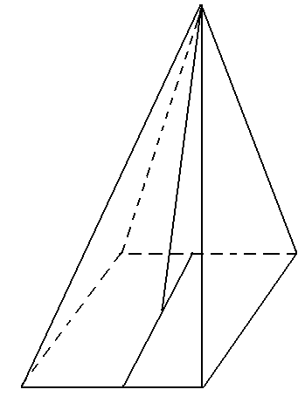

D N C

O

A M B
b) Calculate the surface area of the figure below.
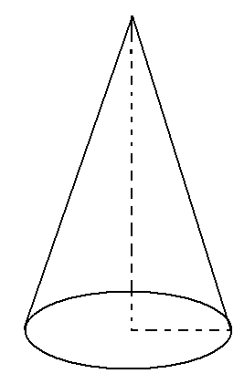
Where; h = 14cm.
r = 3.9cm.
h

r (3 marks)
- a) Given that f(x) = x² $–$ 3 and g(x) = 3x + 2, Find the value of;
- fg($-4$) (3 marks)
- gf($-4$) (3 marks)
- the value of for which g(x) is meaningless. (3 marks)
f(x)
b) Find f ⁻¹(x) (3 marks)

- A certain country’s income tax structure is such that a person’s gross monthly income has certain allowance deducted fro it before it is subjected to taxation. The allowance spent out are as follows; marriage allowance ¹/₂₀ of the gross monthly income, family relief and insurance shs. 120,000 per annum, water and electricity shs. 12,500 per month, medical (self and family) shs. 240,000 per annum. Transport shs. 800 per day. Family allowance for four children only at the following rates.
Shs. 5,800 for each child above the age of 16, shs 7,200 for a child above 10 years but below 16 years and shs. 9,000 for a child below 10 years. Joy has a family of 4 children with two of them below the age of 9, the elder child is 20 years and the other 14 years. Given that she earns shs. 680,000.

- Calculate the taxable income she pays under the income tax rates below.
Taxable income | Tax rate %
0 – 15,000 | 8.50
15,000 – 84,000 | 16.50
84,001 – 170,000 | 24.00
170001 – 285,000 | 30.00
285,001 – 435,000 | 37.50
Above 435,000 | 48.0
- Determine the percentage of her gross monthly income paid in tax. (12marks)
END

