P720/2
TECHNICAL DRAWING
BUILDING DRAWING
Paper 2
August 2014
3 hours
END OF TERM TWO EXAMINATIONS
TECHNICAL DRAWING
BUILDING DRAWING
Paper 2
SENIOR FIVE
3 Hours

INSTRUCTIONS TO CANDIDATES
This paper consists of two questions.
Answer all questions.
A sheet of drawing paper size A2 is provided. Use both sides of the paper if necessary.
Where dimensions are not given suitable dimensions are to be chosen.
Accuracy and good draughtsman ship are essential.

Figure 1 shows the ground floor plan of a shopping arcade not drawn to scale.
SPECIFICATIONS:
ROOF: | Hipped roof covered with galvanized corrugated iron sheets pitched at 30º on purlins 50x50 on Rafters& struts 125mm x 50mm on Tie beams 150mm x 50mm, on 100x75 wall plate.  Trusses placed 2230mm center to center.  Fascia boards/ verge boards are 200mm x 25mm.
WALLS: | External and internal are one brick wall thick in Flemish bond.
DOORS: | D3- 2400mm x 2100mm. casement double leaf.D1- 2100mmx900mm steel casement door, D2-2100x 900 panel doors.
WINDOWS: | W1- 1500mm x 1200mm casement metallic.
FLOOR: | Concrete floor with 20mm cement/ sand screed laid over 100mm thick over-site floor concrete and 150mm thick hardcore.
FOUNDATION: | Concrete strip foundation 675mm wide by 230mm thick at a depth of 1300mm below the ground level.

- Draw a free hand pictorial sketch of the building with corner T at the fore ground. (Use of instruments will be penalized).

- To a scale of 1:50, draw the vertical sections on cutting planes M-M and S-S showing all the necessary constructional details.(name all parts)

END

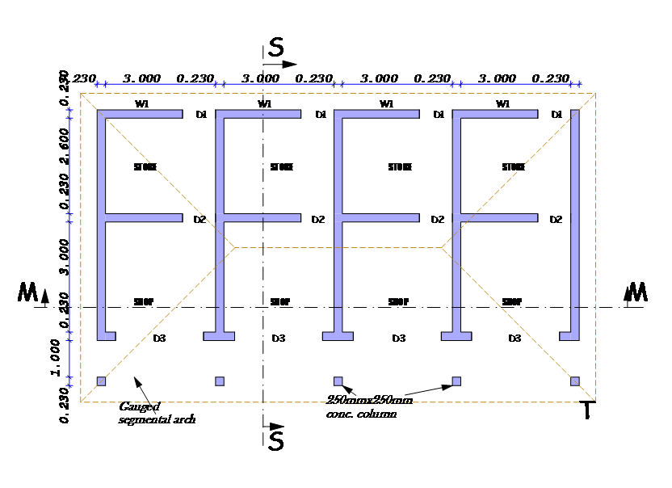

Fig 1

