NAME:.............................................................................. INDEX NO:..............
SIGNATURE:............................

553/1
Biology
(Theory)
Paper 1
2 ½ hours

Uganda Certificate of Education
BIOLOGY(THEORY)
PAPER 1
2 HOURS 30 MINUTES
INSTRUCTIONS
- Answer all questions in sections A and B in the spaces provided on the question paper and any two questions from section C.
- Answer section A by writing the correct alternative A,B,C or D in the box on the right hand side of each question.

FOR EXAMINER’S USE ONLY
Section | Marks | Examiner’s Initials
A
B 31
32
33
C No:
No:
Total

SECTION A(30 MARKS)
- To which oneof the following phyladoes the earthworm belong?

- Arthropoda
- Choroata
- Annelid
- Nematode

- During dry conditions the spirogyra reproduces sexually by

- Budding
- Conjugation
- Fragmentation
- Sporulation

- Which one of the following statements about pure wateris correct?
- Has a high osmotic potential
- Has a high solute potential
- Has a low osmotic potential
- Has a negative osmotic potential

- The type of cells attacked mainly by the HIV virus in the human body are:-

- Erythrocytes
- Platelets
- Leucocytes
- Lymphocytes

- The genes for inheritance of ABO blood groups are an example of

- Lethal alleles
- Multiple alleles
- Codominant alleles
- Dominant alleles

- A dry fruit that splits along many lines of weakness is a:

- Samara
- Legume
- Capsule
- Caryopsis

- The vitamin requires for good night vision is

- Vitamin B
- Vitamin A
- Vitamin C
- Vitamin D

- Biological control of rats in a habitat would involve;

- Clearing bushes
- Use of rat poison
- Use of rat poison
- Breeding cats

- Denitrifying bacteria change

- Ammonia into nitrates
- Nitrogen into nitrates
- Nitrates into free nitrogen
- Nitrites into nitrates

- The highest amount of energy in a food chain is present in

- Decomposers
- Primary consumers
- Tertiary consumers
- Producers

- Addition of humus to a sandy soil would
- Decrease soil mineral content
- Improve soil water retention
- Increase soil erosion
- Decrease capillarity of the soil

- Secondary growth in a flowering plant is caused by;

- Cortex cells
- Xylem vessels
- Phloem cells
- Cambium cells

- Which one of thefollowing cellorganelles wouldbe largest innumber inactive muscle tissue?

- Ribosomes
- Mitochondria
- Golgi bodies
- Chloroplasts

- The graph below shows the number of individuals varying with a given characteristic in a population.
Number of Individuals
Characteristics
Figure 1

Figure 1

Which one of thefollowing characteristics would produce the graph infigure 1 above?

- Height
- Sextype
- Blood group
- Albinism

- The part of a Bryophyllum plant leaf for vegetable propagation is the;

- Lamina
- Notch
- Bud
- Apex

- Crossing over occurs during;

- Prophase of mitosis
- Prophase of meiosis
- Metaphase of mitosis
- Metaphase of meiosis

- Which one of thefollowing vertebrae has demifacets?

- Thoracic vertebra
- Lumbar vertebra
- Cervical vertebra
- Atlas

- The excretory structures for an insect are;

- Trachea
- Malpighian tubules
- Tracheoles
- Spiracles

- Which of the following parts are for hearing and body posture?
- Cochlea and cerebellum
- Cochlea and cerebrum
- Eustachian tube and cerebrum
- Eustachian tube and cerebellum
- Eustachian tube and cerebrum

- The products of hydrolysis of lactose are;

- Sucrose and galactose
- Glucose and galactose
- Fructose and glucose
- Fructose and sucrose

- Which one of the following forms the pioneercommunity inprimary succession?

- Grass
- Lichen
- Angiosperm
- Moss

- The figure 2 below shows part of a plant
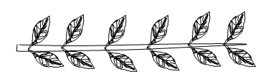
Figure 2
The best descriptionfor figure 2 is;

- Compound palmate
- Compound Bipinnate
- Compound pinnate
- Simple pinnate

- Which one of thefollowing limits growth in arthropods?

- Jointed legs
- Segmented body
- Endocoelomic fluid
- Exoskeleton

- The relationship between rhizopus and bread (rotting) is described as

- Parasitic
- Saprotrophic
- Mutualistic
- Commensalistic

- The amount of light entering a light microscope stage is controlled by the:-

- Diaphragm
- Fine adjustment knob
- Coarse adjustment knob
- Mirror

- Which one of the following human diseases is caused by a parasitic protozoan?

- Cholera
- Typhoid fever
- Malaria
- Influenza

- A trait whose phenotype can only express itself once homozygous is said to be

- Dominant
- Codominant
- Recessive
- Lethal

- Which one of the following is typicalof insect pollinated flowers?
- Are large and inconspicuous
- Are small and conspicuous
- Have brightly coloured petals and conspicuous
- Have dull coloured petals and inconspicuous

- A distinguishing feature of monocotyledonous plants is
- Leaf sheath and parallel venation
- Leaf sheath and network venation
- Solid petiole and parallel venation
- Solid petiole and network venation

- The non-functional human appendix is an example of;

- Homologous structures
- Analogous structures
- Vestigial structures
- None of the above

SECTION B(40 MARKS)

- The figure3 below represents the changes in the population of Tilapia fish in a pond over a period of 9 months.The pond is situated in a country withevenly distributed rainfallthroughout the year.
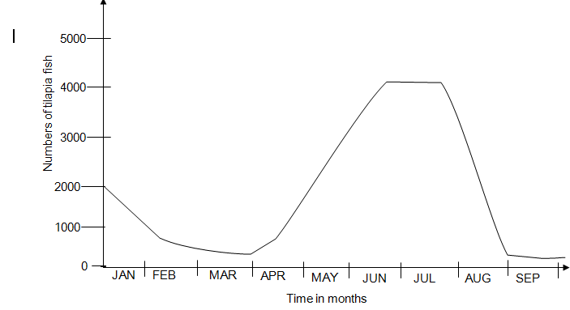
Figure 3
(a)(i)What times of the year affect the population of tilapia adversely from the graph and why. (4 marks)
………………………………………………………………………………………………………………………………………………………………………………………………………………………………………………………………………………………
Reason(s)
………………………………………………………………………………………………………………………………………………………………………………………………………………………………………………………………………………………
(ii) What is the average number of tilapia fish between April and June?
(2 marks)
………………………………………………………………………………………………………………………………………………………………………………………………………………………………………………………………………………………
(b)Explain the changes in number of Tilapia fish in the pond during the periods
(i) January and February. (2 marks)
………………………………………………………………………………………………………………………………………………………………………………………………………………………………………………………………………………………
(ii) April and June (2 marks)
………………………………………………………………………………………………………………………………………………………………………………………………………………………………………………………………………………………
(iii)August and September (4 marks)
…………………………………………………………………………………………………………………………………………………………………………………………………………………………………………………………………………………………………………………………………………………………………………………………………………………………………………………………………………………
(c)(i) Name one suitable method you could use to estimate the Tilapia population in the pond with a reason. (2 marks)
Method
………………………………………………………………………………………………………………………………………………………………………………………………………………………………………………………………………………………
Reason
………………………………………………………………………………………………………………………………………………………………………………………………………………………………………………………………………………………
(ii) How would you calculate the total population of tilapia fish in the above period? (2 marks)
………………………………………………………………………………………………………………………………………………………………………………………………………………………………………………………………………………………

(iii) State any two precautions taken to get accurate results in (c)(i)above.
(2 marks)
…………………………………………………………………………………………………………………………………………………………………………………………

- (a)What is meant by the term Endothermy? (2 marks)
………………………………………………………………………………………………………………………………………………………………………………………………………………………………………………………………………………………
(b) How does an endotherm respond to a rise in body temperature?
(4 marks)
………………………………………………………………………………………………………………………………………………………………………………………………………………………………………………………………………………………………………………………………………………………………………………………………………………………………………………………………………………………………………………………………………………………………………………

(c) Explainthe importance of eachof the following structuralfeatures toanimals living in cold zones of the world
(i) Thick fur (2 marks)
………………………………………………………………………………………………………………………………………………………………………………………………………………………………………………………………………………………
(ii)Extremities reduced in size (2 marks)
………………………………………………………………………………………………………………………………………………………………………………………………………………………………………………………………………………………

- The figure below shows a longitudinal section through part of a plant to show its structure
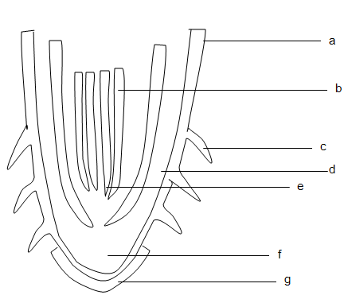
Figure 4
- (i) Name the parts labelled a-f.

a…………………………………………………………………………………
b…………………………………………………………………………………
c…………………………………………………………………………………
d…………………………………………………………………………………
e…………………………………………………………………………………
f……………………………………………………………………………………
(ii)Name the part from which figure 4 was obtained with a reason.
(1 mark)
Part …………………………………………………………………………………….

Reason ……………………………………………………………………………………..
(b) State the functions of parts labeled e and f and g to the plant.
(3 marks)
e………………………………………………………………………………………………………………………………………………………………………………
f………………………………………………………………………………………………………………………………………………………………………………
g………………………………………………………………………………………………………………………………………………………………………………
(c) How is part labeled C adapted for its function? (2 ½ marks)
………………………………………………………………………………………………………………………………………………………………………………………………………………………………………………………………………………………………………………………………………………………………………………………………………………………………………………………………………………………………………………………………………………

SECTION C(30 MARKS)
Answer any two questions from this section.

- (a)(i)What is transpiration pull? (2 marks)
(ii) How does transpiration occur in a plant? (10 marks)
(b) Explain the significance of transpiration to a plant (3 marks)

- (a) How is soilair important to plants? (3 marks)
(b) Describe an experiment to determine the percentage of air in a soil sample. (12 marks)
- (a)(i) Distinguish between complete dominance and codominance.
(2 marks)
(ii) State the laws of Heredity. (2 marks)
(b)A breeding experiment between two heterozygous plants with purple flowers got from pure breeding plants for red flowers and yellow flowers produced 412 plants.
(i) Why were all F₁ generation plants having purple flowers?
(1 marks)
(ii)How many of the F₂ generation plants had red flowers, purple flowers and yellow flowers? Show your working. (8 marks)
(iii) Give two modern applications of Genetics. (2 marks)

37. (a) State two characteristics of a spirogyra cell. (2 marks)
- Briefly describe sexual reproduction process in spirogyra.
(13 marks)

**END**

