- Compulsory question :MAP WORK (25 MARKS)
Answer all parts of this question.
Study the 1:50,000 (UGANDA) MINAKULA map extract, part of sheet 31/2, series Y732, edition 2-U.S.D and answer the questions that follow.
- i) State the grid reference of the culvert on river Panyjok, south east of Minakula sub county headquarters. (01mark)
ii) Identify the man made feature found at grid reference 295761 (01 mark)
- determine the ;
- general direction of flow of river Tochi (02marks)
- Distance of the all-weather loose surface road from Achaba road junction to the trigonometric station north of Minakula trading center. (02 mark)
- Amplitude of the relief of the area shown. (02marks)
- Draw a sketch map of the area shown and on it ,mark and name ;
- River Tochi and its main tributaries
- Permanent swamps
- The all –weather bound surface road,
- Minakula trading Centre. (06marks)
d). Describe the relationship between relief and
i)settlement
ii)drainage ( 06marks)

- Giving evidence from the map extract, describe the problems faced by the people living in the area. (06marks).

2 PHOTOGRAP INTERPRETATION (COMPULSORY)
Answer all parts of this question
Study the photograph provided below and answer the questions that follow;
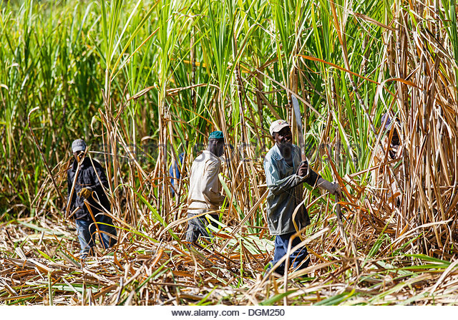
- Identify the:
- Activity taking place in the photograph, (2mark)
- Crop shown in the photograph. (2mark)
- Describe the conditions that have favoured the growth of the crop. (06marks)
- Identify the problems facing people carrying out an activity mentioned in a(i) above (6marks)
- State the importances of the activity on the physical environment. (07marks)
- Giving reasons for your answer, suggest an area in east Africa where this photograph could have been taken. (02marks)

