ASSHU-MUBENDE JOINT MOCK EXAMINATIONS
Uganda Certificate of Education
GEOGRAPHY 273/2
MARKING GUIDE
UCE June / July 2019

1 a) (i)
In land basins A Congo Basin 01
B L. Chad basin 01
C. Niger basin 01 03

(ii) Towns 1. Cape Town 01
2. Lagos 01
3. Alexandria 01 03

(iii) Island N - Madagascar 01

(iv) River P - R. Benue 01 T = 08marks

b) Formation of inland drainage basin
Basins were formed as a result of down warping. Part of the earth’s crust was acted upon by down warping forces forcing it to sink down wards. This led to formation of a shallow broad saucer shaped depression called a basin.
Identifying the process-01
Explanation of the process -03
Identification of features formed-01 Total = 04 marks
c) Usefulness of inland drainage basins.
• Contain lakes, rivers, swamps leading to fishing.
• Rivers promote water transport.
• Rivers are used for generation of hydroelectric power.
• Provide great tourist potential hence leading to the development of the tourism industry.
• Source of water for Industrial use and domestic use.
• Modification of climate.
• Habitant for aquatic animals
• Source of minerals thus leading to mining industry.
• Provides raw materials for art and craft industry.
Any five identified and well explained, 05x1 = 05marks

d) Problems facing people living in these areas (basins).
• Poorly developed transport and communication network
• Flooding of rivers leading to loss of lives and destruction of property.
• Pests and diseases
• Dense forests discourage settlements hence sparse population leading to shortage of labor and market.
• Inadequate capital to develop wastes.
• Hides out for rebels due to thick vegetation
• Accidents due to drowning in rivers
• Harbor dangerous animals i.e crocodiles.
• Pollution caused by dumping of industrial wastes

1 identifying a factor 4 X 2 = 08 marks
1 Explanation

T = 25marks

2. [a] A sketch map of Africa showing Rivers: Zambezi, Niger, and Congo; multipurpose development schemes Inga and kainji dams.

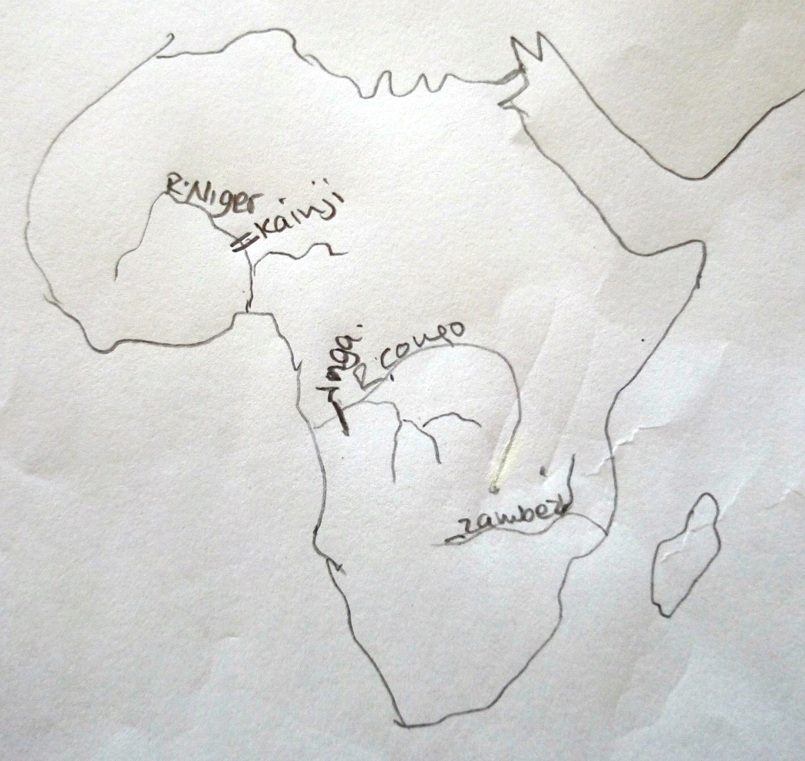 (05marks)

(b) The following are conditions which have favoured the establishment of anyone multipurpose scheme named in (a) (ii) above.

NOTE: -A candidate is to choose one of the multi-purpose schemes and explain the factors that have favoured the establishment of the scheme.
- The factors are more or less the same for the two schemes
- The factors are both physical and human as explained below
➢ Existence of a narrow gap in the flood plain as river Niger flows through a low lying plateau made it easy for construction of the dam.
➢ Presence of river Niger which has fluctuating regime between the wet and dry seasons hence the need to control floods
➢ Presence of wide valley to act as a reservoir for the water behind the dam availability of sufficient raw materials such as gravel and sand for the construction of the dam
➢ Presence of hard basement rocks which offered a firm foundation for the construction of the dam.
➢ Availability of large volume of water in river Niger which would be impounded behind the dam.
➢ High levels of technology for the construction of the dam
➢ Favourable government policy to develop the multi-purpose scheme to promote economic development of the country
➢ Availability of adequate capital for the construction of the project especially from World Bank and government of Nigeria, USA and Britain
➢ Presence of skilled labour especially from abroad and cheap labour provided by Nigerian nationals for the construction of the project
➢ Presence of large market for power produced by Nigeria due to large population expanding industries
➢ Presence of sparse population in the area thus large area for reservoir was available
➢ There was a need to develop alternative source of power for industrialisation other than relying on petroleum majorly.
Any 05 identified and well explained 05x2= (10marks)
(c)The following are the benefits of Kainji dam to the people living in the area.
➢ Flooding of Niger River has been controlled due to construction of Kainji dam.
➢ It has provided water for irrigation of crops like rice sugarcane and vegetable
➢ The project act as tourist attractions and this earns Nigeria foreign exchange E.g. Kainji lake national border the reservoir with antelopes, buffalos and leopards
➢ The project has generated employment opportunities to many Nigerians in tourism, agriculture, and established manufacturing industries hence improving on the standards of living
➢ Hydroelectric power is generated which has stimulated industrial development especially in west Nigeria and this earns the country foreign exchange for development of the economy
➢ It has led to development of infrastructure such as roads which have been constructed on the top of dam- wall to ease communication
➢ The depth of t water in Niger up- river from Lake Kainji has increased, making navigation possible all year round
➢ Lake Kainji is the source of water for both domestic and industrial purposes
➢ The people’s standards of living have improved due to increased income and electricity
➢ It has promoted the growth of urban centres such as new Bussa and Yalwe with associate infrastructure such as piped water, electricity and housing facilities.
Any 06 identified and well stated 06x1= (06marks)

(d) The following are the effects of the establishment of a multipurpose scheme on environment in Nigeria
➢ Loss of silt behind the dam to fertilise agricultural land down streams as it settles behind the dam
➢ Pollution of land, air and water as a result of industrialization, reducing on the standards of living and low yields
➢ High rates of evaporation leading to loss of water
➢ Destruction of the natural beauty especially the water fall through the construction of the dam
➢ Stagnant water behind the dam that has provided a breeding ground for pests
. (03marks)
T= 25 marks

3. A sketch map of Africa showing major fishing grounds; lakes, ocean currents, ports and bays.

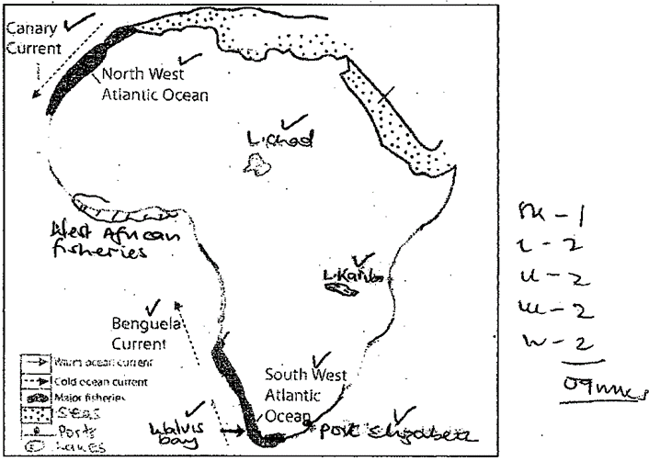

b) Conditions which have favoured the development of the fishing industry.
- A long indented coastline that favours the development of landing ports such as Agadir, Tan Tan. The indented coast line shelters the breeding grounds for fish.
- The canary Island in the Atlantic Ocean offers opportunities for off shore fish landing.
- Extensive fishing ground in the Atlantic Ocean offers a wider area for fishing activities.
- Presence of plenty of planktons/ fish food which favours multiplication of fish.
- Relatively smooth sea floor in the Atlantic Ocean favours use of deep sea fishing methods like Trawling.
- Presence of temperature forests that provide timber for boat construction and floaters got from cork trees.
- Large number of commercial fish species such as Tuna, Mackerel, mussels which are palatable.
- Adequate local and international market in Morocco and countries such as Britain, Spain, Sweden, Holland for the fish products.
- Supportive government policies inform of tax holidays to foreign investors attracted them to the fishing industry hence development.
- Adequate transport network of roads and railways linking fish landing sites to market centres has facilitated the distribution of fish in Morocco.
- Adequate technology for example the use of motor boats, Trawlers which have simplified fishing activities.
- The use of modern and efficient fishing methods such as drifters, lining, Trawling favoured the development of the fishing industry. (06 marks)

c) The contribution of the fishing industry to any on country in Africa. N.B Identify a country (1mark)
- South Africa, Namibia, Morocco, Angola, Nigeria.
Contributions
- Lead to the development of industries for example the fish canning, ship building industries at Port Elizabeth that provide employment.
- Development of towns such as Port Elizabeth, Cape Town which provide accommodation and social services to the people.
- Employment for example fisherman, fish mongers, ship captains who earn incomes.
- Revenue is earned through taxing fishing industries and fish industry workers which revenue is used to establish social services.
- Foreign exchange is earned through the exporting of fish products to countries such as Saudi Arabia, Kuwait, used in setting up social services to the people.
- International relationships has improved between fishing states and countries dealing in fish commodities such as Saudi Arabia, Kuwait, Britain attracting more investors in the country.
- Development of infrastructure such as Roads, railway have developed connecting fishing grounds to market centers.
- Source of food for example proteins improving diet among the people.
Any 5 X 1 = 05 marks (06 marks)

d) Problems faced by the fishing industry in Africa.
- Limited capital to invest in the fishing industry for example they have limited money to buy modern equipment for example Trawlers to develop the fishing industry.
- Inadequate technology for the fishing sector for example limited use of Trawlers, long lining and drifting. This has resulted into limited fish catch in the country like Morocco.
- Over fishing resulting into decline of fish in Africa eg Salmon and Cod.
- Competition with other countries such as Japan, Norway, Spain, Denmark etc has led to reduced markets.
- Fishing vessels have polluted the water as they dump fuel or oil products into the water resulting into death of fish.
- Accidents resulting from drowning collusion of vessels due to fog affects the fishing sector.
- Limited skilled labour to work under the sector for example Trawler operators, ship engineers thus affects fish output hence affecting the fish industry. (04 marks)
Total = (25 marks)

4. (a) A bar graph showing population growth in Nigeria (1994-2001)

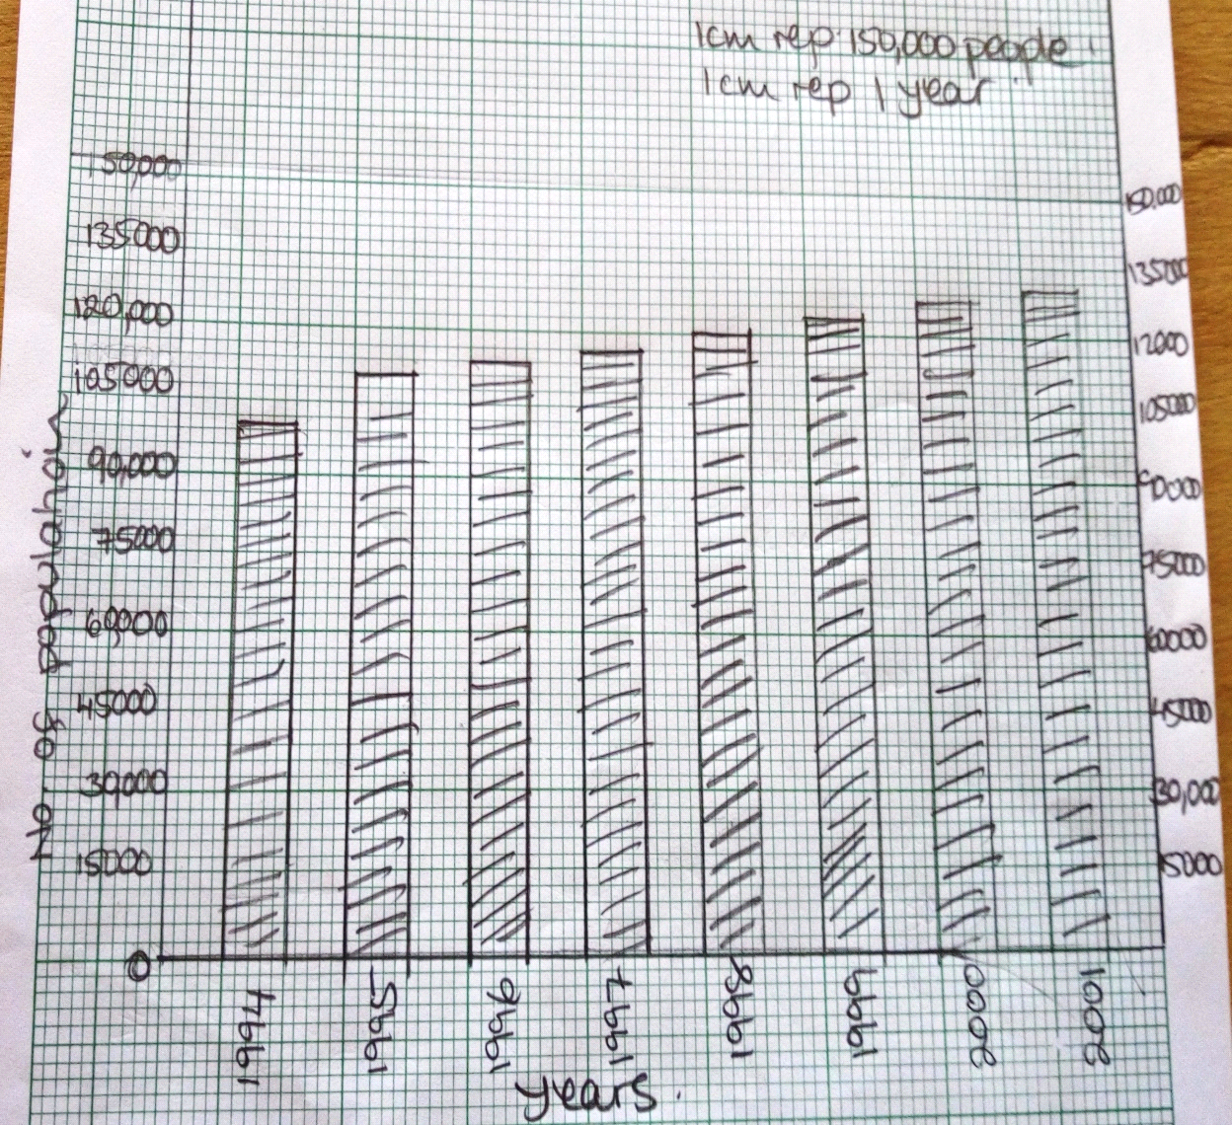 (07 marks)

4. (b) The following is the trend of population growth in Nigeria
➢ Between 1994– 1995, there was sharp increase in the population of 3260 people
➢ Between 1996- 1997, there was a slight increase by a difference of 3230
➢ Between 1997-1998, there was a sharp increase of 3140
➢ Between 1998 – 1999, the population sharp increased by 3180
➢ Between 1999- 2000, there was a slight increase in the population from 126910 to 129870 people.
➢ Between 2000-2001, there was a slight increase of 2960 people
➢ There was a steady increase in the number of people living in Nigeria (04 marks)
4. (c) The following are the conditions that have led to an increase in the population of Nigeria:
➢ Improved health services that has led to control and treatment of diseases
➢ High fertility rate in women that has resulted into giving birth to many children
➢ Increased food production that has improved people’s diet thus living longer lives
➢ Political stability in the country that has favored settlement of people from other neighboring areas
➢ Favorable climate that attracts many emigrants from neighboring areas.
➢ Ignorance about family planning methods leading to uncontrolled births
➢ Religious beliefs for example among the Moslems polygamy is highly encouraged and this has led to giving birth to many children, thus increasing the population (04 marks)

No. 4 (d) The following are the problems faced by countries in Africa with a large population:
➢ Land disputes due to land shortage leading to loss of lives
➢ High dependency ratio as most of population is children thus leaving the working population with less income to save
➢ Over cultivation of land leading to loss of soil fertility.
➢ Deforestation that leads to soil erosion.
➢ Governments are overburdened by high expenditure which
➢ Congestion due to many people in the area
➢ High rates of unemployment leading to high crime rates
➢ Development of slums leading to easy spread of diseases
➢ Wide spread poverty due to too many people compared to available resources.
➢ Shortage of food resulting in hunger and famine.
➢ Low standard of living due to low incomes earned and saved
➢ Pollution of the environment due to poor waste disposal hence diseases
➢ Encroachment on marginal lands such as game parks and forest reserves destroying habitats for wild animals.
➢ Increased demand for goods and services provided by the large population (10 marks)

5a) A sketch map of the Great lakes and St. Lawrence seaway showing rivers, lakes, canals and ports.

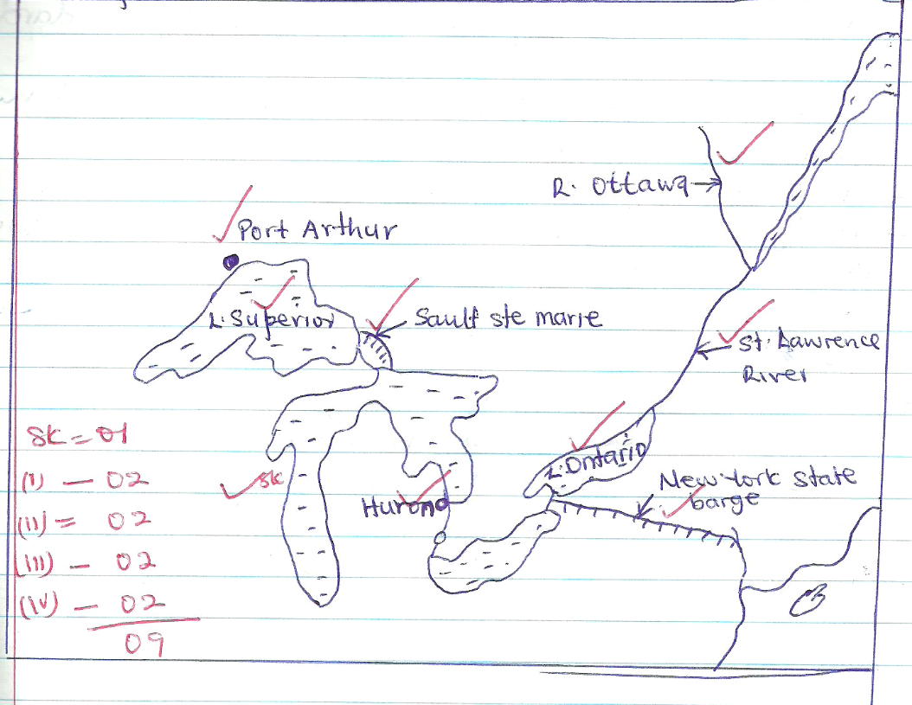

b) Reasons why the St. Lawrence Seaway was constructed.
- To open up the rich interior hinterland
- To improve navigation in the Great lakes region
- To provide a cheap transport of bulk materials such as wheat, timber, Iron ore etc.
- To generate H.E.P
- To control flooding of R. St. Lawrence
- To promote industrial development in the region Any 4 = 04mks

c) Benefits of the St. Lawrence sea way to U.S.A and Canada.
- It has provided cheap transport for bulk materials such as timber, wheat, iron ore etc.
- It has led to development of industries/industrialization.
- It has led to the development of ports/urbanization such as Chicago, Montreal etc.
- It is a source of employment
- It is a source of income/improved standards of living.
- It is a source of revenue to the gov’t in form of taxes.
- It is a tourist attraction
- It promoted trade between the interior with other countries
- It has created regional cooperation between U.S.A and Canada.
- It has led to the exploitation of agriculture and mineral resources
- It is a source of foreign exchange 3 X 2 = 06mks

d) Problems which are still facing the people using the St. Lawrence Seaway.
- Freezing of water bodies during winter i.e. (Nov – April)
- Dense fog especially at the mouth of St. Lawrence River.
- Some sections are still narrow and shallow to allow large ships to sail through.
- Accidents due to oil spills
- Delays at the ports due to numerous locks
- Silting of the canals
- Poor visibility due to smog
- Congestion Any 6 = 06mks T = 25mks

6 (a)
Means of Transport
i) Subway (underground trains) 01
ii) Train ≅ 32⁰ 01

iii) Bus X 360 = 21.6 ≅ 32⁰ 01

iv) Ferry X 7.2 ≅ 7⁰ 01

v) Others X 360 ≅ 47⁰ 01 T = (05 marks)

A PIE CHART SHOWING THE RELATIVE IMPORTANCE OF EACH MEANS OF TRANSPORT IN NEW YORK CITY.
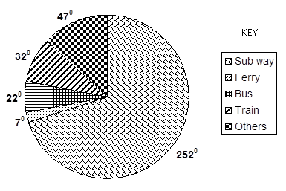 Accuracy = (05marks)

b) Give three reasons favoring the most utilized means of transport in Manhattan, New York.
- Cheapest mode of transport
- Works on a time table
- Carries many people at ago
- It saves time (03marks)

b iii) Describe the problem faced by the transport sector in New York city.
- Traffic congestion leading to delays along roads.
- High cost of constructing bridges and tunnels
- Transshipment from ferry to land is costly and time wasting
- High transport fares
- Accidents
- Fog leading to poor visibility
- Congestion at ports leading to delays 3 X 2 = (06 marks)

c) Explain the effects of the transport sector on the environment
- Pollution from the vehicles emitting fumes.
- Poor visibility due to smoke and smog
- Creation of barren land where rocks were excavated.
- Global warming/increased temperatures due to emission of gases.
- Loss of bio-diversity i.e migration of animals and bird species due to pollution.
- Encroachment on land for other land uses.
- Development of trade within the country and abroad.
- It facilitates movement of people and goods.
- International co-operation.
- Urbanization.
- Source of income
- Employment opportunities 3 X 2 = (06 marks)

T = (25marks)

7 a) (i) Fishing grounds
D; North West Atlantic
E: North East Pacific 02

(ii) Ocean Currents
A : North Pacific Currents
B: Labrador Current (cold) 02

(iii) Rivers
1: Mississippi
2: Mackenzie 02

(iv)Bay
C: Hudson 01

Identification of the ground (01 mark)
08marks
b) Explain conditions favoring fishing
- Mixture of warm and cold currents
- Presence of planktons
- A shallow continental shelf allowing penetration of Sunshine
- Fresh water allowing breeding
- Various species of commercial value
- Natural harbors allowing port construction
- The cool temperatures presenting fish from going bad quickly
- Presence of many offshore islands which act as fishing grounds.
- Many forests for making boats/vessels
- Indented coastlines for breeding of fish.
Identification (5)
Explanation (5)
Any 5 x2 = (10 marks)

C (i) Benefits of the fishing industry
- Led to growth of ports/towns/urbanization
- Led to industrialization
- Used as medicine
- Used to make fertilizers
- Source of food
- Source of employment
- Source of income
- Source of foreign exchange
- Improves international relations Any 5 x 1 = (05 marks)
- Source of raw materials for industries
- Economic diversification
(ii) Modes of transporting fish
- By road/use of vehicles
- By air/planes
- By water/ship
- By railway/trains Any 3= (03 marks)
T = (25marks)

8 a) Glaciations is the process of erosional, transportation and deposition of materials caused by moving ice (02 marks)
ii) Give two ways through which glaciers erode.
- Plucking
- Abrasion (02marks)
iii) The factors which influence the down ward movement of glaciers in Switzerland.
- Thickness of the glacier
- The load of the glacier
- Gradient of the slope
- Temperature of the glacier (04marks)
b) i) Any two glacial erosion features
Arêtes, cirques, pyramidal peaks, hanging valleys, U-shaped valley (02marks)
ii) Glacial depositional features in Switzerland
Moraine, moraine plains, kettles, Drumlins (02marks)

c) Explain the importance of glaciations to the economy of Switzerland.
- Beautiful scenery leading to development of tourism
- Glacial lakes that favor fishing
- Deposited soils favor agriculture
- U-shaped valleys favors settlement and dairy farming
- Rivers promote power generation due to presence of water falls.
- Source of water for both home use and industries
- Rivers promote transport
- Industrial development due to power generated.
4 X 2 = (08 marks)
d) Outline the problems associated with glaciation in Switzerland
- Avalanches lead to loss of life and destruction of property
- Infertile soils on upper slopes limiting agriculture
- Blockage of transport network
- Flooding in the lower areas
- Water falls limit navigation. (05 Marks)
T = 25marks
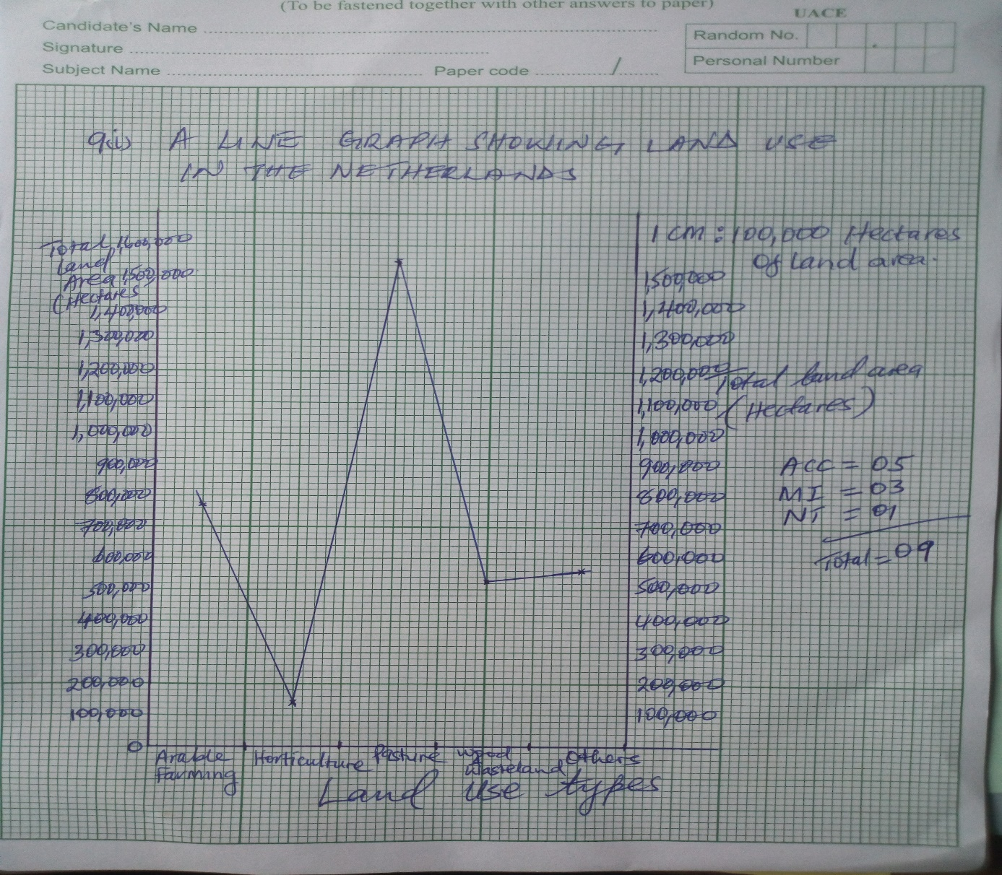
(b) Reasons why a large part is under pasture
- Grass improves soil fertility of reclaimed areas from the sea.
- It improves on areas below sea level with high water tables
- Soil infertility and saline support pastures
- Government policy to specialize in ranching or dairy farming
- Maritime climate is good for dairy farming
- Grass is used as fodder for livestock
- The area is generally flat for easy movement of animals and paddocking
Any 3 X 2 = 06mks

- i) Any two types of dairy cattle
- Black and white Fresian /Holland breed
- Red and white Meuse/Rhine Yosel breed Any 2 X 1 = 02mks
ii) Describe conditions for dairy farming
- Enough flat land on polders which allows mechanizations
- There is cultivation of fodder to feed the animals especially in winter
- Mud winter conditions that favour dairy cattle.
- Presence of market both within and outside Netherlands
- Presence of enough skilled labour force
- Availability of sufficient capital to buy farm inputs
- Presence of folder land into which dairy farms were established
- Presence of research into improved breeds
- Presence of processing industries. Any 5 X 1 =05mks
- Problems facing dairy farming
- Winter frost
- Pests and diseases
- Competition for market
- Competition for land with other activities like horticulture
- Inadequate skilled labour
- High production costs such as machines which are expensive
- Price fluctuations due to competition for market.
- Products are highly perishable. Any 3 X 1 = (03marks)
Total =25marks

- a)
- A – River Lippe
B – River Rhine 02 marks
- 1 – Dortmund EMS Canal
2 – Lippeseite Canal
02 marks
- T – Dusserdorf
U – Essen
S – Duisburg 03 marks
(b) Describe factors favouring coal mining
- Presence of high grade coal that is used as a source of energy in homes and industries.
- Presence of well-developed transport system for example roads, railway lines and canals like Lippeseite canal that ease the transportation of coal to market centres.
- Availability of adequate skilled labour force which is well experienced in using the machines.
- Supportive government policy which encourages mining in Germany through provision of incentives like tax holidays.
- Availability of high level of technology developed for example automation of machines in mines.
- The Ruhr coal fields especially in the exposed coal field in the South was easily mined using open cast method of mining.
- Presence of a large market for coal given its various uses.
- The large volumes of water provided by rivers for use by machines.
- Presence of large reserves where coal mining takes place.
- Presence of various types of coal eg peat, lignite Bitumen with wide products.
07 marks
c) Explain conditions for decline in Coal.
- Coal mining has declined because of exhaustion of coal especially in the exposed coal fields.
- Competition from other sources of energy like thermo energy, H.E.P, oil etc reducing its demand.
- The rising mining costs have discouraged mining of coal especially in the concealed coal field in the north of Ruhr region.
- Rising costs of mining due to depth.
- There has been great improvement made in technology which has necessitated use of less coal burnt to produce the required energy especially in the iron and steel industry.
- Reduced Cheap labour to be employed in coal mining became scarce since majority is now engaged in industries rather than coal mines.
- Germany also imports coal at a cheap cost from world leading coal producers e.g U.S.A.
06 marks
(d) Effects of coal mining on Physical environment
- It has led to the destruction of vegetation in mining fields.
- It has limited agricultural land.
- Air and water pollution by coal dust and wastes.
- Coal mining has led to the creation of depressions and heaps which have degraded land.
- Mining has accelerated soil erosion due to clearance of the vegetation / Landslides.
- Hollows have become breeding ground for pests
- Deposition of wastes has created wasteland
- It has led to the destruction of the soil structure. (05 marks
- 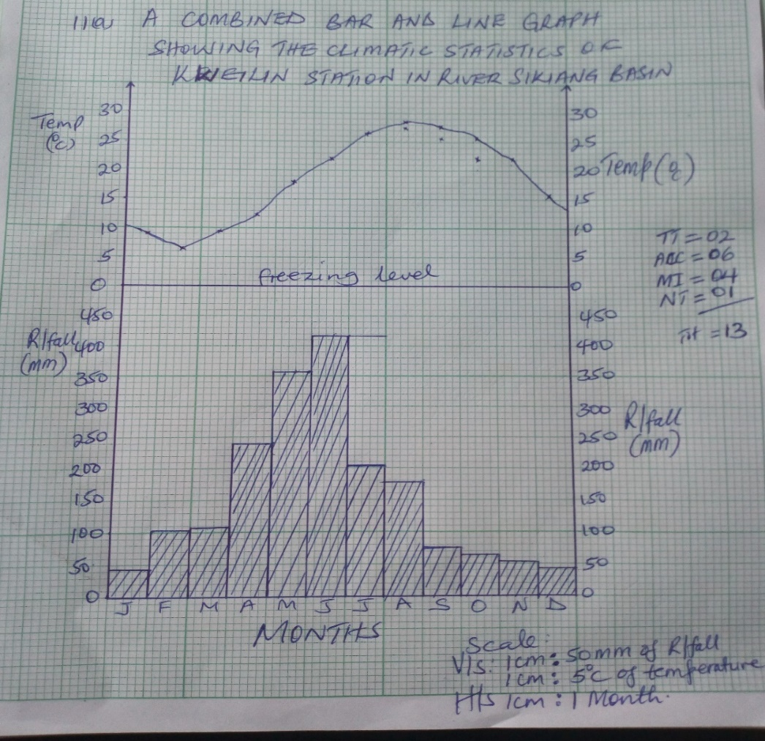
- (i) Annual range of temperature
(28.5 – 6.8)⁰C = 21.7⁰C 01mark

(ii) Mean annual rainfall
41 + 102 + 109 + 239 + 358 + 417 + 203 + 178 + 76 + 53 + 41 + 66
1

= = 1883mm
02marks

(iii) Mean annual temperature
9 + 6.8 + 9.6 + 12.3 + 18.2 + 22.1 + 26.3 +28.5 + 27.7 + 25.9 + 22.3 + 15.5
12
=

= = 18.7⁰C 02marks

(c) Economic activities taking place in the area.
  - Heavy rainfall has led to excessive growth of trees leading to lumbering/forestry.
  - Heavy rainfall/wet has led to crop growing e.g. rice
  - Heavy rainfall has provided water for rivers and this has supported navigation i.e. water transport.
  - High temperatures have favoured the ripening of crops
  - Heavy rainfall/wet season has led to the existence of lakes and rivers where fishing can take place.
  - Heavy rainfall has led to the existence of forests which are tourist attraction leading to the tourism industry
  - Excessive growth of trees has led to the development of Industries related to processing of wood products.
  - Excessive growth of trees has led to bee keeping. Any 4 X 1 = 04mks

- Problems faced by the people living in the surrounding areas.
  - Hot and humid conditions have favoured the existence of pests like Mosquitoes and water snails.
  - Diseases like malaria and bilharzia
  - Flooding of the river valleys which destroys crops
  - Poor road transport in the river valleys
  - Heavy rainfall has accelerated soil erosion which hinders farming
  - Saltation of rivers and canals has affected navigation.
  - Rainfall seasonality has necessitated the construction of dams to conserve water.
03 marks
12. (a) Any two communes.
Gele, Chaunshan, Dai Yunan commune in South West China. Ping Chau commune. (02 marks)
(b) Characteristics of communal /collective farming.
- Farms are managed communally or by a selected committee.
- Farms are highly merchandised.
- The profits are shared among the members.
- Marketing of the produce is controlled by the state.
- Farms are amalgamated into larger farm units either voluntarily or compulsory.
- Farmers engage in production of specified crops. (06 marks)

c) Explain the factors that favoured the establishment of agricultural communes.
- Relief in North East China is relatively flat and favors the development of big merchandised farms favorable for communes.
- They are large farms in N.E China which are more productive than those in South East parts.
- The South East is more densely populated than the NE thus leaves limited land for communal farming.
- In the South East there are more activities like industries as compared to agricultural activities in the N.E. This makes communal farming more concentrated in the agricultural land.
- Fresh water for irrigation is got from river Huang He.
- Fertile alluvial soil in the river basins supports growth of several crops.
- Cheap and abundant labour to work on the farms.
- Adequate capital to invest in agriculture. (06 marks)

d) (i) Benefits of commune farming.
- Improved farming techniques through research, crop breeding, and application of fertilizers.
- The system has eliminated land fragmentation and associated problems such as land conflicts.
- Increased output and better quality of produce hence promotion of self – sufficiency in food requirements.
- Development of agro – based industries such as wheat mills, rice mills, providing employment to a number of people.
- Created employment opportunities to people involved in crop research, farm managers, and transport.
- Foreign exchange has been earned through exporting rice, wheat to countries such as Saudi Arabia, Kuwait and others.
- Promoted diversification of the economy reducing reliance on oil mining.
- Idle land has been put to use particularly in the West into productive use through irrigation farming.
- It has encouraged easy provision of social services like health care, education and transport services to the people. (06 marks)

- (ii) Problems facing the commune farming in China.
- Dry conditions in the West limits agriculture.
- Floods in river basins destroys crops.
- Pests such as caterpillars, aphids destroy crops affecting output.
- Diseases such as fungal diseases, wilting attack crops lowering quality and output.
- Infertile soils in the West limit crop cultivation lowering crop output.
- Steep relief in the mountainous regions limit transport of agriculture.
- Limited land for extensive farming due to land fragmentation.
- Limited cooperation between members in the farming communes lead to low crop yields. (05 marks)

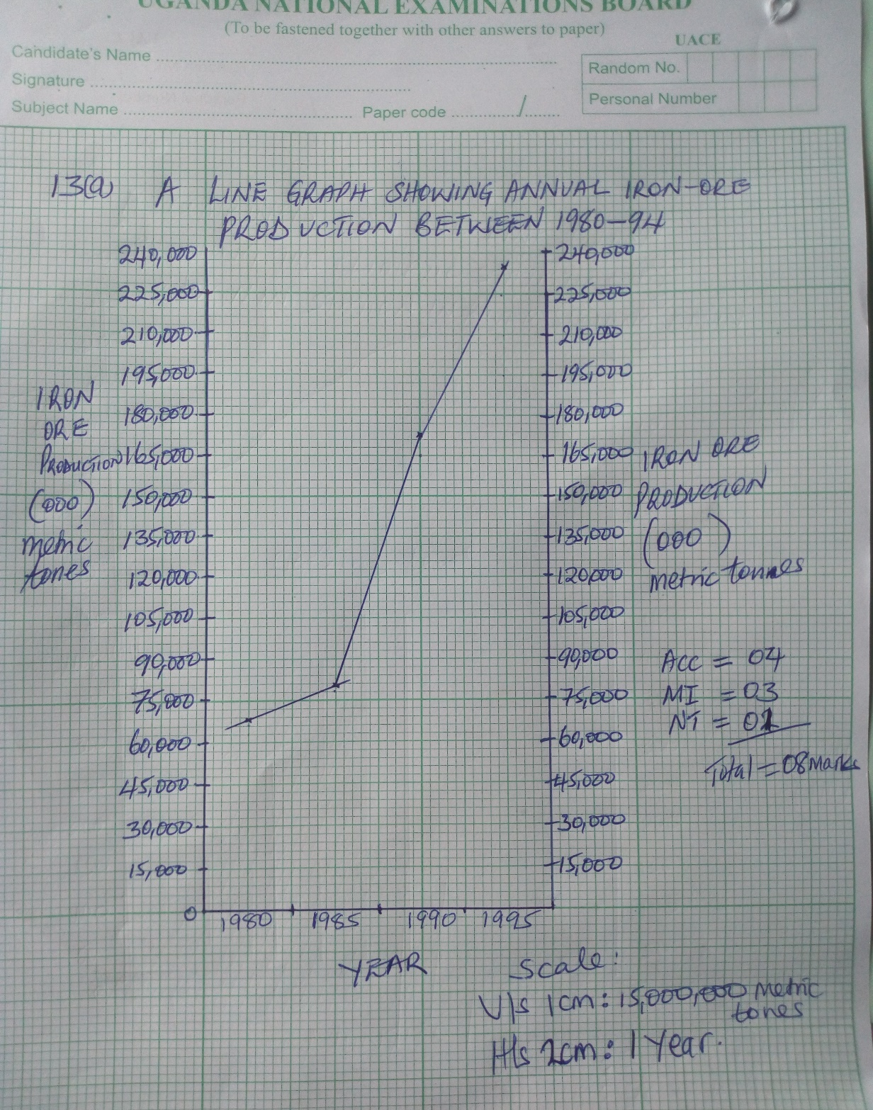
B (i)the trend of Iron ore production
- Between 1980 and 95, there has been an increase in Iron ore production.
- Highest increase is between 1985 and 1990 02mks
ii) Between 1980 -1990, consumption is higher than production.
Between 1990 – 95, production is higher than consumption. 02marks
OR
-Between 1980 to 1995 consumption increased as production increase
- In 1995 production increased as consumption declined

C (i) Manchuria, Yunnan 01mark

(ii) –The factors that have favoured the production of iron ore in china include;
- Presence of Iron ore deposits in large quantities
    - Presence of various sources of energy like H.E.P, coal etc. used in the production process
    - Accessibility of the mining areas by road and rail for easy transportation.
    - Presence of water from rivers used in the industry
    - High levels of technology employed in mining and processing
    - Availability of market where Iron products are sold.
    - Presence of capital to invest in Iron production favorable government policy of industrialization
    - Presence of skilled and unskilled labour to work in the mines and industries.
(07marks)
  - Contribution of Iron ore mining
    - Source of raw materials to industries
    - Source of employment
    - Source of income which improve S.O.L
    - Has led to urbanization
    - Source of foreign exchange from exports
    - Has led to economic diversification. (05 marks)

End

