273/2
Geography
Paper 2
July/August 2019
2 ½ hours

KAYUNGA SECONDARY SCHOOLS EXAMINATION COMMITTEE
Uganda Certificate of Education
JOINT MOCK EXAMS
GEOGRAPHY
PAPER TWO
2 HOURS 30 MINUTES

INSTRUCTIONS TO CANDIDATES
- Answer four questions only.
- Choose two questions from part I and two from part II
- In part II, only one question should be chosen from any one region.
- Any additional question(s) answered will not be marked

PART 1
THE REST OF AFRICA
Answer Two questions in this part
1. (a) Draw a sketch map of Africa and on it mark and name;
(i) The great African rift valley
(ii) Atlas mountain ranges
(iii) Port Alexandria
(iv) River Orange
(v) Tropic of cancer (07 marks)
(b) Describe the process of formation of either the African rift – valley or a gorge. (08 marks)
(c) Outline the importance of one of the land form features identified in (b) above. (04 marks)
(d) Explain the problems facing the people living in areas where the features identified in (b) are found. (06 marks)

2. Study the figure 1 map of the republic of South Africa and answer questions that follow.
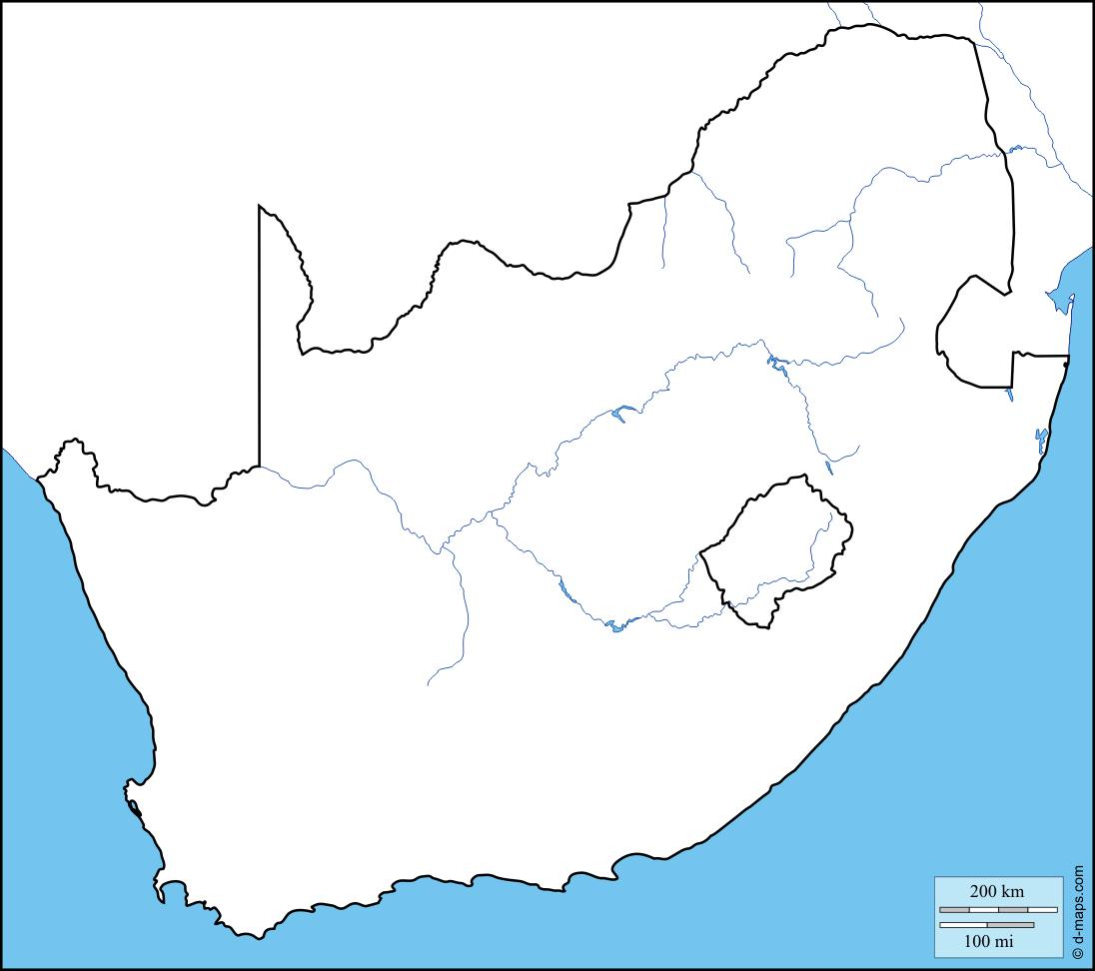

C
B
F

E
A
D
INDIAN OCEAN
R. ORANGE
NAMIBIA
BOTSWANA

Name the;
- Countries A and B (02 marks)
- Towns E and F (02 marks)
- River C (01 mark)
- Port D (01 mark)

(b) Describe the factors that have favoured industrialization in either town E or F. (08 marks)
(c) Outline the problems facing the industrial sector of south Africa.(4 marks)
(d) State the;
(i) importance of the industries to South Africa. (04 marks)
(ii) effects of the industries to the environment in South Africa. (03 marks)
3. Study the table 1 below showing acres of forest cover destruction in selected African countries and answer questions that follow.
Country | Year
 | 1995 | 2000 | 2005 | 2010
Swaziland  DR Congo  Ivory coast  Namibia  Liberia | 3,600  49,800  6,100  4,120  4,500 | 2,100  40,300  5,700  3,200  4,320 | 2,000  32,600  4,180  3,120  3,200 | 1,300  18,900  3,900  2,800  2,000

(a) Calculate the percentage change in forest cover destruction between 2005 to 2010. (05 marks)
(b) State the country with;
(i) highest forest over destruction (01 mark)
(ii) least forest cover destruction (01 mark)
(c) Draw a line graph to represent the country with the highest forest cover destruction. (07 marks)
(d) (i) Explain the reasons for rapid destruction of natural forests in Africa. (08 marks)
(ii) State the problems resulting from destruction of Natural forests in Africa (03 marks)
4. (a) Draw a sketch map of Ghana and on it mark and name;
(i) Rivers: White and Black volta
(ii) Ports: Tema and Accra
(iii) Lake Volta
(iv) Bui dam (07 marks)
(b) Explain the factors that favoured the growth of Accra as a port.(08 marks)
(c) Describe the advantages of using road transport over other transport types. (06 marks)
(d) State the factors limiting the use of water transport in Africa. (04 marks)

PART II
STUDIES IN DEVELOPMENT
NORTH AMERICA
5. (a) Draw a sketch map of the area covered by the Tennessee Valley and on it
mark and name;
- Rivers: Mississippi and Ohio
- Dam: Kentucky
- State: Alabama
- Town: Nashville. (06 marks)
(b) (i) What is a multi – purpose project? (01 mark)
(ii) State any other two multi – purpose projects in North America. (02 marks)
(c) Explain what caused soil erosion in the Tennessee valley region. (8marks)
(d) Outline steps that were taken to solve the problem of soil erosion in Tennessee valley region. (04 marks)

6. Study the figure 2, a sketch map of the Canadian prairies and answer the questions that follow.
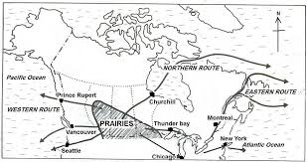
X
A
3
2
1

C

B
(a) Name the;
(i) Ports B and C
(ii) Town A
(iii) Provinces 1, 2, 3
(iv) Water body X (07 marks)
(b) Name any two cereal crops grown on the Canadian prairies apart from wheat. (02 marks)
(c) Describe the factors that favoured wheat growing on the Canadian prairies. (08 marks)
(d) (i) Outline the problems facing wheat farmers on the prairies (04marks)
(ii) State the changes that have taken place on the Canadian prairies (04 marks)
7. Study the table 2 showing the number of tourists visiting New England and answer the questions that follow.
State | No. of tourists to New England in ‘000’ | Continent of origin %
State | No. of tourists to New England in ‘000’ | Africa | Asia | Europe | N.America
Massachussetts  Connecticut  Maine  Vermont  Rhode island | 241  164  173  83  213 | 04  06  02  0.2  05 | 19  28  31  15  17 | 68  40  34  38  43 | 13  27  42  33  29

(a) Draw a bar – graph to represent the number of tourists to the states of New England. (08 marks)
(b) (i) State reasons why there are few tourists from Africa to New England. (02 marks)
(ii) Outline any two tourist attractions found in New England.(2marks)
(c) Explain factors that have favoured the growth of the tourism industry in New England. (08 marks)
(d) Outline the problems facing the tourism industry in New England. (05 marks)
REGION II
RHINE LANDS
8. (a) Draw a sketch map of Switzerland and on it mark and name.
(i) Relief regions: Jura, Swiss plateau, Alps
(ii) Rivers: Rhine and Ticino
(iii) Towns: Champery and Basel. (09 marks)
(b) (i) Define factory farming (01 mark)
(ii) State any two types of livestock reared and two crops grown in
Switzerland. (04 marks)

(c) Explain the factors that have favoured arable farming in Switzerland. (08 marks)
(d) Outline the importance of farming to the economy of Switzerland. (03 marks)
9. Study the table 3, showing types of cargo transported along the Rhine water – way and answer questions that follow.
Types of cargo | Amount in Tonnes
Types of cargo | 2000 | 2005
Military hardware  Glass – ware  Chemicals  Foods and beverages  Oil and wood products | 382,000  413,000  390,000  470,000  730,000 | 706,000  502,000  516,000  621,000  612,000

(a) Draw a pie – chart to show the relative importance of the types of cargo handled by the Rhine water way in the year 2005. (07 marks)
(b) Explain the problems experienced on the Rhine water – way. (08 marks)
(c) State the measures taken to solve the problems on the Rhine water – way. (04 marks)
(d) Describe the benefits of the Rhine water – way to Germany. (06 marks)

10. Study the figure 3, map of Netherlands and answer questions that follow.
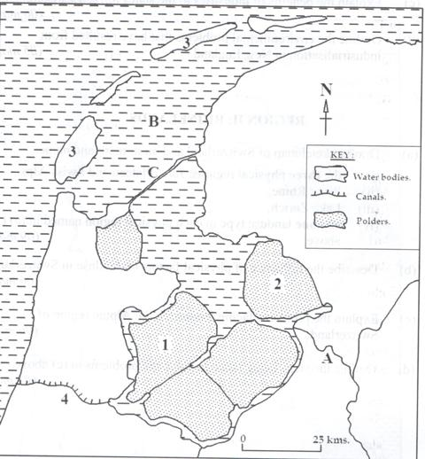
NORTH SEA
5
1
W
T
Y

Z
X
X

(a) Name the;
(i) Lake Y
(ii) Canal T
(iii) Polder 1 and 5
(iv) Port W
- Dam Z
- Island X (07 marks)
(b) Describe the factors that favoured the growth and development of Amsterdam port. (08 marks)
(c) Outline the functions of Amsterdam port and city in Netherlands.(4marks)
(d) (i) State the problems facing Amsterdam port and city. (04 marks)
(ii) Outline any two commodities handled by the port of Amsterdam. (02 marks)

REGION III
CHINA
11. Study the table 4 below showing types of fish caught in China and answer questions that follow.
TYPE OF FISH | AMOUNT CAUGHT IN TONNES
Japanese seerfish  Silver cap  Balkhash  Yellow perch  Cod fish | 2,060,000  2,670,000  3,720,000  1,860,000  1,200,000

(a) Draw a pie – chart to represent the types of fish caught in China. (08 marks)
(b) Describe any one commercial method used for catching fish in china. (08 marks)
(c) Outline the problems facing the fishing industry in china. (04 marks)
(d) State the measures taken to improve fishing in china. (05 marks)

12. (a) Draw a sketch map of Manchuria and on it mark and name.
(i) Rivers: Skianga
(ii) Mining centres: Penki, Fushun
(iii) Towns: Dairen, Harbain
(iv) Port: Hong kong. (07 marks)
(b) Describe the factors that have favoured industrial growth in any one town
of china. (08 marks)
(c) Outline the problems facing the industrial sector in china. (05 marks)
(d) (i) State any two types of industries found in china. (02 marks)
(ii) Outline the measures taken by the Chinese government to solve problems facing the industrial sector. (03 marks)

13. Study the figure 4, map of China showing population distribution in China and
answer questions that follow.
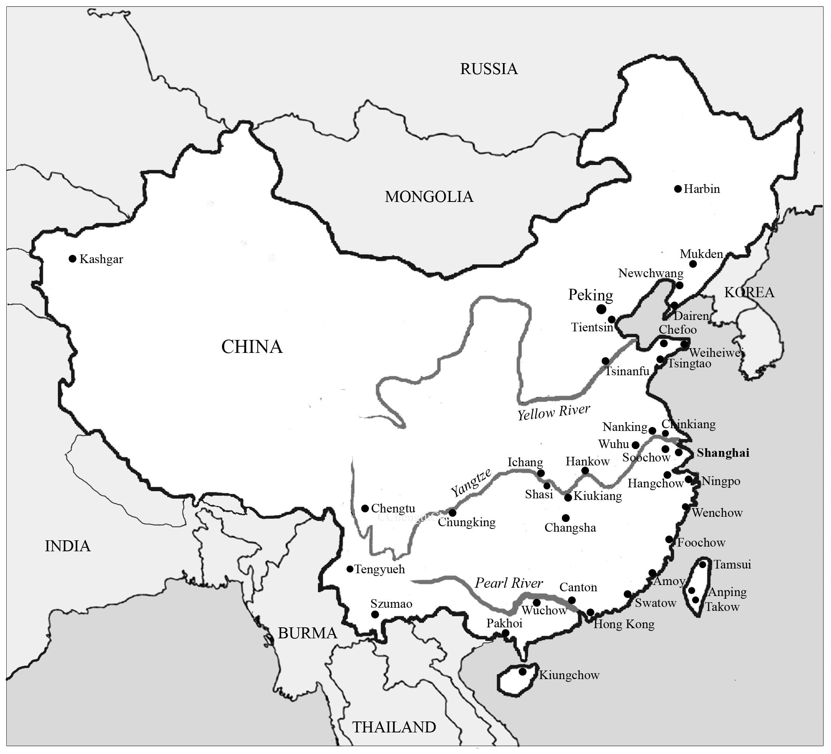
X
F
D

A
B
C

(a) Name the;
(i) Port A
(ii) Water body X
(iii) Rivers B and C
(iv) Canal D
(v) Mountain F (06 marks)
(b) Describe the factors that have favoured rapid population growth in China. (08 marks)
(c) State the;
(i) advantages of having a big population size in china (4marks)
(ii) disadvantages of having a very big population size in china. (04 marks)
(d) Outline reasons why Northern china is sparsely populated compared to
other regions. (03 marks)
END

