NOAH’S ARK LWEBITAKULI SEC. SCHOOL
273/2 GEOGRAPHY PAPER 2
MID TERM 1 EXAMINATION 2019
TIME: 2HRS
Instructions to candidates.
Answer four questions in all.
Two questions should be chosen form part I and two from part II.
In part II not more than one question may be chosen from any one region.
PART 1
REST OF AFRICA
- Study the sketch map of Africa below showing natural vegetation and all latitudes and answer the questions that follow:
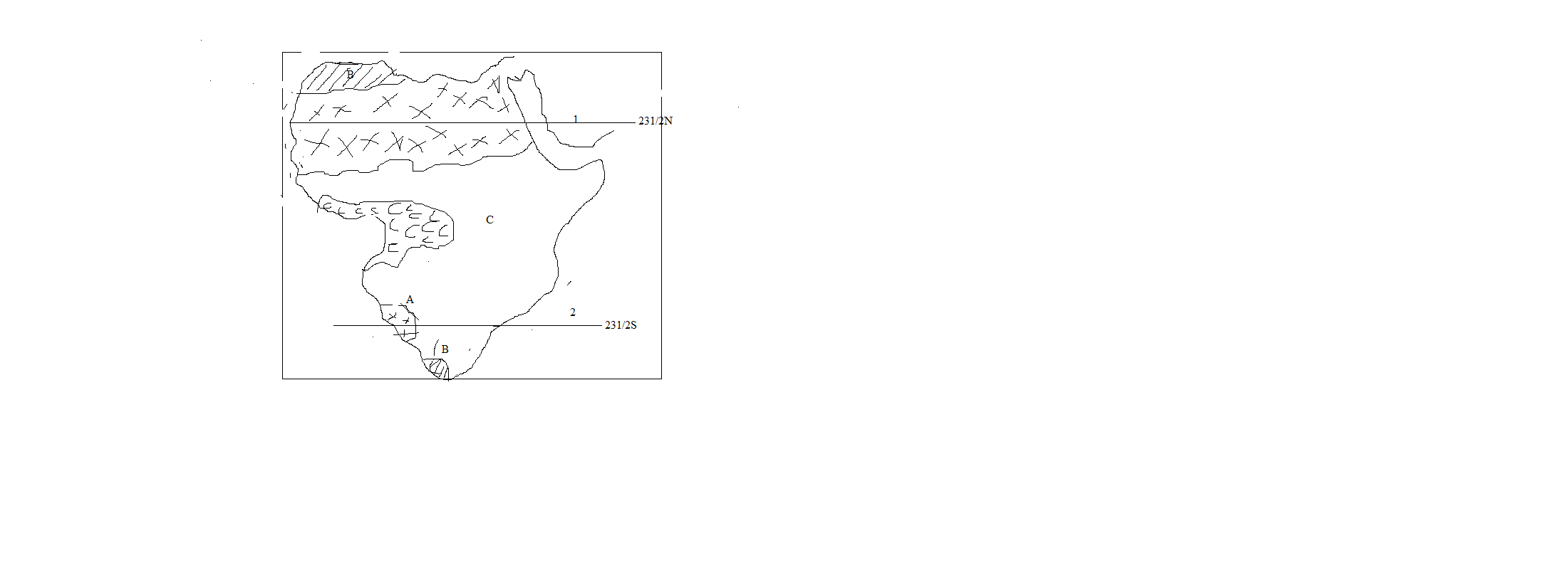
- i).Name the vegetation zones marked A, B, C and D.
ii).Latitude marked 1 and 2.
- Describe the characteristics of the vegetation type marked either A or D.
- i).Identify the economic activities taking place by people living in vegetation type marked D in a (i) above.
ii).What problems face the people carrying out the economic activities identified in C (i) above.
- For any one country found in the region marked either A or D, explain the steps taken to improve the human activities.
- Study table one below showing Africa’s population growth rate between 1950 and 2000 in millions people.
TABLE 1
Africa’s population growth rate between 1950 to 2000 in millions.
YEAR | POPULATION (MILLIONS
1950 | 199
1960 | 270
1970 | 344
1980 | 453
1990 | 616
2000 | 818

- i).Calculate the percentage change in population between 1950 and 2000.
ii).Describe the trend of the population of Africa between 1950 and 2000.
iii).Give reason for the trend described above.
- Draw a line graph to illustrate the population growth rates of Africa between 1950 to 2000.
- Explain the problems caused by high population growth rate in Africa.
- Suggest measures to the problems caused by high population in Africa.
- Draw an outline map of Ghana and on it, mark and name;
- i).Cocoa producing area.
ii).The railway line
ii).Ports Takoradi, Tema, and Accra.
iv).Akasombo dam and Lake Volta.
- Describe the conditions that have favoured cocoa growing in Ghana.
- What are the problems that are facing cocoa growing in Ghana?
- Explain the measures being taken by the government of Ghana to address the problems.
- Name other three countries in Africa producing cocoa.
- Draw the sketch map of Africa and on it, mark and name;
  - i).Multi-purpose river project; Aswan high dam, Akasombo, kariba and Orange River scheme.
ii).The Nile delta and SuezCanal.
  - For either Aswan high dam or Akasombo;
Describe the factors that favoured the establishment of the dam chosen in (b) above.
  - Explain the contribution of the dam to the development of the region.
  - Outline the problems caused by the establishment of the dam.
- Table 2 below shows gold production in Africa and the rest of the world 1975.
TABLE 11
Country | Tonnes | Percentages (%)
South Africa | 758.5 | ………………………….
Ghana | 21.4 | 1.5
Zimbabwe | 18.6 | 1.3
Congo | …………………………………. | 0.4
Rest of the world | 651.1 | 44.7
World total | 1454.0 | 100.0

- i).Calculate the percentage of the world gold produced bySouthAfrica.
ii).Calculate the amount of tonnes produced by Congo.
- Draw a pie chart to show the percentage of gold production in Africa and rest of the world (1975).
- i).Name any two states in SouthAfrica where gold is mined.
ii).Name any one mineral which is mined with gold.
- Describe the factors that have favoured mining of gold in SouthAfrica.
- What problems are faced by mining sector in Africa?
- Study the outline sketch map of Egypt and answer the questions that follow:
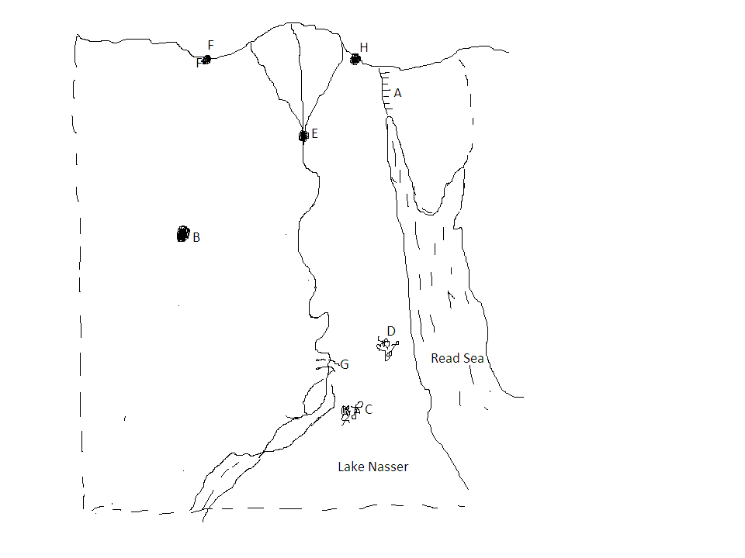

  - Name:
  - Canal marked A.
  - Industrial towns E, F and H.
  - Mineral obtained from areas marked B, C and D.
  - Dam marked G.
  - Explain the condition which has led to the development of industries in Egypt.
  - Mention any two industries found in town marked;
- E
- F
  - i).Identify the benefits resulting from the establishment of industries from the industrial town mentioned in (b) above.
ii).Outline the problems resulting from the establishment of industries.

PART II: STUDIES IN DEVELOPMENT.
Answer two questions from this part.
REGION 1: NORTH AMERICA

- Study the sketch map of great lakes region and answer questions that follow:

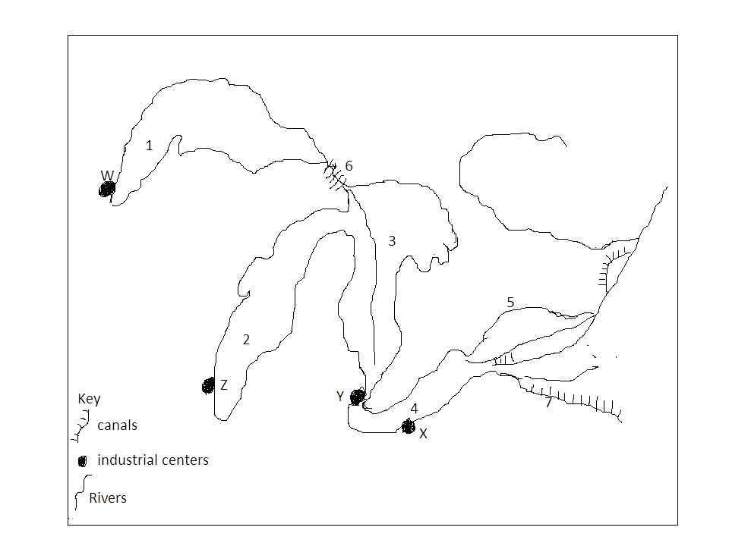

  - Name the:
  - Lakesmarked 1, 2, 3 and 4.
  - Canal marked 6 and 7.
  - Industrial towns marked W, X, Y and Z.

  - Identify two industries in any one of the industrial centers in in (a) (iii) above.
  - Describe the factors that have led to growth of industrial cities marked in (a) (iii) above.
  - Explain the contribution of industrial sector to the development of great lakes region.

- Study table III below showing Canadian wheat export routes.

TABLE III
Routes | Percentage of wheat exported
Eastern | 51
Western | 45
Northern | 04
Total | 100

- Draw a pie chart to illustrate the relative importance of Canada’s wheat export routes.
- Name any:
- One port found at the terminal of each export route.
- Three wheat growing provinces in Canada.
- Two countries which import Canadian wheat.
- Explain the physical factors that have favoured wheat growing in Canadian prairies.
- Explain the contribution of wheat growing to the development of Canada.
- Study the sketch map of California below and answer the questions that follow.
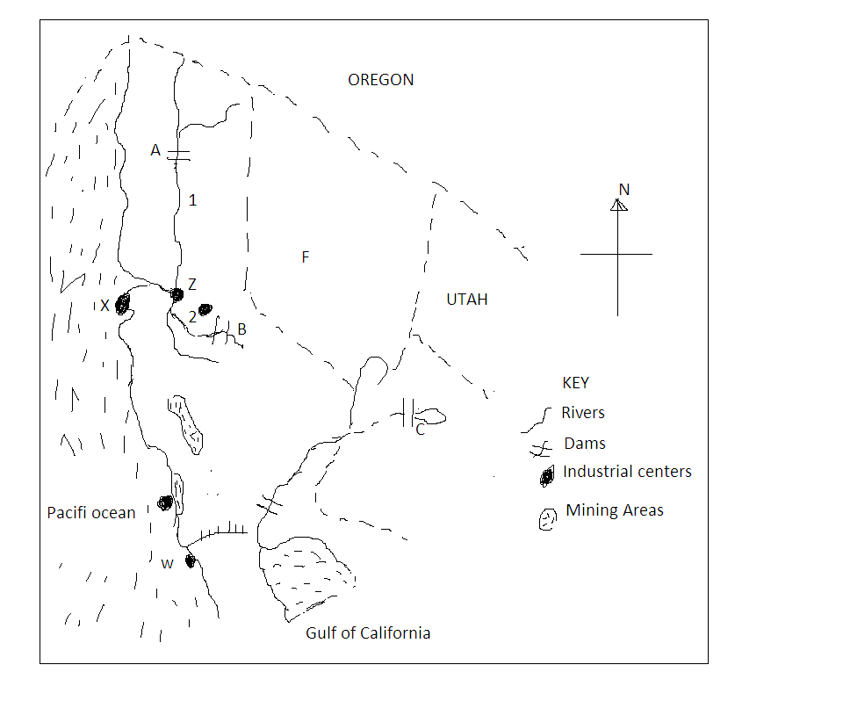

  - Name the;
  - Rivers marked 1 and 2
  - Dams marked A, B and C.
  - Industrial centers X, W and Z.
  - State marked F.
  - Name any two types of industries found in California.
  - Describe the conditions which have favoured industrial development in California.
  - What are the contributions of the industrial development in California?

REGION11: RHINELANDS
- Draw a sketch map of Switzerland and on it mark and name:
- i).Physical region; Jura, Alps and Swiss plateau.
ii).Tourist centers: Zurich, St. moritz and Lugano.
iii).Lakes; Constance, Geneva, Neuchâtal.
iv).Rivers; Rhine and Rhone
- State any;
- Two tourist attractions in Switzerland.
- Three tourist activities in Switzerland.
- Explain the factors that have favoured tourist industry in Switzerland.
- Why tourism is less developed in east Africa compared to Switzerland.
- Read the passage below and answer the question follow.
“Many countries in the world are land locked, Switzerland inclusive. Accessing international market is very expensive and difficult. The countries must devise various means to coup up with such situation; some have poor agriculture and mineral resources”.
- i).What is a land locked country?
ii).Explain how Switzerland has tried to solve her problem of being land locked.
- Explain how Switzerland despite of having few valuable mineral resources has been able to develop industries.
- Why is agriculture in Switzerland less developed?
- State measures taken to improve agriculture in Switzerland.
- Study table IV below showing reclamation of land in Netherlands in km² and answer the questions that follow.
CENTURY | LAND RECLAIMATION (km²)
1400-1500 | 430
1500-1600 | 730
1600-1700 | 1150
1700-1800 | 510
1800-1900 | 1200
1900-2000 | 730

Adopted Gibbs CW, The Rhine’s page 6
- Draw a line graph to illustrate the trend of land reclamation in the Netherlands.
- Name any two reclamation projects in the Netherlands.
- Identify the century when the largest land was reclaimed.
- Explain the benefits of any one reclamation projects to Netherlands.
- Identify the problems facing the projects.

END

