273/2
Geography
Paper 2

1 ½ hours

INTERNAL MOCK EXAMINATIONS 2019
Uganda Certificate of Education
Geography
Paper 2
2 hours

INSTRUCTIONS TO CANDIDATES
- This paper consists of two parts I and II.
- Answer four questions in all.
- Attempt two questions in part I
- In part II not more than one question should be chosen from any one given region.
- Any additional question(s) done will not be marked.

PART I: REST OF AFRICA

1. a) Draw a sketch map of Africa and on it mark and name: (9 marks)
i) Vegetation types: Montane,desert and Savanna
ii) Latitudes: 23½°N and 23½°S of the equator
iii) Gulf of Suez
iv) Cities: Cape Town and Cairo
b) Describe the characteristics of the Sahelian type of vegetation. (5 marks)
c) Explain the conditions that have led to the growth of the Sahelian type of vegetation in Africa. (7 marks)
d) Outline the challenges facing land use in the Sahelian vegetation zone of Africa. (4 marks)
2. Study the table below showing the area and population of South Sudan by state and answer the questions that follow.

STATE | AREA (km²) | POPULATION (‘000)
Central Equatorial | 22,956 | 1,103
Jungoli | 122,479 | 1,358
Lakes | 40,235 | 695
North Bahr-al-Ghazal | 33,558 | 720
Upper Nile | 77,773 | 964
Warap | 31,027 | 972
Total | 619,745 | 8,260

a) Calculate the: (4 marks)
i) Area of Other states of South Sudan
ii) Population of Other states of South Sudan.

b) Determine the population density of: (4 marks)
i) Central Equatoria state
ii) South Sudan
c) Draw a line graph showing the population of South Sudan by state including Other states. (7 marks)
d) i) Explain the population problems facing either Jungoli or upper Nile state.
ii) Outline the steps being taken to solve the problems in d(i) above.
(4 marks)

3. Study the map below showing part of Ghana and answer the questions that follow.

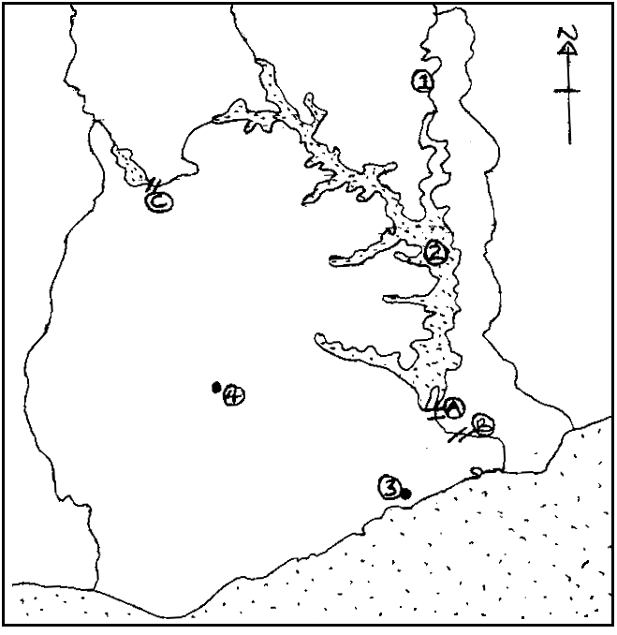

a) Name the: (7 marks)
i) Dams marked A, B and C.
ii) Water bodies marked 1 and 2
iii) Towns marked 3 and 4
b) Describe the conditions that favoured the development of any one dam named in a (i) above. (5 marks)
c) Explain the importance of dam development in Ghana. (7 marks)
d) Outline the:
i) Problems resulting from dam development in Ghana. (3 marks)
ii) Steps being taken to solve the problems in d(i) above. (3 marks)
4. a) Draw a sketch map of Morocco and on it mark and name: (8 marks)
i) Fishing grounds: Atlantic Ocean and Mediterranean Sea.
ii) Fishing ports: Agadir, Casablanca and Tangier
iii) Neighbouring countries: Spanish Sahara and Algeria
b) Describe ht physical conditions that have favoured the development of fishing in any one fishing port named in a(ii) above. (7 marks)
c) Explain the contribution of fishing activities to the development of Morocco.
(6 marks)
d) i) Outline the problems limiting the development of fishing activities in Morocco. (2 marks)
ii) What steps are being taken to overcome the problems in d(i) above?(2 marks)

PART II: STUDIES IN DEVELOPMENT
REGION I: NORTH AMERICA
(Choose one question from this region)

5. a) Draw a sketch map of California and on it mark and name the following:
i) River Sacramento and River San Joaquin
ii) Towns: Sacramento and San Francisco.
iii) The central valley
iv) Dams:Friant and Shasta
v) The delta Mendota canal (9 marks)
b) Explain the conditions which have led to the growth of market gardening in Southern California. (8 marks)
c) Outline the problems facing market gardening in Southern California.
(5 marks)
d) Outline the measures being taken to overcome the above problems.
(3 marks)
6. Study the table below and answer the questions that follow.
Table: land use in Canada (2009)

Total land area | Forest | Permanent | Arable | Others
9,093,599km2 | 34.1% | 0.7% | 5.0% | 60.2%

Adapted: 2011 World development indicators, World Bank, Washington DC pp130

a) Draw a pie chart to represent the information given in the table.
b) Calculate the total area in Canada under
i) Forests (2 marks)
ii) Arable land (2 marks)
c) i) Name any one province in Canada where forests are the dominant type of land use. (1 mark)
ii) Describe the characteristics of the forests found in the province named in c (i) above. (8 marks)
d) Explain the contribution of the forestry industry in Canada. (6 marks)

7. a) Draw a sketch map of New York and on it mark and name: (7 marks)
i) Bays: upper and lower
ii) Rivers: Hudson and Hackensack
iii) Islands: Bronx and Coney
iv) Jersey city
b) Explain the factors that led to the growth of New York as a city. (4 marks)
c) i) Give the differences between Kampala and New York city. (4 marks)
ii) Explain the problems facing the inhabitants of New York. (4 marks)
d) i) Outline the steps being taken to solve the above problems. (4 marks)
ii) Outline the:
Imports
Exports handled by New York port (2 marks)

REGION II: RHINELANDS
(Attempt one question from this region)

8. a) Draw a sketch map of the Rhine water way and on it mark and name:
i) Rivers: River Mossel, River Main
ii) Towns: Brussels, Koblenz
iii) Countries: France, Switzerland
iv) The North Sea (7 marks)
b) Describe the factors which have led to the development of the Rhine into an international water way. (8 marks)
c) Explain the importance of the Rhine water way to the development of the Rhine lands. (6 marks)
d) Outline the:
i) Problems faced by countries using the Rhine water way. (3 marks)
ii) Steps being taken to improve navigation on the Rhine water way.(2 marks)
9. a) Draw a sketch map of Switzerland and on it mark and name the:
i) Physical regions: Alps, Swiss plateau and Jura
ii) Rivers: Rhine and Ticino
iii) Tourists resorts: Lausanne, Interlaken, Moritz (9 marks)
b) State any two tourists attractions found in the:
i) Swiss plateau (2 marks)
ii) Swiss Alps (2 marks)

c) Describe the conditions which have favoured the development of the tourist industry in Switzerland. (5 marks)

d) Explain the contribution of the tourists industry to the development of Switzerland. (7 marks)

10. a) Draw a sketch map of the Netherlands and on it mark and name:
i) The North sea
ii) Lake ysell
iii) River Rhine
iv) Towns Utrecht and Rotterdam
v) Dairy farming province: South Holland, North Holland and Friesland.(9 marks)
b) Name any two types of dairy cattle breeds reared in any one province named in (a) v above. (2 marks)

c) Describe the conditions which have favoured the development of the dairy farming industry in the Netherlands. (7 marks)

d) Explain the benefits of dairy farming to the people of the Netherlands.(7 marks)

END

