112/1
ENGLISH LANGUAGE
Paper 1
2 Hours

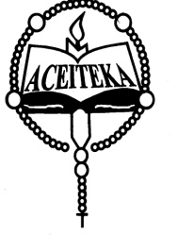
ACEITEKA JOINT MOCK EXAMINATIONS 2018
UGANDA CERTIFICATE OF EDUCATION
ENGLISH LANGUAGE
PAPER 1
TIME: 2 HOURS

INSTRUCTIONS:
The paper consists of two sections A and B
Section A is compulsory
Choose only one question from section B
Attempt two questions in all

SECTION A
- As the outgoing Head Prefect of your school, write an address you would deliver to an expectant audience. In attendance is the staff, the area member of parliament, the chairperson Board of Governors, and the head teacher.
You may consider, among other issues, your achievements, the challenges, and advice to the incoming protectorate.

SECTION B
Choose a topic and write a composition of between (500- 600) words.
2. Write a composition with a title ‘I Saw it all Happen’.
3. Describe the events of a music dance and drama competition that turned rowdy.
4. How is a marriage ceremony conducted in your culture?
5. Write a composition to end with ‘…he was the last person to put my trust in’.
6. Discuss the importance of social media in your society today.
7. Narrate a story to illustrate the saying “A stitch in time saves nine”.

END

