Name………………………………………………Index Number ……………….…Admission Number ………………..Candidate’s Signature…………………

451/2
COMPUTER STUDIES
Paper 2
March 2019
Time: 2 ½ Hours

MOKASA EVALUATION EXAMINATION

INSTRUCTIONS TO CANDIDATES

1. Type your name and index number at the top right hand corner of each printout.
2. Write your name and index number on the CD provided
3. Write the name and version of the software used for each question on the answer sheet.
4. Passwords should not be used while saving in the CD
5. Answer all questions.
6. All questions carry equal Marks.
7. All answers must be saved in the CD
8. Make a printout of the answers on the answer sheets provided.
9. Hand in all the printouts and the CD

This paper consists of 5printed pages. Candidates should check the question paper to ensure that all pages are printed as indicated and no questions are missing.

Question One
The following data is an extract of data obtained from Kahawa company records. Study the data and answer the questions that follow.
AREA | PRODUCER  ID | NAME | QUANTITY DELIVERED (KG) | TOTAL COST | TRANSPORT COST | GROSS COST | DEDUCTION | NET PROFIT
101B | 115 | John Kamau | 4562
79A | 145 | Mathew Barasa | 1254
79A | 012 | Kanuga Symon | 235
79A | 561 | Ann Wangige | 8954
101B | 016 | Joseph Kaitano | 9658
20Z | 123 | Namachanja Esther | 7895
20Z | 458 | Kerobo Betty | 456
101B | 654 | Flo Ngina | 421
20Z | 758 | Mary Nguriareng’ | 7895

a) Enter the data shown above into a spreadsheet giving it an appropriate title, center and bold across the worksheet. Save the workbook as CHAT 001. Rename the worksheet as June records (10 Marks)
b) Copy the data to a new worksheet and add the details of producer James Kirega of area 101B, ID 452 with quantity of produce of 2,700kg in an appropriate row. (1 Mark)
c) Insert double borders around every cell and every row. (2 Marks)
d) Use a function to calculate the Total cost for the producer with ID number 115 given that the price per KG of the produce is Sh.41 .00 (2 Marks)
e) Use the formula for Total cost obtained for producer John Kamau and use it to calculate the gross cost for all the farmers (2 Marks)
f) Use if function to calculate transport cost for all the producers given that transport is charged per Kg is as follows (5 Marks)
AREA | Price per kg
101B | 5.00
20Z | 3.50
79A | 4.00

g) Insert the value 20% in cell E14. Using absolute cell referencing calculate deductions, given that the deduction is 20% of the Total cost. (4 Marks)
h) Using a function calculate the Net cost, given that Net cost is Gross cost minus deductions and gross cost is Total cost plus Transport cost (4 Marks)
i) Format the columns containing currency values to currency with 2 decimal places and prefix Ksh. Rename the worksheet PRODUCE PAY. (3 Marks)
j) Arrange the records in ascending order of the producer ID. (2 Marks)
k) Copy the contents of worksheet June records to a new worksheet and rename it as Filtered. By applying suitable filter condition, display records for all producers except those from area 79A. (4 Marks)
1) Use subtotals function to calculate subtotals for the quantity delivered, gross pay and net pay from each area. (3 Marks)
m) Create an embedded pie chart showing the total quantity of produce delivered for each area .The chart should have the following details.
i. Chart title: Area Total produce delivered
ii. Legend Position: Right
Save it as CHART 1 (5 Marks)
n) Print June records, Produce Pay and Filtered in landscape orientation. (3 Marks)

Question 2
You are part of a wedding committee of your friend and you have a vast knowledge of using a computer; you are tasked to be in charge of the wedding cards. Using a desktop publishing software, design the wedding card as it appears. Name the file as W_Card. (24marks)

- Prepare the page layout specifications as follows:
- Paper size: A4 portrait (2mks)
- Grid guides (3mks)
- Column guides: 1
- Row guides: 2
- Spacing: 0.3”
- Margins guides (2mks)
- Left and right: 0.24”
- Top and bottom: 0.25”

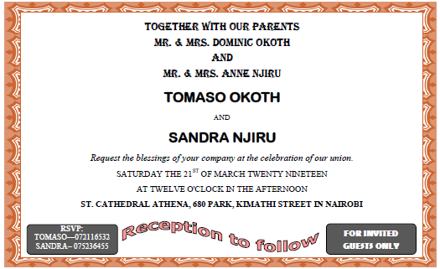

- Format the Outer heart shape in the middle part of the design to the following specifications: (4marks)
    - Color: Red
    - Outline: Light blue
    - Height: 2.64”
    - Width: 2.84”
- Perform the following formatting on the rectangle of the first part of the design.
    - Apply an outline shadow. (1mark)
    - Background Texture fill - Newsprint. (2Marks)
    - Add a glow (Accent 1, 18pt glow), glow size 25pts, and 57% transparency. (4marks)
- Change the paragraph text starting from “Request the blessings…” to color cold with line spacing of 0.75sp. (2marks)
- Format the names of the bride and bridegroom to have a strikethrough and a dotted underline. (2marks)
- Group all objects in the design. (2marks)
- Insert a page header “LOVE IS A GOOD THING”. (1mark)
- Print the publication. (1mark)

