
S.4 BIOLOGY TOPICAL TEST (TRANSPORT IN PLANTS)
Time: 1 hour 20 minutes
Instructions: Attempt All.
PART I
- The table shows results of an experiment in which small pieces of potatoes were placed in different concentrations. After four hours, they were removed from the solution, wiped to dry and weighed. The results are as shown in the table below. Study the table carefully and answer the questions that follow.
Percentage salt concentration | Percentage change in weight
2.5 | +11
5.0 | +8
7.5 | +5
10.0 | +3
12.5 | +2
15.0 | +1
17.5 | -2
20.0 | -8
22.5 | -9.5
25.0 | -11
NB: (+) sign indicates an increase in weight; (-) sign indicates a decrease in weight.
(a) Plot a graph on the graph paper below to represent the information in the table above.
(07 marks)
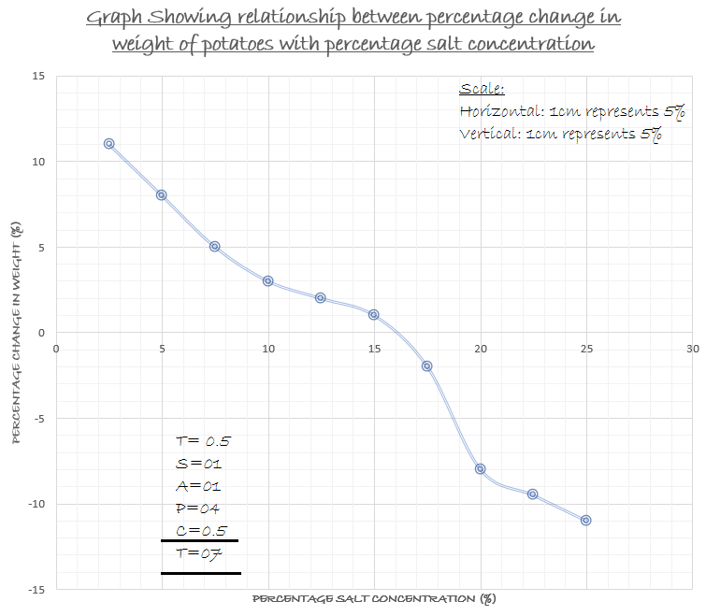
(b) Describe the shape of the graph. (04 marks)
- Initially at 2.5% salt concentration, the percentage change in weight of potatoes was high;
- From 2.5% to 10% salt concentration, the percentage change in weight of potatoes decreased rapidly;
- From 10% to 15% salt concentration, the percentage change in weight of potatoes decreased gradually;
- From 15% to 20% salt concentration, the percentage change in weight of potatoes decreased rapidly;
- From 20% to 25% salt concentration, the percentage change in weight of potatoes decreased gradually;
(c) Explain the changes in weight of potatoes:
- At 2.5% salt concentration (02 marks)
- At 2.5% salt concentration, the percentage change in weight of potatoes was highest; this is because the potatoes were highly hypertonic to the salt concentration; hence water moved from salt concentration into the potatoes; leading to increase in weight.
- Between 2.5% and 15.0% salt concentration. (03 marks)
- Between 2.5% and 15.0% salt concentration, the percentage change in weight of potatoes decreased; this is because of increasing salt concentration; that led to reduced movement of water from the salt solution to the potatoes by osmosis.
- At 25.0% salt concentration. (02 marks)
- At 25.0% salt concentration, the percentage change in weight of potatoes was lowest; this is because the potatoes highly hypotonic to the salt concentration; hence water moved from the potatoes to the salt solution by osmosis, leading to reduction in weight of potatoes.
(c) From the graph in (a) above determine the salt concentration that is isotonic to the sap. Briefly explain what happens at this concentration. (01½ mark)
- 16%
- There is no net movement of water molecules by osmosis between the salt concentration and the potatoes.
(d) What physiological process was being investigated in the experiment above? (½ mark)
- Osmosis
PART II
- a) Define the term transpiration. (01 mark)
- Transpiration is the process by which plants lose water in form of water vapour to the atmosphere.
b) Describe the process of transpiration in a leaf of a plant. (04 marks)
- During the process of transpiration, water is continuously lost from the xylem within the leaves through the mesophyll cells to the outside.; the Xylem vessels in the lamia /veins are continuous with the xylem of the main vein and stalk and those of the stalk with the stem.
- Within the leaf, water is lost from the xylem to the neighboring mesophyll cells by osmosis; It then continues from cell to cell towards the stands still by osmosis; Water movement also takes place through other pathways i.e. by diffusion along the freely permeable cell walls and cytoplasm of the neighboring cells; The temperature around the leaf heats up the water in the air space making it to evaporate; Around each stoma is s free space of air (air space); the vapor formed fills the airspaces and eventually escapes by diffusion through the stomata to the outside. (@ ½ mark)
c) Describe an experiment to demonstrate transpiration pull. (06 marks)
Experiment to demonstrate transpiration pull
Materials:
Plant shoot, glass tube, cork, water, mercury
Procedure:
- A leafy shoot is cut under water to avoid entry of air into the xylem vessels.
- The shoot is carefully fitted on to the end of a glass tube filled with water using a cork. The other open end of the tube is kept covered with a finger to keep water to the tube.
- The tube is then inverted into a trough containing half-filled mercury and the finger removed.
- The setup is then placed near an open window.
Observation:
- After a short time it is observed that the amount of water reduces in the tube and mercury rises up the tube.
Explanation:
- As water evaporates through the leaves, the amount in the tube reduced. This loss through the tube exerted a pulling effect (due to the loss) that raised mercury upwards. This pulling effect / force is shown as transpiration pull.

Conclusion:
- Transpiration pull occurs in a shoot of a plat.
d) Explain why transpiration is regarded as a necessary evil. (04 marks)
Transpiration has got a number of advantages, that include;
- Allowing continuous supply of water and mineral salts to the plant from the soil,
- Cooling the plant under hot conditions,
- Allowing the plant to get rid of excess water,
- Maintaining the cells turgid which is important in maintenance of plants structures e.g. leaves and fruits,
- Giving young and non-woody plants support above the ground because of strengthening their cells by turgidity.
However, in spite of all these advantages, excessive transpiration is dangerous to plants since it leads to their drying and eventually death.

END

