553/1
BIOLOGY
PAPER 1
JUNE/JULY 2019
2 HOURS 30 MINUTES

UCE MOCK EXAMINATIONS 2019

Uganda Certificate of Education

BIOLOGY
(THEORY)

PAPER 1

Duration: 2 hours 30 minutes

INSTRUCTIONS TO CANDIDATES:

- Answer all questions in section A and B, plus any two questions in section c.
- Answers to section A, must be written in the boxes provided adjacent to each question.
- Answers to section B must be written in the spaces provided.
- Answers to section C must be written in the answer booklets provided.

FOR EXAMINER’S USE ONLY

SECTION | MARKS
A
B
C: NO
NO
TOTAL

SECTION A:
1. A farmer usually retains a bull in the population whose ancestors have good qualities. This is an example of:
A. Natural selection B. Artificial selection
C. In breeding D. Out breeding

2. Meiosis normally results in:
i) Halving the chromosome number.
ii) Producing identical cells
iii) Maintaining the number of chromosomes.
iv) Propagation of new organism
Which of the following is correct?
A. i) and iv) B. ii) and iv)
C. ii) and iii) D. i) and iii)

3. A student complained of seeing blurred images of nearby objects, what was the eye defect and what is its remedy?
A. short sight, concave lens B. short sight, concave lens
C. long sight, convex lens D. long sight, concave lens

4. Which of the following muscles causes the arm to straighten when it contracts?
A. Triceps B. Biceps C. Erector pili D. Flexor

5. Plants convert glucose to starch after synthesis during photosynthesis because it is:
A. Not as sweet as other sugars formed.
B. source of vitamins as well as energy
C. Better source of energy than other sugars.
D. Insoluble hence can be conveniently stored.

6. Figure 2 below shows the structure of a sperm cell.

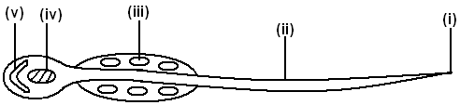

Which one of the following pairs consists of parts which contain the genetic material and provide energy for the cell during propulsion respectively?
A. (iv) and (i) B. (v) and (ii)
C. (iii) and (i) D. (iv) and (iii)
7. Arachnids can easily be identified by:
A. three pairs of legs B. two body parts.
C. two main body parts D. a pair of antennae.

8. The figure 3 below shows a pyramid of numbers for a food chain.
Producers
Primary consumers
Secondary consumers
Tertiary consumers

Which of the following correctively represents the information in diagram?
A. a herd of antelopes in an African plain
B. a locust swarm in a maize field
C. a plague of caterpillars on a tree
D. round worms in a child’s gut

9. What is the possible reason for the fall in the volume of oxygen gas released during photosynthesis after 40°C?
A. there was no more oxygen in the atmosphere.
B. there was no more carbondioxide in the atmosphere.
C. there was too much light intensity.
D. enzymes were denatured.

10. Leguminous plants are characterized by:
A. production of seeds in a capsule pod
B. production of seeds in a follicle pod
C. presence of nodes in shoots
D. presence of nodules in roots

11. The following events occur in seeds during germination:
i) Seed coat splits
ii) Hypocotyls grows fast
iii) Epicotyls grows fast
iv) Cotyledons appear above the ground
v) Cotyledons remain below the ground

Which of the following occur during epigealgermination?
A. i), ii), iii) B. i), iii), iv)
C. i), ii), iv) D. ii) and iv) only

12. The structure below shows the side view of a human tooth. Study and identify it.
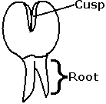
A. Molar B. Premolar C. Canine D. Incisor

13. A student performed an experiment to determine the percentage of humus in a soil sample. The following results were obtained.
- mass of empty dish = 50g
- mass of dish + soil = 200g
- mass of dish + soil after heating to constant mass = 170g
What is the percentage of humus in the soil?
A. 15% B. 30% C. 20% D. 90%

14. Mostly an enzyme is a ………………………. in nature.
A. protein B. carbohydrate C. lipid D. vitamin

15. Blood rich in the products of digestion enters the liver through:
A. hepatic vein B. hepatic artery
C. hepatic portal vein D. renal portal vein

16. Birds pass out nitrogenous waste in the form of:
A. Uric acid B. urea
C. aminonic D. trimethylamine oxide

17. Which of the following represents the correct order of taxonomic ranks starting with the largest?
A. kingdom, phylum, class, order, family, genus and species
B. kingdom, phylum, class, family, order, genus and species
C. species, genus, family, order, class,phylum, kingdom
D. species, genus, order, family, class, phylum, kingdom

18. The basic unit of chlorophyll is?
A. Nitrogen B. Magnesium C. iron D. potassium

19. Biological control is preferred to use instead of insecticides in pest control management. This is because insecticides:
A. are quite expensive
B. are indiscriminative in their action
C. require skill to use
D. make the soil infertile
20. Which one of the following fruits represents a capsule?
A. Bean pod B. cassia
C. Dutch man’s fruit D. coconut

21. Which of the following root systems of plants is specialized for gaseous exchange?
A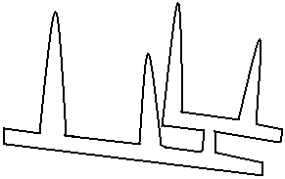 B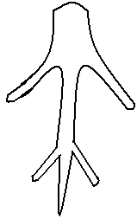 C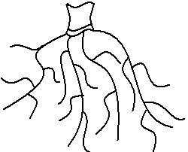D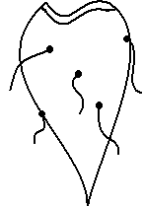

22. The rate of flow of blood through the renal artery was found to be 1200cm³/min; the urea concentration in the renal artery was 32mg/100cm³ and in the renal vein 24mg/100cm³. if the flow rate of the blood remained constant, determine the quantity of urea removed from the kidney in one hour.

A. 480mg B. 96mg C. 11520mg D. 5760mg

23. Which one of the following insects undergoes complete metamorphosis?
A. locust B. bee C. grass hopper D. cockroach

24. A seedling was grown on a horizontal board and the shoot grew towards light while the root grew downwards as shown in the diagram.

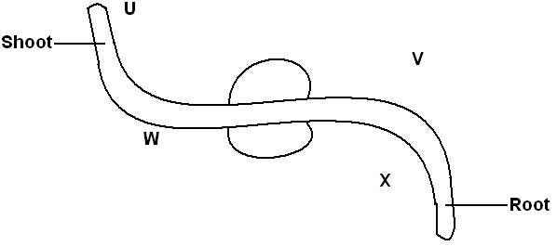
This was due to:
A. more auxin on side U and less auxin on side V
B. less auxin on side W and more auxin on side V
C. less auxin on side W and more auxin on side X
D. more auxin on side W and less auxin on side V

25. By which process does oxygen move from the leaf cells to the air spaces.
A. diffusion B. osmosis
C. active transport D. capillarity
26. Below are some of the characteristics of vertebrae. Which of the characteristics listed, could be used to identify a cervical vertebra?
A. Vertebraterial canals B. glenoid cavity
C. symphisis with Ilium D. metapophyses

27. A couple produced four children who are of different blood groups with the following genotypes, AO, BO, AB and OO. Identify the genotypes of the blood groups of the couple.
A. aa and BO B. AO and BO
C. BB and BO D. AB and OO

28. Study the dichotomous key below.

1
a) has 8 legs ----------------------------------------- P
b) has 6 legs ----------------------------------------- 2

2
a) has long antenna ------------------------------ Q
b) has short antenna ------------------------------ 3
3

a) has proboscis ----------------------------------- R
b) has mandibles ----------------------------------- S
Which of the organisms is a house fly?
A. P B. Q C. R D. S

29. Which one of the following organisms reproduce by budding?
A. bacteria B. amoeba C. spirogyra D. fungi

30. Which one of the following parts is most important in promoting insect pollination?
A. calyx B. stamens C. corolla D. pistil

SECTION B:

31. The table below shows the changes in the percentage composition of two substances in the glomerular filtrate as they move along the nephrones from the Bowman’s’ capsule to the collecting ducts.

Distance along nephron (arbitrary units) | 0.1 | 0.2 | 0.4 | 0.5 | 0.6 | 0.7 | 0.8
Percentage of glucose | 2.5 | 2.0 | 1.2 | 0 | 0 | 0 | 0
Percentage of urea | 1.5 | 1.8 | 2.6 | 3.0 | 3.8 | 4.0 | 4.0

a) On a graph paper, draw a graph to represent the above data. (8 marks)
b) i) Using your graphs, describe the percentage changes in the two components above along the nephrons. (5 marks)
……………………………………………………………………………………………….....
……………………………………………………………………………………………….....
……………………………………………………………………………………………….....
……………………………………………………………………………………………….....
……………………………………………………………………………………………….....
……………………………………………………………………………………………….....
………………………………………………………………………………………………............................................................................................................................................................................................................................................................................................................................................................................................................................................
ii) Explain the trend shown by each graph. (3 marks)
……………………………………………………………………………………………….....
……………………………………………………………………………………………….....
……………………………………………………………………………………………….....
……………………………………………………………………………………………….....
……………………………………………………………………………………………….....
……………………………………………………………………………………………….....……………………………………………………………………………………………….....
……………………………………………………………………………………………….....
……………………………………………………………………………………………….....

c) i) Outline any two factors that favour the process of ultra filtration to occur successfully in one part of the kidney nephrone.(2 marks)
……………………………………………………………………………………………….....
……………………………………………………………………………………………….....
ii) From the table above, state two functions of the kidneys nephrone. Give reasons for your answer. (2 marks)
……………………………………………………………………………………………….....
……………………………………………………………………………………………….....
……………………………………………………………………………………………….....
……………………………………………………………………………………………….....

32. An experiment to investigate the effect of an active substance on a food substrate was set up as shown in the figures below. The three set ups were left to stand for 5 minutes when the temperature was maintained at 25°C.
Test tube A Test tube B Test tube C
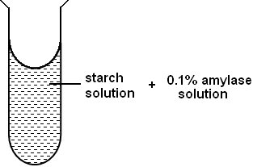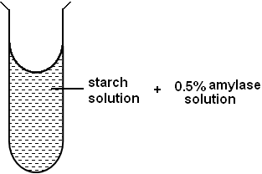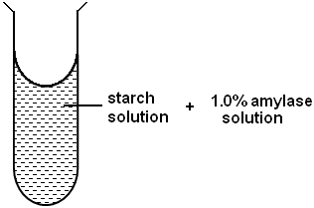
a) After 5 minutes,1cm³ of the contents in each test tube was added to a separate test tube and 1cm³ of Benedict’s solution was added and the mixture boiled.
i) Complete the table below using the observation made. (3 marks)

Test tube | Observation | deduction
A | Turbid solution turned to blue solution to green solution
B | Turbid solution turned to blue solution to green solution to yellow precipitate
C | Turbid solution turned to blue solution to green solution to yellow precipitate to orange precipitate

ii) Explain the results in: (3 marks)
Test tube A.
……………………………………………………………………………………………….....
……………………………………………………………………………………………….....
Test tube B.
……………………………………………………………………………………………….....
……………………………………………………………………………………………….....
Test tube C.
……………………………………………………………………………………………….....
……………………………………………………………………………………………….....
iii) What is being investigated in the experiment? (2 marks)
……………………………………………………………………………………………….....
……………………………………………………………………………………………….....
iv) From the experimental set up and the results, state two properties of the active substances used. (2 marks)
……………………………………………………………………………………………….....
……………………………………………………………………………………………….....
33. The diagram below shows a state in a cell division.
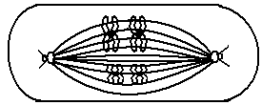
a) i) Name the stage of cell division. (1 mark)
……………………………………………………………………………………………….....
ii) Give two reasons to explain your answers in a(i) above. (2 marks)
……………………………………………………………………………………………….....
……………………………………………………………………………………………….....
……………………………………………………………………………………………….....
……………………………………………………………………………………………….....
iii) Name two organs in a mammal where this type of cell division is likely to take place.
……………………………………………………………………………………………….....
……………………………………………………………………………………………….....
b) The diagram below represents a mammalian embryo and associated maternal structures. Study it and answer the questions which follow.

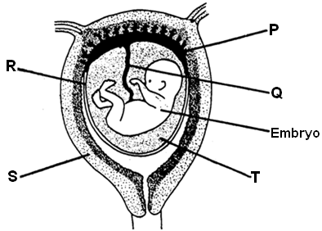

i) Name the partslabeled R and S. (1 mark)
R.
……………………………………………………………………………………………….....
S.
……………………………………………………………………………………………….....
ii) What is the function of T. (1 mark)
……………………………………………………………………………………………….....
……………………………………………………………………………………………….....
c) State four (4) differences between the composition of blood entering the placenta and the blood leaving it in the table below. (4 marks)

No | Foetal blood entering placenta | Foetal blood leaving placenta
1
2
3
4

SECTION C:
(Attempt any two questions from this section)

34. a) Describe the life cycle of a housefly. (9 marks)
b) What is the economic importance of a housefly? (2 marks)
c) How would you minimize the spread of houseflies in a home?
(4 marks)
35. a) What is meant by the terms:
i) Co dominance (1 mark)
ii) Incomplete dominance (1 mark)
b) In a certain maize specie plant, the presence of a recessive gene / allele in the homozygous state causes the seedlings to be white. Such seedlings die at an early stage.
In heterozygous state the plants are pale green but grow to maturity.
i) If a pale green maize plant was crossed with a normal green plant, what would be the genotypic ratio of the F1 generation?
Show your working (5 marks)
ii) Work out the phenotypic ratio of the plants that would grow to maturity from seeds obtained by selfing the pale green maize plants from the F1 generation. (4 marks)
c) Suggest any 4 importances of genetics in the human population.
(4 marks)

36. a) Define hypogeal germination. (2 marks)
b) List the factors necessary for germination. (3 marks)
c) Describe the internal changes that occur in a seed during the first few weeks of germination. (10 marks)

37. a) Give effects of four air pollutants on living things. (4 marks)
b) Describe how human activities interfere with soil environment in Uganda. (11 marks)
END

