NAME: ……………………………………………………… RANDOM NO. ……………
CANDIDATE NO. ………………………………………….

553/1
BIOLOGY
THEORY
2 ½ HOURS

ACEITEKA MOCK EXAMINATIONS 2019
UGANDA CERTIFICATE OF EDUCATION
BIOLOGY THEORY
553/1

TIME: 2 HOURS 30 MINUTES
INSTRUCTIONS
- Answer all questions in section A and B
- Write the answers to section A in the boxes in the margin of each question
- Write answers to section B in the spaces provided
- Answer only two questions from section C
- Write the answers to section C on the answer sheets provided.

FOR EXAMINERS USE ONLY
SECTION | MARKS
A
B 31
B 32
B 33
C
C
TOTAL

SECTION A: 30 MARKS

- The commonest pioneer species during ecological succession are
  - Lichens
  - Mosses
  - Ferns
  - Forests

- One major characteristic feature present in mesophyll cells but lacking in other plant cells is
  - Sap vacuole
  - Chloroplasts
  - Mitochondria
  - Cell walls

- One major disadvantage of an exoskeleton is that it is
  - Impermeable to water
  - Impermeable to oxygen
  - Rigid, hindering movement
  - Rigid, hindering growth

- When amoeba is placed in a hypertonic solution, formation of contractile vacuoles occurs at a
  - High rate in order to eliminate excess water
  - High rate in order to eliminate excess salts
  - Slow rate because there is little water
  - Slow rate because there is little salt

- The tape-like structure of a tapeworm is for increasing
  - Camouflage
  - Rate of reproduction
  - Diffusion rate
  - Protection from the hosts enzymes

- Brightly coloured large petals in flowers increases the following chances except
  - Self pollination
  - Insect pollination
  - Cross pollination
  - Variability

- Which one of the following may not be considered as a contraceptive method?
  - Rhythm method
  - Abstinence method
  - Tubal ligation
  - Coitus interuptus

- One advantage of complete metamorphosis over incomplete metamorphosis in insects is that complete metamorphosis
  - Occurs faster
  - Occurs slowly
  - Involves 4 stages
  - Reduces competition

- The figure below shows part of the skin and scales on a fish. The most probable position of the head to the fish is in direction:
A
B
D
C

- Which one of the following is the major factor in leaching soil?
  - Large number of micro organisms
  - High nutrient content
  - Large number of macro organisms
  - High rainfall

Number of individuals
Character

The following characters may give rise to the curve above except
  - Height in humans
  - Weight in cattle
  - Skin colour in humans
  - Blood groups in humans

- Genes on the same chromosome are usually inherited together because they are
  - Dominant
  - Linked
  - Recessive
  - Co-dominant

- Amino acids are to proteins as ………………… are to starch
  - Glucose molecules
  - Fatty acid molecules
  - Glycerol molecules
  - Maltose molecules

- Which combination of the following factors will lead to high transpiration rate?

- High temperature  - High humidity  - High atmospheric pressure  - High wind velocity | - Low temperature  - Low humidity  - Low atmospheric pressure  - Low wind velocity

  - i, ii, iii, iv
  - v, vi, vii, viii
  - i, iii, iv, vi
  - i, iv, vii, viii

- Agglutination of blood is most likely to occur when the respective donor and recipient are of blood group
  - A and AB
  - B and AB
  - O and AB
  - AB and O

- The major advantage of narrow lumen of arteries is
  - Fast delivery of metabolites to far organs
  - Reduced blood pressure
  - Protection from bursting
  - Fast return of blood to the heart

- The enzyme property under investigation in the figure below is that enzymes are

Water
Irish cubes
Hydrogen peroxide
Gas bubbles

  - Protein in nature
  - Specific
  - Affected by pH
  - Denatured by heat

- When Mimosa pudica is touched, its leaves fold, this response belongs to same group as
  - Growth of plant shoots towards light
  - Opening of flowers of some plants in the morning
  - Euglena swimming towards light
  - Plant shoot growth away from the pull of gravity

- Which one of the following is a major reason for lack of special excretory organs in plants?
  - Plants do not excrete
  - Plants do not use proteins
  - Plants deposit some excretory products in organs which are later shed off
  - Plants do not take in oxygen during respiration

- Which one of the following sets of hormonal deficiency lead to excessive loss of water from the body
  - Insulin and ADH
  - Oestrogen and Insulin
  - Thyroxine and ADH
  - Oxytocin and insulin

- Fusion of some bones in birds’ skeletons is for
  - Reduction in weight
  - Streamlining the body
  - Formation of a rigid framework
  - Increasing surface area

- Which one of the following would increase the “green house effect”?
  - Planting more trees
  - Using solar energy instead of fossil fuels
  - Building more industries which use petroleum
  - Increased use of hydro-electric power, HEP

- The stage in cell division where synthesis of protoplasm and replication of genetic material is
  - Prophase
  - Interphase
  - Metaphase
  - Telopahse

- Insects are one of the most successful classes of animals because of the following except
  - They lay very many eggs
  - Short life cycle
  - Many mouth modifications
  - Intermittent growth

- Which one of the following pairs constitutes homologous organs
  - Wings of a bat and those of insects
  - Flippers of whales and wings of a bird
  - Hands of humans and wings of insects
  - Wings of insects and fins of a fish

- The figure below shows the scolex of a tapeworm. The part labeled X is used for
X

  - Sight
  - Feeding
  - Excretion
  - Anchorage

- Products of digestion absorbed into the lacteals are transported by the
  - Blood capillaries
  - Lymphatic vessels
  - Veins
  - Arteries

- The figure below shows an inverted pyramid
C
B
A

Which one of the sets below shows the correct organisms at trophic levels A, B and C in their respective order?
  - Tree, Birds, Mites
  - Grass, Cattle, Ticks
  - Grass, Antelopes, Lions
  - Trees, Termites, lizards

- The figure below shows a Bidens fruit

Q

Part labeled Q is formed from
  - Corolla
  - Calyx
  - Style
  - Filaments

- A small body needs more covering on a cold day than a bid adult because the small body has a
  - Delicious skin
  - Small surface area to volume ratio
  - Large surface area to volume ratio
  - Low metabolic rate

SECTION B

- An investigation was carried out into the concentration of lactic acid in the blood of a man before, during and after a vigorous exercise. The results are summarized below.
Time (minutes) | Concentration of lactic acid (mg/100cm³)
-10 | 9
0 | 14
10 | 80
15 | 95
20 | 70
40 | 35
60 | 22
80 | 18

- Represent the above information on a suitable graph.

- Where in the human body is lactic acid produced during the exercise?

- i) Describe the graph obtained.

ii) Give reasons for the observed changes in concentration of lactic acid in blood.

- In an experiment, a measuring cylinder was filled with water and then inverted over a delivery tube. 200cm³ of exhaled air was bubbled into the measuring cylinder. A piece of phosphorus burning on a wire was pushed into the exhaled air in the cylinder. After phosphorous stopping to burn, the volume air was 168cm³.
Original water level
Water
Remaining air 168cm³
Burning phosphorous in exhaled air

Iron wire
Exhaled air 200cm³
Mouth
Measuring Cylinder
Final water level

- State the aim of the above experiment

- i) Calculate the percentage decrease in volume of air after the burning of phosphorus.

- Explain why the volume of air decreases at the end of the experiment.

- What volume of air would remain if the same volume of atmospheric air was used instead of exhaled air?

- The diagram below shows part of the human nephron

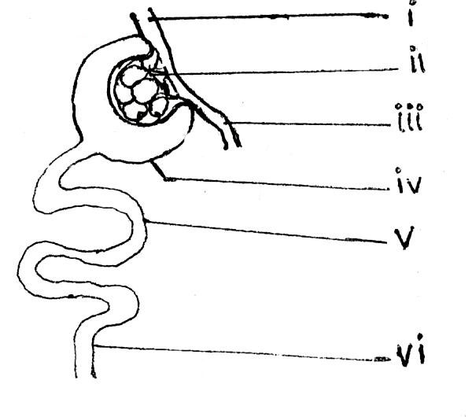
- Name the labeled parts
i iv)
ii v)
iii vi)

- Explain how part (ii) is adapted for its functions

- What is the importance of the diameter of vessels (i) and (iii)?

- State the importance of the process which occurs in part(v)

SECTION C (30 MARKS)
Answer two questions

- In which ways is water important to living organisms? (15 marks)

- a) State the importance of bones in a human body
b) State the difference between an exoskeleton and endoskeleton
c) Describe the process leading to bending of a human arm.

- a) Explain how plants adapt for
- cross pollination
- wind pollination
- insect pollination

b) State the differences between the processes leading to fertilization in flowers and humans

- A cross between Red and White flowered snapdragon plants produces F₁ offspring with Pink flowers only
- Explain the absence of white and red flowered plants in the F₁. Fully show your working.
- Calculate the genotypic and phenotypic ratios of a cross between F₁ plant and a white flowered plant

**END**

