RESPONSE AND CO-ORDINATION IN PLANTS

1. 1991 Q11 P1
In the experiment was set up to investigate the affect of unilateral light on the growth
of oat coleoptiles. The diagram in the table represents the experimental
set ups at the start, and the result at the end of the experiment,

Setup | Start of experiment
A

B | Aluminium  Foil cap. | Aluminium  Foil cap.
C

D | Plate of mica
E

a) Account for the results in the experiment set up A
b) Explain the purpose of experiment set ups B and C
c) Explain the results in the experiment set ups D and E

2. 1994 Q9 P1
Name the type of response exhibited by
(a) Leaves of mimose pudica when they fold after being touched.
(b) Euglena when it swims towards the source of light

3. 1995 Q14 P1
The diagram below represents growing seedlings which were subjected to unilateral
light at the beginning of an experiment
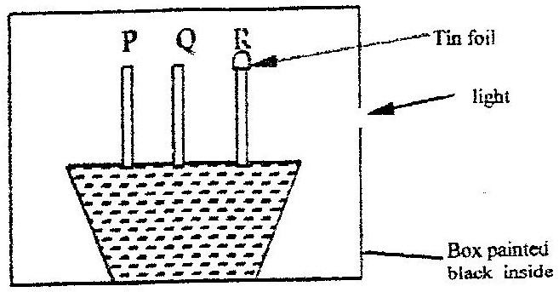

(a) (i) State the results of P,Q and R after 5 days? (5 marks)
(ii) Account for your answer in (a) (i) above (3 marks)

(b) If the tin foil were removed from the tip of the seedling R, what results would be
observed after 2 days? (1 mark)
(c) State the expected results after 3 days if the box were removed (1 mark)

4. 1996 Q16 P1
A shoot of seedling exposed to light on one side bends towards the source of light
as it grows
(a) Name the response exhibited by the shoot of the seedling (1 mark)
(b) Explain how the bending towards the source of light occurs (3 marks)

5. 2003 Q15 P1
A response exhibited by a certain plant tendril is illustrated below.
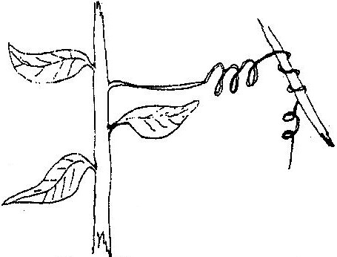

a) i) Name the type of response (1 mark)
ii) Explain how the response named in (a)(i) above occurs (2 marks)
b) What is the importance of tactic responses to microscopic plants? (2 marks)

6. 2006 Q20 P1
a) What name is given to response to contact with surface exhibited by tendrils
and climbing stems in plants? (1 mark)
b) State three biological importance of tropisms plants. (3 marks)

7. 2007 Q23 P1
(a) Name the hormone that is responsible for apical dominance (1 mark)
(b) What is thigmotropism? (1 mark)

8. 2010 Q23 P1
State one survival value for each of the following in plants:
- Thigmotropism in stems; (1 mark)
- Geotropism in roots. (1 mark)

9. 2011 Q28a P1
(a) What is a tropic response
(b) state two ways by which auxins regulate growth in seedlings. (2 marks)

10. 2013 Q22 P1
The diagram below illustrates a response by a certain plant.
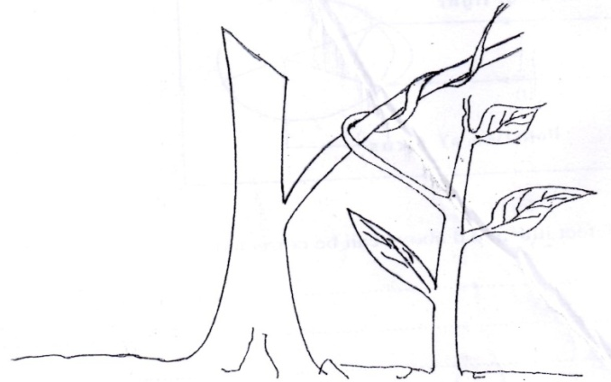

(a) Name the type of response. (1 mark)
(b) Explain how the response illustrated above occurs. (3 marks)

RESPONSE AND CO-ORDINATION IN PLANTS
MARKING SCHEME

1. 1991 Q6 P1
- S – Action potential/ spike potential
- T – Resting potential
2. 1994 Q9 P1
- Nastic/ Haotonanasty/Thigmonasty
- Phototaxis
3. 1995 Q14 P1
(a) (i) P – will tend/ grow towards light
Q – will remain straight/ little/ no growth
R – will remain/ grow straight / Acc. Grow upwards

(ii) P – Growth substances or hormones/ auxins/IAA are produced by the stem tip. They move downwards and get disturbed to the side away from the side of light. Where they cause more rapid growth/ cell division/ elongation ( that results in bonding)

The source of auxin has been removed and the auxins are not affected by light because the era has been covered.

- Tip will bend towards the light
- All the seedlings will grow upwards.

4. 1996 Q16 P1
(a) – Phototropism
(b) Auxins / hormones; move diffuse to the demised/ away from the light side; causing elongation/ growth on the dark sides hence bending

5. 2003 Q15 P1
a) i) Thigmotropism / haptotropism
ii) Contact with support; causes migration of auxine to enter the side; causing faster growth on the side away from centre of surface
(causing tendrils curl around support.)

b) Escape injurious stimuli / seek favorable habitats; move towards
light / stimuli.

c) Induce foot growth in stem cutting
- Selective weed killers
- Encourage apical dominance
- Encourage sprouting of side brances
- Breaking seeds dormancy
- Induce pathencarpy
- Promotes flowering
- Induce fruit fall
- Accelerates ripening of fruits.

6. 2006 Q20 P1
(a) Thigmotropism/ Haptotropism; rej. Haptotrophism/ thigmotrophism
(b) Exposes leaves/ shoots for maximum/ a lot of absorption for sunlight for
photosynthesis;
- Enable roots of plants to seek/search water; rej mineral salts/ ions alone.
- Enables plants stems to obtain mechanical support especially those that lack
woody stems
- Enables roots to grow deep in soil fro anchorage
- Enable pollen tube to grow towards embryo sac to facilitate fertilization

7. 2007 Q23 P1
(a) Auxin
(b) Growth response due to touch of a part e.g. tendrils

8. 2010 Q26 P1
(a) Failure of homologous chromosomes to segregate during meiosis/ anaphase I/
meiosis I
Failure of sister chromatid to segregate during meiosis/ anaphase II / meiosis II.
(b)
i) Down’s syndrome; Turner’s syndrome; Klinefelter’s syndrome
Surnerz syndrome
Acc. Mongolism for Doran’s syndrome
ii) Albinism; single cell anaemia; heamophilia; colour blindness
Chondrodytrophic dwarfism/ Achondroplasia

9. 2011 Q28a P1
- It is a growth movement in plants/parts in response to a unidirectional stimulus;
- Accelerates growth of shoots; Can inhibit growth of roots;

10. 2013 Q28a P1
- Thigmotropism / haptotropism
- Auxins migrate away from the point of contact; hence less auxins leading to less
elongation hence less growth; The side further away from point of contact has higher
concentration of auxins hence more elongation hence more growth and the stem
curves/twines along the supporting structures.

