GROWTH AND DEVELOPMENT
Growth is defined as an irreversible or permanent increase in the size and dry weight of an organism. Growth in multicellular organisms is divided into 3 phases.
- Cell division
This involves increase in the number of cells mainly as a result of mitosis.
- Cell expansion
This is the permanent increase in the cell size as a result of uptake of water or synthesis of living materials.
- Cell differentiation
This involves specialization of cells to suit particular functions. Growth is usually accompanied by an increase in the complexity of an organism which is also called development.
Development is the increase in complexity and change of form of an organism.

FACTORS AFFECTING GROWTH
- External factors
- Nutrients
Growth of an organism increases in the availability of nutrients and decreases when nutrients are in short supply. This is because nutrients are used in the building up of new protoplasm and organic matter. Also nutrients can be oxidized to provide energy required for growth. Therefore lack of nutrients can lead to decrease in growth or even death.
- Accumulation of the byproducts of metabolism (excretory substances):
Growth may be inhibited by metabolic waste products which are toxic to the body cells. Fortunately most plants and animals are not affected much because they can convert these substances to less toxic excretions.
- Temperature:
Growth depends on bio-chemical reactions which are catalyzed by enzymes. Temperature affects growth by affecting enzymes which catalyzes the chemical reactions in the body. Increase in temperature to the optimum increases the rate of growth, beyond which retardation of growth occurs.
- Light:
In plants, light affects growth by affecting the rate of photosynthesis which adds more organic matter to the plant. Therefore increase in light intensity in green plants increases the rate of growth and decrease in light intensity decreases the rate of growth.
- PH:
The PH affects the activity of enzymes which catalyzes reactions in the body. This can result into decrease in growth of an organism.
- Carbon dioxide:
In animals, carbon dioxide is a waste product of metabolism. If allowed to accumulate, it can lead to a decrease in the rate of growth while in plants carbon dioxide is a raw material for photosynthesis therefore increase in carbon dioxide concentration increases the rate of growth.
- Internal factors
- Hormones:
In animals, the presence of growth hormones and thyroxin in blood increases the rate of growth while in plants the presence of auxins also increases the rate of growth.
- Hereditary factors:
Growth is under the control of genes which determines the particular size of an organism.

GROWTH AND DEVELOPMENT IN PLANTS
In plants, growth is continuous processes which occurs mainly at the tips of the root and shoot systems. These regions are called meristems. A meristem is a group of undifferentiated plant cells which are capable of dividing repeatedly by mitosis.
Types of meristems
- Apical meristems
They are located at the tip of roots and shoot. They bring about increase in length or height of the plant. This type of growth which involves increase in length or height of a plant is known as primary growth.
- Lateral meristems
These are laterally situated in the stems and roots of the dicot plants. It brings about secondary growth after primary growth. Secondary growth (secondary thickening) involves increase in girth/thickness in a plant.
Lateral meristems are of 2 types namely:
- Cork cambium; which forms the secondary cortex
- Vascular cambium; which gives rise to the secondary phloem and xylem tissues.

SEED GERMINATION
This is defined as the emergence and development of an embryo into a seedling capable of existing as a new and independent plant under favorable conditions.
The process of germination
During germination, a seed absorbs water from the soil by imbibition mainly through the micropyle which makes the cotyledons swell and split the testa. The water enables the enzymes in the cotyledons to hydrolyze the stored food into soluble products which are later used by the germinating seed.
The enzymes involved in hydrolysis include diastase, protease and lipase. The soluble food substances diffuse into the cell where it is required for the growing embryo. Simple sugars and fats are oxidized to produce energy. Amino acids are used to make protoplasm of new cells. Absorption of water from the soil results into increase in the size of the seed and growth of the radicles and plumule which brings about rapturing of the seed coat and an embryo emerges.

TYPES OF GERMINATION
- Epigeal germination:
In this type of germination, the cotyledons appear above the ground due to the rapid elongation of the hypocotyl (i.e. the portion of the stem below the cotyledons) e.g. in tomatoes, beans, cotton, lettuce.
During epigeal germination the seed absorbs water through the micropyle in a process called imbibition. This softens the testa and makes the cotyledons to swell. The testa splits to allow the radicle and plumule to emerge. The water hydrolyses the stored food reserves and the products are passed from the cotyledons to the radicle and plumule where they are used for growth. The radicle emerges first and the hypocotyls start to elongate pushing the cotyledons upwards. The cotyledons may turn green in some plants and can carry out photosynthesis. The cotyledons open to allow out the plumule. The leaves are formed and they start to photosynthesize.
Diagrammatic illustration of epigeal germination
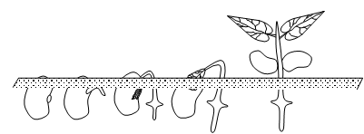
- Hypogeal germination:
In this type of germination, the cotyledon remains below the ground due to the rapid elongation of the epicotyl (i.e. the portion of the stem above the cotyledons) e.g. in broad bean, peas and maize.
During hypogeal germination, the seed absorbs water by imbibition. The radicle appears first bursting its protective sheath called coleorhizae. The radicle produces fibrous roots, which absorb water and anchor the plant. The protective plumule sheath (coleoptiles) opens to allow the plumule out. The epicotyls elongate pushing the cotyledons below the ground.
Diagrammatic illustration of hypogeal germination
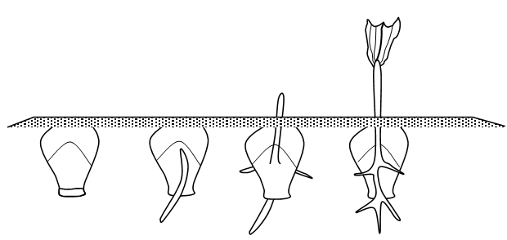
Conditions necessary for seed germination
- Water
Water is needed for the following:
- It activates the enzymes within the seed to hydrolyze the stored food.
- It makes the seed swell, soft and the testa to bursts.
- It dissolves the stored food.
- It is a medium in which all the chemical and enzymatic reactions proceed.
- It is a medium of transport of the dissolved food substances to the developing shoot and root of the new plant.
- Water is needed for the development of cell vacuoles. Large cell vacuoles contribute to increase in size of cells.
- Oxygen
Oxygen is necessary for the process of respiration, the oxidation of food to provide energy required for growth.
- Warmth
Suitable temperature is important for the enzyme controlled reactions in the cotyledon of the germinating seed. At low temperatures, the enzymes are inactive and at high temperatures, they are denatured hence no germination. Germination will require an optimum temperature which varies from 10̊C-50̊C for most tropical seeds.

EXPERIMENTS ON GERMINATION
An experiment to demonstrate the conditions necessary for germination
Apparatus:
4 test tubes, Cotton wool, Seeds, Oil and Water.
Procedure:
- Arrange four test tubes labeled 1-4
- To test tube 1 add moist cotton wool, seeds and leave test tube open.
- To test tube 2 add dry cotton wool, seeds and leave test tube open.
- To test tube 3 add seeds, boiled cooled water and a layer of oil.
- To 4 add seeds, moist cotton wool, ice and leave test tube open. Leave all test tubes for 3 days.
Setup:
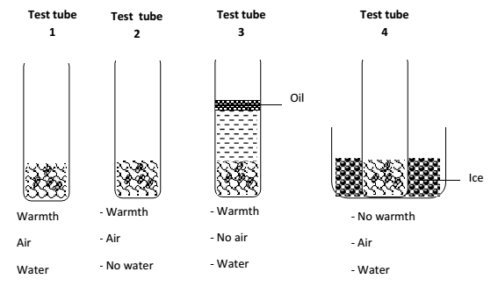

Observations
Seeds germinated in only test tube 1 and those in 2, 3 and 4 did not germinate.
Conclusion:
Air, water and warmth are necessary for germination.

Experiment to show that oxygen is necessary for germination
Apparatus:
2 conical flasks, 2 corks, Water, Cotton wool, Seeds and Pyrogallic acid.
Procedure:
- 1. Pour some water in one conical flask and some alkaline pyrogallol in another conical flask.
- Tie some seeds in wet cotton wool and suspend the cotton wool in the flasks using a thread.
- Fix the threads using a cork.
- Leave the set up for three days
Set up:
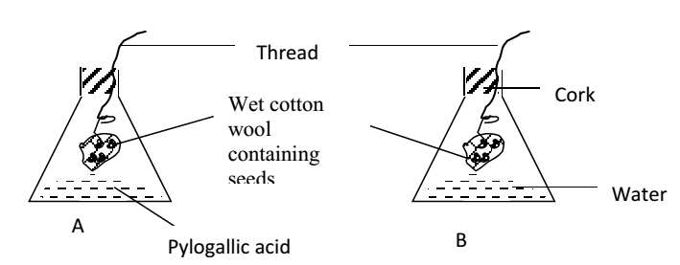

Observation:
After a few days the seeds in B germinated while those in A did not germinate.
Conclusion:
Oxygen is necessary for germination.

Explanation:
Alkaline pyrogallol absorbs oxygen from air in flask A thereby preventing germination.

MEASUREMENTS OF GROWTH
Measurement of growth involves the use of fresh weight and dry weight of a seedling.
- Fresh weight/mass:
This is the total amount of organic matter and water in an organism.
Advantages of measuring growth by using the fresh weight of an organism
- It does not involve the killing of the organism.
- It is a very method of determining growth.
- It is the most suitable method of determining growth of seedlings.
Disadvantages of measuring growth by measuring the fresh weight of an organism
- It is less accurate since the biggest part of an organism is water.
- It is not reliable because the mass keeps on fluctuating due to water loss by transpiration and evaporation.

- Dry weight/mass
This is the total amount of organic matter making up the body of an organism after removing water. It involves heating of an organism in an oven to a constant weight.
Advantages
- It is a more accurate method of determining growth.
- It is reliable because constant results are obtained.
Disadvantages
- It involves killing of an organism.
- The volatile tissues may decompose before removing all the water.

CHANGES IN DRY WEIGHT OF A GERMINATING SEED
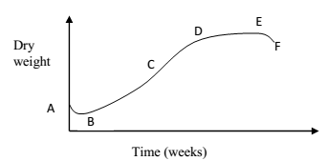
Description and explanation of the graph:
From point A-B, the dry weight of the seed decreases. This is because the stored food in food reserves is hydrolyzed (broken down) to produce energy for germination.
From point B-C, the dry weight increases steadily and rapidly. This is because the seed has produced leaves, which are carrying out photosynthesis. It makes food, which causes its dry weight to increase.
From points C-D, the growth rate decreases. This is because the plant has matured and preparing for flowering and fruiting.
From points D-E, the dry weight remains constant. The plant has produced fruits and no more growth takes place.
From point E-F, weight drops because the seed are dispersed, the plant leaves dry and fall off. This causes a reduction in dry weight.

CHANGE IN TOTAL WEIGHT OF A GERMINATING SEED.
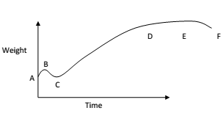
Explanation of the graph:
Most of the changes are similar to those in the graph showing changes of dry weight with time in a germinating seed except that for dry weight, the weight of water in the seed is not considered. For the total weight of the seed during germination, water is put into consideration.
The initial slight increase in weight from point A-B is due to imbibition (absorption) of water into the seed. The other changes that follow in the subsequent points on the curve are similar to those in the change of dry weight with time.

GROWTH CURVE
This is a graph which shows the change of a given growth parameter with time. This graph is S-shaped in most living organisms and it is called the sigmoid curve.
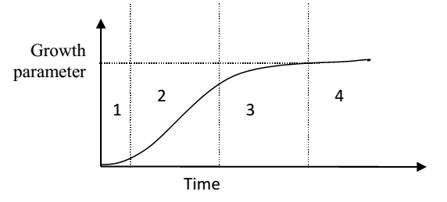
The curve shows 4 phases.
1. Lag phase.
This is a period of slow growth. It is the first phase of growth where there are very few cells dividing and the organism is getting used to the environment.
2. The exponential phase.
This is a phase of rapid growth. It is the second phase where the cells dividing are many and the organism is used to the environment.
3. Decelerating growth phase.
This is a period where growth slows down. The deceleration in growth may be due to;
- Competition for food, space and other resources.
- The organism is preparing for reproduction.
- The organism is aging.
4. The plateau phase. /stationery phase.
This is a period where there is no change in the growth parameter under investigation. At this point the number of cells, which die is equal to those produced.
After the plateau, the growth decelerates in seasonal organism due to aging and dispersal. In perennial organisms, growth increases continuously.

GROWTH AND DEVELOPMENT IN ANIMALS
In animals growth occurs throughout the body of the organism unlike in plants where growth is localized in specific areas called meristems. Most animals grow continuously until they reach maturity. This is called continuous growth. In Arthropods like insects growth is discontinuous, i.e. there are periods of growth and no growth.

GROWTH AND DEVELOPMENT IN INSECTS
Insects have an exoskeleton which is rigid and prevents expansion of the insect during growth. Before the insect grows, it sheds the exoskeleton in a process called moulting (ecdysis).
Without the exoskeleton, the insect expands and grows. A new exoskeleton then forms and growth ceases. This kind of growth is referred to as intermittent growth or discontinuous growth. Successive moults result into formation of a new form of the insect. This is called metamorphosis. Metamorphosis has already been discussed under insects.
A graph showing intermittent growth in insects
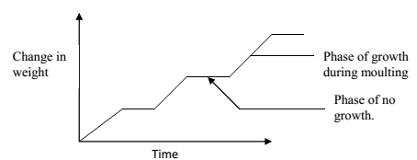

GROWTH AND DEVELOPMENT IN VERTEBRATES
After fertilization, the zygote undergoes three changes during its growth and development. These changes are;
- Cleavage:
This is the mitotic division of the zygote to form a mass of cells. The zygote at this stage is called a blastocyst.
- Gastrulation.
This is the rearrangement of the cells into distinct layers. The outer cells make up a layer called ectoderm. The cells in the middle make up a layer called mesoderm and the inner cells make up the endoderm. From these layers the various organs and systems are formed.
- Organogenesis:
This is the formation of organs and organ systems.

