Name: ............................................................................. Centre/index No………...

School …………………………………………………….. Signature: …..............

553/1
BIOLOGY
(Theory)
Paper1
Thur 4th August 2016
2½ hours

UGANDA TEACHERS’ INTERVENTION SCHEME
Joint Mock Examinations
UGANDA CERTIFICATE OF EDUCATION

Biology

Paper 1

2 hours 30 minutes

INSTRUCTIONS TO CANDIDATES:
This paper consists of sections A, B and C.
Answer all questions in sections A and B plus two questions in section C.
Write the answers to section A in the boxes provided, answers to section B in the spaces provided and to section C in the answer booklets provided.

For Examiner’s Use Only
Section | Marks | Examiner’s Signature
A
B₁
B₂
B₃
C
C
Total

SECTION A (30 MARKS)
1. In a food chain, feeding is from producer, primary consumers, secondary consumers and tertiary consumers. Which is the correct feeding order among the following organisms forming a food chain?
A. Rat, Snake, Mongoose, Vulture
B. Vulture, Mongoose, Snake, Rat
C. Mongoose, Rat, Vulture, Snake
D. Snake, Vulture, Mongoose, rat

2. A person who ate a heavy meal of carbohydrate 3 hour ago will have blood with the highest sugar concentration in:
A. Renal portal vein B. posterior vena cava
C. Hepatic portal vein D. Aorta

3. Which of the following is common to all gaseous exchange system? They:
A. Are enclose in special chambers
B. Have dense capillary network
C. Are exposed to air
D. Are maintained at constant temperature

4. Long internode on the stem of a plant is dominant over short internode. If two heterozygous long internode plants are crossed, what percentage of the offspring’s would be medium length internode?
A. 50% B. 25% C. 75% D. 100%
5. Which of the following is not typical of wind pollinated flowers?
A. Large feathery stigmas
B. Hanging filaments
C. Relatively large pollen grains
D. inconspicuous petals

6. Which of the following contains a set of characteristics which are all for wind dispersed fruits and seeds?
A. parachute like, hooked, light
B. Dry, curled inwards, spiked
C. parachute like, winged, light
D. Succulent, buoyant, light

7. Which of the following organs is supplied with blood by both artery and vein and drained by vein?
A. Liver B. Stomach C. pancreas D. Kidney

the number of chromosomes in a fertilized egg of human that will grow into a male child is:
A. 22 pairs + xx B. 22 pairs + xy
C. 22 pairs + y D. 22 + xy

9. The flow chart below represents part of the nitrogen cycle. Which of the numbered stages represent the process of denitrification?
Soil ammonia
Atmospheric nitrogen
2
3
1
Soil nitrate

A. 3 B. 2. C. 1 D. All of them

10. Which of the following is a modified tap root?
A. Onion bulb B. Carrot tuber
C. Cassava tuber D. Irish potato

11. What group of bacterial converts ammonium ions from dead organisms to nitrites?
A. Nitrosomonas B. Nitrobacter
C. Symbiotic bacteria D. Azotobacter

12. Which of the following digestive processes is catalyzed by salivary?
A. Maltose to glucose
B. Sucrose to glucose and fructose
C. Starch to maltose
D. lactose to Galactose and glucose

13. A person of blood group AB is considered a universal recipient because it:
A. Lacks antibodies a and b
B. Has antigen A and antibody b
C. Lacks antigen A and B
D. has both antibodies a and b

14. Which of the following differentiates a member of class insect from a member of class arachnida?
A. Segmented body B. Jointed limbs
C. Number of body parts D. possession of body parts

15. What makes the left ventricle of the mammalian heart unique?
A. Presence of bicuspid valves to prevent back flow
B. Thick muscular wall to pump blood to all parts of the body
C. Receives blood from the atrium for onward transmission
D. Pumps blood out of the heart.

16. Which of these is a member of the platyhelminthes?
A. Tapeworm B. Hydra
C. Earthworm D. Octopus

17. Which of the following hormones controls the re-absorption of water from the tubules when amount of water is below normal?
A. Adrenaline B. Cerebrum
C. Acetylcholine D. Oxytocin

18. Flexing of the fore arm is brought about by:
A. Relaxation of the biceps and contraction of the triceps
B. Relaxation of both biceps and triceps
C. Contraction of both biceps and triceps
D. Contraction of biceps and relation of triceps

19. The central nervous system consists of :
A. Spinal nerves and sense organs
B. Brain and spinal cord
C. Spinal cord and spinal nerves
D. Brain and neurons

20. Which part of the mammalian brain coordinates support and movement?
A. Cerebellum B. Cerebrum
C. medulla oblongata D. Hypothalamus

21. The four structures listed below are part of the human excretory system:
i. Bladder
ii. Kidney
iii. Ureter
iv. Urethra
In which order does a molecule of urea pass through these structures?

First Last
A | i | ii | iii | iv
B | i | iv | iii | ii
C | ii | i | iii | iv
D | ii | iii | i | iv
22. An athlete runs a 100 meter race. The following changes take place in the athlete’s body during the race:
(i) Increased availability of oxygen to muscles
(ii) Increased breathing rate
(iii) Increased carbon dioxide concentration in the blood
(iv) Increased production of carbon dioxide in the muscles
In which order do these changes occur?
A. (i), (ii), (iii) and (iv) B. (ii), (i), (iv) and (iii)
C. (ii), (iv), (iii) and (i) D. (iv), (iii), (ii) and (i)
23. Which statement is not correct?
A. Anaerobic respiration releases less energy than aerobic respiration
B. The sun is the principal source of energy input into biological systems
C. Energy flowing through biological systems is recycled
D. Active transport is an energy consuming process

24. Which statement is true of asexual reproduction in plants?
A. Insects are needed to transfer pollen
B. New plants grow from seeds
C. off springs are genetically identical to their parents
D. The dominant phenotype must be heterozygous

25. Which statement about the genotypes of organisms is correct?
A. Dominant alleles are only found in homozygotes
B. One recessive allele always causes a recessive phenotype
C. Recessive phenotypes must be homozygous
D. The dominant phenotype must be heterozygous

26. When the foetus is in the uterus, what carries oxygen away from the placenta?
A. The amniotic fluid B. The amniotic sac
C. The lining of the uterus D. The umbilical cord

27. Where in the alimentary canal is water absorbed?
A. Colon B. lleum
C. Oesophagus D. Stomach

28. Which is the function of adrenalin?
A. To convert glycogen into glucose
B. To decrease the breathing rate
C. To increase the rates of peristalsis in the ileum
D. To stimulate cells of the liver to take up glucose

29. Which statement about enzymes is correct?
A. They are all proteins
B. They are changed by the chemical reactions they control
C. They are destroyed by temperatures below 10⁰C.
D. They are found only in the alimentary canal
30. What is due to lack of magnesium ions in plant leaves?
A. All leaves are very green
B. Leaves yellow between the veins-
C. Wilting of the leaves
D. Young leaves become long and thin

SECTION B:
Answer all questions in this section. Write answers in the spaces provided
31. An experiment was carried out to determine population growth of rats in the school laboratory. The experiment was started with 20 young rats placed in a cage. Constant amount of food was made available to the rats each day. The results obtained are shown in the table below.
Time (months) | Number of rats
0 | 20
2 | 20
4 | 65
6 | 115
8 | 310
10 | 455
12 | 450
14 | 190
16 | 145
18 | 160
(a) Plot a suitable graph to represent the information above. (06 marks)
(b) With reference to the graph, give reasons for the changes in the population of rats between: (04 marks)
(i) 0 – 2 months
……………………………………………………………………………………….
(ii) 2 – 10 months
………………………………………………………………………………………
(iii) 10 – 12 months
……………………………………………………………………………………….
(iv) 12 – 16 months
………………………………………………………………………………………
(c) Between which two months was the population change greatest? (01 mark)
……………………………………………………………………………………………………………………………………………………………………………….
(d) Calculate the rate of population change over the period you have given in (c). (03 marks)
………………………………………………………………………………………………………………………………………………………………………………………………………………………………………………………………………………………………………………………………………………………………
(e) What population changes would be expected if the investigation was continued for a further 24 months? (02 marks)
………………………………………………………………………………………………………………………………………………………………………………………………………………………………………………………………………………………………………………………………………………………………
(f) State four factors that would cause a rapid human population. (04 marks)
………………………………………………………………………………………………………………………………………………………………………………………………………………………………………………………………………………………………………………………………………………………………
32. Below is a section of the human reproduction system. Study it and answer question that follow: 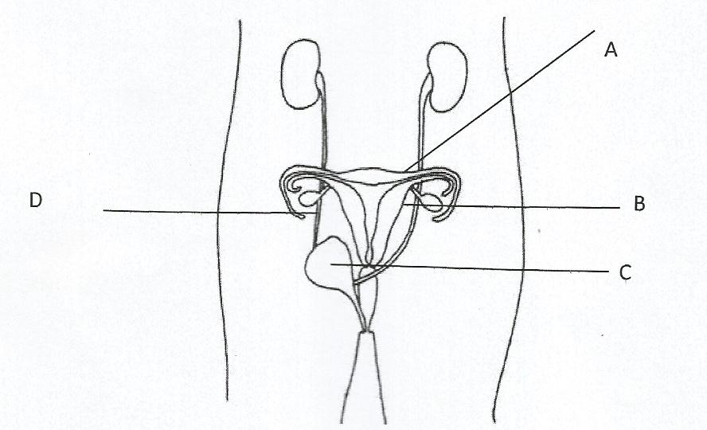
(a) Name the parts labeled.
A ………………………………… B …….………………………
C. ………………………………... D …………………………….
(b) Which hormone is produced by both structures B and C?
……………………………………………………………………………………….

(c) What effect does the hormone produced by B have on the organism?
………………………………………………………………………………………………………………………………………………………………………………………………………………………………………………………………………………………………………………………………………………………………
………………………………………………………………………………………………………………………………………………………………………………
33. A student set up the following experiments to investigate the factors that affect enzymes.
Test Tube 1 | Test Tube 2 | Test Tube 3 | Test Tube 4
Egg white, salivary amylase, temperature 36⁰C | Boiled starch, dilute acid and salivary amylase, temperature 36⁰C | Boiled starch, salivary amylase temperature 36⁰C | Boiled starch, salivary amylase temperature 60⁰C

(a) (i) What is an enzyme?
………………………………………………………………………………………………………………………………………………………………………………
(ii) What property of the enzyme is being investigated by the student in test tubes 1 and 2?
…………………………………………………………………………………………………………………………………………………………………………………………………………………………… …………………………………………
(b) (i) After 3 hours the student tested the contents in the four test tubes for starch using iodine solution.
State the observation expected:
Test Tube | Observation
1.
2.
3.
4.

(ii) Give reasons for your observations in test tube:
3.
……………………………………………………………………………………………………………………………………………………………………………… 4
………………………………………………………………………………………………………………………………………………………………………………

SECTION C:
Answer two questions from this section.

34. Describe the structure and function of the leaf of a flowering plant.
35. (a) Explain how the human blood capillary is adapted to its function.
(b) What aids the movement of blood in the veins?
36. Explain adaptive features that make a liver fluke (Fasciola hepatica) a successful endoparasite. (15 marks)
37. (a) What is homeostasis?
(b) Describe how mammalian blood glucose is regulated.

