  - Name: .......................................................................... Stream………………..
533/1
BIOLOGY
Paper 1
June/July. 2019
2:30 hours.
NYAKATONZI S.S.S
MIDDLE OF TERM, II, 2019
S.4 BIOLOGY EXAM
Paper 1
Time: 2:30 hours
INSTRUCTIONS:
- Attempt all questions in section A and B, plus any two questions from section C.
- Write the answers in Section A in the box presented on right hand side of each question.
- Section B should be answered in the spaces provided.
- Section C should be answered on the answer sheet provided.

SECTION A (30 marks)

- When preparing to test for starch in a leaf, the leaf is boiled in alcohol in order to:
A. burst chloroplasts B. remove chlorophyll in the leaf
C. soften the leaf D. quicken the reaction of starch with iodine
- Organisms that benefit from one another are examples of a relationship known as:
A. parasitism B. symbiosis
C. predation D. commensalisms
- The figure below, is one of the types of fruits. The fruit may be best dispersed by
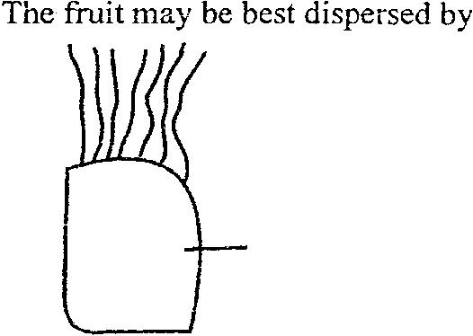
Hair-like structures
Fruit

A. Animals C. Explosive mechanism
B. Water D. Wind
- The role of bacteria in the root nodules of leguminous plants is to
A. fix Nitrogen
B. Break nitrates to nitrogen
C. protect the plant from diseases
D. act as fertilizers
- Which one of the following cell structures is possessed by both animal and plant cells
A. chloroplast B. cell wall. C. flagellum D. cell membrane

- The concentration of chlorophyll in leaves is likely to be affected by lack of
A: copper B: manganese C: magnesium D: zinc

- A tadpole uses………………………….for gaseous exchange.
A. lungs B. gills C. nostrils D. spiracles
- Which one of the following takes place by the process of active transport in plants?
A. up-take of water C. intake of CO₂
B. Transpiration D. uptake of mineral salts
- Breathing in man, air take a route of………………………………..?
A. nose to trachea to bronchus to lungs to alveolus
B. trachea to tracheoles to alveolus
C. nose to bronchus to alveolus
D. bronchus to lungs to the tissues
- Amphibians use the following for gaseous exchange except.
A. skin B. gills C. buccal D. nostrils
- Which one of the following is a characteristic of the class insecta
A. cutineous outer skeleton C. jointed limbs
B. Two pairs of wings D. three body parts
- Which of the following is correct about nutrition in Rhizopus
A. digestion of food occurs outside the organism
B. it makes its own food
C. digestion of food is intracellular
D. it does not produce enzymes
- Which one of the following is not a nitrogenous waste product?
A.Urea B. Ammonia C. Ethanol D. Trimethylamineoxide
- Which of the following diseases are all transmitted by mosquitoes
A. elephantiasis, river blindness and yellow fever
B. malaria, elephantiasis and river blindness
C. yellow fever, river blindness and malaria
D. yellow fever, malaria and elephantiasis
- When 80cm³ of water was added to 100cm³ of soil, the volume of the mixture was 140cm³. What was the percentage of air in the soil sample?
A. 20% B. 40% C. 60% D. 80%
- Which one of the following sets of characteristics of leaves enables them to absorb maximum light?
A. broad lamina, tightly packed palisade cells
B. being thin, possession of numerous stomata
C. possession of numerous stomata, waxy cuticle
D. being thin, large intercellular spaces
- Which one of the following characteristics of insects enables them to live in dry habitats
A. spiracles B. hairy bodies’ C. waxy cuticle D. wings

- During anaerobic respiration, plants for………………..?
A. lactic acid and ethanol B. lactic acid and energy
C. water and ethanol D. ethanol and energy
- The bacteria freely living in the Rumen of Ruminants’ guts exhibit
A. Saprophytic nutrition B. Parastic nutrition
C. Symbiotic nutrition D. Heterotropic nutrition

- The vessel that carries blood rich in end products of digestion is;
A. Hepatic vein B. Hepatic artery
C. Hepatic portal vein D. Renal artery
- Which one of the following is an arachnid?
A. Crab B. Scorpion C. Hydra D. cockroach
- The main use of humus to the soil is to;
A. Absorb water B. Absorb minerals
C. Absorb air D. Absorb sunshine

- Which one of the following is an example of Rhizomes?
A. Straw berry B. Bryophylum C. Ginger D. Bulb
- The area of a leaf where most photosynthesis occurs is;
A. Mesophyll layer B. Pallisade layer
C. Upper epidermis D. Lower epidermis

- Which one of the following is not a feature of carnivores?
A. Possess mainly molars B. Have cannarsial teeth
C. Move faster and are target full D. Feed mainly on flesh
- Which one is not a primary function of roots?
A. Conduct water and mineral salts
B. Anchor the plant into the soil
C. Store food and water
D. Absorb water and mineral salt
- Biological control as a method of prevention of malaria would include;
A. Spraying oil on the surface of stagnant water
B. Spraying of insecticides on the mosquitoes
C. Introducing fish in water bodies
D. Draining of stagnant water
- Paramecium moves by means of;
A. Coelom B. Flagella C. Cilia D. pseudopodia

The diagram below shows the apparatus that can be used to collect the gas evolved in photosynthesis. Use it to answer questions 29 and 30.
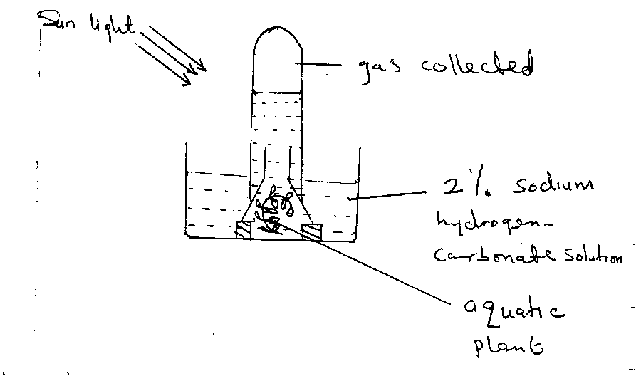
- Which of the following factors would produce the largest volume of the gas in a given time?
A. Increasing light intensity
B. Increasing light temperature
C. Increasing concentration of sodium hydrogen carbonate
D. Increasing both light intensity and sodium hydrogen carbonate
- The reason why sodium hydrogen carbonate was used in the experiment is;
A. It catalyses photosynthesis
B. It supplies carbon dioxide to the aquatic plant
C. It provides a medium for growth
D. It is absorbed to keep the leaves turgid

SECTION B (40 marks)
- a) (i) Define an enzyme (02 mark)
…………………………………………………………………………………………………………………………………………………………………………………………………………………………………………………………………………
ii) Outline three characteristics of enzymes (03 marks)
…………………………………………………………………………………………………………...…………………………………………………………………………………………………………...…………………………………………………………………………………………………………...
…………………………………………………………………………………………………………...………………………………………………………………………………………………………
b) The table below shows the effect of temperature on the rate of an enzyme controlled reaction. Study it and answer the questions which follow.

Temperature ⁰C | Rate of reaction (gm/min)
0 | 0
5 | 42
10 | 50
15 | 55
20 | 62
25 | 68
30 | 75
35 | 84
40 | 90
45 | 96
50 | 92
55 | 80

(c) Represent this information on a graph by plotting rate of reaction against temperature.
(09marks)
(d) Explain the shape of the graph (06 marks)
………………………………………………………………………………………………………………………………………………………………………………………………………………………………………………………………………………………………………………………………………………………………………………………………………………………………………………………………………………………………………………………………………………………………………………………………………………………………………………………………………………………………………………………………………………………………………………………………………………………………………………………………………………………………………………………………………………………………………………………………………………………………………………………………………………

- (a) Define the following terms
- tissue respiration (02 marks )
…………………………………………………………………………………………………………………………………………………………………………………………………….
- aerobic respiration (02 marks )
……………………………………………………………………………………………………………………………………………………………………………………………………
- anaerobic respiration (02 marks )
………………………………………………………………………………………………….…………………………………………………………………………………………………..
(b) Give four differences between photosynthesis and respiration (04 marks)
Photosynthesis | Respiration

- (a) Define the term excretion (02 marks)
……………………………………………………………………………………………………………………………………………………………………………………………………
(b) Give three examples of the following (06 marks)
Nitrogenous wastes
………………………………………
……………………………………….
………………………………………
Non nitrogenous wastes
……………………………………..
……………………………………..
……………………………………
(c) Explain why insects excrete uric acid (02 marks)
………………………………………………………………………………………………………………………………………………………………………………………………………………………………………………………………………………………………………………………
SECTION C (30 marks)
(Answer only two questions in this section. Write your answers on the paper provided to you).
- a) What do you understand by the term “chemical digestion”? (02 marks)
(b) Briefly describe the process of chemical digestion of proteins in the:
(i) Stomach (04 marks)
(ii) Duodenum. (05 marks)
(c) In which different ways is the ileum adapted to its function? (04 marks)
- Describe the breathing mechanism in man (15 marks)
- (a) Define the term soil erosion (02 marks)
(b) What are the causes of soil erosion? (06 marks)
(c) How can a farmer control soil erosion on a farm (07 marks)
37. (a) What is meant by the term transpiration (2mark)
(b) State three types of transpiration (3marks)
(c) describe the environmental factors that affect the rate of transpiration (10marks)
E N D

