LEAVES
A leaf is a thin flattened structure which grows from the nodes of a stem or its branches and has a bud in its axil.

External structure of a leaf

Dicot leaf
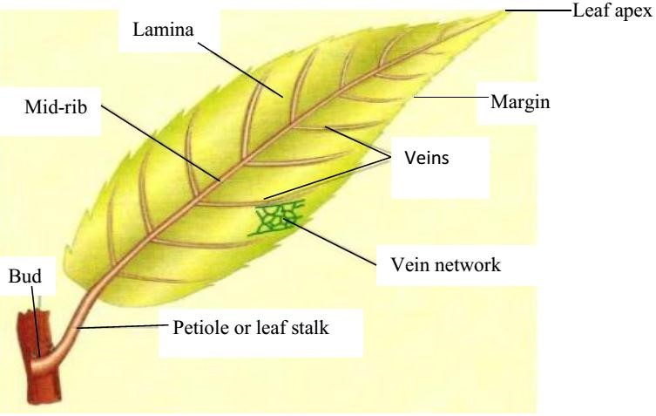

The monocot leaf
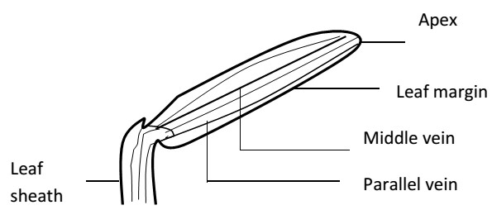

Parts of the leaf
- Leaf base; this is the part which attaches the leaf to the stem.
- Petiole; this is the part which connects the leaf base to the leaf blade. Leaves with a petiole are called petiolate and those without are called sessile.
The leaf stalk is a characteristic of dicots while a leaf sheath is found in monocots.
- Lamina; this is the expanded and flattened portion of the leaf consisting of veins and midrib. Texture of lamina; the lamina may be hairy or smooth. It may be hard or soft.

Functions of leaves to plants a) Primary functions
- The major function is to manufacture food for the plant during photosynthesis.
- Leaves have stomata which allow exchange of gases i.e. O₂ and CO₂.
- Leaves facilitate transpiration which sometimes helps the removal of excess water within the plant.

b) Modified or secondary functions
- They store food and water for the plant e.g. the thick fleshy leaves of onions.
- Some plant leaves are useful in vegetative reproduction e.g. bryophytes.

Venation
The arrangement of veins in the lamina of a leaf is called venation. Two broad types of venation are;
- Network venation/reticulate venation
In network venation, the veins in the lamina branch while intersecting to form a network. It’s a characteristic of dicots.
- Parallel venation
In this venation, the veins run side by side without branching. This is a characteristic of monocotyledonous plants.

Leaf complexity
Leaves can be classified according to whether the leaf lamina is completely divided or not divided. Two broad types are:
Simple leaves
Compound leaves

1. Simple leaves
A simple leaf has a single lamina which isn’t divided up into leaflets e.g. Avocado, mango, orange, hibiscus, pawpaw, cassava, etc. Cassava and pawpaw leaves are partly divided. The lobes are not considered to be leaflets because the divisions do not reach down the midrib. They are simple digitate i.e.
Simple leaf of a mango

Simple leaf of cassava

A swelling at the base of the leaf stalk is called pulvinus e.g. beans and cassava. Some leaves have it while others do not have it.

2. Compound leaves
A compound leaf has a lamina which is completely divided into leaflets. They resemble leaves but are not leaves because the axillary buds are absent in the axis of leaflets e.g. beans, oxalis, cassia, etc.

Types of compound leaves
i) Compound pinnate leaves  These are compound leaves with leaflets arranged either in pairs opposite one another or alternately along the midrib called rachis of the leaf. If the terminal leaflet is present, the leaf is said to be imparipinnate and if the terminal leaflet is absent, the leaf is said to be paripinnate. | Imparipinnate  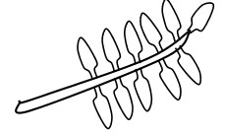 | Paripinnate  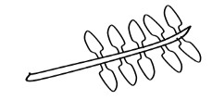
ii) Compound bipinnate leaves  These are compound leaves with 2 orders of leaflets. Leaflets are further divided up to form leaf-like structures called pinnules e.g. jacaranda. | 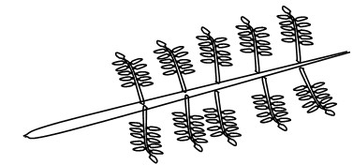
iii) Compound digitate leaves  These are compound leaves with leaflets radiating out from the end of the petiole-like fingers of the hand. | 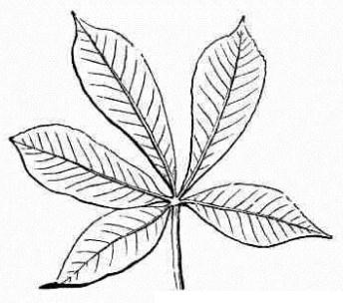
iv) Compound trifoliate leaves  These are compound leaves with only 3 leaflets. They include soya beans, oxalis and straw berry. | 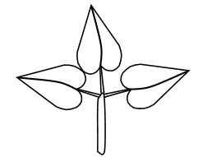

NB: stipules (foliar appendages) are attached to the leaf base or petiole e.g. in beans, hibiscus and cassia.

INTERNAL STRUCTURE OF A LEAF
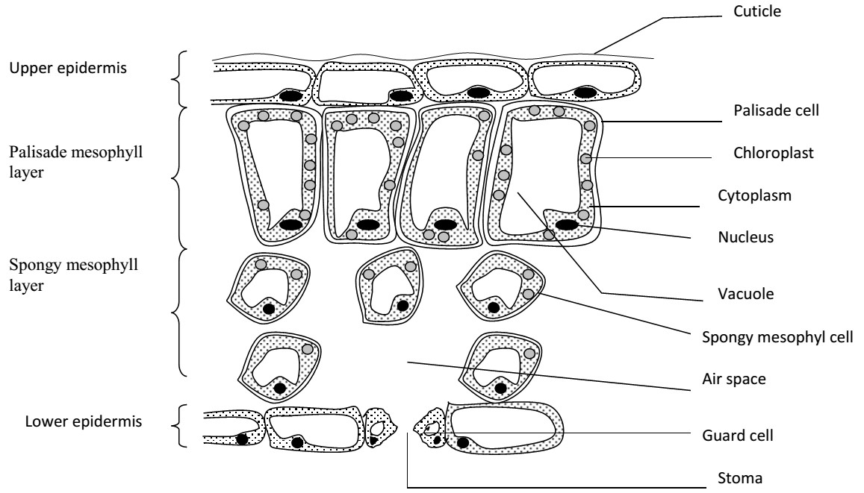
1. Epidermis:
This is the outer most layer of a leaf. It’s covered by a transparent water proof layer of cutin called cuticle. This cuticle allows light penetration into the leaf and prevents excess water loss from the leaf surface.
The epidermal tissue is divided into 2 according to the location on a leaf i.e. upper and lower epidermis. The upper epidermis is a single layer of brick-shaped cells covered by a thick cutin in case of terrestrial plants or land plants. In most plants, it does not possess stomata and if present are few. This is so as to control the amount of water loss during transpiration process.
The major function of this epidermis is to prevent evaporation of water from the leaf cells and protection of the inner cells of the leaf.
The lower epidermis is usually made up of one layer of cells and contains numerous openings called stomata. These stomata are protected by 2 guard cells. In water plant e.g. water lily or hyacinths, stomata are few on this side of the leaf. Some chloroplasts are present in this layer of cells.

Stomata
These are small openings found in the epidermis of a leaf. They are surrounded by 2 guard cells. Plants growing on land have more stomata located in the lower epidermis than in the upper epidermis. (The reverse is true for aquatic plants)
The function of the stomata is to allow entry and exit of important gases like O₂ and CO₂ into the leaf.
The stomata also regulate the loss of water vapour from the plant i.e. they control transpiration.

Structure of the stomata
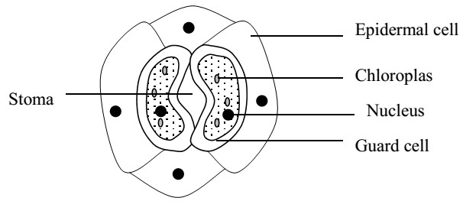
2. Mesophyll:
This is located between the upper and the lower epidermis. It’s differentiated into two layers. i.e.
i) Palisade layer
It’s found just below the upper epidermis. It’s made up of cylindrical shaped cells. The cells are closely packed together without air spaces. The palisade cells contain many chloroplasts which are the major sites for photosynthesis.
Chloroplasts contain chlorophyll which gives green plants their colour. The chlorophyll absorbs sun light energy that is used in the process of food manufacture (photosynthesis).

ii) Spongy mesophyll layer
It’s found under the palisade layer. It consists of cell called spongy cells which are irregularly arranged. These cells are not closely arranged, and therefore have large intercellular air spaces between them. The air spaces are connected with each. There is also the sub-stomatal air chamber where the gases collect before moving out of a leaf. Spongy cells contain fewer chloroplasts than the palisade cells hence they manufacture food.

3. Vascular tissue
These are vascular bundles consisting of veins. Each vein has a phloem for transporting manufactured food and the xylem for conducting and distributing water and mineral salts. The veins also provide mechanical support to the leaf lamina.

Arrangement of leaves on a stem
Arrangement is the insertion of leaves on the stem. Leaves develop at the nodes in the stem and are arranged in different ways.
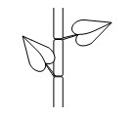Alternate leaf arrangement | 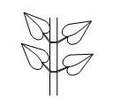  Opposite leaf arrangement | 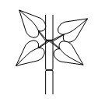  Whorl leaf arrangement

Types of leaf margins Leaves can be classified according to the leaf margins.

1. Entire margin
The margin is smooth and without indentation of 4. Dentate margin
any kind. E.g. mango leaves. The margin has indentations pointing towards the
- Serrate margin petiole.
The margin is with indentations pointing towards 5. Lobed margin
the apex. The margin has relatively few and shallow
- Crenate margin indentations.
The margin has round indentations.

Types of leaf shapes
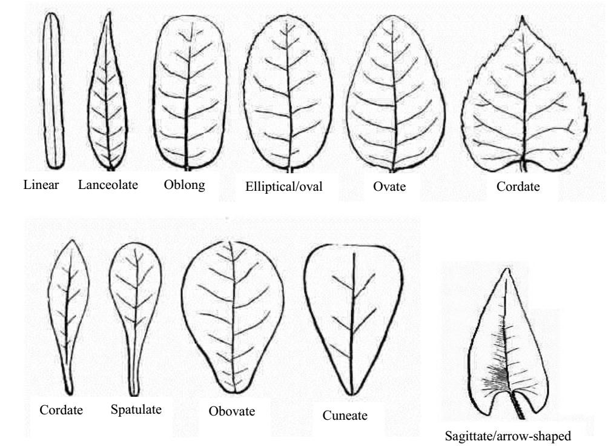
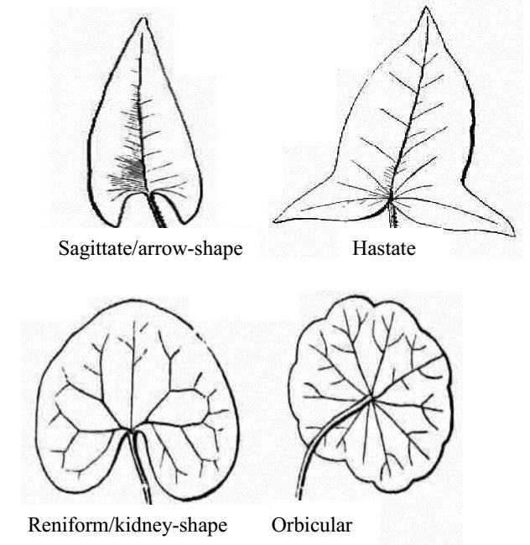

Modification of leaves
Leaves of some plants have become modified to perform other functions other than photosynthesis. 1. Leaf tendrils
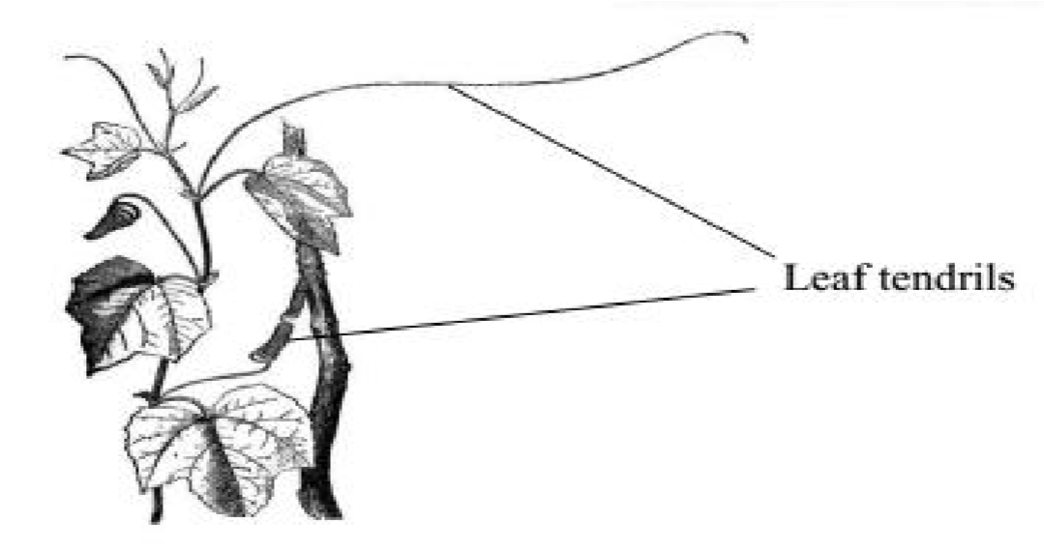
These are slender wire like coil structures used as climbing organs in climbers for support. The leaf may be partly modified into a tendril.

2. Leaf spines
These are sharp pointed structures of certain plants modified for defense.

3. Scale leaves
These are thin, dry membranous structures usually brown in colour and sometimes colourless. Their main function is to protect the axillary bud from mechanical injury and drying out. They are commonly found on underground stems. E.g. scale leaves of onions, rhizome and garlic.

4. Insectivorous leaves
These are modified leaves whose function is to capture and digest insects. Such plants are called insectivorous plants.
Pitcher plants grow in soil with a deficiency of nitrogen/nitrates. They obtain nitrogen from insects. E.g. Venus fly trap, butter wort, sundew, bladder wort, nepenthes, and the pitcher.

5. Bryophyllum leaves
Leaves have series of buds at the end of vein. These buds grow into new plants (plantlet) when the leaf is mature.
