NAME……………………………………………………………..RANDOM NO……………. PERSONAL NUMBER……………………………………………….…………………………
SIGNATURE…………………………………………………………………….………………
535/1
Physics
Paper 1
2019
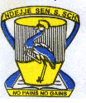
UGANDA CERTIFICATE OF EDUCATION
PHYSICS PAPER ONE
2 HOURS 15 MINUTES
INSTUCTIONS TO CANDIDATES
Write your name, signature and random number clearly in the space above.
Section A contains 40 objective type questions. You are required to write the correct answers A, B, C or D against each question in the box on the right hand side of each page.

Section B contains 10 structured questions. Answers are to be written in the spaces provided on the question paper.

Mathematics tables and non-programmable calculators may be used.

You may find the following constants useful:
Acceleration due to gravity g = 10 m s⁻²
Specific heat capacity of water = 4200 J kg⁻1 K⁻¹
Density of pure water = 1000 kg m⁻³
Specific heat capacity of copper = 400 J kg⁻¹ K⁻¹
Speed of light = 3.0 × 10⁸ m s⁻¹

FOR EXERMINER’S USE ONLY
41 | 42 | 43 | 44 | 45 | 46 | 47 | 48 | 49 | 50 | MSQ | Total

SECTION A
1. Water waves change direction when they move from shallow water to deep water.
What is the name of this effect?
A. diffract B. dispersion C. reflection D. refraction
2. Figure 1 shows a ray of light entering a block of glass.
Fig 1 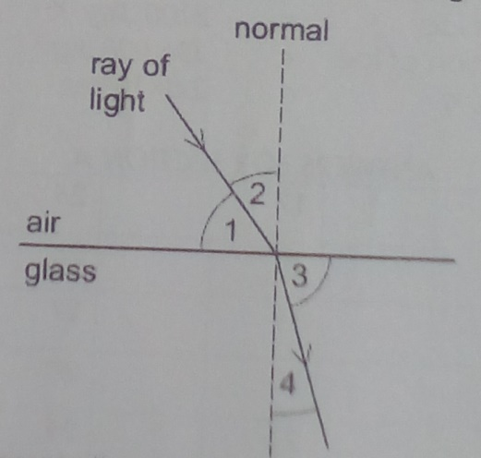
Which numbered angles are the angles of incidence and refraction?

 | Angle of incidence | Angle of refraction
A | 1 | 3
B | 1 | 4
C | 2 | 3
D | 2 | 4

3. Which type of wave cannot travel through a vacuum?
- Infra-red radiation
- Microwaves
- Sound waves
- X-rays
4. How can a permanent magnet be demagnetized?
- cool the magnet for a long time
- hit the magnet repeatedly with a hammer
- leave the magnet in a coil
- pass a small current through the magnet
5. An electromagnet is used to separate magnetic metals from non- magnetic metals. Why is steel unsuitable as the core of the electromagnet?
- It is a good conductor of electricity
- It forms a permanent magnet
- It has a high density
- It has a high thermal density.
6. A polythene rod repels an inflated balloon hanging from a nylon thread. What charges must the rod and the balloon carry?
- The rod and the balloon carry opposite charges
- The rod and the balloon carry like charges.
- The rod is charged but the balloon is not
- The balloon is charged but rod is not
7. Which statement is correct?
- A fuse is included in a circuit to prevent current becoming too high.
- A fuse should be connected to the neutral wire in a plug.
- An electric circuit will only work if it includes a fuse
- An earth wire is needed to prevent the fuse blowing
8. The equation shows the decay of the nuclide X
${}_{88}^{226}x$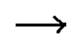${}_{Q}^{p}Y+{}_{2}^{4}{He}$
What are the values of P and Q respectively?
- 230, 90 C. 222, 90
- 230, 86 D. 222, 86
9. A plane mirror is on a wall. Which is a correct description of the image formed by the mirror?
- It is up right and smaller than the object
- It is up right and the same size as the object
- Upside down and smaller than the object
- Upside down and the same size as the objects
10. A straight wire carrying a current produces a magnetic field. Which diagram shows the correct
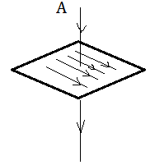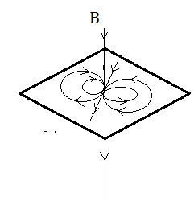
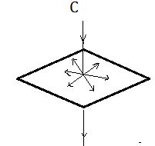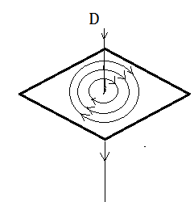
shape of the field?
11. A student carries out an experiment to see the effect of a magnetic field on a wire carrying a current. The wire moves upwards as shown in figure 2.

Fig 2 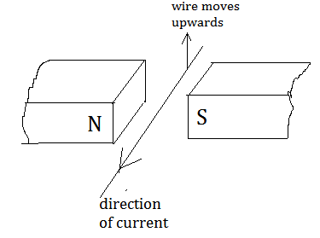
What should the student do to make the wire move downwards?
- Change the direction of the current
- Move the poles of the magnet closer together
- Send a smaller current through the wire
- Use a stronger magnet
12. A beam of cathode rays passes through an electric field between two parallel plates
Fig. 3 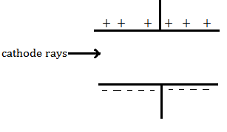
In which direction is the beam deflected
- Into the page
- Out of the page
- Towards the bottom of the page
- Towards the top of the page
13. Which line correctly describes α-particles
 | Electric charge | Penetrates 1cm of aluminum
A | Negative | Yes
B | Negative | No
C | Positive | Yes
D | Positive | no
14. A small amount of a radioactive isotope contains 72 billion unstable nuclei. The half-life of the isotope is 4 hours. How many unstable nuclei wound remain after 12 hours?
- 6 billion
- 9 billion
- 18 billion
- 9 billion
15. A spring is stretched by hanging a piece of metal from it. What is the name given to the force that stretches the spring?
- Friction B Mass C Pressure D weight
16. To mark the lower fixed point of a Celsius scale on a thermometer, the thermometer should be placed in
A pure alcohol. B pure distilled water.
C pure melting ice. D pure mercury.
17. A beaker of water is heated at its base.
Why does the water at the base rise?
- It contracts and becomes less dense.
- It contract and becomes more dense.
- It expands and becomes less dense.
- It expands and becomes more dense.
18. The circuit in figure 4, the reading of ammeter 1 is 2 A.
Fig. 4 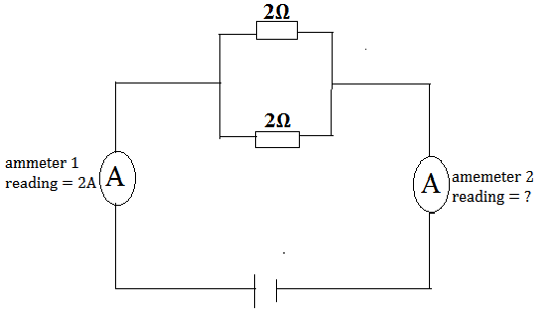
What is the reading on ammeter 2?
A 0 A B 1 A C 2 A D 4 A
19. Which particles are emitted during thermionic emission?
A electrons B ions
C neutrons D protons
20. A vertical stick is dipped up and down in water at P. In two seconds, three waves crests are produced on the surface of the water.
Fig. 5 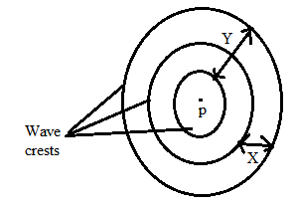
Which of the statements below is true?
- Distance X is the amplitude of the waves.
- Distance Y is the wavelength of the waves
- Each circle represents a wave-front.
- The frequency of the waves is 3Hz.
21. A car starts from rest and accelerates uniformly at 2 m s⁻². Find the distance it covers in 6 s.
A. 12 m B. 36 m C. 72 m D. 108 m
22. A force of 50 N moves an object through a distance of 200 m in 40 s. Find the power used.
- 100 W B. 160 W
C. 200 W D. 250 W
25. A notch on a material spreads more rapidly when the material is
- in tension B. in compression
C. pre-stressed D. reinforced
24. A body of mass 0.4 kg falls freely from a height of 5 m to the ground. Find the kinetic energy with which the body hits the ground.
A. 2 joules B. 4 joules
C. 20 joules D. 50 joules
25. Which of the following is false with respect to convex mirrors?
- Images are virtual for all real object positions
- Images are diminished for all real object positions
- The image is always between the optical Centre and focal point
- They are used as rear-view mirrors in vehicles
P
8 N
6 N
26. Fig. 6 Two forces of 6 N and 8 N act on object P as shown in the figure 3 above. The resultant force on the object is
- 1.33 N B. 2 N C. 10 N D. 14 N
27. A body starting from rest is uniformly accelerated to a velocity of 40 m s⁻¹ in 5 seconds. Calculate the distance travelled in this time interval.
A. 8 m B. 14 m C. 100 m D. 200 m
28. Which one of the following is not a factor on which the frequency of waves produced in strings depends ?
- Length of the string
- Nature of material from which the string is made
- Tension in the string
- Wave length in the wave
29. The graph in figure 7 below shows the variation of efficiency of a block and tackle system with load.
Fig. 7
Load (N)
Efficiency (%)
0
50
100

The graph tends towards 100% efficient as the load increases since
- mechanical advantage is directly proportional to the applied force.
- mechanical advantage is never equal to velocity ratio.
- energy is wasted in overcoming friction.
- The weight of the string and moving pulley becomes negligible small as the load increases
30. A body weighs 80 N in air and 60 N when fully immersed in a liquid. Find the volume of liquid displaced by the body if density of the liquid is 800 kg m⁻³
- 40 m³ B. 20 m³
C. 0.25 m³ D. 0.0025 m³
31. A certain F.M. radio station operates at a frequency 108 x 10⁶Hz. Calculate wave length of the radio waves.
- 2.96 x 10⁻⁶ m B. 2.78 m
C 0.36 m D. 3.37 x 10⁵ m
32. An object is placed 15 cm in front of a convex lens of focal length 10 cm. The position of the image from the lens is
- 6 cm B. 30 cm
C. 25 cm D. 20 cm
33. When a capillary tube is dipped into mercury;
- Cohesion between the mercury molecules is greater than the adhesion of the molecules for glass so the liquid rises in the tube
- Cohesion between the mercury molecules is greater than the adhesion of the molecules for glass so there is capillary depression
- Adhesion force between the liquid and glass is greater hence capillary rise
- Adhesion force between the liquid and glass is greater hence capillary depression
34. Choose the odd statement with respect to action of the lightning conductor.
- A charged cloud near a lightning conductor induces charges in the conductor
- The similar charge to one on the cloud is repelled to the ground
- The sharp end of the lightening conductor serves to pierce the cloud
- Point action occurs at the sharp owing to the high charge density at the point
35. An S1 student made a record 1.34 cm in a lesson on measurements. If taken correctly, which instrument did the student use to take the measurement?
- Metre tape B. micrometer screw gauge
C. Vernier calipers D. tape measure
36. Water is preferred to alcohol as a coolant in the cooling fins because
- water has a higher specific heat capacity than alcohol.
- water moves at a higher speed in the coolant than alcohol.
- water is a better conductor of heat than alcohol.
- water is more viscous than alcohol.
37. A student of mass 40 kg runs up a stair case of 8 steps, each 13 cm high. Find the work done by the student.
- 41.6 J B. 416 J C. 4160 J D. 4610 J
38. The power developed when one joule of work is done in one second is known as,
- a watt B. a joule second
C a newton D. newton second
39. Which of the following statements are conditions for a body to stay in mechanical equilibrium?
(i). The sum of forces in one direction is equal to the forces in the opposite direction.
(ii). The clockwise forces are equal to anticlockwise forces.
(iii) The sum of moments about a chosen point is zero.
(iv) The body rotates in one direction.
- (i) and (iv) only B. (ii) and (iii) only
C (i), (ii) and (iii) only D. (i) and (iii) only
40. Figure 8 shows a uniform meter rule pivoted at its center. A mass of 200 g is hanging at the 5 cm-mark and the meter rule balances horizontally when a mass, m₁ is hang at the 70 cm-mark.
Fig. 8 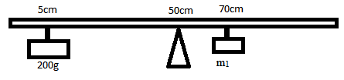
Calculate the value of m₁
- 14.3 g B. 45.0 g
C. 143 g D. 450 g
SECTION B: (40 MARKS)
41. (a) Distinguish between tensile stress and tensile strain (02 marks)
…………………………………………………………………………………………………………………………………………………………………………………………………………………………………………………………………………………………………………………………………………………………………………………………………………………………………………………………………………………………………………………………………………………………………………………………………………………….

(b) A piece of wire 1.0 m long and of cross-sectional area 2.0 x 10⁻⁸ m² is acted upon by a tensile force of 50 N. Calculate the tensile stress on the wire. (02 marks)
………………………………………………………………………………………………………………………………………………………………………………………………………………………………………………………………………………………………………………………………………………………………………………………………………………………………………………………………
42. (a) What is volume? (01 mark)
…………………………………………………………………………………………………………………………………………………………………………………………………………………………………………………………………………………………………………
(b) A tin of volume 30 cm³ has a mass of 94.8 g when full of sucrose and 62.8 g when half filled with the same solution. Find the density of sucrose ($1\frac{1}{2}$marks)
……………………………………………………………………………………………………………………………………………………………………………………………………………………………………………………………………………………………………………………………………………………………………………………………………………………………………………………………………………………………………………………………………………………………………………………………………………………
(c)The graph in figure 9 shows how mass of sand varies with volume. Use it to find density of sand. (1$\frac{1}{2}$marks)
Fig. 9 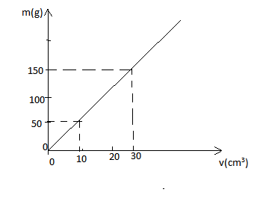
……………………………………………………………………………………………………………………………………………………………………………………………………………………………………………………………………………………………………………………………………………………………………………………………………………………………………………………………..
43. (a) Give two physical properties used in the measurement of temperature. (01mark)
…………………………………………………………………………………………………………………………………………………………………………………………………………………………………………………………………………………………………………
(b) (i) State the equation of state of an ideal gas. (01mark)
…………………………………………………………………………………………………………………………………………………………………………………………………………………………………………………………………………………………………………
(ii) The pressure of a fixed mass of gas is 760 mm Hg at a temperature 47⁰C. Its pressure is lowered to 190 mm Hg while the volume is kept constant. What is the new temperature of the gas?
……………………………………………………………………………………………………………………………………………………………………………………………………………………………………………………………………………………………………………………………………………………………………………………………………………………………………………………………………………………………………………………………………………………………………………………………………………………

44. (a) Sketch the electric field pattern for two positively charged point charges near each other.
(01mark)
…………………………………………………………………………………………………………………………………………………………………………………………………………………………………………………………………………………………………………
(b) A gold leaf electroscope carrying a positive charge has a diverging gold leaf. When its metal cap is touched,
(i) State what is observed. (01mark)
………………………………………………………………………………………………………………………………………………………………………………………………………………………………………………………………………………………………………….
(ii) Explain the observation in b(i) above (02mark)
………………………………………………………………………………………………………………………………………………………………………………………………………………………………………………………………………………………………………………………………………………………………………………………………………………………………………………………………
45. (a) State the principle on which a hydraulic press works (01 mark)
………………………………………………………………………………………………………………………………………………………………………………………………………………………………………………………………………………………………………………………………………………………………………………………………………………………………………………………………
(b) A hydraulic press in which piston A carries a load L and an effort E is applied on piston B. If the area of cross section of piston A is 900 cm² and of piston B is 3 cm². Calculate the load L supported when an effort of 24 N is applied. (03 marks)
……………………………………………………………………………………………………………………………………………………………………………………………………………………………………………………………………………………………………………………………………………………………………………………………………………………………………………………………………………………………………………………………………………………………………………………………………………………………………………………………………………………………………………………………………………………………………………………………………………………………………………………………………………………………………………………………
46. (a) state Ohm’s law. (01 mark)
……………………………………………………………………………………………………………………………………………………………………………………………………………………………………………………………………………………………………………………………………………………………………………………………………………………………………………………………...
(b)
Fig. 10 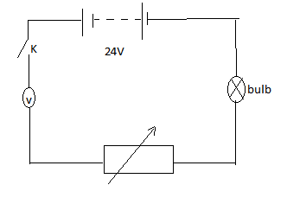
- State what is observed when K is closed ………………………………………………………………......................................................................................................................................................................................................................................................................................................................................................................
- Explain your observation in b (i) above (02maks) ………………………………………………………………………………………………………………………………………………………………………………………………………………………………………………………………………………………………………………………………………………………………………………………………………………………………
47. (a) What are complementary colours? (01mark)
……………………………………………………………………………………………………………………………………………………………………………………………………………………………………………………………………………………………………………………………………………………………………………………………………………………………………………………………….
(b) What will be the appearance of a yellow dress in a room lit with a blue bulb? (01mark)
……………………………………………………………………………………………………………………………………………………………………………………………………………………………………………………………………………………………………………………………………………………………………………………………………………………………………………………………….
(c ) A lens forms an image at 60 cm in front of the lens of an object 5 cm tall. If the height of the image is 20 mm, find the distance of the object from the lens. (02marks)
……………………………………………………………………………………………………………………………………………………………………………………………………………………………………………………………………………………………………………………………………………………………………………………………………………………………………………………………………………………………………………………………………………………………………………………………………………………
48. (a) What is a sound wave? (01mark)
………………………………………………………………………………………………………………………………………………………………………………………………………………………………………………………………………………………………………………………………………………………………………………………………………………………………………………………………
(b) (i) Write down one similarity between light waves and sound waves (01mark)
…………………………………………………………………………………………………………………………………………………………………………………………………………………………………………………………………………………………………………
(ii) Draw a wave of a sound note in an open tube producing a fundamental frequency. On the diagram, name anodes and antinodes (02marks)
………………………………………………………………………………………………………………………………………………………………………………………………………………………………………………………………………………………………………………………………………………………………………………………………………………………………………………………………
49. (a) What is meant by the following terms
- Wavelength of a longitudinal wave. (01mark)
……………………………………………………………………………………………………………………………………………………………………………………………………………………………………………………………………………………………………………………………………………………………………………………………………………………………………………………………..
- Frequency of a wave. (01mark)
…………………………………………………………………………………………………………………………………………………………………………………………………………………………………………………………………………………………………………
(b) Sketch a displacement time graph of a wave of amplitude 0.5 cm and frequency 4 Hz over a time interval of 1.25 seconds (2 marks)
……………………………………………………………………………………………………………………………………………………………………………………………………………………………………………………………………………………………………………………………………………………………………………………………………………………………………………………………………………………………………………………………………………………………………………………………………………………
50. (a) State Newton’s first law of motion (01mark)
………………………………………………………………………………………………………………………………………………………………………………………………………………………………………………………………………………………………………………………………………………………………………………………………………………………………………………….............
(b) (i) What causes uniform acceleration for a body falling freely. (01marks)
…………………………………………………………………………………………………………………………………………………… …………………………………………………………………………………………………...……………………………………………………………………………………………………………………………………………………………………………………………………………………………………………………………………………………………………………………………………………..…………
(ii) A plane moving horizontally at 40 m s⁻¹ at a height of 200 m above the ground releases a 50 kg bag of rice when above the target point. How far from the target does the bag drop on the ground? (02marks) …………………………………………………………………………………………………………………………………………………………………………………………………………………………………………………………………………………………………………………………………………………………………………………………………………………………………………………………………………………………………………………………………………………………………………
END

