MODERN PHYSICS QUESTION

1. (a) Describe the composition of the ²³₁₁Na atom.
(b) A radioactive nuclide²²⁶₈₈X emits an alpha particle and turns into another nuclide Y.
(i) Write a balanced equation to represent this nuclear charge
(ii) How would the nuclide X be affected if a beta particle was emitted instead of an alpha particle?
(c) Describe briefly how x-rays are produced. (Diagram of the x-ray tube is not required)

2. (a) Define the following terms:
(i) atomic number.
(ii) mass number.
(iii) isotopes.

(b) A radioactive nucleus decays by emission of alpha particles
(i) What is an alpha particle?
(ii) What changes occur in mass number and atomic number when the alpha particle is emitted.
(iii) State any three differences between alpha particles and beta particles

(c) The table shows the count rates of a certain radioactive material
Plot a graph and use it to find the half-life of the material

3. (a) A radioactive nuclide ${}_{88}^{226}{Ra}$ decays by emitting alpha particles and two beta particles to a
nuclide Y.
- What is meant by a radioactive nuclide.
- Give three differences between alpha and beta particles.
- State the atomic number and mass number of Y.

(b) What precautions would have to be taken when handling radioactive materials

(c) A certain mass of radioactive material contains 2.7x10²⁴ radioactive atoms. How many atoms will have decayed after 3200y if the half life of the material is 1600y

(d) Explain briefly one industrial application of radioactivity.

4. (a) (i) Name the particles emitted by radioactive nuclides.
(ii) Give one property common to the particles named in (i).

(b)
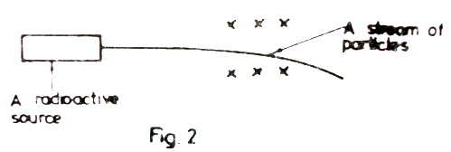

A stream of particles from a radioactive source passes through a magnetic field directed into the plane of the paper as shown in the above figure.
- Identify the particles in the stream.
- Sketch a diagram to show the path of the particles in an electric field.

(c) (i) Define half life (ii) x grams of a radioactive material of half life of 3 weeks, decays
and 5.12g remains after 15 weeks. Determine the value of x.

(d) Distinguish between the terms fusion and fission. State two conditions necessary for each to occur.

5. (a) Define the terms atomic number and mass number.

(b) When lithium is bombarded by neutrons, a nuclear reaction occurs which is represented by the following equation
⁶₃Li + ¹₀n → ³₁H + P .
Complete the equation and name P.

(c) Describe the application of radioactivity in determining the age of fossils (remains of old plants and animals).

(d) The half life of Uranium is 24 days. Calculate the mass of Uranium which remains after 120days if the initial mass is 64 g.

(e) Give two harmful effects of radioactivity.

(f) State three differences between cathode rays and x-rays.
6. (a) The figure shows the main parts of a cathode ray oscilloscope.
Identify the parts labelled U, V and X and briefly describe their functions
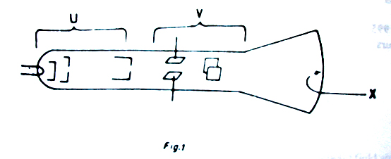
(b) (i) Name the particles emitted by the radioactive materials
(ii) Draw diagrams to show the path of the particles named in (b) (i) and in a cloud chamber.

(c) A Zinc cathode was enclosed in an evacuated glass tube as shown in the figure
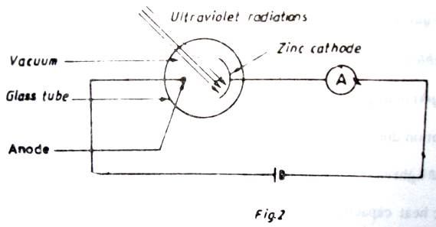
When the cathode was irradiated with ultra violet radiations, the ammeter gave a reading
- Explain why the ammeter gave a reading.
- A gas was gradually introduced into the glass tube. Explain what happened?

7. (a) What is an alpha particle?
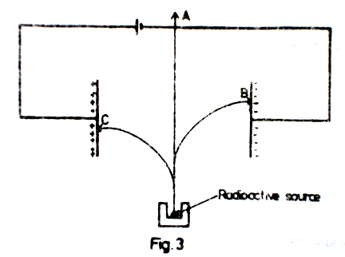

(b) A radio active source decays by emission of all the three radiations. The radiation centre normally into an electric field as shown in the figure above. Which radiations are most likely to be detected at
(i) position A.
(ii) position B.
(iii) position C.
(c)
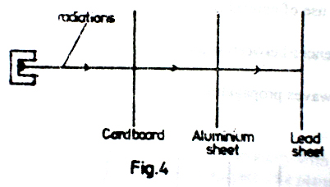
A radioactive source which emits all the there radiations is placed in front of a cardboard, aluminium and lead sheets as shown in the figure above. Name the radiations likely to be between the:
- cardboard and the aluminium sheet,
- aluminium and lead sheets.

(d) Name any three precautions which must be under taken by one working with ionising radiation.

(e) Name one:
(i) industrial use,
(ii) biological use, of radioactivity.

(f) A radioactive material of mass 8g has a half–life of 20 days. Find how much of it will decay after 60days?
8. (a) (i) What is meant by a radio isotope?
(ii) State one industrial application of radio isotopes.

(b) Describe what happens when a beam of radiation consisting of α-, β- and γ- rays is incident on a thin sheet of lead.
(c)
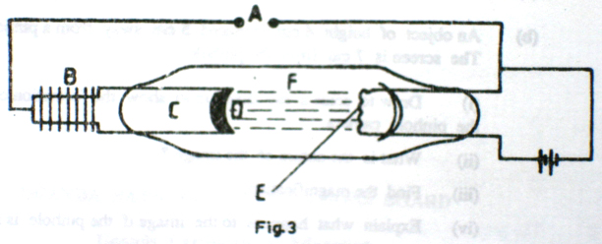
The diagram above shows the essential parts of an X-ray tube.
- Name the parts labelled A, B, C, D, E and F.
- State the function of each part.
- Describe how X-rays are produced.

(d) What safety precautions must be taken in an X-ray laboratory?

9. (a)
*****
The above diagram shows the main parts of a cathode ray oscilloscope(C.R.O)
- Name the parts labelled A,B and C.
- Why is the C.R.O evacuated?

(b) (i) Describe briefly the pricipals of operation of C.R.O.
(ii) How is the bright spot formed on the screen?

(c) Use diagrams to show what is observed on the screen of a C.R.O when
(i) the C.R.O is switched on and no signal is applied on the Y-plates.
(ii) the time base is switched on and no signal is applied on the Y-plates.
(iii) an alternating signal is applied on the Y-plates while the time base is switched off.

(d) Give two uses of the C.R.O.

10. (a) Name the electromagnetic radiation which
(i) causes sensation of heat.
(ii) passes though a thin sheet of lead.
- is used in satellite communication.
- is used for remote control of a television receiver.

(b) Figure 2 shows the main parts of an x-ray tube.
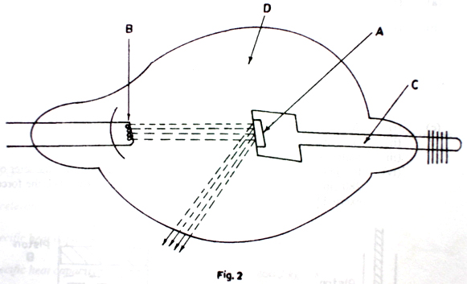

(b) Name the parts labelled A, B, C and D.

(c) List in order the energy changes which occur in the x-ray tube.

(d) Describe one industrial use of x-rays.

(e) (i) What is meant by the half-life of a radioactive material?
(ii) The activity of a radioactive source decreases from 4000 counts per minute to 250 counts per minute in 40 minutes. What is the half-life of the source?
11. (a) Describe a simple structure of the atom. (4marks)

(b) Define the following;
(i) atomic number (1mark)
(ii) isotopes of an element (1mark)

(c) State two differences between an α- and a β-particle (2marks)

(d) (i) What is meant by nuclear fission and nuclear fusion. (2marks)
(ii) Give one example where each one occurs. (2marks)

(e) The half-life of a radioactive substance is 24 days. Calculate the mass of the substance which has decayed after 72 days if the original mass is 0.64 g.

12. (a)
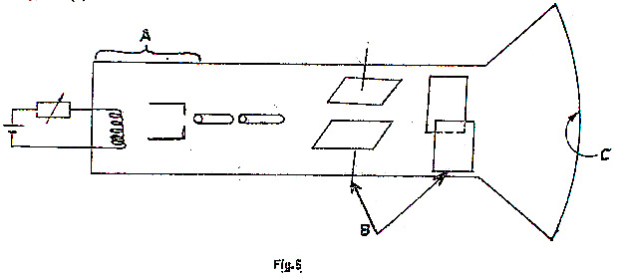
Tthe diagram in figure 5 shows the main parts of a cathode ray oscilloscope (C.R.O.)
- name the parts labeled A, B and C.
- Why is the C.R.O evacuated.
(b) (i) Describe briefly the principles of operation of C.R.O.
(ii) How is the bright spot formed on the screen?
(c) Use diagrams to show what is observed on the screen of a C.R.O. when
(i) The C.R.O. is switched on and no signal is applied on the Y-plates
(ii) The time-base is switched on and no signal is applied to the Y-plates.
(iii) An alternating signal is applied to the Y-plates while the time-base is switched off.
(d) Give two uses of C.R.O.
13. (a) (i) What is meant by cathode rays
(ii) With the aid of a diagram, describe how cathode rays are produced by thermionic effect?
(b) With reference to the cathode ray oscilloscope, describe;
(i) the function of the time base
(ii) how the brightness is regulated
(c) A cathode ray oscilloscope (C.R.O) with time-base switched on is connected across a power supply. The waveform shown in the figure below is obtained.
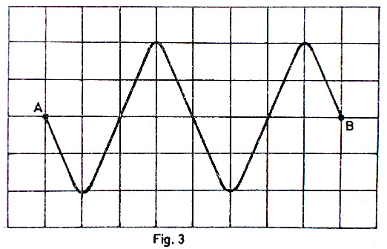

Distance between each line is 1cm.
- Identify the type of voltage generated by the power supply
- Find the amplitude of the voltage generated if the source of the time-base setting on the C.R.O is 5x10⁻³cm⁻¹
14. (a) Draw a labelled diagram to show the main bands of the electromagnetic spectrum.
(b) (i) With the aid of a labelled diagram, describe how x-rays are produced in an x-ray tube.
(c) State two applications of x-rays.
(d) The half life of a radioactive substance is 3 h. Find how long it take.* for the mass of the substance to reduce to one-quarter of its original mass.

15. (a) (i) Distinguish between nuclear fusion and nuclear fission. (02marks)
(ii) State one example where nuclear fusion occurs naturally. (01mark)

(b) State one use of nuclear fission. (01mark)

(c) The following nuclear reaction takes place when a neutron bombards a sulphur atom.
${}_{16}^{34}S$ + ${}_{0}^{1}n$ → ${}_{b}^{a}Y$
(i) Describe the composition of the nuclide, Y, formed. (02marks)
(ii) The nuclide, Y, decays by emission of an -particle and a -ray. Find the changes
in mass and atomic number of the nuclide. (02marks)
(iii) State two properties of -particle. (02marks)

(d) The half-life of the isotope cobalt-60 is five years. What fraction of the isotope remains after
15 years? (03marks)

(e) State:
(i) one medical use of radioisotopes. (01mark)
(ii) two ways of minimizing the hazardous effects of radiation from radioactive
Materials
16. ( a) What are X-rays? (01mark)

(b) With the aid of a labeled diagram, describe the structure and operation of an X-ray tube.

( c) Explain briefly how each of the following can be increased in an X-ray tube:
(i) intensity of X-rays. (02marks)
(ii) penetrating power of X-rays. (02marks)

(d) State four ways in which X-rays are similar to gamma rays. (02marks)

( e) Give two biological uses of X-rays. (02marks)

17. (a) (i) What are cathode rays? (01 mark)
(ii) State two differences between gamma rays and cathode rays. (02 marks)

(b) Describe a simple experiment to distinguish the three radiations that are emitted by radioactive materials. (04 marks)

(c) A radioactive element has a half life of 4 minutes. Given that the original count rate is 256 counts per minute,
- Find the time taken to reach a count rate of 16 counts per minute. (02 marks)
- What fraction of the original number of atoms will be left by the time the count rate is 16 counts per minute. (01 marks)

(d) (i) Which of the following nuclei belongs to the same element:
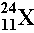, 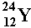, ? (02 marks)

- What is nuclear fusion?
18. (a) Distinguish between thermionic emission and photoelectric emission.
(b)
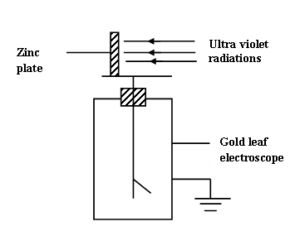
Ultra violet radiation is incident on a clean zinc plate on the cap of a charged gold leaf electroscope as shown in figure 2. Explain what is observed if:
(i) the gold leaf electroscope is positively charged.
(ii) radio waves is used instead of ultra violet radiations.
(c) (i) With the aid of a labeled diagram, describe how X-rays are produced in an
X-ray tube.
(ii) Explain why soft X-rays are used instead of hard X-rays to take photographs of internal parts of a patient in hospitals.

