535/2
PHYSICS
Paper 2
June 2017
2¼ hours

RESOURCE MOCK EXAMINATIONS, 2017
Uganda Certificate of Education
S.4
PHYSICS
Paper 2
2 hours 15 minutes

INSTRUCTIONS TO CANDIDATES
Answer five questions in all.

Any additional questions attempted will not be marked.

Write in blue or black ink only. You may use pencil for diagrams or graphs only.
All the necessary working must be clearly shown.
Silent non-programmable scientific calculators may be used.
Where necessary, use;

Acceleration due to gravity, g = 10ms⁻²
Speed of light = 3.0 10⁸m/s
Specific heat capacity of water = 4200Jkg⁻¹k⁻¹
Speed of sound in air = 330ms⁻¹

1.a)(i) Distinguish between fundamental quantity and derived quantity. (02 marks)
(ii) Define linear motion (01 mark)
b.) Briefly describe how a rocket engine works. (04 marks)
c.) When the brake is applied to a car having mass of 1,500kgs, its speed is reduced from 10ms⁻¹ top 6ms⁻¹, in a distance of 30m. Find;
(i) How much work did the brake do on the car? (03 marks)
(ii) What force did the brake exert on the car? (03 marks)
d.) Explain what happens to the motion of a feather and a coin when both are released at the same time inside a long evacuated glass tube. (03 marks)

2.a)(i) What is meant by up thrust? (01 mark)
(ii) Explain what causes up thrust. (03marks)
(iii) A certain metal of density 11,400kgm⁻³ weighs 0.228kg in air. Find its apparent weight when half immersed in oil of density 800kgm⁻³. (04 marks)
(iv) State a condition for a body to sink in a liquid. (01 mark)
b.) Describe what happens at the power stroke of a four stroke engine. (03 marks)
c.) Describe an experiment to measure limiting static friction. (04 marks)

3.a)(i) What is a neutral axis? (01 mark)
(ii) Explain why bars for construction are made hollow. (04 marks)
(iii) How is concrete is reinforced? (02 marks)
(iv) Explain why concrete is reinforced. (03 marks)
b.) Give four advantages of glass as a construction material. (02 marks)
c. State the kinetic theory of mater. (01 mark)
(ii) Use kinetic theory to explain the pressure exerted by a gas. (03 marks)

4.a) Define the following;
(i) a wave (ii) a crest (02 marks)
b.) The note shown in the figure 1 is prdu3ed in an open pipe. If the length of the pipe is 50cm and speed of sun in air is 330ms⁻¹.
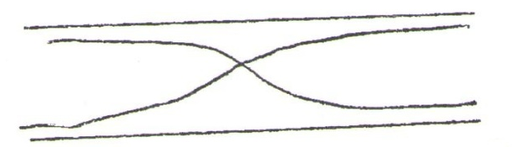
(i) wave length of the note. (02 marks)
(ii) frequency of the note (03 marks)
c.)(i) Sketch a complete electromagnetic spectrum in the order of increasing frequency. (04marks)
(ii) Give three differences between sound waves and light waves.

5. What is meant by
(i) dispersion of light (01amrk)
(ii) a pure spectrum (01 mark)
b.) Calculate the critical angle for an air glass interface given refractive index of a glass in 1.5. (03 marks)
c.) Describe how you would determine the focal length of a converging lens using an illuminated object and a plane mirror. (05 marks)

d.)(i) With the aid of a labeled diagram, distinguish between regular reflection and diffused reflection. (04 marks)
(ii) Two mirrors A and B are placed 12m apart facing each other. An object is laced mid way between the two mirrors. Mirror B is then moved 2m towards the objects. Find the distance between the two images. (02 marks)

6.a) State the first law of electrostatics. (01 mark)
(ii) Explain when two insulators are rubbed together they acquire equal and opposite charges. (03 marks)
b.) Describe how a gold leaf electroscope can be charged negatively by induction. (04 marks)
(ii) State two precautions when carrying out experiments in electrostatics. (02 marks)
c.)(i) Explain how a lightening conductor safe guards a house against lightening. (05 marks)
(ii) Draw electric field pattern between two points unlike charges. (01 mark)

7.a) State Lenz’s law of electromagnetic induction. (01 mark)
b.) Figure II shows a coil in a circuit connected to galvanometer. State the observation and the polarity of the coil near the magnet when;
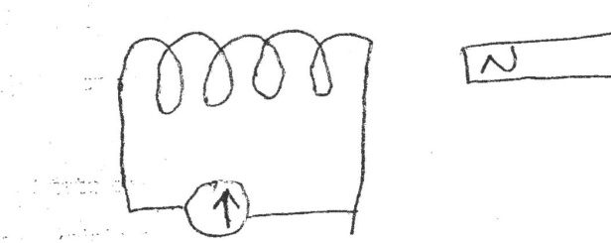
(i) the magnet move towards the coil. (02 marks)
(ii) the magnet moves away from the coil. (02 marks)
c.) What are electromagnets? (01 marks)
(ii) State three applications of electro magnets. (03 marks)
(iii) State three ways of increasing the strength of an electro magnet. (03 marks)
d.) Moving coil galvanometer has a resistance of 5Ω and gives a full scale deflection of 15mA. How can it be converted into an ammeter to measure a maximum current of 3A? (04 marks)

8.a)(i) What are x – rays? (01mark)
(ii) Draw a well labeled diagram of an x – ray tube. (02 marks)
(iii) Use the diagram above to describe how x – rays are produced. (03 marks)
b.) Distinguish between nuclear fission and nuclear fusion. (02 marks)
(ii) State two conditions for each to occur. (04 marks)
(iii) Give one use of each. (01 mark)
c.) Give three differences between cathode ray and gamma rays. (03 marks)

END

