535/2
PHYSICS
Paper 2
Jul/Aug 2019
2 ¼ Hours



MUKONO EXAMINATION COUNCIL
Uganda Certificate of Education
PHYSICS
Paper 2
2 Hours 15 Minutes

INSTRUCTIONS TO CANDIDATES:
Answer any five questions.
Any additional question(s) answered will not be marked.
Mathematical tables and silent non-programmable calculators may be used.
These values of physical quantities may be useful to you:
Acceleration due to gravity 10 ms⁻².
Specific heat capacity of water 4200 Jkg⁻¹K⁻¹.
Specific heat capacity of copper 400 Jkg⁻¹K⁻¹.
Specific latent heat of fusion of water 340000 Jkg⁻¹.
Speed of sound in air 320 ms⁻¹.
Velocity of electromagnetic waves 3.0 X 10⁸ ms⁻¹.

1. (a)(i) State Pascal’s principle. (1mark)
(ii)In an experiment to measure the pressure of a gas supply, a U-tube manometer is connected to a gas cylinder as shown in the figure below. The length, h of the mercury column is 18cm and atmospheric pressure is 760mmHg.
Find the pressure of the gas. (3marks)
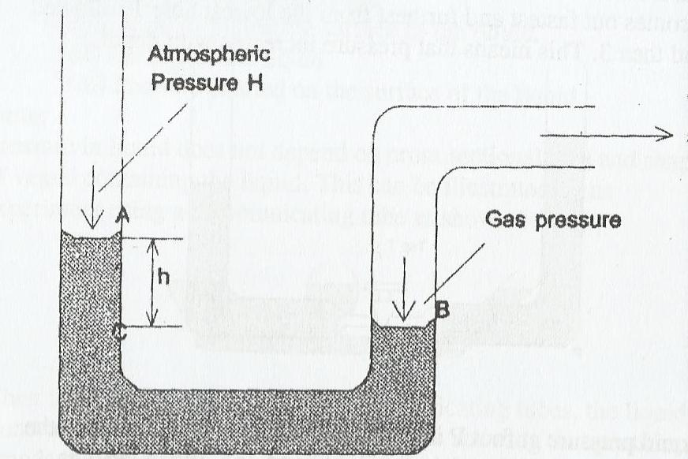
(b) Explain what happens when an inflated balloon is released in air. (2marks)
(c)(i) Describe with the aid of a labelled diagram, how a force pump works. (4marks)
(ii) State one application of atmospheric pressure. (1mark)
(d)(i) State the law of conservation of energy. (1mark)
(ii) A stone of mass 0.2kg is thrown vertically upwards attaining a maximum potential energy of 16J. Calculate its initial velocity. (4marks)
2(a). State the laws of refraction of light. (2marks)
(b) Describe an experiment to determine the focal length of a convex lens using a plane mirror. (4marks)
(c) Define the following:
(i) Refractive index of a material. (1mark)
(ii) Critical angle. (1mark)
(d) Calculate the critical angle for a water-glass boundary if the refractive index of water is 1.4
while that of glass is 1.52 (2marks)
(e)(i) State two applications of total internal reflection. (2marks)
(ii) Draw a ray diagram to show how a convex lens forms a virtual, magnified image of a real
object. (2marks)
(f) A convex lens produces a real image magnified four times of an object placed 5cm from the
lens. Determine focal length of this lens. (2marks)

3. (a) Define the following terms as applied to waves:
(i) Wavelength. (1mark)
(ii) Amplitude. (1mark)
(iii) Wave front. (1mark)
(b)(i) Distinguish between longitudinal and transverse waves. (2marks)
(ii) List three differences between sound waves and light waves. (3marks)
(c)(i) Define resonance as applied to sound waves. (1mark)
(ii) Describe how the speed of sound in air is determined using a resonance tube. (4marks)
(iii) Explain why an open tube is preferred as an musical instrument than a closed tube.
(1mark)
(d) A man standing midway between two cliffs makes a loud sound and hears the first echo after 3 s, Calculate the distance between the cliffs. (2marks)
4. (a) Define acceleration due to gravity and state its SI unit. (2marks)
(b) The diagram below shows a section of a tape obtained when pulled by a trolley through a ticker timer vibrating at 40Hz. Use the diagram to explain how the acceleration of the trolley may be obtained. (3marks)
6cm 3cm

Direction of motion.
(c) Sketch the velocity-time graph for the motion of the trolley in (b) above. (2marks)
(d)(i) State the principle of conservation of momentum and explain its application. (2marks)
(ii) Distinguish between elastic and inelastic collisions. (2marks)
(c) A body of mass 500g moving at 40ms-1 collides with another stationary body of mass 1000g placed on a smooth horizontal surface. If the bodies move together after collision, calculate the
(i) Common velocity of the two bodies after collision. (2½marks)
(ii) Kinetic energy lost by the moving body. (2½marks)

5. (a)(i) What is meant by strength of a material? (1mark)
(ii) State the factors that affect the strength of a material. (2marks)
(b) A spring of natural length 5cm extends by 2mm when a force of 1.8N acts on it. Calculate the
extension when a force of 10N is applied to the spring. (2marks)
(c) Give four reasons why bicycle frames are made of hollow cylindrical structures. (4marks)
(d)(i) State the composition of reinforced concrete. (2marks)
(ii) Explain why the lower part of a ceiling of a building is made of reinforced concrete while the upper part is not reinforced. (3marks)
(e) Explain how one can show that a beam on a building is a strut or tie. (2marks)

6. (a) What is meant by the terms?
(i) Temperature? (1mark)
(ii) Lower fixed point of a thermometer. (1mark)
(b) Briefly describe an experiment to determine the lower fixed point of a thermometer. (4marks)
(c) State two advantages and two disadvantages of using mercury as a thermometric liquid. (2marks)
(d) Explain how the boiling point of a liquid depends on altitude. (2marks)
(e) A copper block of mass 100g is heated to 200°C and then quickly transferred to a copper calorimeter of mass 300g containing 400cm³ of water at 25°C.
(i) Calculate the maximum temperature attained by the water in the calorimeter. (3marks)
(ii) Sketch the graph to show the variation of temperature with time. (2marks)
(iii) Explain one application of heat capacity. (1mark)
7. (a)Define electromotive force of a cell. (1mark)
(b)Four resistors are connected across a 12V battery of negligible internal resistance as shown in the figure below.


A

3.0
3.0
Ω

2.0
Ω

4.0
Ω

V
12

(i) Determine the reading of the ammeter. (2marks)
(ii) The power dissipated by the 2Ω resistor. (1mark)
(c) An electric appliance is rated 1200W, 240V.
(i) Explain what this statement means. (2marks)
(ii) Calculate the cost of running this appliance for a week if it is used for 30 minutes each day, given that the cost of a unit of electricity is 500/=. (3marks)
(iii) Draw the magnetic field pattern due to an electric current in a solenoid through which a direct current is flowing. (2marks)
(d) Describe how a lightning conductor works. (5marks)

8. (a) What are X-rays? (1mark)
(b)(i) With the aid of a labelled diagram, describe how X-rays are produced in an X-ray tube. (5marks)
(ii) State one medical use and one industrial use of X-rays. (2marks)
(c) Define the following:
(i) Nuclear fission. (1mark)
(ii) Nuclear fusion. (1mark)
(d) A nuclide ${}_{92}^{235}W$ decays by emission of two alpha particles. The resulting nuclide emits three beta particles resulting into a nuclide, which emits gamma rays.
Determine the atomic mass and the number of protons of W and write a balanced equation for the decay. (3marks)
(e)(i) What is meant by half-life of a radioactive substance? (1mark)
(ii) The half-life of Radium is 1,620 years. How long will it take 16g of Radium to decay to 2g? (2marks)
END

