Name:………………………………………………………………….……………… Random No…………………………
Signature: ………….…………………………………………………..
840/1
COMPUTER
STUDIES
THEORY
PAPER 1
2½ HOURS

Uganda Certificate of Education
COMPUTER STUDIES
PAPER 1
2 hours 30 minutes

INSTRUCTIONS TO CANDIDATES:
(Read all instructions in this paper carefully)
- This paper consists of three sections A, B and C
- Section A contains 20 compulsory objectives-type questions. The correct alternative A, B, C or D against each question must be written in the box provided on the first page.
- Section B contains six structured questions. Attempt all of them.
- Answers to section B must be written in the spaces provided in the question paper.
- Section C contains three easy questions .Attempt only one .Answers to section C must be written in the answer booklet provided.
Section A
1 |  | 5 |  | 9 |  | 13 |  | 17
2 |  | 6 |  | 10 |  | 14 |  | 18
3 |  | 7 |  | 11 |  | 15 |  | 19
4 |  | 8 |  | 12 |  | 16 |  | 20

For examiner’s use only
MCQ | Q21 | Q22 | Q23 | Q24 | Q25 | Q26 | Q27 | Q28 | Q29 | TOTAL
SECTION A (20 Marks)
- A feature in a presentation that will make slides appear and disappear from the screen is

- Slide show
- Transition
- Animation
- Loop until escape.

- Which one of the following makes up a machine cycle

- Fetch-store-execute-decode
- Fetch-decode-execute-store
- Fetch-store-decode-execute
- Fetch-decode-store-execute

- Nanaasi opened a word processor and typed a word open as apen and it indicated a red wavy underline. When she right clicked on it a short cut menu displayed the following options except

- Ignore
- Ignore all
- Add to dictionary
- Edit

- What is a record in a database?

- A row of items
- A table of information
- A folder of database files
- A column of items.

- A group of cells selected in a spreadsheet is referred to as

- Table
- Worksheet
- Range
- Workbook

- A protocol is referred to as…..
- A network device
- A set of rules governing communication of devices
- A message on the network.
- An internet message.

- Which of the following is application software?

- Ms Dos
- Ms windows
- Software wizard
- Ms publisher

- The following are features of a web page except

- Banner
- Navigation buttons
- Website
- Hyperlinks

- A personal computer on a network can be restricted from unauthorized access by ….

- Activating firewall
- Installing an antivirus
- Creating user accounts
- Installing firmware.

- As the computer performs the same task again and again without getting tired it referred to as

- Automatic
- Versatile
- Diligent
- Artificial intelligence

- Which of the following was not a characteristic of computers developed during the mechanic era?

- Punched cards
- A set of gears
- Expert systems
- Moving parts

- Computer hardware is categorized into storage,inputs,ouputs and

- Key board
- System unit
- Processing
- Cables

- A flash disk is a good example of

- Solid state storage
- Optical storage
- Magnetic storage
- Read only memory

- What device is used in supermarkets for taking stock records

- Barcode reader
- CCTV camera
- Computer
- Finger print scanner

- Microsoft office is a/an..

- A word processor
- Software suit
- Freeware
- Integrated software

- Name the electronic component which was used in the first generation

- Integrated circuits
- Microprocessors
- Transistors
- Vacuum tubes

- How many options can be selected from a radio button list?

- Zero
- Only one
- All options present in the list
- As many as required

- Which of the following data transmission modes takes place in both directions but not simultaneously.

- Half duplex
- Simplex
- Full duplex
- Parallel transmission

- Which of the following is the right order when writing a program

- Code>Complier>Run
- Run>Code>Compile
- Compile>Code>Run
- Run>Compile>Code

- Which of the following will copy its self into memory or a disk until no more space is left

- Bug
- Email
- Virus
- Antivirus

SECTION B (60 Marks)
21. (a) Briefly describe the following classes of computers
(i) Hybrid computer (02 Marks)
……………………………………………………………………………………………
……………………………………………………………………………………………
(ii) Stand alone computers (02 Marks)
……………………………………………………………………………………………
……………………………………………………………………………………………
(iii) Client computers (02 Marks)
……………………………………………………………………………………………
……………………………………………………………………………………………

(b) State any four technological advancements in the banking industry today. (04 Marks)

……………………………………………………………………………………………
……………………………………………………………………………………………
……………………………………………………………………………………………
……………………………………………………………………………………………
……………………………………………………………………………………………
……………………………………………………………………………………………

22. (a) State one technological difference between a disc and a disk. (02 Mark)
……………………………………………………………………………………………
……………………………………………………………………………………………
(b) State fouradvantages of using discs for data storage (04 Marks)
……………………………………………………………………………………………
……………………………………………………………………………………………
……………………………………………………………………………………………
……………………………………………………………………………………………
(c) Mention one function of random Access Memory:- (04 Marks)
(i) During booting
……………………………………………………………………………………………
……………………………………………………………………………………………
(ii) When the computer is in use
……………………………………………………………………………………………
……………………………………………………………………………………………
23. (a) A trader enters his records in the spread sheet as indicated below.
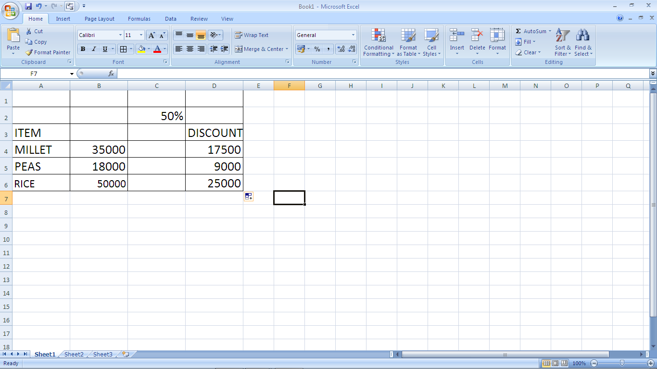
- If this trader wants to present this information graphically by using data in column A and D only, give the steps this trader would follow to achieve this goal. (04 Marks)

……………………………………………………………………………………………
……………………………………………………………………………………………
……………………………………………………………………………………………
……………………………………………………………………………………………
……………………………………………………………………………………………
……………………………………………………………………………………………
- If the shopkeeper used an absolute cell referencing to determine the discounts which is 50% of the item value in column C2, Write the formula that was used to get the values in column D. (01 Marks)
……………………………………………………………………………………………
……………………………………………………………………………………………
- State one measure that would be used for (02 Marks)
- Ensuring data integrity in electronic databases
……………………………………………………………………………………………
……………………………………………………………………………………………
- Avoiding data redundancy in electronic databases
……………………………………………………………………………………………
……………………………………………………………………………………………
- Outline three uses of query objects in a school database. (03 Marks)
……………………………………………………………………………………………
……………………………………………………………………………………………
……………………………………………………………………………………………
……………………………………………………………………………………………

24. (a) Give three characteristics of a good application program (03 Marks)
……………………………………………………………………………………………
……………………………………………………………………………………………
……………………………………………………………………………………………
……………………………………………………………………………………………
(b) (i) Define a function as used in programming (01 Mark)
……………………………………………………………………………………………
……………………………………………………………………………………………
- State three rules governing a valid function name (03 Marks)
……………………………………………………………………………………………
……………………………………………………………………………………………
……………………………………………………………………………………………
- Outline three management functions of an operating system
(03 Marks)
……………………………………………………………………………………………
……………………………………………………………………………………………
……………………………………………………………………………………………
……………………………………………………………………………………………

25. (a) Name the software that is responsible for reporting computer system errors to the user (01 Mark)
……………………………………………………………………………………………
……………………………………………………………………………………………
(b) State one implication of each of the following error messages (02 Marks)
(i) Continuous beeping sound.
……………………………………………………………………………………………
……………………………………………………………………………………………
- Display of all saved file icons on a storage media as shortcuts.
……………………………………………………………………………………………
……………………………………………………………………………………………
- Mention one validation checks with a word processor (01 Mark)
……………………………………………………………………………………………
……………………………………………………………………………………………
- Under what circumstance would one use presentation software?
(06 Marks)
……………………………………………………………………………………………
……………………………………………………………………………………………
……………………………………………………………………………………………
……………………………………………………………………………………………
……………………………………………………………………………………………
……………………………………………………………………………………………
……………………………………………………………………………………………
……………………………………………………………………………………………

26. (a) Explain three methods of error detection in a program code
(03 Marks) ……………………………………………………………………………………………
……………………………………………………………………………………………
……………………………………………………………………………………………
……………………………………………………………………………………………
(b) Give three qualities of a good website (03 Marks)
……………………………………………………………………………………………
……………………………………………………………………………………………
……………………………………………………………………………………………
……………………………………………………………………………………………
(c) List four justifiable reasons for studying computer studies .(04 Marks)
……………………………………………………………………………………………
……………………………………………………………………………………………
……………………………………………………………………………………………
……………………………………………………………………………………………

SECTION C (20 Marks)
Attempt only one question in this section.

27. You have completed your UCE examinations and you are interested in using your computer skills to earn a living.

- Explain eight computer based opportunities you can take up to get income in your community
(16 Marks)
- Outline four negative impacts of your computer activities to society (04 Marks)

28. Describe the step by step you can go through to perform the following tasks;
(i) Establishing the hard disk space (05 Marks)
(ii) Formatting a flash disk for use (05 Marks)
(iii) Uninstalling an application program from your PC. (05 Marks)
(iv) Checking your computer specifications (05 Marks)

29. You are given a computer to use and you eventually discover that it’s too slow in performingthe taskyou are handling.
- Establish the hardware components that might have caused this poor performance. (05 Marks)
- Explain how you can solve this problem of slow performance. (15 Marks)

**END**

