

JINJA JOINT EXAMINATIONS BOARD
MOCK EXAMINATIONS 2019
MARKING GUIDE
840/1 COMPUTER STUDIES

SECTION A: (20 MARKS)

 | A |  | C |  | A |  | A
 | D |  | A |  | B |  | C
 | B |  | B |  | B |  | C
 | D |  | C |  | C |  | D
 | A |  | C |  | C |  | B

SECTION B: (60 MARKS)

In this section, fill in the spaces provided for questions 21 to 26. This section is compulsory.

- (a). Statetwo characteristics of computing devices developed during the mechanical
era. (02 marks)

- They had moving parts.
- They had a set of gears.
- They had a set of dials.
- Very much limited memory for storage and recall.
- Most of them were made to order (one – instruction at a time).

(b). Explain the following terms used in relation to a good computer.

(i). Artificial Intelligence. (02 marks)

- Ability for a good computer to behave and reason like a human being by taking decision.

(ii). Automation. (02 marks)

- Ability of a computer to perform tasks with limited supervision from the user.

(c). State two causes of computer system failure. (02 marks)

- Use of aging hardware components.
- Computer virus.
- Acts of God e.g. floods, lightening, e.t.c.
- Power failure (over voltage, under voltage, power spikes, brownout, black out).
- Vandalism of equipment.
- Theft of equipment.
- System hacking and related computer crime.

(d). Write down two buttons on a computer’s keyboard that work as ON and OFF
switch. (02 marks)

- Caps Lock.
- Num Lock.
- Scroll Lock.

- (a). State any two parts that make up the Central Processing Unit. (02 marks)

- Arithmetic logic unit.
- Control unit.
- Register.

(b). (i). Give two characteristics of impact printers. (02 marks)

- They are very slow in operation.
- Physical contact between printing medium and mechanism.
- Output is of poor quality.
- Makes a lot of noise due to the embossing mechanism.
- Can work in dusty environment.

(ii). State onereason for supplying computer software on a CD-ROM. (01 mark)

- It is portable.
- Cheaper in cost.
- Has a faster access speed.
- Holds relative large amounts of software.
- Rarely affected by computer viruses.
- Content is kept permanent.

(c). Describe one use of a Control Panel during software installation. (02 marks)

- It provides a user with the ability to view and change system settings.

(d). (i). Give two reasons for having a partitions in a hard disk. (02 marks)

- To have a better way of organizing data and files on the drive.
- To enable a user run different operating systems on one PC.
- To reduce the threats of data loss.
- To have a more convenient approach for backing up and restoring data.
- To have more selective options when encrypting drive.
- To improve performance.

(ii). Identify the role of Random Access Memory in the booting process of a
computer. (01 mark)

- It provides primary storage facility to the operating system.

- (a). Give two characteristics of number data type as used in a spreadsheet program. (02 marks)
- It is aligned to the right hand side of a cell.
- It is used in a calculation.
- When converted into text, it will align to the left of the cell.

(b). (i). If I select a cell range A4:E15, how many cells have I selected? (01 mark)

- 60 cells.

(ii). State any two examples of cell referencing techniques used in an electronic
spreadsheet. (02 marks)

- Mixed cell referencing.
- Absolute cell referencing.
- Relative cell referencing.

(c). Explain the following field properties as used in database design.

(i). Caption. (02 marks)

- A label text that is displayed for this field by default in forms, reports, and queries.

(ii). Input mask. (02 marks)

- Displays editing characters to guide data entry. For example, an input mask might display a dollar sign ($) at the beginning of the field.

(d). Give one requirement of a good primary key field in a database table. (01 mark)

- Never null or empty.
- It must be unique.
- It does not change.

- (a). State two qualities of a good computer network. (02 marks)

- should have large storage facilities.
- Should have a fast processor speed.
- Should have large amount of RAM.
- Should have appropriate network operating system.

(b). Give one function of the following network protocols:

(i). Internet Protocol (IP). (02 marks)

- It enables a computer or device to be identified on across a network.

(ii). Hyper Text Transfer Protocol. (02 marks)

- It defines how messages are formatted and transmitted, and what actions Web servers and browsers should take in response to various commands.

(c). Give two activities that are carried out by a webmaster of an organisation. (02 marks)
- He creates, designs websites.
- He updates content in the site.
- He changes site layout and navigation.
- He hosts webpages.
- He troubleshoots websites by cleaning viruses and faulty links and codes.
- He markets and advertises the website.

(d). Identify the possible actions that would be taken when the following HTML
statements are written and preview in an HTML editor.

(i). <u>I love computer studies</u> (01 mark)

- ThestatementI love computer studiesisunderlined.

(ii). <marquee behavior = “alternate”>I love computer studies</marquee> (01 mark)

- The statement I love computer studies will move across the screen from right to left continuously.

- (a). Describe the following as used in a word processor.

(i). Text highlight. (02 marks)

- Refers to the selection of text to be prepared for further commands from the user.
- Refers to placing a background colour behind selected text in a word processor.

(ii). Page orientation. (02 marks)

- Page orientation is the direction in which a document is displayed or printed.
(b). State any two document referencing facilities that are found inside an
electronic word processor. (02 marks)

- Footer.
- Footnote.
- End note.
- Page numbering.
- Line numbering.
- Table of contents.
- List of figures.

(c). State two advantages of using a presenter view in a class presentation. (02 marks)

- Enables the user to edit a slide while in slideshow view.
- Enables the user to view speaker notes to the presenter.

(d). Give two specific data sections that a note page when printed can display
compared to a slide mode print. (02 marks)

- Speaker notes section.
- Slide printed in a single handout.

- (a). Define a computer application program. (02 marks)

- A compute program designed to perform a specific end user task.

(b). State three factors to consider before buying a software program for use. (03 marks)
- Compatibility
- Functionality
- Price
- Credibility
- User Friendliness
- Agility
- Exit Strategy

(c). (i). Give one advantage of using a compiler by a programmer. (01 mark)

- Is converts source code into executable files.
- It helps the programmer to identity errors before making an executable file.
- It helps the user to know the line where a syntax error is.

(ii). What is a source code? (02 marks)

- It refers to a computer program that is not yet compiled.
- A computer program written in high level language using a language processor not yet compiled into an executable file.

SECTION C: (20 MARKS)

Attempt only one question from this section.

- (a). Outline four characteristics of a good pseudo code. (04 marks)

- The statement must be short, clear and readable.
- The statements must not have more than one meaning i.e. should be unambiguous.
- The pseudo code lines should be clearly outlined and indented clearly
- A pseudo code should show clearly the start and stop of executable statements and the control structures (to be discussed later in the section)

(b). A flow chart showing tax payable for each income bracket. (16 marks)

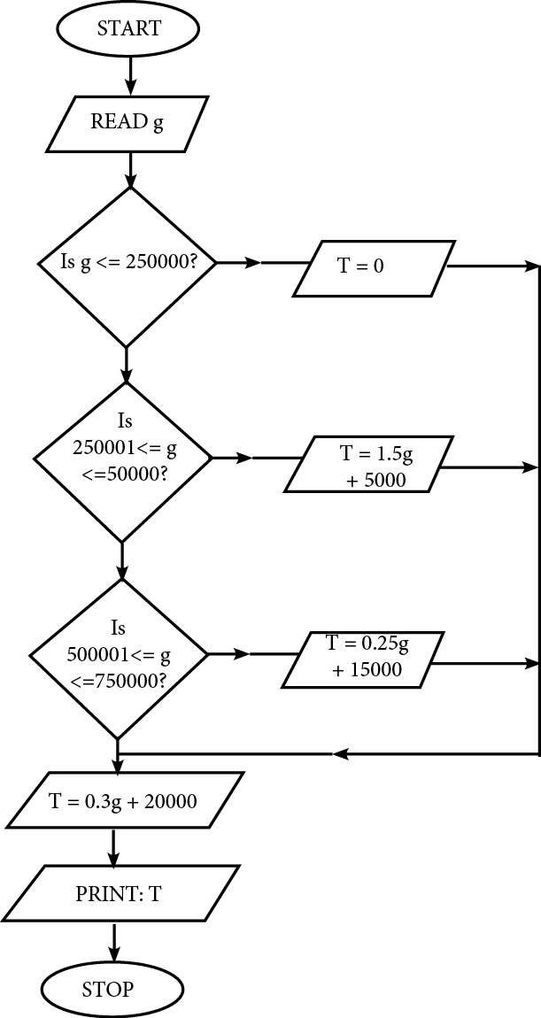

- Describe five computer networking devices you would use to set up a local area network for an organisation. (20 marks)

- Network Hub.
- Network Switch.
- Network Router.
- Bridge.
- Repeater.
- Gateway: Firewall:
- Network interface card (NIC).

- (a). Outline five causes of computer failure in a laboratory. (10 marks)

- Voltage spike.
- Circuit board fails with no visible indication of damage.
- Failure to load software upgrades.
- Failure to keep virus protection up to date.
- Inadequate cooling.
- Loss of Power.
- Storage defective.
- Hardware vandalism.
- Poor handling of equipment.
- Computer crime like virus, hacking, piracy, e.t.c.

(b). Explain five ethical issues computer users should be concerned about while in a
computer laboratory. (10 marks)

- Unauthorized access.
- Software piracy.
- Information privacy.
- Information accuracy.
- Intellectual property rights.
- Code of conduct.
END

