535/4
Physical Practical
Paper 4
July/august 2019
2 ¼ hours



KAYUNGA SECONDARY SCHOOLS EXAMINATIONS COMMITTEE (KASSEC)
Uganda Certificate of Education
JOINT MOCK EXAMS 2019
PHYSICS
PAPER 4
2 Hours: 15 MINUTES

INSTRUCTIONS TO CANDIDATES
- Answer question 1 and any other question from question 2 or question 3.
- Candidates are not allowed to use the apparatus for the first fifteen minutes
- Graph papers are provided
- Candidates are reminded to record their observations as soon as they are made.
- Candidates should put their observations and calculations in a suitable table drawn in advance.
- Marks are given mainly for a clear record of the observations actually made for their suitability and accuracy, and for use made of them.

1. In this experiment, you will determine the weigh, Q, of the unknown mass, Z provided
- Balance the metre rule provided on the knife edge.
- Note the position ,P, of the knife edge where the metre rule balances and record its distance Xo from end B.
- Place a mass M = 20g at the 10.0cm mark and adjust the position of the knife until the metre rule balances again as shown in the figure below.
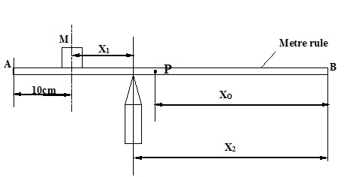
- Measure and record the distance X₁ and X₂.
- Calculate the weight , W, of the metre rule from the expression
W = $\frac{0.2 {X_{1}}^{}}{X_{2}-X_{0}}$

- Remove the mass, M
- Place the knife edge on the wooden block provided
- Suspend an unknown mass, Z at a distance d = 5.0cm from the zero end of the metre rule.
- Adjust the meter rule on the knife edge until it balances as shown in the figure below

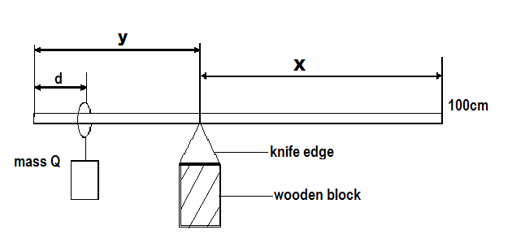
- Measure and record the distance X and y
- Repeat procedures (h) to (j) for values of d = 15.0 cm, 25.0cm, 35.0cm, and 45.0cm respectively.
- Record your results in a suitable table including values of (x – y) and (y – d)
- Plot a graph of (x – y) (along the vertical axis) against (y – d) (along the horizontal axis)
- Find the slope, S, of the graph
- Calculate the weight of the unknown mass, Z, from the expression
Z= $\frac{WS}{2}$
2. In this experiment, you will determine the refractive index, n, of the glass block provided.
- Fix the plain white sheet of paper on the soft board using drawing pins.
- Trace the outline PQRS of the glass block on the paper as shown in the figure below.
- Draw a normal WN to the face PQ at N such that PN = 2.0cm

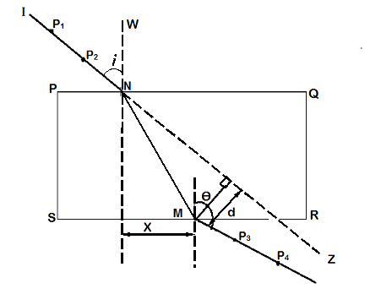
P₄
P₃

- Draw a line IN at an angle i= 10º to WN
- Replace the block on its outline
- Stick two pins P₁ and P₂ along IN
- Looking through the glass block from side SR, stick two pins P₃ and P₄ such that they appear to be in line with the images of P1 and P₂.
- Remove the block from its outline and pin P₃ and P₄
- Draw a line through pins marks P₃ and P₄ to meet SR at M.
- Produce IN to Z
- Measure angle $θ$ and distances x and d
- Repeat procedures (d) to (k) for values of i= 20º, 30º, 40º, 50º and 60º respectively.
- Enter your results in a suitable table including values of $\frac{\sin{i}}{sinθ}$ and $\frac{x}{d}$
- Plot a graph of $\frac{\sin{i}}{sinθ}$ (along the vertical axis) against $\frac{x}{d}$ (long the horizontal axis)
- Find the slope, n, of the graph
NB: HAND IN YOUR TRACING PAPER TOGETHER WITH YOUR SCRIPT
3. In this experiment, you will determine the internal resistance, r, of the cell provided.
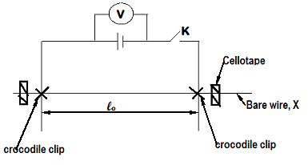
- Connect the circuit as shown in the figure above
- Adjust the distance lo = 0.20m.
- Close switch K
- Read and record the reading V, of the voltmeter
- Repeat procedures (c) to (e) for lo = 0.30, 0.40, 0.50, 0.60, 0.70 and 0.80m respectively.
- Enter results into a suitable table including values of $\frac{1}{V}$ and $\frac{1}{l_{0}}$
- Plot a graph of $\frac{1}{V}$ (along the vertical axis) against $\frac{1}{l_{0}}$ (along the horizontal axis)
- Find the slope, S, of the graph
- Calculate the internal resistance, r, of the cell from the expression; r= 7.95S.

END

