TIE AND DYE
Tie-dye is a bound resist method of decorating a fabric. In the process, a piece of fabric or cloth is tied and dyed typically using bright colors. The fabric is tied, folded or stitched to prevent penetration of dye.

Materials

- Cloth
- Dyes such as dylons
- Nylon threads
- Salt

Tools
- Heat source
- Flat iron or iron box
- Objects such as stones and bottles tops
- Saucepan
- Needles
- Nylon threads and rubber bands or raffia

Methods
- Gathering and folding
This is a method in which the cloth is folded, tied and dipped in the dyes. The cloth can be folded to form pleats, strips, circles or spirals

- Knot tying
Hold the cloth at both ends and twist into a long rope form, Tie this long rope into a knot and tighten as much as you can without damaging the cloth. You can tie as many knots as you have room for. Rubber bands or string can be tied over the knots to reinforce them as well as provide fine lines in the pattern.

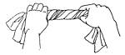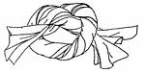

- Pleats
Lay the cloth on a flat surface and fold it into small folds (pleats) this is done following the length of the cloth or diagonally from one corner of the cloth, be careful not to lose any pleats and then tie accordingly. Loop rubber bands or string very tightly around all the pleats several times and knot. You can use as many ties as you want. This useful technique is also employed in tying ovals, squares, diamonds or any shape you can imagine which has symmetry.
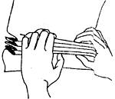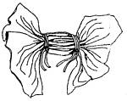

- Stripes
Lay the cloth on a flat surface, gather the cloth following its length and tie it
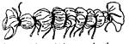

- Circles
Pull up a point on your cloth and twist it clock wise to form an anti-hill form. Tie it from the base up-wards. This can be done at several points on the cloth. The cloth can also be tied with objects of different sizes at different at different points.
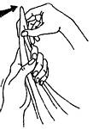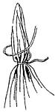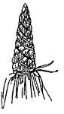

- Spirals
At the middle of the cloth, pinch a part and twist it to form a curl, and tie the entire cloth
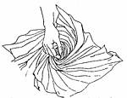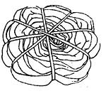

- DIAMONDS, OVALS AND SQUARES
Fold the cloth once along an imaginary line which will run through the intended form. Draw half of the intended design with a pencil or with your mind's eye, starting and ending on the crease.
Form pleats, starting at one end of your line. Try to keep that line in the center between your hands while pleating until you come to the end of your line.
Wrap string or rubber bands around all the gathered pleats several times, and tie a secure knot.
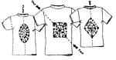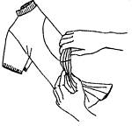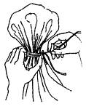

- ROSETTES
A Rosette is many little circles, touching or overlapping each other. Using a pencil or your mind's eye, make a few dots on the cloth in any pattern. Each dot will be the center of a small circle, with the thumb and forefinger pick up dot after dot and transfer to the other hand. Wrap string or rubber bands several times around the base of all the circles which have been gathered together. Continue to wrap to the tip and back, making sure your ties are very tight.
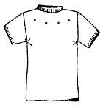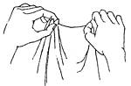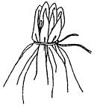
Technique
- Select a theme/ source of inspiration
- Make sketches of your composition on paper
- Collect and prepare the materials and tools to be used.
- Follow a method of your choice and tie the cloth, but make sure the knots are tight
- Mix the dye in water and boil according to their instructions.
- Dip the cloth in the first color of the dye
- Remove the cloth and dry it in a cool dry place to prevent it from fading.
- When the cloth is dry, tie it further in the areas you want to retain first colour and dip in another dye
- Dry the cloth and go through the same process for the third time until the desired design is got
- Untie the cloth and rinse in water to get rid of excess dye
- Dry the cloth and iron it

- Stitchery/ sewing
This is a method of tie and dye where threads are sewed in the patterns drawn on the fabric and tightened in order to resist the penetration of dyes.

Begin by sketching the required pattern on paper with a pencil and the trace the sketch on the cloth. Using a sizable needle with a tread and saw the patterns. The treads can be left hanging at the beginning and at the end of each stitch.

Techniques
- Select a theme and source of inspiration
- Sketch your design out using a pencil on paper.
- Collect and prepare the materials and tools to be used.
- Transfer the sketch of your design out using a pencil on the fabric and create contours.
- Use a large needle and nylon threads stitch through the contours of the design by using running stiches.
- Tie a very thick knot at the end of the thread to prevent them from falling out.
- One stitch at a time, pull the fabric back towards the knot until it is bunched up. Pull the fabric as tight as possible. Secure the thread with another thick knot.
- Mix the dye according to the dye instructions
- Dip the fabric in the first colour of the dye.
- Dry in a cool dry place to prevent the dye from fading
- Pull other stiches in places you want to retain the first colour and dip in second colour of dye
- Dry the cloth and go through the same process until the design is got.
- Cut the stitches out to reveal your tie dye patterns.

