Topic 2 FABRIC DECORATION
Fabric/ textile design is patterning an essentially plain fabric to render it more appealing to serve a particular purpose. This includes any of the many concepts and activities used for enriching a fabric medium, in any case the action or technique used is a result of a design and expression of elements and principles of a design.
TYPES OF FABRIC DESIGN
Surface fabric design; this is a design that is achieved by ornamenting the surface of a fabric.
Surface fabric designs can be achieved in the following ways;
- Printing
- Painting
- Tie and dye
- Batik
- Embroidery
- Appliqué
- Patch work.

Structural fabric design; this is a design that is achieved as the material/fabric is made; this includes the overall design, form and shape plus all the details involved in assembling the sections of the fabric.
Structural fabric decoration can be achieved in the following ways;
- Weaving
- Knitting
- Netting
- braiding

WHY WE DECORATE FABRICS
- For aesthetic reasons; Fabrics are decorated to make a plain piece of fabric look interesting

- For social reasons; Fabrics are decorated to differentiate social classes

- For cultural reasons; Fabrics are decorated according to the culture that has been put in them. People base on historical and ancestral believes.

- Fabrics are also decorated to suite the social classes of people and also recognize companies, institutions and organizations from the way they dress and present themselves.

- Fabrics are also decorated to earn a living.

- Fabrics are also decorated for communication purposes. They are decorated especially for advertisements by different organizations and individuals

- PRINTING/ PRINT MAKING
This is the process of duplicating a design by transferring its image from a prepared surface to another. The process is carried out in four basic methods namely
- Relief method. This is printing made by a raised surface (puff printing)
- Intaglio. This is printing made from sunken areas
- Lithography. This is printing made from a flat surface
- Serigraphy. This is printing made through a surface (screen printing)

Tools used | Materials required
- Wood blocks  - Linoleum blocks  - Screen mesh  - Squeegees  - Hammer  - Drawing tools  - Art books/paper  - Cutters/ blades  - Gouges  - Stencil films  - Cleaning rags  - Plates, etc | - Fabrics (cotton/silk/tetron/polyester cloths  - Printing paste  - Thickener  - Urea  - Water  - Colorants/ stains  - Nails (tack and framing nails)  - Wood frames

MOTIF
Before printing can happen, a motif/ design must be made and then transferred to a block, screen or a plate.
A motif is a repeated pattern used in a design during printing, or it’s a source of inspiration.

Process of developing a design/motif
Making a motif involves a lot of creativity, thus changing from an ordinary theme to the extraordinary i.e from the known to the unknown.

Procedure for motif development
- Select a theme or a source of inspiration for the design. This can be got from nature or artificial settings of still life or daily human activities, one may be inspired by textural patterns, shapes and color. For example, cabbage.
- Draw the inspiration on paper and study its shape and surface with tones. The purpose of the study is not to leave out interesting features of the object.
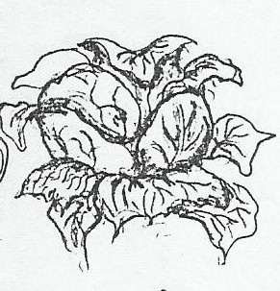

- Simplify the drawing in outlines
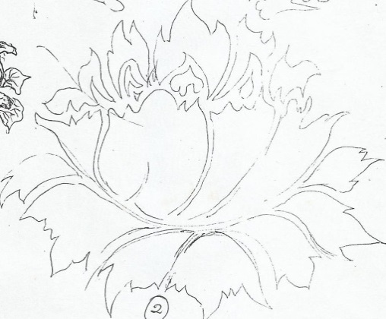

- Rearrange the object from its natural setting to your own composition while incorporating principles such as movement and rhythm so the design appears continuous when printing.
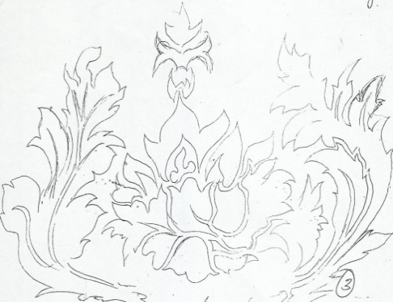
- Draw a square or rectangle to rearrange the ideas while incorporating the elements and principles of art
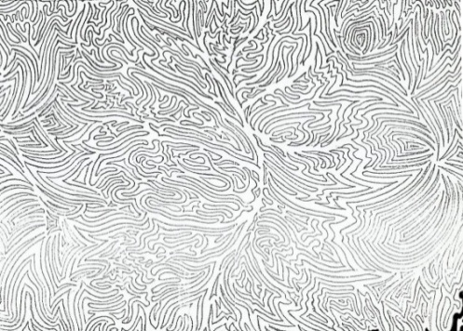
- Introduce positives and negatives by shading black for the positives to make the motif ready for printing
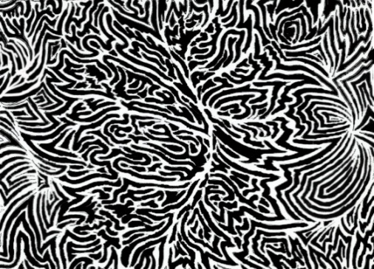

The first motif is complete and can be successfully used provided the edge grains of the motif join accurately. However, in the 2nd one, portions of the motif can be transferred to the opposite side to form a jigsaw fitting as seen below.
The jigsaw motif pattern
The advantage with the jigsaw fitting is that mistakes in the joints can be disguised as compared to the straight joinery.
The complete motif is then transferred onto a transparent plastic film/ wood block or exposed onto a screen for photo emulsion screen.

REPEATS
Once a pattern has been decided on, the type of repeat can be chosen. There are three basic types of repeats; the full repeat, the half drop and full drop repeat. Each type can be varied to produce interesting effects by rotating, inverting or reversing the design unit. The basic surface is divided geometrically into networks ie;

- BLOCK PRINTING
Block printing is a method of decorating a fabric by the use of a wooden block or linoleum-block into which a design is cut. The block is subsequently coated by thickened dye which is transferred or applied to the surface of a fabric. It’s a technique that works also in text printing, images and patterns.

Materials
- Fabric
- Dyes/ printing paste
- Thickeners

Tools
- Carving tools i.e. chisel
- Rubber gloves
- Dyeing utensils i.e. saucepans
- rollers
- Printing blocks

Processes / technique
- Select a theme and source of inspiration for your design.
- Develop a motif, and identify the negatives and positives
- Trace the design on the wooden or linoleum block and using a block cutter or chisel, carve out the parts of the design that will not receive color leaving the finer parts i.e. cut out the negative areas of the design. When finished, the block presents the appearance of sunken relief or a design standing out like a stamp. If a design has two colors, then a separate block is needed for each distinct color
- Prepare the fabric and Pin it to the printing surface and suggest repeat units
- To print, apply printing paste to the block by Rolling out printing ink onto a flat palette, then transfer ink to the surface of your block and press it firmly and steadily on the cloth. For flow of pattern and repeats, ensure perfect registration of the motif on cloth by recognizing previous points of impression made both horizontally and vertically, when the ones on the right fall at the ones on the left and the ones on top fall at the ones at the bottom.
- If a pattern contains several colors, dry the cloth after the first printing before the next one commences
- After printing leave it to dry before ironing. Ironing helps to permanently fix the color onto fabrics.

Possibilities
- It can add a simple yet intriguing effect to your item.
- It is a simple way of transferring text, patterns or images to your item.
- It’s a faster way of printing a fabric

Limitations
- The carving of the pattern onto the wood can be difficult, as it requires a lot of skill and a steady hand!
- It can get extremely messy with the use of paint!
- It takes time to carve a design in the wooden or linoleum block
- Once a mistake is made during carving it’s hard to correct

- STENCIL AND SCREEN PRINTING
Stencil printing is a method of fabric design where designs are cut in a stencil and (printed) transferred to the fabric.

A stencil is a perforated sheet (plastic/ paper/ metal) through which ink is forced to create a printed pattern on a surface or a sheet where a design can be cut to force ink through during printing, for example cardboards, manila papers, photographic films, x-ray films etc.

To print the pattern on a given surface, the designer applies printing paste, paints and inks through the open areas of the stencil

Tools
- A motif
- stencil
- Razor blades and cutters
- Sponge
- Squeegee. This is a rubber blade that is used to press printing ink through a screen to a prepared surface.
- Screen. This is a silk mesh stretched on a wooden frame.
- Masking tape

Materials
- Cloth, fabric
- Printing paste
- Water
- Thickeners

Technique/process
- Select a theme and source of inspiration.
- Develop a motif, and identify the negatives and positives
- Place the paper with your motif on a flat surface table and attach/ staple your stencil
- Cut out the positives on the stencil using a cutter or a razor blade.
- Place the cut stencil on top of the fabric to be printed
- Add printing paste on a sponge and press through the cut gaps
- Repeat the motif throughout the cloth to cover it with the design
- When done, dry the cloth in a cool dry place before ironing.

Possibilities
- It’s a cheap way of printing since it does not involve many costs.
- Three is easy registration of colour.

Limitations of stencils
- Cannot be used for patterns with the negatives locked up by positives
- It takes time execute, i.e. cutting the stencil
- Stencil destructs and distorts some patterns when cutting
- Uneven distribution of color on a fabric

- PHOTO EMULSION AND SCREEN PRINTING
Photo emulsion is a fine suspension of insoluble light sensitive crystals in a colloid solution, usually containing gelatin.

TOOLS
- Screen
- Squeegee
- Printing table/ light table
- Motif
- Scrapper
- Fabric rag
- Computer and printer
- Flood light (Bright Sun light also works effectively)

Materials
- Cloth
- Printing paste
- Water
- Thickeners
- Photo coat /Emulsion solution
- Wood frames
- Nails and shoe tacks

Preparation of photo emulsion `````````````````
- Select a theme and develop a motif, and identify the positives and negatives.
- Prepare a stretched mesh on a wooden frame to form a screen
- Prepare a solution of photo emulsion
- Spread a thin layer on the screen and let it to dry in a dark place for about 45mins
- Scan the motif to a computer and print it to a transparent material for example tracing paper.
- Put the screen upside down on top of a black surface, then put your transparency with positives and cover it with a glass block
- Expose the screen to light, the light causes the emulsion to harden and bind to the screen. Where the light passes makes a solid layer and where the light is blocked by the positives, remains water soluble.
- Wash and spray the screen with water only in the areas of the positives; this clears the areas where the ink will be pressed during printing.

Procedure and process
- Select a source of inspiration/ theme.
- Develop a motif and identify the positives and negatives
- Transfer your motif to the screen with photo coat/ photo emulsion.
- Prepare the materials and tools to be used.
- Lay a cloth on a printing table
- Place the screen at the starting point of printing and apply just enough printing paste on a squeegee and make the first print
- Continue the printing throughout the cloth
- When complete, Wash the screen after printing and leave the cloth to dry and iron it after

Possibilities
- It’s a fast way to decorate a fabric
- It can produce detailed images, rich texture and intense shading. i.e. It is also feasible to utilize actual found objects (both three dimensional and two dimensional) in the prints that have been photocopied

Limitations of photo-emulsion
- It is relatively expensive in terms of materials
- It solely depends on power which is not reliable i.e. power cuts are high
- It is difficult to be used by an inexperienced artist
- It’s a permanent technique which does not allow corrections during the printing process

Factors considered in printing
- Creativity; depends on how one develops a design from known to unknown
- Line and pattern; the organization and simplicity of shapes, and use of several quantities of line to create pattern
- Color; this includes choice and harmony
- Balance; in terms of space, shape and color
- Rhythm; ability to create movement in a design
- Craftsmanship; registration of the motif without creating unnecessary lines in the designs and the neatness of the print
- Purpose; the use of the print v/s the technique. I.e. patterns (designs) with angular patterns may be used for table cloths and carpets, while patterns with intricate designs are more suitable for dresses or shirts and bigger patterns are more suitable for curtains and carpets.
- Message; it should have a theme to communicate a given message.

b) TIE AND DYE
Tie-dye is a bound resist method of decorating a fabric. In the process, a piece of fabric or cloth is tied and dyed typically using bright colors by immersion. The fabric is tied, folded or stitched to prevent penetration of dye.

Materials
- Cloth
- Dyes such as dylons
- Nylon threads
- Salt

Tools
- Heat source
- Flat iron or iron box
- Objects such as stones and bottles tops
- Saucepan
- Needles
- Nylon threads and rubber bands or raffia

Methods
- Gathering and folding
This is a method in which the cloth is folded, tied and dipped in the dyes. The cloth can be folded to form pleats, strips, circles or spirals

- Knot tying
Hold the cloth at both ends and twist into a long rope form, Tie this long rope into a knot and tighten as much as you can without damaging the cloth. You can tie as many knots as you have room for. Rubber bands or string can be tied over the knots to reinforce them as well as provide fine lines in the pattern.

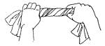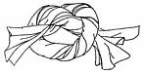

- Pleats
Lay the cloth on a flat surface and fold it into small folds (pleats) this is done following the length of the cloth or diagonally from one corner of the cloth, be careful not to lose any pleats and then tie accordingly. Loop rubber bands or string very tightly around all the pleats several times and knot. You can use as many ties as you want. This useful technique is also employed in tying ovals, squares, diamonds or any shape you can imagine which has symmetry.
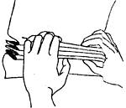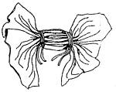

- Stripes
Lay the cloth on a flat surface, gather the cloth following its length and tie it
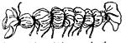

- Circles
Pull up a point on your cloth and twist it clock wise to form an anti-hill form. Tie it from the base up-wards. This can be done at several points on the cloth. The cloth can also be tied with objects of different sizes at different at different points.
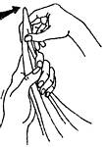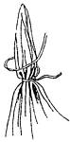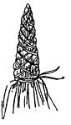

- Spirals
At the middle of the cloth, pinch a part and twist it to form a curl, and tie the entire cloth
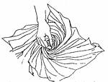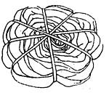

- DIAMONDS, OVALS AND SQUARES
Fold the cloth once along an imaginary line which will run through the intended form. Draw half of the intended design with a pencil or with your mind's eye, starting and ending on the crease.
Form pleats, starting at one end of your line. Try to keep that line in the center between your hands while pleating until you come to the end of your line.
Wrap string or rubber bands around all the gathered pleats several times, and tie a secure knot.
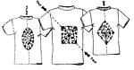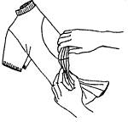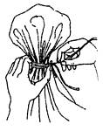

- ROSETTES/ Random circles
A Rosette is many little circles, touching or overlapping each other. Using a pencil or your mind's eye, make a few dots on the cloth in any pattern. Each dot will be the center of a small circle, with the thumb and forefinger pick up dot after dot and transfer to the other hand. Wrap string or rubber bands several times around the base of all the circles which have been gathered together. Continue to wrap to the tip and back, making sure your ties are very tight.
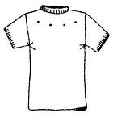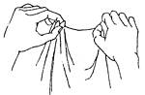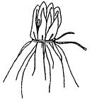
Technique
- Select a theme/ source of inspiration
- Make sketches of your composition on paper
- Collect and prepare the materials and tools to be used.
- Follow a method of your choice and tie the cloth, but make sure the knots are tight
- Mix the dye in water and boil according to their instructions.
- Dip the cloth in the first color of the dye
- Remove the cloth and dry it in a cool dry place to prevent it from fading.
- When the cloth is dry, tie it further in the areas you want to retain first colour and dip in another dye
- Dry the cloth and go through the same process for the third time until the desired design is got
- Untie the cloth and rinse in water to get rid of excess dye
- Dry the cloth and iron it

- Stitchery/ sewing
This is a method of tie and dye where threads are sewed in the patterns drawn on the fabric and tightened in order to resist the penetration of dyes.

Begin by sketching the required pattern on paper with a pencil and the trace the sketch on the cloth. Using a sizable needle with a tread and saw the patterns. The treads can be left hanging at the beginning and at the end of each stitch.

Techniques
- Select a theme and source of inspiration
- Sketch your design out using a pencil on paper.
- Collect and prepare the materials and tools to be used.
- Transfer the sketch of your design out using a pencil on the fabric and create contours.
- Use a large needle and nylon threads stitch through the contours of the design by using running stiches.
- Tie a very thick knot at the end of the thread to prevent them from falling out.
- One stitch at a time, pull the fabric back towards the knot until it is bunched up. Pull the fabric as tight as possible. Secure the thread with another thick knot.
- Mix the dye according to the dye instructions
- Dip the fabric in the first colour of the dye.
- Dry in a cool dry place to prevent the dye from fading
- Pull other stiches in places you want to retain the first colour and dip in second colour of dye
- Dry the cloth and go through the same process until the design is got.
- Cut the stitches out to reveal your tie dye patterns.

- BATIK
Batik is a "wax resist" process for making designs on fabric/ a wax resist method of decorating a fabric. Hot wax is applied to portions of the fabric and penetrates the cloth. After the wax dries, it prevents the dye from spreading to those areas of the fabric that have been waxed.

Materials
- Wax
- Fabric
- Dye
- Water and soap
- Sodium hydrosulphite
- Caustic soda
- Tttable

Tools
- Heat source
- A flat surface as a work area
- Papers
- Flat iron / iron box
- Pencils
- Tjanting tool
- Brushes different sizes
- Sauce pan
- Containers

Techniques/methods and processes
- Brushed waxing
This technique involves the use of hard bristle brush to apply very hot wax onto the stretched fabric to create desired images or patterns. Other brushes are used to apply different colors/dyes.
Steps
- Select a theme and make sketches of the composition on paper.
- Collect the materials and tools to be used.
- Lay the cloth on flat surface and transfer your sketch on the fabric.
- Prepare the dye according to the dye instructions
- Melt the wax in a container
- Using a brush apply wax on all areas you would like to maintain white and apply the first colour of dye to the entire cloth
- Spread the cloth to dry in a cool dry, to prevent wax from melting and the dye from fading.
- When the cloth is dry, apply more wax to places where you want to retain the first color of the dye and dip in the second colour of dye.
- Spread the cloth to dry in a cool dry, to prevent wax from melting and the dye from fading.
- When you are done with the design you want, Remove the wax from the cloth by squeezing and creasing the cloth
- Lay several layers of paper on a flat surface and the put the cloth on top. Cover the cloth with other papers and iron, keep on changing the paper until the excess wax is removed by creazing and ironing.

- Drip waxing
This is creation of patterns by dripping hot wax onto fabric with a multiple pointed tool e. g a wooden or metal comb. This is done either randomly or following a particular direction creating dotted designs or stroked stripes.

- Tjanting technique
A tjanting is a tool made up of a copper bowl with a thin spout mounted with a wooden handle.
Hot wax is poured in the tjanting tool and systematically oozed onto the fabric following the drawn pattern.
Tjanting tool.

Steps /processes
- From inspiration, drawings are made for the desired pattern/ design or composition on paper.
- Lay the fabric on a flat raised firm surface with newsprint paper beneath and transfer the composition on it.
- Melt the wax in a large container and pour some in the Tjanting tool.
- Carefully apply the hot wax following the desired plan/ design outline then apply the first lightest color.
- Apply more wax in different areas as preplanned and apply the second color. This is repeated till the last color is applied. The tjanting technique produces linear designs or patterns that offers detailed work.
- Wax is removed by creezing, scrapping and ironing.

- Crackled and Marbled effect
A fabric can be completely waxed then crackled and dyed to produce a cracked or marble effect.

Steps /processes
- Prepare the dye according to the dye instructions
- Collect the materials and tools to be used.
- Lay the cloth on flat surface.
- Melt the wax in a container
- Using a brush or tjanting tool apply wax on all areas you would like to maintain white and apply dye to the entire cloth.
- Crackle the cloth in the desired patterns and paint or immerse the cloth a lighter color and allow fabric to dry.
- Crackle the cloth again in different areas and apply second color (slightly darker than the first one) and allow to dry.
- Repeat this till the darkest color or black for that matter.
- Remove the wax from the cloth by squeezing and creasing the cloth.
- Lay several layers of paper on a flat surface and the put the cloth on top. Cover the cloth with other papers and iron, keep on changing the paper until the excess wax is removed. This technique produces crack or marble like effects.
The fabric is now ready for display/ domestic use or sale.

- TEXTURED EFFECT
This is the creating of texture effects in a batik artwork.

Steps
  - Select a theme and make sketches for the composition on paper
  - Collect and prepare the materials to be used.
  - Prepare the dye according to the dye instructions.
  - Lay the cloth on flat surface and transfer your sketch on the fabric
  - Place the cloth on a rough surface and rub wax on areas you would like to maintain white and apply dye to the entire cloth.
  - Spread the cloth to dry in a cool dry, to prevent wax from melting and the dye from fading.
  - When the cloth is dry, rub more wax to places where you want to retain the first color still on a rough surface.
  - When you are done with the design you want, Remove the wax from the cloth by squeezing and creasing the cloth
  - Lay several layers of paper on a flat surface and the put the cloth on top. Cover the cloth with other papers and iron, keep on changing the paper until the excess wax is removed.

- SCRATCHED EFFECT
The fabric is waxed and then scratched with a blunt instrument to produce fine lines.

Steps
    - Select a theme and make sketches for the composition on paper
    - Collect and prepare the necessary materials and tools to be used.
    - Lay the cloth on flat surface and transfer your sketch on the fabric.
    - Mix the dye according to the dye instructions.
    - Melt the wax in a container
    - Using a brush or tjanting tool apply wax on all areas you would like to maintain white and apply the first colour of dye to the entire cloth
    - Spread the cloth to dry in a cool dry, to prevent wax from melting and the dye from fading.
    - When the cloth is dry, apply more wax to places where you want to retain the first color and dip in the second colour of dye.
    - Apply the entire cloth with wax and scratch through the wax with a pin or any other blunt instrument and dip the cloth in a dark colour.
    - When you are done with the design you want, Remove the wax from the cloth by squeezing and creasing the cloth
    - Lay several layers of paper on a flat surface and the put the cloth on top. Cover the cloth with other papers and iron, keep on changing the paper until the excess wax is removed.

