NAME: |  | INDEX NO:
SCHOOL: |  | SIGNATURE:

535/3
PHYSICS
PRACTICAL

Community
UNNASE MOCK EXAMINATIONS

Paper 3
2 ¼ hours

Uganda Certificate of Education
PHYSICS PRACTICAL
Paper 3
2 hours 15 minutes

Instructions to Candidates:
- Answer question 1 and one other question.
- You will not be allowed to start working with the apparatus for the first quarter of an hour.
- Marks are given for clear record of the observations actually made for their suitability and accuracy and for the use made of them.
- Whenever possible, candidates should put their observation and calculations in a suitable table drawn in advance
- Graph papers are provided

1) In this experiment you will determine the density of the liquid L. 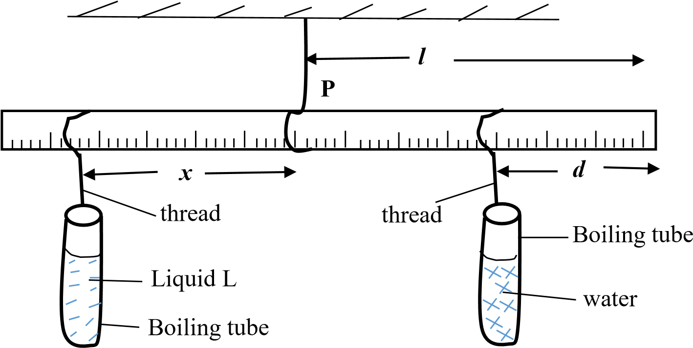B

  - Suspend the metre rule from a retort stand using a piece of thread so that the rule balances horizontally.
  - Note and record the balancing point P and its distance l from the end B.
  - Measure 25cm³ of water and pour it into a boiling tube and put it aside in a test tube rack.
  - Measure 25cm³ of the liquid mark L into another boiling tube. Place it in the test tube rack.
  - Suspend the boiling tube containing water at a distance d = 10.0cm from end B using a piece of thread.
  - Suspend the boiling tube containing the liquid marked L and adjust its position until the metre rule balances horizontally as shown in the figure.
  - Measure and record the distance, x, from P.
  - Repeat procedures (c) to (g) for values of d = 15.0, 20.0, 25.0, 30.0 and
35.0 cm.
  - Record your results in a suitable table including values of (l - d)
  - Plot a graph of x against (l - d)
  - Find the slope, S, of the graph.
  - Calculate the density, of liquid L from the expression $nsity= \frac{1000}{s}$ .

- In this experiment, you will determine the constant, w, of the glass block provided.
    - Fix a plane sheet of paper on the soft board using the thumb pins.
    - Place the glass block on the plane sheet of paper with its broad face upper most.
X

A

B

N

O

D

C

P
2

P
1

x

l

θ

M

Z

P
4

P
3

    - Draw the outline ABCD of the glass block and then remove it.
    - Mark points O and N on AB such that AC = 1.0cm and AN = 2.0cm
    - Draw a perpendicular XZ cutting AB and DC at O and Z respectively, with OX about 6.0cm.
    - Replace the glass block onto its outline, fix pin P₂ at a distance x = 1.0cm from 0 along the perpendicular XZ.
    - Fix pin P₁ at N, looking through the glass block from side DC, fix pins P₃ and P₄ such that they are in a straight line with the images of P₁ and P₂.
    - Remove the glass block, draw a line through points P₃ and P₄ to meet DC at M. join M to N.
    - Measure the length MN = l and angle θ.
    - Keeping pin P₁ at N, repeat the procedures (f) to (i) for values of x = 1.5,
2.0, 3.0, 4.0 and 5.0 cm.
    - Tabulate your results including values of .
    - Plot a graph of l against .
    - Find the slope, w, of the graph.
- In this experiment you will determine the constant, R of a touch bulb.
    - Connect the circuit as shown in the figure below.

Torch bulb
$$x$$
Crocodile Clip
A
Switch K

Crocodile clip
V

Bare wire

    - Starting with length x = 0.100m, close the switch K.
    - Read and record voltmeter and ammeter readings V and I respectively and open the switch K.
    - Repeat the procedures (b) and (c) for values of x = 0.200, 0.300, 0.400,
0.600 and 0.800m
    - Enter your results in a suitable table including values of $\frac{1}{I}$ and $\frac{1}{v}$.
    - Plot a graph of $\frac{1}{I}$ against $\frac{1}{v}$ .
    - Find the slope, R of the graph.

**** END ****

