535/3
PHYSICS
PRACTICAL
PAPER 3
$$2\frac{1}{4}HOURS$$

RESOURCEFULMOCK EXAMINATIONS 2017
UGANDA CERTIFICATE OF EDUCATION
PHYSICS PRACTICAL
Paper 3
2 hours 15 minutes

INSTRUCTIONS TO CANDIDATES:
- Answer question 1 and one other question.
- You will not be allowed to start working with the apparatus for the first 15 minutes.
- Marks are given mainly for a clear record of the observations actually made. Wherever possible, candidates should put their observations in a suitable table drawn in advance.
- An account of the method of carrying out the experiment is not required.
- Graph papers are provided.
- Mathematical tables and non programmable scientific calculators may be used.

- In this experiment, you will determine the relationship between the length of the pendulum and the intercept values.
- Tie a piece of thread to the pendulum bob provided
- Place the free end of the thread between two pieces of wood and clamp as shown in the figure.
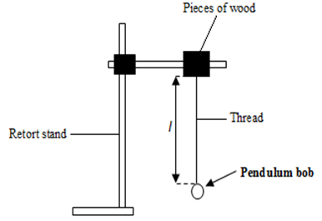
Figure 1
- Adjust the length $l$ of the pendulum to 100.0cm
- Displace the pendulum through a small angle and release it to oscillate in a vertical plane.
- Measure and record the time for 20 oscillations.
- Calculate the period $T_{1}$
- Adjust the length $l$ to 80.0cm
- Displace the bob through a small angle and release it to oscillate.
- Measure and record the time for 20 oscillations and calculate the period $T_{2}$
- Repeat the procedures (g) to (i) for $l=70.0,60.0,50.0, 40.0 and 30.0.$
- Record your results in a suitable table including values of $T^{2}=T_{1}^{2}-T_{2}^{2}$
- Plot a graph of $T^{2 }againstl .$
- Read and record the intercepts $C_{1}$ on $T^{2}-axis$ and $C_{2}$ on the$l-axis$.

- In this experiment, you will determine the focal length, f, of the converging lens L. provided.
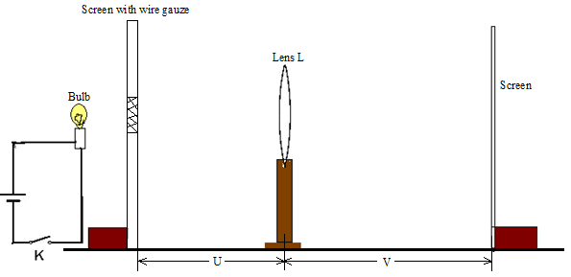
Figure 2
- Connect the bulb, the dry cells and the switch, K, in series.
- Arrange the bulb, the lens and the screen as shown in the figure above.
- Adjust the distance, u, between the wire gauze and the lens L to 70cm.
- Close switch K.
- Adjust the position of the screen to obtain a sharp image of the cross wires on it.
- Measure and record the distance, v, between the screen and the lens.
- Open the switch.
- Repeat procedures (c) to (g) for values of u = 60, 50, 40, 30, and 20cm.
- Enter your results in a suitable table including values of .
- Plot a graph of against u.
- Read and record the intercept, C on the u – axis.

- In this experiment, you will determine the internal resistance, r, of the dry cell provided.

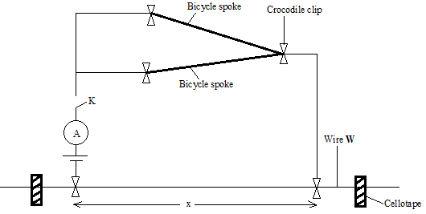
Figure 3
- Fix the resistance wire, W, provided firmly on the table using cello tape.
- Connect the circuit as shown in the figure 3 above.
- Adjust the length $x$ of the resistance wire to 0.100m.
- Read and record the ammeter reading$I$.
- Repeat procedure (c) and (d) for values of$x=0.200, 0.300, 0.400, 0.500 and 0.600m$.
- Tabulate your results including values of $\frac{1}{I}$ .
- Plot a graph of $\frac{1}{I}$ against$x$.
- Find the slope S of the graph.
- Read and record the intercept C on the $\frac{1}{I}-axis.$
- Calculate the internal resistance $r$ of the cell from the expression$r=\left[4.42\frac{C}{S}-0.2\right]$.

END

