NAME……………………….………………………………..... INDEX NO………………….

CANDIDATE’S SIGN………….….….….…..DATE……………………….

443/2 AGRICULTURE
PAPER 2
MAY, 2019
TIME: 2 HOURS

ACK DIOCESE OF NAMBALE

FORM FOUR 2019 JOINT EXAMINATIONS

INSTRUCTIONS TO CANDIDATES:
• Write your name and index number in the spaces provided above.
• Sign and write the date of examination in the spaces provided above.
• This paper consists of THREE Sections A, B and C.
• Answer all questions in Section A and B and any Two in Section C.
• All answers must be written in the spaces provided.

FOR EXAMINER’S USE ONLY
Section | Question | Maximum  Score | Candidate’s  Score
A | 1 – 18 | 30
B | 19 – 21 | 20
C | 22 -24 | 40
Total Score |  | 90

SECTION A
Answer ALL the questions in this section
1. What is zero grazing? (1mk)
………………………………………………………………………………………………………………………………………………………………………………………………………………
2.List any four farm structures that are necessary for handling dairy animals. ( 2mks)
………………………………………………………………………………………………………………………………………………………………………………………………………………………………………………………………………………………………………………………………………………………………………………………………………………………………………………………………………………………………………………………………………

3. Apart from a tractor and electricity, name four other sources of power that may be use for
doing work on the farm ( 2mks)
………………………………………………………………………………………………………………………………………………………………………………………………………………………………………………………………………………………………………………………………………………………………………………………………………………………………………………………………………………………………
4. Which tool would be required for each of the following farm operations?
(i) Cutting wool from sheep. (1mk )
……………………………………………………………………………………………………
(ii) Castrating piglets (1 mk)
………………………………………………………………………………………………
5. Give three conditions under which a farmer may prefer to use an ox-cart instead of a tractor drawn trailer? ( 1 ½mks)
…………………………………………………………………………………………………………………………………………………………………………………………………………………………………………………………………………………………………………………………………………………………………………………………………………………………….

6.Give four factors that should be considered when siting a beehive in a farm. ( 2mks)
……………………………………………………………………………………………………………………………………………………………………………………………………………………………………………………………………………………………………………………………………………………………………………………………………………………………………………………………………………………………………………………………………
7. State four management practices that would ensure maximum harvest of fish from fishpond. ( 2mks )
………………………………………………………………………………………………………………………………………………………………………………………………………………………………………………………………………………………………………………………………………………………………………………………………………………………………………………………………………………………………………………………………………
8. Give two predisposing factors to foot-rot disease in sheep. ( 1mk )
………………………………………………………………………………………………………………………………………………………………………………………………………………………………………………………………………………………………………………………

9. What is the intermediate host for liver fluke? (1mk )
…………………………………………………………………………………………………….
10. Give two causes of soft shell in eggs. (1mk )
………………………………………………………………………………………………………………………………………………………………………………………………………………………………………………………………………………………………………………………
11.List four factors associated to the animal that determine the amount of feed that an animal consumes. ( 2mks)
…………………………………………………………………………………………………………………………………………………………………………………………………………………………………………………………………………………………………………………………………………………………………………………………………………………………
12Give four reasons why the feeding of colostrums is important in the rearing of piglets. ( 2mks)
…………………………………………………………………………………………………………………………………………………………………………………………………………………………………………………………………………………………………………………………………………………………………………………………………………………………………………………………………………………………
13. Give four reasons why young rams should be docked. (2mks)
…………………………………………………………………………………………………………………………………………………………………………………………………………………………………………………………………………………………………………………………………………………………………………………………………………………………………………………………………………………………………
14. List four diseases caused by viruses. ( 2mks)
…………………………………………………………………………………………………………………………………………………………………………………………………………………………………………………………………………………………………………………………………………………………………………………………………………………………………………………………………………………………………
15. Give the difference between maintenance ration and production ratio ( 2mks)
……………………………………………………………………………………………………………………………………………………………………………………………………………………………………………………………………………………………………………………………………………………………………………………………………………………………………………………………………………………………………………………………………………………………………………………………………………………………………………

16. Give two signs that would show that a doe is just about to give birth. ( 1mk)
………………………………………………………………………………………………………………………………………………………………………………………………………………………………………………………………………………………………………
17. Name three importance of lubricating system in tractor. (1 1/2mks)
………………………………………………………………………………………………………………………………………………………………………………………………………………………………………………………………………………………………………………………………………………………………………………………………………………………………

18. State any two causes of stress in a flock of layers (2mks)
……………………………………………………………………………………………………………………………………………………………………………………………………………………………………………………………………………………………………………………………………………………………………………………………………………………………………………………………………………………………………………

SECTION B :Answer all questions
19.) The diagram below is about one of the tractor systems. Study it and answer the questions that follow.

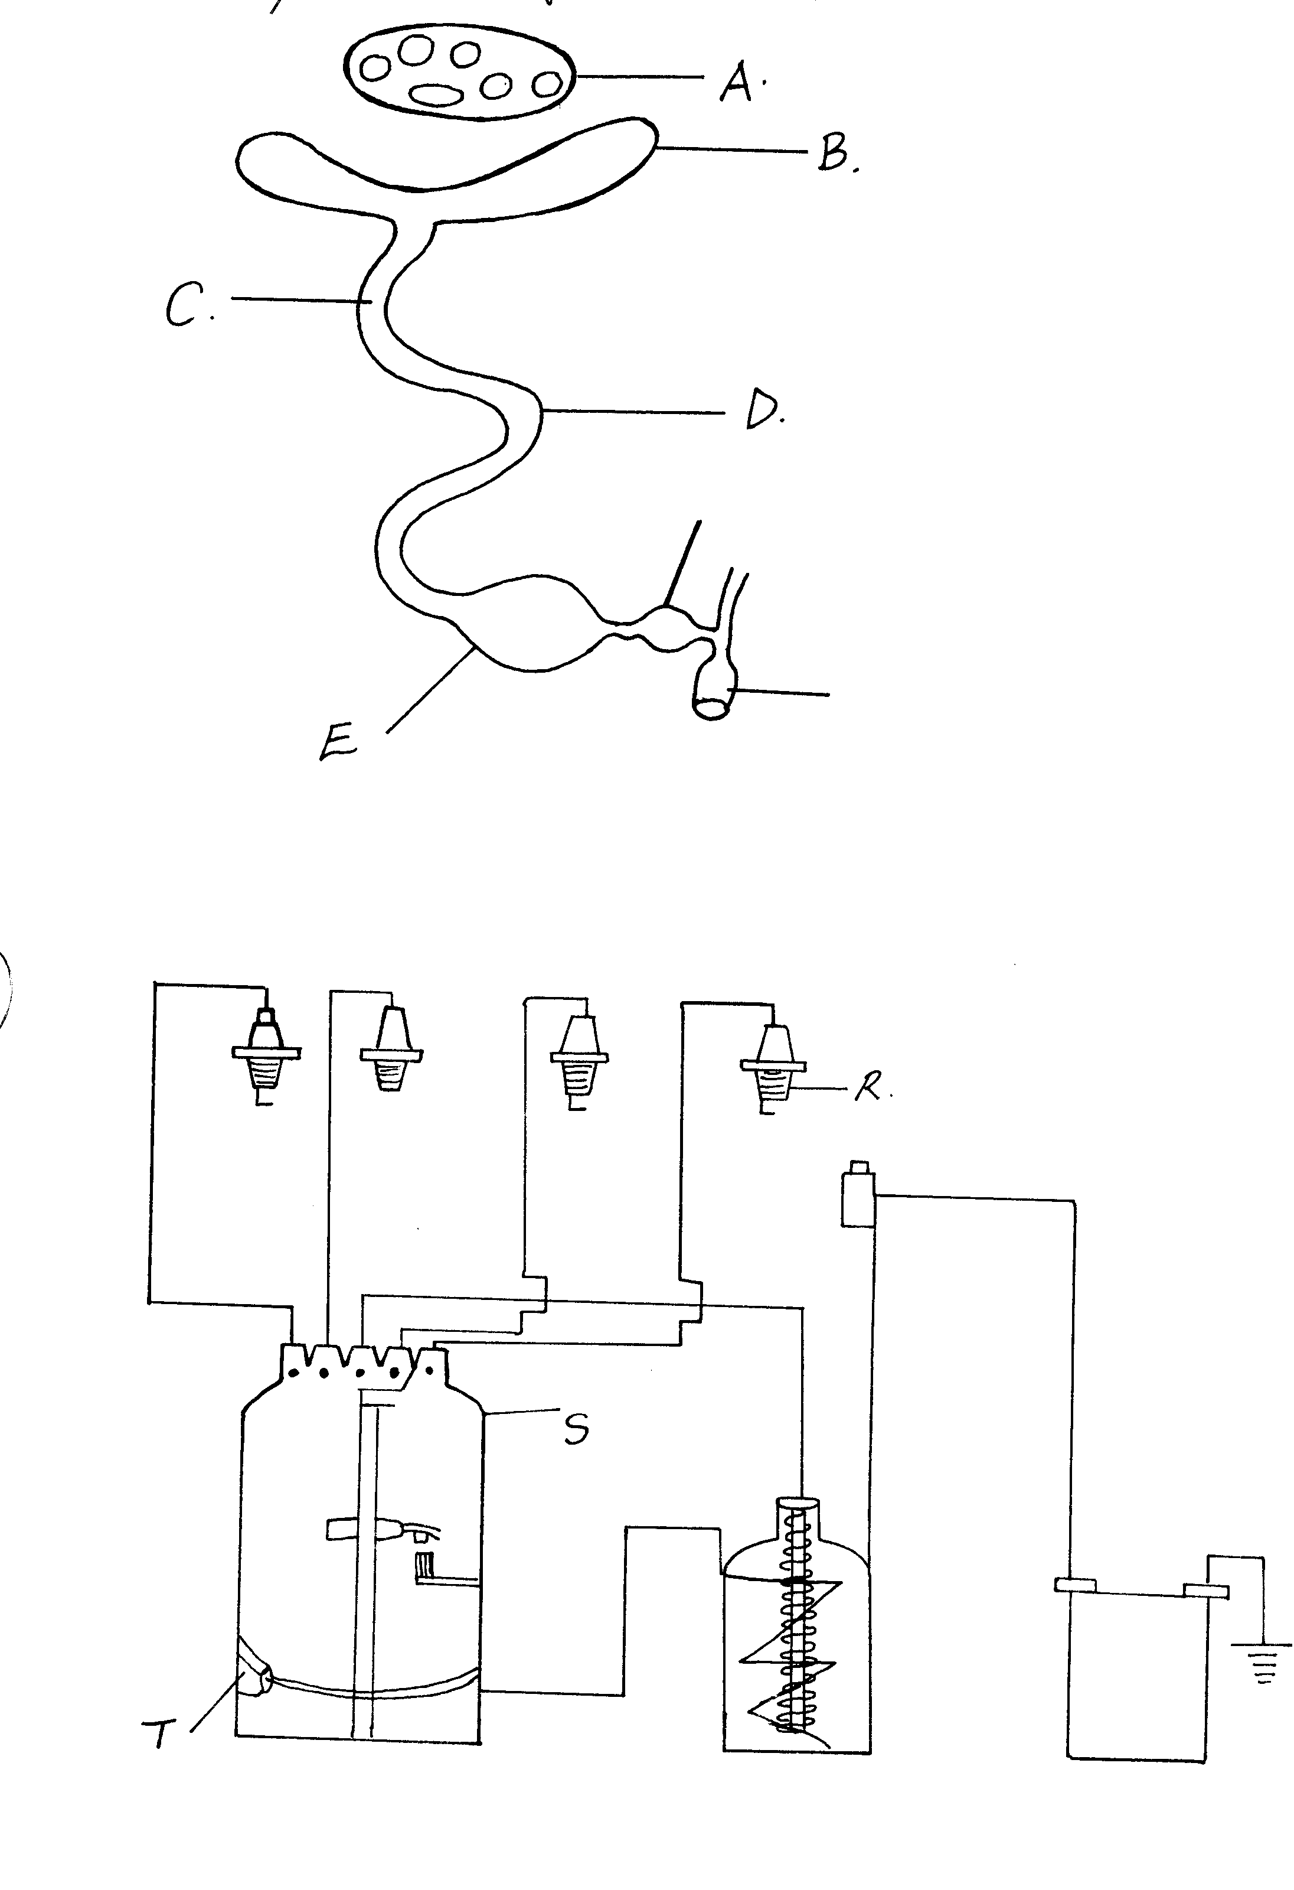
Q
i) Identify the system shown above. (1mk)
……………………………………………………………………………………………………………………………………………………………………………………………..
ii) Name the parts Q, R,S and T. (2mks)
Q ………………………………………………………………………………..
R ………………………………………………………………………………….
S ……………………………………………………………………………………
T …………………………………………………………………………………..
iii) State four maintenance of the above system (4mks)
…………………………………………………………………………………………………………………………………………………………………………………………………………………………………………………………………………………………………………………………………………………………………………………………………………………………………………………………………………………………………………………………………………………………………………………………………………………………………………………………………………………………………………………………………………………
20.Study the diagram below and answer the questions that follow:

cloaca
Vagina
- Name part A and D (2mks)
A…………………………………………………………………………………..
D……………………………………………………………………………………

ii)Describe two changes that occur on the yolk at each of the parts B to E. (2mks)
…………………………………………………………………………………………………………………………………………………………………………………………………………………………………………………………………………………………………………………………………………………………………………………………………………………………
iii)State four disadvantages of inbreeding (4mks)
………………………………………………………………………………………………………………………………………………………………………………………………………………………………………………………………………………………………………………………………………………………………………………………………………………………………

21.Study the structure and answer the questions:
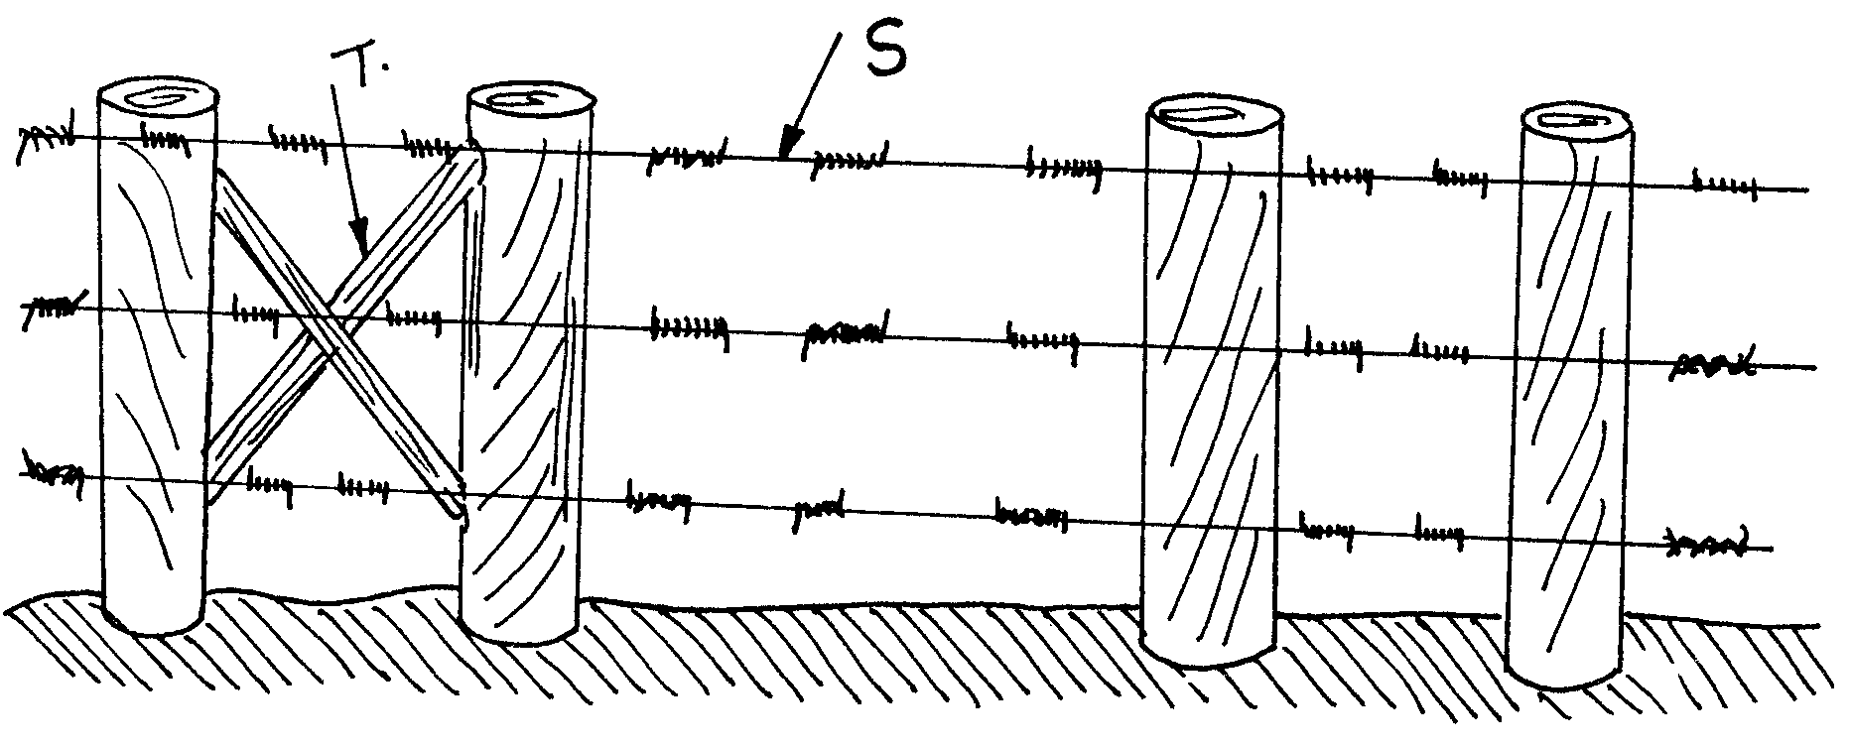
a) Name the structure above. (1mk)
………………………………………………………………………………………………………
b) Name the parts labeled: (2mks)
S…………………………………………………………………………………….
T……………………………………………………………………………………
c) State the functions of parts labeled (2mks)
T …………………………………………………………………………………………………………………………………………………………………………………………………………
S
…………………………………………………………………………………………………………………………………………………………………………………………………………….
SECTION C:Anwer any two questions in this section

22. a) Discuss the essentials of clean milk production. ( 14mks )
b) Name the common poultry vices and outline their control. (6mks)
23.Discuss bloat disease under the following sub-headings.
a) Species of the animals affected by the disease. (3mks)
b) Causes of the disease. (4mks)
c) Symptoms of the disease. (6mks)
d) Control measures of the disease (2mks) e) Treatment of the disease. (5mks)

24.Explain the measures used to control
a) Livestock diseases (14mks)
b) Livestock parasites. (6mks)
................................................................................................................................................................................................................................................................................................................................................................................................................................................................................................................................................................................................................................................................................................................................................................................................................................................................................................................................................................................................................................................................................................................................................................................................................................................................................................................................................................................................................................................................................................................................................................................................................................................................................................................................................................................................................................................................................................................................................................................................................................................................................................................................................................................................................................................................................................................................................................................................................................................................................................................................................................................................................................................................................................................................................................................................................................................................................................................................................................................................................................................................................................................................................................................................................................................................................................................................................................................................................................................................................................................................................................... ...................................................................................................................................................................................................................................................................................................................................................................................................................................................................................................................................................................................................................................................................................................................................................................................................................................................................................................................................................................
................................................................................................................................................................................................................................................................................................................................................................................................................................................................................................................................................................................................................................................................................................................................................................................................................................................................................................................................................................................................................................................................................................................................................................................................................................................................................................................................................................................................................................................................................................................................................................................................................................................................................................................................................................................................................................................................................................................................................................................................................................................................................................................................................................................................................................................................................................................................................................................................................................................................................................................................................................................................ .......................................................................................................................................................................................................................................................................................................................................................................................................................................................................................................................................................................................................................................................................................................................................................................................................................................................................................................................................................................................................................................................................................................................................................................................................................................................................................................................................................................................................................................................................................................................................................................................................................................................................................................................................................................................................................................................................................................................................................................................................................................................................................................................................................................................................................................................................................................................................................................................................................................................................................................................................................................................................................................................................................................................................................................................................................................................................................................................................................................................................................................................................................................................................................................................................................................................................................................................................................................................................................................................................................................................................................................................................................................................................................................................................................................................................................................................................................................................................................................................................................................................................................................................................................................................................................................................................................................................................................................................................................................................................................................................................................................................................................................................................................................................................................................................................................................................................................................................................................................................................................................................................................................................................................................................................................................................................................................................................................................................................................................................................................................................................................................................................................................................................................................................................................................................................................................................................................................................................................................................................................................................................................................................................................................................................................................................................................................................................................................................................................................................................................................................................................................................................................................................................................................................................................................................................................................................................................................................................................................................................................................................................................................................................

