612/2
IPS ART
Paper 2
July 2017
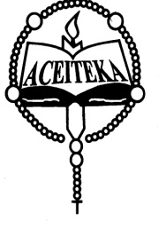
ACEITEKA JOINT MOCK EXAMINATIONS 2017
UGANDA CERTIFICATE OF EDUCATION
IPS (ART AND CRAFT)
Paper 2
DRAWING OR PAINTING FROM STILL LIFE/NATURE STUDY
TIME: 2 HOURS 30 MINUTES

Instructions to candidates
- Attempt ONE question out of the alternatives
- On the top right corner of the final work measure 5cm x 12cm that space should not be painted and in it write your name, class stream, index number if you have one.
- The use of rulers or any other mechanical means is not allowed.

ALTERNATIVE A: (STILLL LIFE)

Either
- On a low platform place a medium size round tray and on its right side place a 2kgs sliced loaf of bread facing the candidates at 3¼ view. The front is part is open and some few slices are seen lying on the tray but leaning against each other in pattern. On the left of the tray but slightly next to the loaf placed is a kettle with its spout facing the left and the handle upright. A 1kg tin of blue band is placed in front of the kettle but slightly on the right next to the slices of bread is seen. In front of the blue band tin but on the left randomly place a ripe banana and an egg. Candidates draw the whole setting.

OR
ALTERNATIVE B: (NATURE STUDY)
- Make a study or studies of a coffee berry branch with some few leaves and clusters of berries intact.
- Make a study or studies of a house fly.
- Draw a landscape from your school entrance and in it show two buildings, a path, some trees in the background and some hedges in the foreground.

END

