Topic 2 FABRIC DECORATION
Fabric/ textile design is patterning an essentially plain fabric to render it more appealing to serve a particular purpose. This includes any of the many concepts and activities used for enriching a fabric medium, in any case the action or technique used is a result of a design and expression of elements and principles of a design.
TYPES OF FABRIC DESIGN
Surface fabric design; this is a design that is achieved by ornamenting the surface of a fabric.
Surface fabric designs can be achieved in the following ways;
- Printing
- Painting
- Tie and dye
- Batik
- Embroidery
- Appliqué
- Patch work.

Structural fabric design; this is a design that is achieved as the material/fabric is made; this includes the overall design, form and shape plus all the details involved in assembling the sections of the fabric.
Structural fabric decoration can be achieved in the following ways;
- Weaving
- Knitting
- Netting
- braiding

WHY WE DECORATE FABRICS
- For aesthetic reasons; Fabrics are decorated to make a plain piece of fabric look interesting

- For social reasons; Fabrics are decorated to differentiate social classes

- For cultural reasons; Fabrics are decorated according to the culture that has been put in them. People base on historical and ancestral believes.

- Fabrics are also decorated to suite the social classes of people and also recognize companies, institutions and organizations from the way they dress and present themselves.

- Fabrics are also decorated to earn a living.

- Fabrics are also decorated for communication purposes. They are decorated especially for advertisements by different organizations and individuals

TOOLS USED DURING FABRIC PRINTING
- GOUGES (U, V, NARROW U shaped)
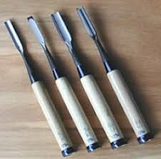
Used to carved design/ motif on wood plates, linoleum board and any other soft material that can be used for block/ relief printing.
- INK ROLLER
This tool is used to apply printing ink or paste onto the block such that only raised parts (positives) receive the ink which is then pressed onto the fabric to create patterns.
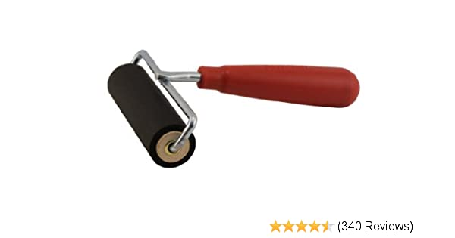

- SCREEN (SILK OR IMPROVISED MESH)
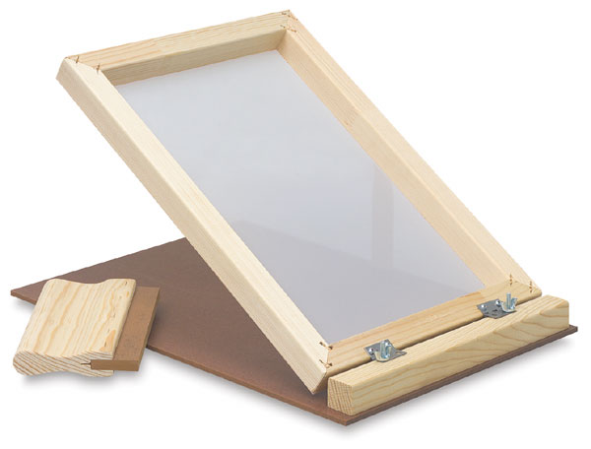
This is a fine fabric mesh through which printing ink or paste is pressed onto the fabric laid on a flat surface. The designs are made by mounting a stencil beneath it or by exposing the positive image on emulsion solution thinly applied on.

- SQUEEGEE
This is a rubber blade fixed on a wooden/plastic/metallic handle used to press ink through a screen that has an emulsion motif or stencil beneath onto a fabric. (See the small tools on the screen)
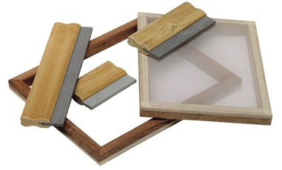
Sqeegee

- STENCIL
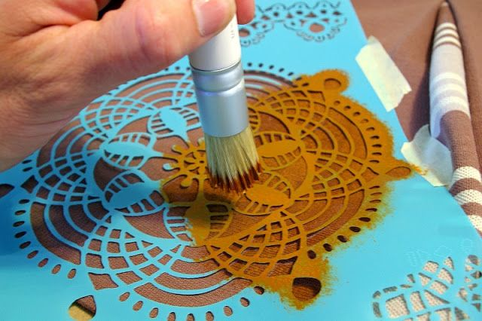 This is a design pafforated sheet of material (plastic/metal/paper, e t c through which ink is pressed directly or when beneath a screen onto a flat surface (fabric). Ink is directly pressed by brush or sponge as seen above.

