SAMIA SUB COUNTY JOINT EXAM
CHEMISTRY PAPER 3 PRACTICAL
MARKING SCHEME
TABLE 1
Complete table ------------------1mrk
(i)Complete the table with 3 titrations done –(1mrk)
(ii) Incomplete table with 2 titrations done ---(1/2mrk)
(iii)Incomplete table with 1 titration done –(0mrk)
Penalties
- Wrong table
- Inverted table
- Unrealistic value
Penalize ½ mark for each to a maximum of 1/₂mrk
Decimals ---------------1mrk
(Tied to the first and second row only )
Conditions
Accept either 1or 2 decimals points used consistently
If the 2 ^{nd} decimal point is used . can only be o or 5
Accuracy -------1mrk
Compare any titre value in the 3rd row with the school value (sv)
Conditions
- If with or +0.1cm³ of sv ---1mrk
- If within +0.2cm³of sv ---1/₂ mark
- Beyond +0.2cm³ of sv -----omrk
NB/ if there is wrong arithmetic in the table compare the sv with the correct value and credit accordingly.
Principle of averaging ----1mrk
Value average must be shown and must be within +0.2 cm³ of each other conditions.
- 3 values averaged and consistent -1mrk
- 3 values done and only 2 possible averaged –1mrk
- 2 titrations done and averaged -1mrk
- 2 titrations done and inconsistent -0mrk
- 3 titrations done and consistent but only two averaged -0mrk
Final accuracy -1mrk
Compare with the (sv )
- If within +_0.1 of sv-1mrk
- If within +_0.2 of sv -1/2mrk
- If beyond +_0.2 of sv -0mrk
NB// If the candidate has averaged wrong values pick the correct value if any ,average and credit accordingly
(ii) 106g of Na₂ CO₃ =1 mole
8 = x 8x1 ½
106
=0.0755M Na ₂ CO ₃ ½
iii)In 1000cm³ of Na₂CO₃= answer in (ii)
in 25 cm3 =25 x answer in (ii) ½
1000
= answer in (iii) ½
iv) Na₂ CO _{3(aq)} +Na₂ CO_{3(aq)}----------------------Na₂SO_{4 (aq)}+CO_{2(g)} +H₂O(l)
Ratio Na₂CO₃.H₂ SO₄
1 : 1
answer in (iii) : answer in (iii) ½

average titre in cm³= answer in (iii)
In 1000cm³= 1000x answer in (iii) ½
Average titre
= answer in (iv) M ½

v) Concentration of sulphuric (vi) acid

in 1000cm³ ………………………… answer in (iv)
250cm³ ………………………………..?
answer in (iv) ×250 = answer in moles
1000
in 25cm ³= answer in moles
in 1000cm³= ?
answer in moles x1000= answer in (v) M ½
25
Alternatively
M₁V₂ = M₂V₂
answer in (iv) X 250 = M₂ X 25
M₂ = answer in (iv) X 250
25
= answer in (V)

Conditions
- If units given they should be correct however if not given ignore.
- Molarity should be given to at least 3 decimals place otherwise penalize ½ marks for the answer.
- Numbers of moles should be given to at least 4 decimal places, otherwise penalize ½ mark for answer.
TABLE II
a) Complete table -2mrks
5-6 experiments done -2mks
3-4 experiments done -1 mark
Less than 3 experiments done -0mrk
Penalties
- Penalize ½ mark for inverted table
- Penalize fully for unrealistic temperature readings i.e. Above50⁰c or below 10⁰c .
Decimals -1mark
Must be 1 dp or whole numbers used uniformly.
The first digit after the decimal must be a zero or 5 otherwise penalize fully.
Award either 1mk or zero. No half mark.
C) Accuracy -1mark
Accuracy is pegged on the candidate initial temperature reading
Conditions
- Award 1 mark if the candidate value is within +2units the school value.
- The initial temperature reading should be the same for all the six experiments otherwise penalize fully.

D) Trend -1mrk (tied to ΔT)

- Award1mark for a continuous rise followed by continuous drop.
- Award 1mark for a continuous rise, a constant then followed by continuous drop

GRAPH-3mks

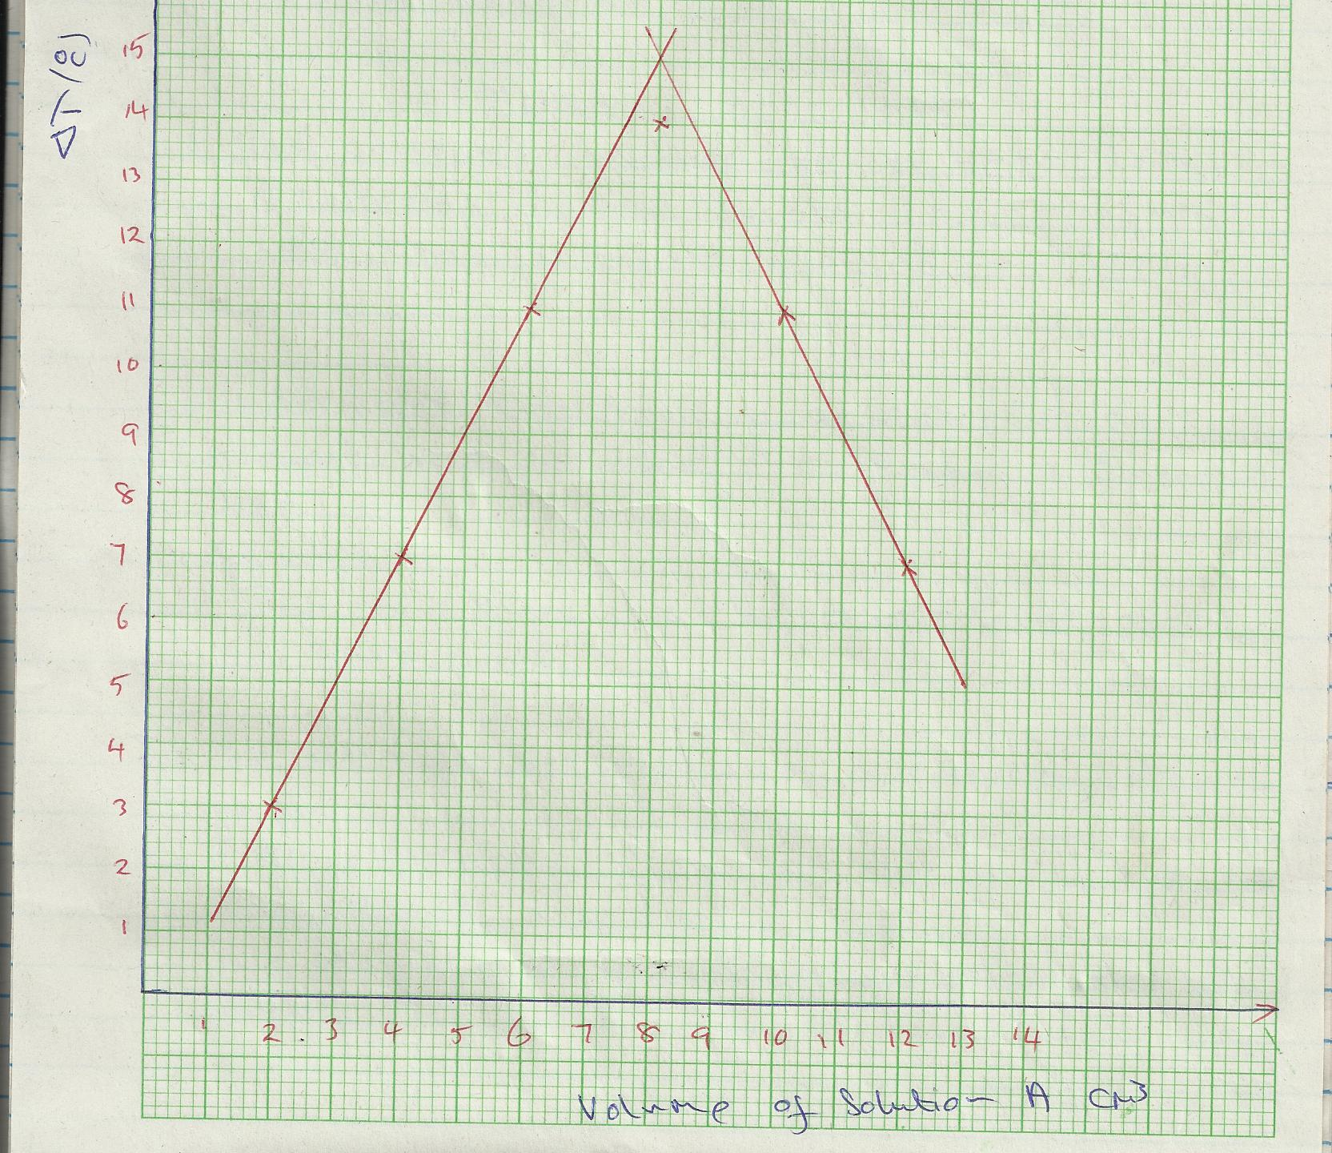
- Labeling – ½ mrk
The vertical and horizontal axis must be correctly labeled with correct unit otherwise penalize fully
Scale – ½ mark
The actual plot must cover at least seven big squares on the vertical axis and at least 8 big squares on the horizontal axis, otherwise penalize fully.
c)Plotting
5-6 correct plotted points -1mark
4 correctly plotted points- ½ mark
Less than 4 points plotted – 0mark
Line -1mrk
A straight line showing a continuous rise followed by a line showing a continuous drop.
Condition the two lines must be extrapolated above the last point.
I i) The Δt must be read from a correctly drawn graph.
ii) ΔT is correctly shown on the graph but not read correctly, award accordingly ½ mk.
The graph must be extrapolated above the last point.
II The volume of A must be read from a correctly drawn graph .
-The reading must be shown on the graph. Without showing, penalize fully.

(iii) I Answer in (ii) above x answer (v) in procedure A ½
1000
=correct answer 1 ½
II a) Δ H=mcΔT
=16x4.2xΔT (answer (ii)I above )1 ½
1000
=correct answer ½
b) = 1 x correct answer above ½
Answer (iii)I above
=correct answer ½ in kJmol⁻¹
Penalize ½ mk if wrong units. Reject KJ
QUESTION 2-SOLID G

OBSERVATIONS | INFERENCES
(i) No white precipitate 1mk | Na⁺, K⁺, NH₄⁺ present 1mk  If a candidate infers Zn²⁺, Al³⁺, Pb²⁺ absent, award ½ mk
(ii) burns with a yellow flame 1mk | Na⁺ present 1mk
(iii) white precipitate 1mk | CO₃²⁻, SO₃²⁻, SO₄²⁻ present  3 ions 1mk  2 ions ½ mk  1 ion 0mk  Penalize ½ mk for any contradictory ion to a maximum of 1mk
(iv) white precipitate dissolves / effervescence/ bubbles of a colourless gas. 1mk | CO₃²⁻, SO₃²⁻ present  2 ions - 1mk  1 ion – 0 mk  SO₄²⁻ absent, award ½ mk.  Penalize fully for any contradictory ion
(iv) orange colour changes to green 1mk  Candidate must mention original and final colour, otherwise penalize fully. | SO₃²⁻ present 1mk  Penalize fully for any contradictory ion

NB// 1 Penalise ½ mark for every contradictory ions to a maximum of I mark .
2 For the inference to be correct ,the observation must be correct .

QUESTION 3-Solid T
OBSERVATIONS INFERENCES
a) Burns with a yellow luminous /sooty/ smoky flame 1mark ̦̀C=C̦΄ or -C=C- present 1mk
unsaturated hydrocarbon ½ mk
hydrocarbon with high C:H ratio 1mk

b) Effervescence /bubbles/ fizzing ½ R –COOH / H⁺ / H₃O⁺present ½
reject: hissing/fizzling/sizzling Penalize fully for any contradictory ion

ii) pH=4 or 5 ½ mrk Weakly acidic ½ mrk
ii) Purple KMnO₄ turns colourless / = C=C= ,-C=C- present
purple colour is decolourised 1mk Penalize ½ mk for any contradictory
reject: turns colourless functional group

iii) Orange colour of K₂ Cr₂ O₇ persists/ is retained 1mk R-OH absent 1mrk

NB//1 Penalize fully for- C=C- and C= or H-C=C-H and H-C=C-H
2 The pH value should not be a range of values e.g. 4-5
3 Penalize fully for weak acid in the inference of b(ii)

