735/1
BUILDING AND
MECHANICAL DRAWING
Paper 1
July/August 2019
3 Hours.


KAYUNGA SECONDARY SCHOOLS EXAMINATIONS COMMITTEE (KASSEC)
JOINT MOCK EXAMINATIONS, 2019
Uganda Certificate of Education
BUILDING AND MECHANICAL DRAWING
Paper 1
3 Hours

INSTRUCTIONS TO CANDIDATES;
- The question paper consists of two sections A and B and a total of eight questions are set
- Attempt any four questions. Not more than two questions may be chosen from any one section.
- All dimensions are in millimeters unless otherwise stated.
- The given figures are not drawn to scale.
- All questions carry equal marks.

SECTION A (Plane Geometry)

1. a) Assume the distance between Kampala and Jinja is 100km and it is represented on a map by a line 20mm. (13mks)
i) Using the information above, draw a diagonal scale showing a single kilometer and long enough to measure up to 600km.
ii) Indicate on your scale distance 237km.
b) i) Using the scale in 1.a) (i) above, construct an equilateral triangle of altitude 237km (12mks)
ii) Measure and state the sides of the triangle.
ii) Divide the triangle into 3 parts of equal areas.
2. The figure below shows a site plan. AC is hyperbolic, P is the turning point; XY and XZ are its asymptotes. AB is a quarter an ellipse and BC is parabolic.
a) Construct the site. (15mks)
b) Draw a normal and a tangent onto the curve AB at a point 30mm above line AC. Show your working. (10mks)

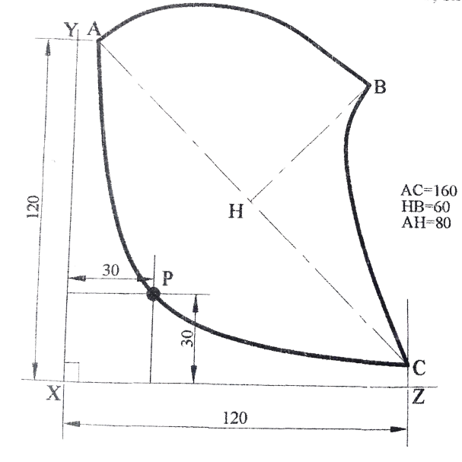

3. The figure below shows the relative positions of two points P and Q on a straight line AB and a circle of 40mm diameter with its Centre at R.
(i) Draw the figure. (05mks)
(ii) Construct a circle which will pass through points P and Q and touch the given circle. State its diameter. (10mks)

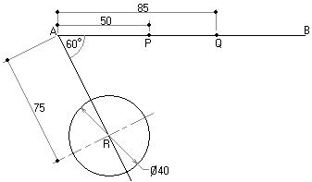
b) Draw the view given in the figure showing clearly all centers of radii and points of tangency. (10mks)
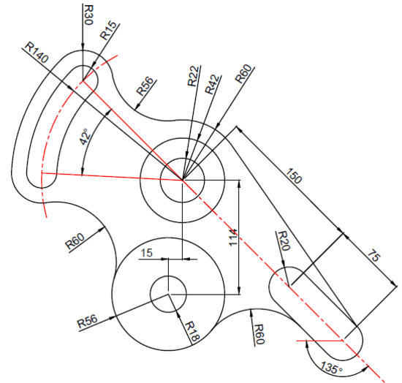

4. In the figure below, two equal cranks AB and CD connected by a link BD, rotates in opposite directions.
Draw one complete revolution the locus of
(i) Point P. (13 marks)
(ii) Point Q. (12 marks)
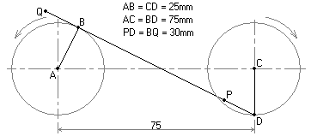

SECTION B (Solid Geometry)
5. The elevation of a hexagonal pyramidal lamp shade is shown in the figure below. Draw;
(a) The elevation as shown. (05mks)
(b) A plan in the direction of arrow P. (10mks)
(c) The development of the surfaces taking the seam on A-A. (10mks)

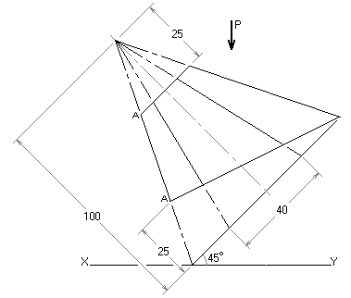

6. The figure below shows a square based pyramid of sides 50mm intersecting with a square prism of side 25mm. Draw the given front view in third angle projection, project the complete plan and end views showing the details of intersection. (25mks)

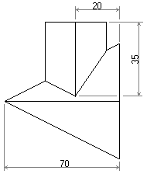

7. The figure below shows two views of a machine block in first angle projection. Draw an isometric view of the block with point P in the fore ground. Hidden details are not required. (25mks)

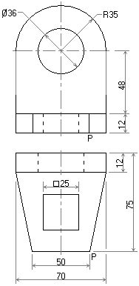

8. The figure below shows orthographic views drawn in first angle projection.
Draw an auxiliary elevation in the direction of the arrow E. (25mks)
40
20
30
Elliptical
60
50
20
50
40
60⁰
E

END

